APS 321 INTRODUCTION TO ENVIROMENTAL PSYCHOLOGY
Course outline
INTRODUCTION
Welcome to this Unit. You probably have heard about the environmental psychology. You could have formed and developed your own versions of what the term constitutes. In this module, we will introduce you to the basic concepts in environmental psychology and why you should study it. This is an interactive instructional module that uses both action and collaborative learning styles that provide you with diverse online learning experiences and effective learning processes.
The key purpose of this unit is to introduce you to the Environmental psychology, the course is designed to help the learner appreciate human behavior in the environment i.e. Human behavior depends on the environment in which it takes place, while in turn people also influence the environment by their presence and activities

In this unit, we shall define the basic concepts in the term environmental psychology, different environmental contexts these are natural, physical, social, built and informational environment. Why we learn environmental psychology and human environmental dependence. For example, the environment can influence peoples' behavior and motivation to act. For instance environment can influence mood, the results of several research studies reveal that rooms with bright light, both natural and artificial, can improve health outcomes such as depression, agitation, and sleep.
Exposure to hazardous substance in the air, water, soil, and food, can subject human beings to a lot of stress while natural , technological disasters and climatic change can subject human beings to psychological trauma and finally the environmental aesthetic allows people to appreciate the beauty of the natural and built environment. We hope that you will find this module exciting, educative, and engaging.

INTRODUCTION TO ENVIRONMEMTAL PSYCHOLOGY
WEEK | TOPIC
 | INTRODUCTION (YOUR CONTEXT, YOUR GOALS, THOUGHTS ABOUT ENVIROMENT
WEEK 1: | DEFINATION AND CONCEPT IN ENVIRONMENTAL PSYCHOLOGY
WEEK 2: | PROXEMICS, PERSONAL SPACE AND PERSONAL DISTANCE.
WEEK 3: | MEANING AND CONCEPTS OF TERRITORIALITY
WEEK 4: | ARCHITECTURE AND BEHAVIORS
WEEK 5: | ENVIRONMENTAL STRESSORS: POLLUTION
WEEK 6: | WASTE MANAGEMENT
WEEK 7: | URBANIZATION AND BEHAVIOR
WEEK 8: | DENSITY AND CROWDING
WEEK 9: | NATURAL, MAN-MADE AND TECHNOLOGICAL DISASTERS AND THEIR IMPACT ON ENVIRONMENT
WEEK 10: | ENVIRONMENTAL AESTHETICS
WEEK 11&12 | EXAMINATION

OVERVIEW OF THE COURSE
Introduction (Your Context, Your Goals)
This lesson is intended to help you acclimatize to blended learning and to create a community of learners who will motivate each other during the course. You will be expected to introduce yourself to your lecturer and colleagues during a face to face session or even online before other academic interactions start.. It will be important to state your context and goals as well as what you think about environmental psychology. You can also share any experience that you may have regarding environmental psychology.

Week 1: Definitions and Concepts in Environmental psychology
The purpose of this lesson is to enable you understand the definition of the term environmental psychology. Different environmental contexts these are natural, physical, social, built and informational contexts and then, the importance of learning environmental psychology and theories of environmental psychology

Week 2: Proxemics, Personal Space and Personal Distance.
This lesson will enable you to understand the meaning of the term proxemics, personal space and personal distance
Week 3: Meaning and Concepts of Territoriality
The purpose of this lesson is to enable you understand the meaning and concepts of territoriality, by defining the term, territoriality and classifying territories, identifying the functions and characteristic of territories and finally explaining how to establish and maintain territories
Week 4: Architecture and Behaviors
This lesson focuses on the definition of the term architecture and how architectural designs influence human behavior
Week 5: Environmental Stressors: Pollution
This lesson will introduce you to environmental stressors especially environmental pollution. The lesson will help you identify different forms of environmental pollution and explain the environmental noise pollution

Week 6: Waste Management
The lesson will help you understand environmental waste management, by defining the term waste management and explaining waste management strategies.

Week 7: Urbanization and Behavior
This lesson introduces you to urbanization and behavior, first the definition, social and economic impacts of urbanization

Week 8: Density and Crowding
This lesson introduces you to the density and crowding by defining, density and crowding and identifying the measurement of density and conditions that cause people to feel crowded and finally social and psychological effects of overcrowding

Week 9: Natural, Man-Made and Technological Disasters and their Impact on Environment
This lesson introduces you the topic Natural and Man-Made disaster and their Impact on environment. The lesson seeks to identify natural disasters, manmade disasters and technological disasters and their impact to the environment.
Week 10: Environmental Aesthetics
This lesson introduces you the topic environmental aesthetics by explaining the environmental aesthetics and identifying their use or applications of aesthetics in different context under the philosophy of art

Week 11&12: Examination
These two weeks bring together the work you have been doing to an end. This course unit will be examined and will partially contribute to the award of the degree in the program me that you are undertaking. We acknowledge that different universities across East Africa may have different Semester dates. It is however anticipated that most Universities will have a minimum of 13 weeks’ semester. We have therefore placed examinations in the last two weeks but Universities are allowed to go with their schedules. Your university examinations regulations will apply.

APS 321: ENVIRONMENTAL PSYCHOLOGY
LECTURE ONE
CHAPTER ONE: NATURE, FUNCTION AND MODELS OF ENVIRONMENTAL PSYCHOLOGY
LEARNING OUTCOMES
- Definitions –psychology and environment
- Different environmental contexts-natural, physical, social, learning and informational
- Interface of Behaviors and environment
- Functions of environmental psychology
- Orientations –problem oriented, system oriented, interdisciplinary and time-space
DEFINITION OF ENVIRONMENTAL PSYCHOLOGY
Environmental psychology is an interdisciplinary field focused on the interplay between human’s actions or behaviors and their surroundings. The field defines the term environment broadly, encompassing natural environments, social settings, built environments, learning environments and informational environment.
Ingredients of the definition
- Interdisciplinary-involves the combining of two or more academic fields into one single discipline
- The natural environment encompasses all living and non-living things occurring naturally on earth or some region thereof. It is an environment that encompasses the interaction of all living species The concept of the natural environment can be distinguished by components:
- Complete ecological units that function as natural systems without massive human intervention, including all vegetation , microorganism, soils, atmosphere, natural phenomena that occur within their boundaries
- Universal natural resources and physical phenomena that lack clear-cut boundaries, such as air, water, climate as well as energy, radiations, electric charges and magnetism not originating from human activity.
iii) The social environment of an individual, also called social context or milieu, is the culture that s/he was educated and/or lives in, and the people and institutions with whom the person interacts
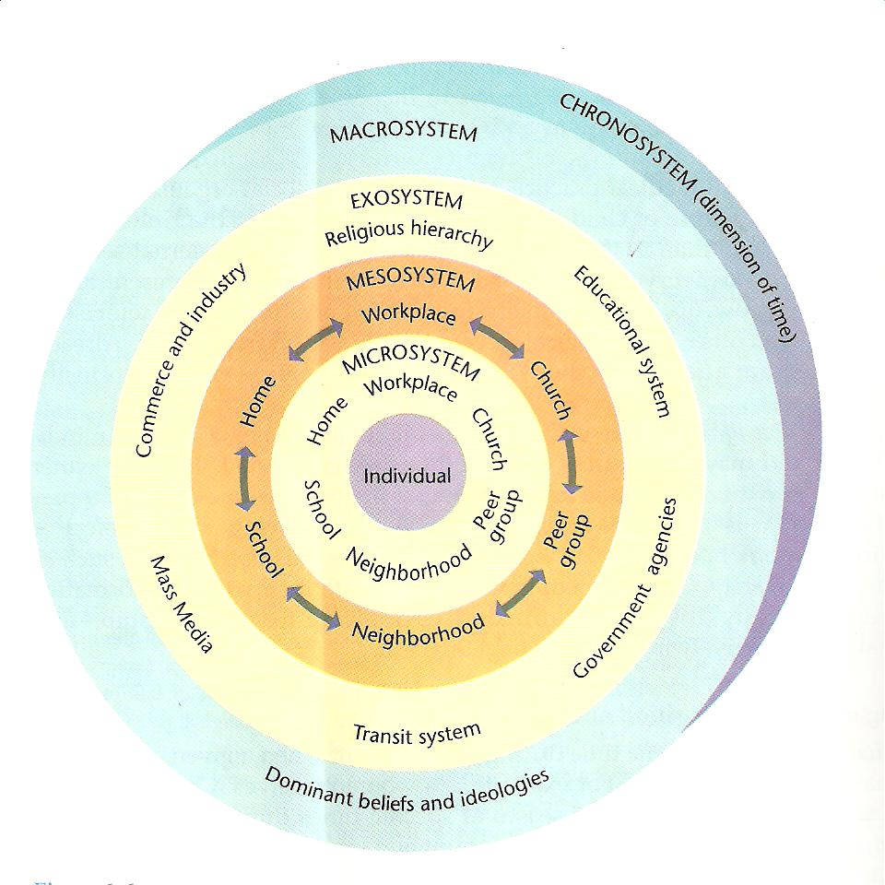

iv) The term-built environment refers to the human-made surroundings that provide the setting for human activity ranging in scale from personal shelter and buildings to neighborhoods and cities that can often include their supporting infrastructure, such as water supply or energy network. The built environment is a material, spatial and cultural product of human labor that combines physical elements and energy in forms necessary for living, working and playing.
v) Learning environment, the sum of the internal and external circumstances and influences surrounding and affecting a person's learning.
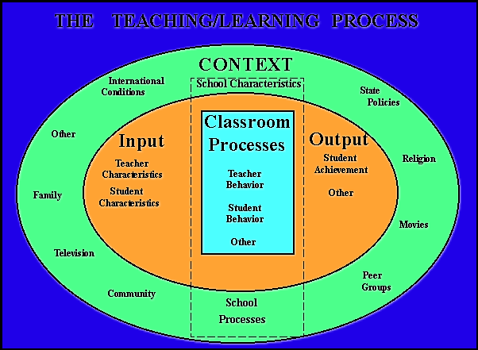

vi) Informational environment
The entire infrastructure, organization, personnel, and components that collect, process, store, transmit, display, disseminate, and act on information. The information environment consists of the source, message, channel, receiver and feedback.
INTERFACE OF BEHAVIOR AND ENVIRONMENT
Human behavior depends on the environment in which it takes place, while in turn people also influence the environment by their presence and activities. As part of the environment, people behave in response to both physical and social settings. In fact, every individual not only adapts to his or her physical and social environment but also makes up part of the social environment of other individuals
WHY ENVIRONMENTAL PSYCHOLOGY?
The knowledge of environmental psychology may assist in solving environmental problems. When solving problems involving human-environment interactions, whether global or local, one must have a model of human nature that predicts the environmental conditions under which

humans will behave in a decent and creative manner. With such a model one can design, manage, protect and/or restore environments that enhance reasonable behavior, predict what the likely outcome will be when these conditions are not met, and diagnose problem situations

THEORIES OF ENVIROMENTAL PSYCHOLOGY
ORIENTATION OR THEORIES/MODELS OF NVIRONMENTAL PSYCHOLOGY
1. Problem Oriented
Environmental psychology is a direct study of the relationship between an environment and how that environment affects its inhabitants. Specific aspects of this field work by identifying a problem and through the identification of said problem, discovering a solution. Therefore it is necessary for environmental psychology to be problem oriented. The problems identified by environmental psychologists affect all members of society. These problems can be anything from the psychological effects of urban crowding to the architectural design of public schools and extend from the public arena into the individual household. Environmental psychology addresses environmental problems such as density and crowding, noise pollution, substandard living and urban decay. Noise increases environmental stress. Although it has been found that control and predictability are the greatest factors in stressful effects of noise; context, pitch, source and habituation are also important variables. Environmental psychologists have theorized that density and crowding can also have an adverse effect on mood and may cause stress related illness. To understand and solve environmental problems, environmental psychologists believe concepts and principles should come directly from the physical settings and problems being looked at. For example, factors that reduce feelings of crowding within buildings include:
- Windows - particularly ones that can be opened and ones that provide a view as well as light
- High ceilings
- Doors to divide spaces and provide access control
- Room shape - square rooms feel less crowded than rectangular ones
- Using partitions to create smaller, personalized spaces within an open plan office or larger work space.
- Providing increases in cognitive control over aspects of the internal environment, such as ventilation, light, privacy, etc.
- Conducting a cognitive appraisal of an environment and feelings of crowding in different settings. For example, one might be comfortable with crowding at a concert but not in school corridors.
- Creating a defensible space
2. System Theory
The systems oriented approach to experimenting is applied to individuals or people that are a part of communities, groups, and organizations. This approach particularly examines group interaction, as opposed to an individual’s interaction and it emphasizes on factors of social integration. In the laboratory, experiments focus on cause and effect processes within human nature.
3. Interdisciplinary Approach
Environmental psychology relies on interaction with other disciplines in order to approach problems with multiple perspectives. The first discipline is the category of behavioral sciences, which include: sociology, political science, anthropology, and economics. Environmental psychology also interacts with the interspecializations of the field of psychology, which include: developmental psychology, cognitive science, organization theory, psychobiology, and social neuroscience. In addition to the more scientific fields of study, environmental psychology also works with the design field which includes: the studies of architecture, interior design, urban planning, industrial and object design, landscape architecture, and preservation
4. Time space orientation
Space over time orientation highlights the importance of the past. Examining problems with the past in mind creates a better understanding of how past forces, such as social, political, and economic forces, may be of relevance to present and future problems. Time and place are also important to consider. It’s important to look at time over extended periods. Physical settings change over time; they change with respect to physical properties and they change because individuals using the space change over time. Looking at these spaces over time will help monitor the changes and possibly predict future problems. OTHER THEORIS IN THE POWEROINT

LECTURE TW0
A cognitive bias refers to the systematic pattern of deviation from norm or rationality in judgment, whereby inferences about other people and situations may be drawn in an illogical fashion. Individuals create their own "subjective social reality" from their perception of the input.
What are cognitive biases in decision making?
The most common cognitive biases are confirmation, , and overconfidence. 1. Confirmation bias: This bias occurs when decision makers seek out evidence that confirms their previously held beliefs, while discounting or diminishing the impact of evidence in support of differing conclusions.

In psychology, decision-making is regarded as the cognitive process resulting in the selection of a belief or a course of action among several alternative possibilities. ... Decision-making is the process of identifying and choosing alternatives based on the values, preferences and beliefs of the decision-maker.

A cognitive bias is a systematic error in thinking that affects the decisions and judgments that people make. Sometimes these biases are related to memory.
What is a cognitive bias example?

There are several types of cognitive bias. Some examples include the following: Bandwagon effect: This is the tendency for people to do or think things because other people do or think them

Confirmation bias: This is the tendency for people to seek out or interpret information so that it confirms their belief

LECTURE THREE
CHAPTER TWO: PROXEMICS
Definition- Proxemics is the study of the human use of space within the context of culture. He mentioned that there are three fundamental areas related to proxemics: space, distance, and territory.
PERSONAL SPACE-Space that people attempt to keep around themselves when they interact feels ownership and control of the space. Each person has an invisible boundary around their body into which other people may not come. If someone pierces this invisible boundary, which is your own personal space, they will feel uncomfortable and move away to increase the distance between them. The size of your own personal space changes, depending on a number of things like the relationship to the people nearby, the person's emotional state, cultural background, and the activity being performed. When a person is alone, his or her individual distance is infinite; but personal space is always carried, although it disappears in certain situations such as crowding. When personal space is violated, people react with defensive gestures, shifts in posture, attempts to move away, and actually moving away.
Functions of personal space
There are three main purposes of personal space and all have to do with interpersonal boundary regulation
1. Protective function: serves as a buffer zone against potential emotional and physical threats. Arms length distance allows an individual to see the hands and feet of others and protect against surprise physical assaults.
2. Adjusting sensory input: regulate amount of sensory information we get from others and prevents overloads;
3. Communication function: level of closeness and intimacy that we desire with another. Distance in which we interact determines the channel of communication we can use.
4. it mechanism for achieving privacy. People use the space around them as buffer to protect their privacy. Privacy determines the amount of space individual claims as personal.
5. Gives people identity. By claiming space around themselves, people can signal that they indeed unique individuals who are independent of others.
6. Used as regulation of intimacy. People interact at closer distance with others whom they like than with the one they dislike. We signal attraction for others by looking into their eyes, smiling and leaning towards them. We communicate dislike by moving away from people, reducing eye contact and frowning.

Types of personal space
i) Fixed-feature space- This comprises things that are immobile, such as walls and territorial boundaries. It is usually one of the ways in which people organize activities. Houses, buildings, cities, rooms, etc. are organized spatially. Objects and activities are related to these spatial arrangements; and if objects or activities are moved, people react.
ii Semi fixed-feature space- This comprises movable objects, such as furniture. However, again, some furniture is fixed, and is classified as a fixed-feature. Semi-fixed space is of primary importance in interpersonal communication, because it can be used in many different ways to convey meaning. There are two types of semi-fixed feature space:
a) Socio-petal spaces are those which bring people together and stimulate involvement,
b) socio-fugal spaces keep people apart and promote withdrawal. Furniture arrangement in public places has a distinct relationship to the degree of conversation. Some spaces such as railway waiting rooms in which the seating provisions are formally arranged in fixed row, tend to discourage conversation.
iii) Informal space -This comprises the personal space around the body, that travels around with a person as he/she moves, and that determines the personal distance among people.
Informal space is significant because it includes the distances people unconsciously maintain when they interact. Informal spatial patterns have distinct bounds and such deep, if unvoiced, significance that they form an essential part of culture. Informal space is classified into four subcategories: intimate, personal, social, and public
PERSONAL DISTANCE
People have certain patterns for delimiting the distance when they interact, and this distance varies according to the nature of the social interaction. There are four types of distances:
• Intimate;
• Personal;
• Social;
• Public.
These distances can vary according to personality and environmental factors, since an abnormal situation could bring people closer than they usually are. It should be noted that some individuals never develop the public phase of their personalities and, therefore, cannot fill public spaces; they make very poor speakers or moderators. Other people have trouble with the intimate and personal zones and cannot endure closeness to others. Each of the four distance zones described below has a near and a far phase
- Intimate distance ranges from body contact to approximately 45 cm. At intimate distance, the presence of the other person is unmistakable. Sight, olfaction, heat from the other person’s body, smell, and feel of the breath all combine to signal unmistakable involvement with another body. According to Hall, the close phase, up to15 cm, includes intimate activities which require extensive contact of the bodies while the far phase, from 15 to 45 cm, does not allow for much, if any, body contact (Hall, 1966, p. 116-119).
- Personal distance consistently separates the members of the non-contact species. It might be thought as a small protective sphere that a person maintains between itself and others. Personal distance ranges from 45 to 120 cm between people. The close phase, 45 to 75 cm, permits one person to touch another, while the far phase of personal distance, 75 to 120 cm, "an arm's length" does not permit this. Subjects and personal interest can be discussed at this distance (Hall, 1966, p. 119-120).
- Social distance is the casual interaction-distance between acquaintances and strangers. It is common in business meetings, classrooms, and impersonal social affairs. Social distance ranges from 120 to 360 cm. Its close phase, 120 to 210 cm, is the characteristic of informal interaction, while more formal interaction requires the far phase 210 to 360 cm. Some physical barriers such as desks, tables, and counters, usually make people keep this distance. Proxemic behavior of this sort is culturally conditioned and arbitrary
- Public distance is at 360 cm or more. Its close phase, 360 to 450 cm, provides the amount of space generally desired among strangers, while its far phase 450 cm or more is necessary for large audiences. In this case, speech must be projected or amplified for interaction

Factors that affect the shape and size of personal space and distance
- Gender
Distance kept in interacting males is larger that interacting females or mixed sex. Males protect their frontal space while female protect their lateral space. Males in library place books and possessions in front of them and females place their belongings in at their sides-reduce invasion from that direction.
- Culture
Some people interact at closer range than others
- Contextual factors- Characteristics of situation in which interaction takes place. People maintain greater distance in small rooms than large rooms, in rectangular rooms than square rooms. People interacting indoor maintain greater distance than people in outdoor activities. When people are in a setting that is likely to arouse a great tension (dean’s office) they maintain greater distance than less anxious provoking setting (TV lounge).
Personal space and counseling
Counselors who seat across tables from their clients are apt viewed less positively than those seated corner to corner
In summary
Intimate distance for embracing, touching or whispering
o Close phase - less than 6 inches (15 cm)
o Far phase - 6 to 18 inches (15 - 45 cm)
Personal distance for interactions among good friends
o Close phase - 1.5 to 2.5 feet (45 - 75 cm)
o Far phase - 2.5 to 4 feet (75 - 120 cm)
Social distance for interactions among acquaintances
o Close phase - 5 to 7 feet (1.5 - 2.1 m)
o Far phase - 7 to 12 feet (2.1 - 3.6 m)
Public distance used for public speaking
o Close phase - 12 to 25 feet (3.6 - 7.5 m)
o Far phase - 25 feet (7.5 m) or more

Proxemics is also the Study of Space , the search for the lingual foundations of human culture will lead to non verbal communication without which the diversity and sophistication of today’s language system would be impossible. While commenting on the significance of non verbal communication in the evolution of human language, Harrison and Crounch (1972) suggest that “in the development of each human being, non verbal communication precedes and perhaps structures all subsequent communication.”
When our communication is supplemented by the aspects of non-verbal cues, – like facial expression, gestures etc- its message paired with the lexical content, makes the interpretation of the sender’s meaning complete
There various classifications regarding the types, factors and the influences of the non verbal communication.
Knapp’s (1971), one of the scholars in this field has classified non verbal communication in the following way.
- Environmental Factor, It consists of elements such as furniture, architectural style, lighting, smells, colors and temperature.
- Proxemics It is defined as the use and perception of one’s social and personal space, such as in seating and spatial arrangements.
- Kinesics, It is defined as body motions that include gestures, body movements, postures, facial and eye behaviors.
- Touching Behavior, It deals with the touching behavior of an individual
- . Physical Characteristic, It comprises of personal characteristics such as physique, breath odor, height, weight, and hair and skin color.
- Paralanguage It consists of nonverbal cues surrounding speech, such as pitch, volume, tempo and intensity of the voice.
- Artifacts, the manipulated objects that are in contact with the interacting persons such as perfume, clothes, lipstick, hair pieces, eyeglasses and miscellaneous beauty aids.
Proxemics has attracted many researches belonging to multiple disciplines like Culture, Psychology, and Architecture etc. The Proxemics behavior becomes an important field of study as it widens the research in the area of non-verbal communication.
The term Proxemics - denoting, “The study of how human beings communicate through their use of space”- was coined by E.T.Hall, an Anthropoligist by profession. He defines the term as, “The spatial dimension of non-verbal behavior” (Hall 1963; p 122). It has created a revolution in this field and has given a new dimension to the study of non-verbal communication. He popularized this theory through his two books entitled The Silent Language (1959) and The Hidden Dimension (1966) which brought him a great fame.
As we all know, “Humans are territorial animals, everyday people claim space, built on it and this way, mark their territory”
. For an instance, a student feels uncomfortable in a class, when he finds his seat to be taken by someone else. This gives a vulnerable feeling that someone has invaded his/her personal space or territory.
This, in general shows that the people are anchored in space and have developed a strong sense of territory.
Blyth, an expert in the field, while talking about Proxemics states ,that, ‘Hall sets forth a theory about how people react to others at various distances from their own bodies, indicating thereby a sense of territoriality, similar to that shown by animals or birds and develops notation for this purpose.”
In simple words, Proxemics can be defined as the study of means in which individuals make use of the physical space in the interaction between the individuals. Each and every organism in the universe tries to occupy, cultivate, preserve and utilize space. This process of owning the space by above said means differ from culture to culture. People often feel uncomfortable when operating in the spaces different from those in which they are familiar.
There are three fundamental areas with which the experts in the field categorize Proxemics
  - Distance
  - Spaces
  - Modes of behavior and perception
A brief description of the above said fundamental areas of Proxemics as follows:
  - DISTANCE:
Based on observation in social situations, Hall classifies the distance as,
a) Intimate Distance (0- 1.5) ft the zone is mainly for non verbal communication. Only the intimate people like members of the family and friends can enter into it. It is considered improper for the public places.
b) Personal Distance (1.5 ft-3ft) this zone is popularly known as the Bubble and it is meant for the people who are well known to us. It varies in different cultures and depends on individual’s personality and the style of communication.
c) Social Distance (4 ft – 11 ft ) this zone is meant for general gatherings and business meetings or generally interacting with someone who is not particularly well known.
d) Public Distance (12 ft-25ft) in this zone only public interaction is possible. It demands louder voice, more formal style of language and reduced speech rate.
- SPACE
The representation of space is only briefly dealt within Hall’s Proxemics. He distinguishes three categories of space.
- Fixed Feature Space: This space is formed by walls and territorial buildings. For example Houses, Buildings, Cities, Class rooms etc. The use of the class room space could either make the students comfortable or uncomfortable, feel motivated or de motivated.
- b) Semi fixed space: This category of space is more important in interpersonal communication. In this, the objects are already fixed and the position of the objects and the space resulted provide details on the nature of the interaction as well as the status of the participants. This category of space is sub divided into two. They are,
  - Sociofugal Space: It keeps the people away from the process of communication. It transmits connotative meanings such as large, cold, impersonal and so on.
  - Sociopetal Space: It brings the people together and stimulates involvement in the process of communication
For example,
Thomas E. Harris and John C. Sherblom suggest us some ways in which seating arrangements can be used to facilitate communication between the members.
“Individuals sitting across a table from each other maximize their interpersonal distance, increase their potential for sending and receiving both verbal and nonverbal messages and thus perhaps conflicting messages, and increase the likelihood of becoming competitive. Sitting with a corner of the table between participants reduces interpersonal distance, focuses attention on the project and materials rather than on the individuals’ non verbals, and may help enhance the cooperativeness of the participants. Sitting side by side reduces the interpersonal distance still farther and, unless that interpersonal distance is too intimate to feel comfortable, may also be a cooperative seating arrangement”
- Informal Space: This refers to the private space which people maintain when they interact. According to Hall, “informal spatial patterns have distinct bounds and such deep if unvoiced, significance that they form an essential part of culture. To misunderstand this significance may invite disaster.”

MODES OF BEHAVIOR AND PERCEPTION
The third fundamental area describes the eight variables of Proxemics behavior identified by Hall which acts as an extension of the research in this field. They are,
- Postural-Sex Identifier It refers to the postural status and sex identities of the participants in the interaction
- Sociofugal and Sociopetal Axis It refers to the positioning of one’s shoulders and face which will encourage or discourage the process of communication.
- Kinesthetic Factor, It refers to the distance between the individuals which provides capability to touch each other.
- Touch Code, It deals with the individual’s manner of touching one another
- Visual Code, It refers to the eye contact with reference to the space between the individuals.
- Voice Loudness, It refers to the loudness of the voice with reference to the space between the individuals.
- Thermal Code, it refers to the heat transmitted from the individuals’ bodies with reference to the space.
- Olfaction Code. It refers to the individual’s degree of breath and odors that can be felt by the other individual standing next to him.
Thus, the understanding of the above mentioned eight variables of the Proxemic behavior gives an ability to read the behavior of the participant in an interaction.
Conclusion:
Proxemic research is based on the concept of territoriality. Territoriality is a basic concept in the study of animal behavior. It is defined as behavior by which an organism characteristically lays claim to an area and defends it against members of its own and other species. Most individuals are generally unaware of the norms of Proxemic behavior within their culture, but they do become conscious of them when these norms are violated or when they notice differences in spatial behavior due to the norms of foreign culture. The study of space plays a significant role in social, cultural and economic spheres of the world; the researchers in this field have to be encouraged to understand the above said disciplines at a wider perspective. This will, for sure, dispel the myth hidden in the field of Proxemics for a decade

LECTURE FOUR
TERRITORIALITY
The term territoriality means a geographic area that indicates ownership and defense of this territory against "invaders". Behavior associated with ownership or occupation of a place or area which involve personalizing the place and defending it against intrusion from individuals or the group.
Types
- Primary –exclusively owned and controlled by individuals or groups on a permanent basis e.g. somebody’s home
- Secondary –under less personal control. It personalized while being occupied but personalization ends when the owner leaves the area. E.g particular seat in library
- Public- area that is temporarily controlled by individual and their no feeling of ownership. Everyone has right to use them.
Functions of territory
- Helps to provide stable social organization
- Aids in the regulation of privacy (individual’s freedom to chose what s/he will communicate about her/himself and to whom she will communicate it in a given circumstance)
Needs for privacy
- Allows personal identity-provides the means to control the environment
- It gives opportunity for emotional release from tensions of everyday life
- Gives an opportunity for self evaluation by allowing us to withdraw and take stocks of ourselves
- Allows us limited and protected communication by permitting us to decide when and with whom we will share our thoughts and feelings
- Protection function-people perform better on their own territory
- Establishes independence and personal identity-territory allows people to define who they are and draw boundaries between themselves and others e.g decorate offices reflect identity
Disadvantage of territorial behaviors
- Fear of giving up territory or changing territory may cause people forgo opportunities for job advancement and travel
- Some people become so attached to territory that they will not part with a possession even after it no longer serves any useful purpose
- Rigid adherence to territory claims and opportunities and the opportunity to pass on territory to next generation makes social change very difficulty
Establishing and maintaining territory
- Human beings erect high fences to protect their territory
- Use of tress pass signs or armed guards
- Use of non-verbal gestures-angry stare/gaze
- Place a coat/ book in library to establish territorial control

READ MORE ON TERRITOTIES

