CILIATES

Balantidiasis

The intestinal protozoan Balantidium coli is the only member of the ciliate group that is pathogenic for humans. Disease produced by B. coli is similar to amebiasis, because the organisms elaborate proteolytic and cytotoxic substances that mediate tissue invasion and intestinal ulceration.

Life cycle

The life cycle of B. coli is simple, involving ingestion of infectious cysts, excystation, and invasion of trophozoites into the mucosal lining of the large intestine, caecum, and terminal ileum. The trophozoite is covered with rows of hair like cilia that aid in motility. Morphologically more complex than amebae, B. coli has a funnel-like primitive mouth called a cytostome, a large (macro) nucleus and a small (micro) nucleus involved in reproduction.

Epidemiology

B. coli are distributed worldwide. Swine and (less commonly) monkeys are the most important reservoirs. Infections are transmitted by the faecal-oral route; outbreaks are associated with contamination of water supplies with pig faeces. Person-to-person spread, including through food handlers, has been implicated in outbreaks. Risk factors associated with human disease include contact with swine and substandard hygienic conditions.

Clinical features

As with other protozoan parasites, asymptomatic carriage of B. coli can exist. Symptomatic disease is characterized by abdominal pain, tenderness, tenesmus,

nausea, anorexia, and watery stools with blood and pus. Ulceration of the intestinal mucosa, as with amebiasis, can be seen; a secondary complication caused by bacterial invasion into the eroded intestinal mucosa can occur. Extra intestinal invasion of organs is extremely rare in balantidiasis.

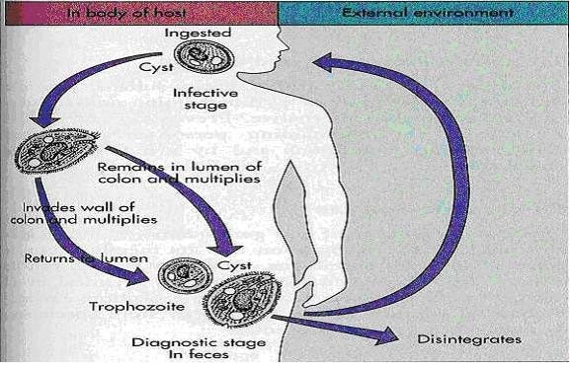
Figure 14; life cycle of Balantidium coli

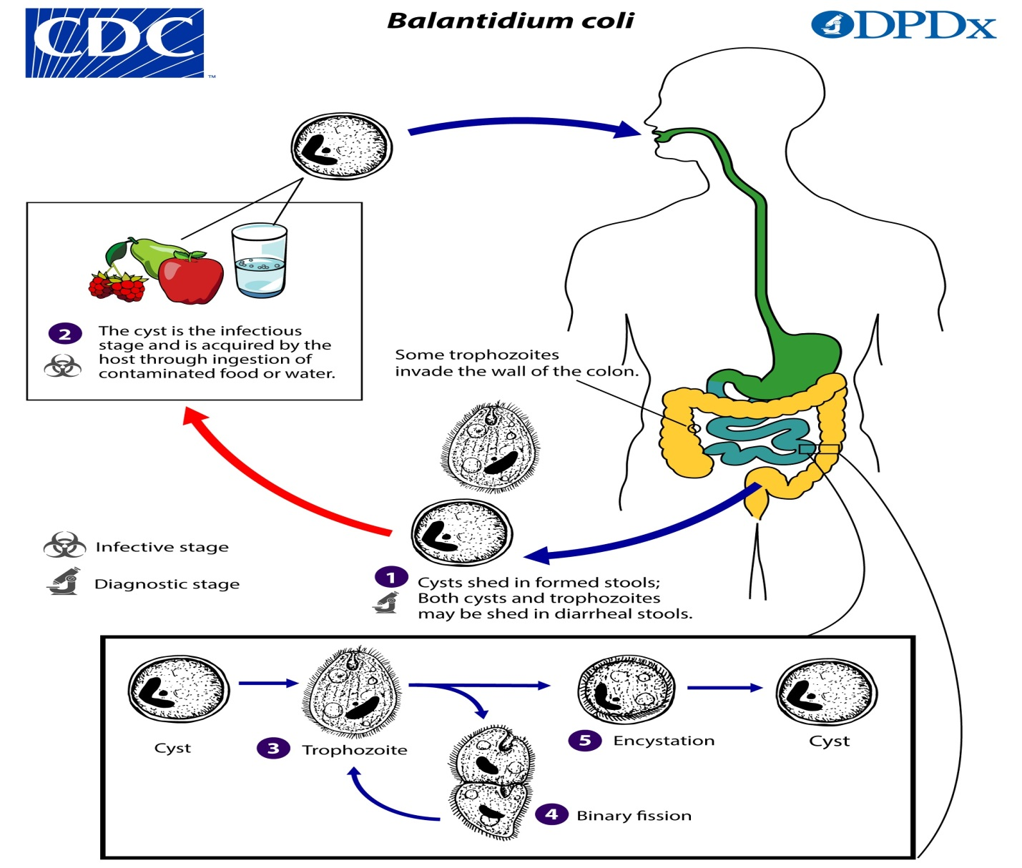

Laboratory Diagnosis

Microscopic examination of faeces for trophozoite and cysts is performed. The trophozoite is very large, varying in length from 50 to 200μm and in width from 40 to 70μm. The surface is covered with cilia.
Balantidium coli cysts in wet mounts.
Both Balantidium coli trophozoites and cysts may be shed in stools. Both stages may occur in diarrheal stools, and usually only cysts are observed formed stools. Trophozoites are characterized by: their large size (40 µm to 200 µm), the presence of cilia on the cell surface, a cytostome, and a bean shaped macronucleus which is often visible and a smaller, less conspicuous micronucleus. Cysts are seen less frequently and range in size from 50 µm to 70 µm. B. coli trophozoites can also invade tissue.

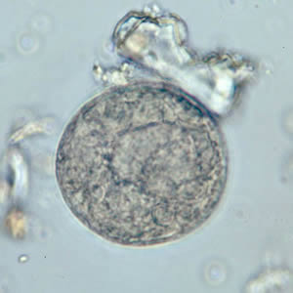
Figure A: B. coli cyst in a wet mount, unstained.
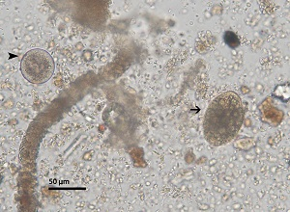
Figure B: B. coli cyst (dart) and trophozoite (arrow) in the same field, from a primate fecal sample.
Balantidium coli trophozoites.
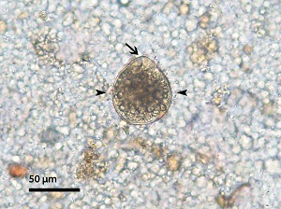
Figure A: B. coli trophozoite in a primate fecal sample. Note the prominent groove of the cytostome (arrow), cilia (darts), and starch granules within the cell.
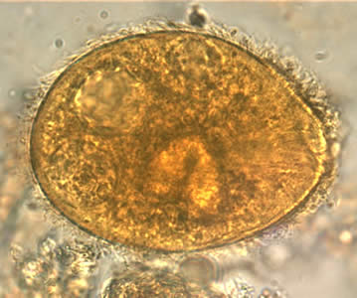
Figure D: B. coli trophozoite in a wet mount, 1000× magnification. Note the visible cilia on the cell surface. Image contributed by the Oregon Public Health Laboratory.
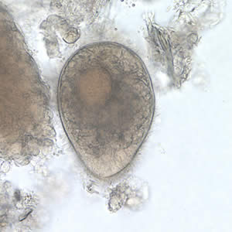
Figure B: B. coli trophozoite in a wet mount, 500× magnification. Note the visible cilia on the cell surface.
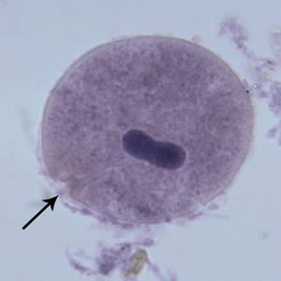
Figure E: B. coli trophozoite in a Mann's hematoxylin stained smear, 500× magnification. Note the cytosome (black arrow) and the bean shaped macronucleus.
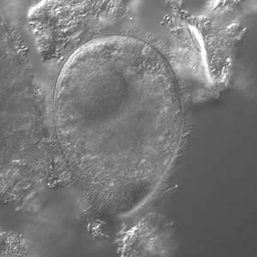
Figure C: B. coli trophozoite under differential interference contract (DIC) microscopy, 500× magnification
Balantidium coli trophozoites in intestinal tissue, stained with hematoxylin and eosin (H&E)
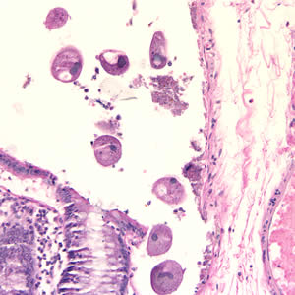
Figure A: B. coli trophozoites in colon tissue stained with hematoxylin and eosin (H&E) at 200x magnification.
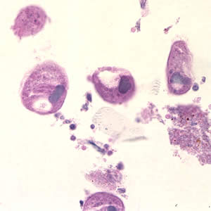
Figure B: B. coli trophozoites in colon tissue stained with hematoxylin and eosin (H&E) at 400x magnification.

Treatment

The drug of choice is tetracycline; iodoquinol and metronidazole are alternative agents.

