COCCIDIA

Malaria
There are four species normally infecting humans, namely,
- Plasmodium falciparum
- Plasmodium vivax
- Plasmodium ovale
- Plasmodium malariae.
- Plasmodium knowlesii

Life cycle
- The life cycle of malaria is passed in two hosts (alternation of hosts) and has sexual and asexual stage (alternation of generations).
- Vertebrate host - man (intermediate host), where the asexual cycle takes place.
- The parasite multiplies by schizogony and there is formation of male and female gametocytes (gametogony). Invertebrate host - mosquito (definitive host) where the sexual cycle takes place.
- Union of male and female gametes ends in the formation of sporozoites (sporogony).
- The life cycle passes in four stages:
Three in man
- Pre - erythrocytic schizogony
- Erythrocytic schizogony
- Exo- erythrocytic schizogony One in mosquito - Sporogony
Introduction into humans - when an infective female Anopheles mosquito bites man, it inoculates saliva containing sporozoites (infective stage).
Pre- Erythrocytic schizogony
- sporozoites reach the blood stream and within 30 minutes enter the parenchymal cells of the liver, initiating a cycle of schizogony. Multiplication occurs in tissue schizonts, to form thousands of tiny merozoites.
- Merozoites are then liberated on rupture of schizonts about 7th – 9th day of the bites and enter into the blood stream.
- These merozoites either invade the RBC’s or other parenchymal liver cells. In case of P. falciparum and possibly
- P. malariae, all merozoites invade RBC’s without re-invading liver cells.
- However, for P. vivax and P. ovale, some merozoites invade RBC’s and some re-invade liver cells initiating further Exo-erythrocytic schizogony, which is responsible for relapses. Some of the merozoites remain dormant (hypnozoites) becoming active later on.
- Erythrocytic schizogony (blood phase) is completed in 48 hrs in P. vivax, P. ovale, and P. falciparum, and 72 hrs in P. malariae. The merozoites reinvade fresh RBC’s repeating the schizogonic cycles
- Erythrocytic merozoites do not reinvade the liver cells. So malaria transmitted by blood transfusion reproduces only erythrocytic cycle

Gametogony
- Some merozoites that invade RBC’s develop into sexual stages (male and female gametocytes). These undergo no further development until taken by the mosquito.

Sporogony (extrinsic cycle in mosquito)
- When a female Anopheles mosquito vector bites an infected person, it sucks blood containing the different stages of malaria parasite.
- All stages other than gametocytes are digested in the stomach.
- The microgametocyte undergoes ex-flagellation. The nucleus divides by reduction division into 6-8 pieces, which migrate to the periphery.
- At the same, time 6-8 thin filaments of cytoplasm are thrust out, in each passes a piece of chromatin.
- These filaments, the microgametes, are actively motile and separate from the gametocyte.
- The macrogametocyte by reduction division becomes a macrogamete. Fertilization occurs by entry of a micro gamete into the macro gamete forming a zygote.
- The zygote changes into a worm like form, the ookinete, which penetrates the wall of the stomach to develop into a spherical oocyst between the epithelium and basement membrane.
- The oocystes increase in size. Thousands of sporozoites develop inside the oocysts. Oocysts rupture and sporozoites are liberated in the body cavity and migrate everywhere particularly to the salivary glands. Now the mosquito is infective
- The sporogonous cycle in the mosquito takes 8-12 days depending on temperature

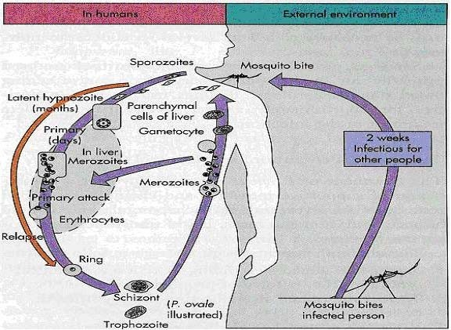
Figure 15; Life cycle of Plasmodium species

In summary
The malaria parasite life cycle involves two hosts.
During a blood meal, a malaria-infected female Anopheles mosquito inoculates sporozoites into the human host . Sporozoites infect liver cells and mature into schizonts , which rupture and release merozoites . (Of note, in P. vivax and P. ovale a dormant stage [hypnozoites] can persist in the liver (if untreated) and cause relapses by invading the bloodstream weeks, or even years later.) After this initial replication in the liver (exo-erythrocytic schizogony ), the parasites undergo asexual multiplication in the erythrocytes (erythrocytic schizogony ). Merozoites infect red blood cells . The ring stage trophozoites mature into schizonts, which rupture releasing merozoites . Some parasites differentiate into sexual erythrocytic stages (gametocytes) . Blood stage parasites are responsible for the clinical manifestations of the disease. The gametocytes, male (microgametocytes) and female (macrogametocytes), are ingested by an Anopheles mosquito during a blood meal . The parasites’ multiplication in the mosquito is known as the sporogonic cycle . While in the mosquito’s stomach, the microgametes penetrate the macrogametes generating zygotes . The zygotes in turn become motile and elongated (ookinetes) which invade the midgut wall of the mosquito where they develop into oocysts . The oocysts grow, rupture, and release sporozoites, which make their way to the mosquito’s salivary glands. Inoculation of the sporozoites into a new human host perpetuates the malaria life cycle.

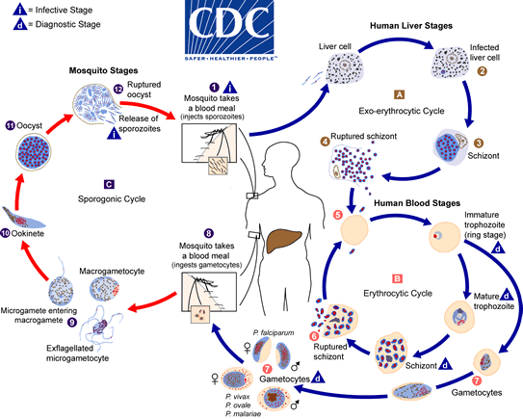Plasmodium falciparum
Plasmodium falciparum demonstrates no selectivity in host erythrocytes, i.e. it invades young and old RBCs cells. The infected red blood cells also do not enlarge and become distorted.
      - Multiple sporozoites can infect a single erythrocyte, and show multiple infections of cells with small ring forms.
      - The trophozoite is often seen in the host cells at the very edge or periphery of cell membrane at accole position.
      - Occasionally, reddish granules known as Maurer’s dots are observed
      - Mature (large) trophozoite stages and schizonts are rarely seen in blood films, because their forms are sequestered in deep capillaries, liver and spleen.
      - Peripheral blood smears characteristically contain only young ring forms and occasionally crescent shaped gametocytes.

Epidemiology
- P.falciparum occurs almost exclusively in tropical and subtropical regions. Weather (rainfall, temperature & humidity) is the most obvious cause of seasonality in malaria transmission.
- To date, abnormal weather conditions are also important causes of significant and widespread epidemics. Moreover, drug-resistant infection of P.falciparum is the commonest challenge in many parts of the world.
- In Ethiopia, even though all the four species of plasmodium infecting man have been recorded, P.falciparum is the one that most causes the epidemic disease and followed by vivax and malariae. P.ovale is rare. Infection rates in Ethiopia are 60%, 40%, 1%, and <1% for P. falciparum, P. vivax, P. malariae, and P. ovale, respectively.

Clinical features
- Of all the four Plasmodia, P. falciparum has the shortest incubation period, which ranges from 7 to 10 days.
- After the early flu-like symptoms, P.falciparum rapidly produces daily (quotidian) chills and fever as well as severe nausea, vomiting and diarrhea.
- The periodicity of the attacks then becomes tertian (36 to 48 hours), and fulminating disease develops.
- Involvement of the brain (cerebral malaria) is most often seen in P.falciparum infection.
- Capillary plugging from an adhesion of infected red blood cells with each other and endothelial linings of capillaries causes hypoxic injury to the brain that can result in coma and death.
- Kidney damage is also associated with P.falciparum malaria, resulting in an illness called “black water” fever.
- Intravascular hemolysis with rapid destruction of red blood cells produces a marked hemoglobinuria and can result in acute renal failure, tubular necrosis, nephrotic syndrome, and death.
- Liver involvement is characterized by
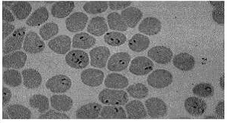
abdominal pain, vomiting of bile, hepatosplenomegally, severe diarrhea, and rapid dehydration.

Figure 16; Ring form of P.falciparum, with multiple infection of an erythrocyte
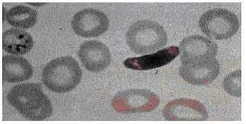
Figure 17; mature gametocyte of P.falciparum.

Treatment

- Because chloroquine – resistant stains of P.falciparum are present in many parts of the world.
- Infection of P.falciparum may be treated with other agents including;
  - mefloquine, quinine, guanidine, pyrimethamine – sulfadoxine, and doxycycline.
  - If the laboratory reports a mixed infection involving P.falciparum and P.vivax, the treatment must eradicate not only P.falciparum from the erythrocytes but also the liver stages of P.vivax to avoid relapses provided that the person no longer lives in a malaria endemic area.

Plasmodium vivax

P.vivax is selective in that it invades only young immature erythrocytes. Infections of P. vivax have the following characteristics:
- Infected red blood cells are usually enlarged and contain numerous pink granules or schuffner’s dots.
- The trophozoite is ring-shaped but amoeboid in appearance.
- More mature trophozoites and erythrocytic schizonts containing up to 24 merozoites are present.
- The gametocytes are round

Epidemiology
P. Vivax is the most prevalent of the human plasmodia with the widest geographic distribution, including the tropics, subtropics, and temperate regions. However, it is the second most prevalent in Ethiopia following P. falciparum

Clinical features
- After an incubation period (usually 10 to 17 days), the patient experiences vague flu-like symptoms, such as headache, muscle pains, photophobia, anorexia, nausea and vomiting.
- As the infection progresses, increased numbers of rupturing erythrocytes liberate merozoites as well as toxic cellular debris and hemoglobin in to circulation.
- In combination, these substances produce the typical pattern chills, fever and malarial rigors. These paroxysms usually reappear periodically (generally every 48 hours) as the cycle of infection, replication, and cell lyses progresses.
- The paroxysms may remain relatively mild or may progress to severe attacks, with hours of sweating, chills, shaking persistently, high temperatures (103⁰F to 106⁰F) and exhaustion. Since P.vivax infects only the reticulocytes, the parasitemia is usually limited to around 2 to 5% of the available RBCs.

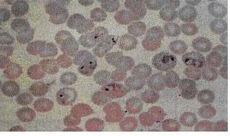
Figure 18; Plasmodium vivax ring form and trophozoites

Treatment
- Chloroquine is the drug of choice for the suppression and therapeutic treatment of P.vivax, followed by premaquine for radical cure and elimination of gamatocytes.

Plasmodium malariae
- In contrast with P.vivax and P.ovale, P.malariae can infect only mature erythrocytes with relatively rigid cell membranes. As a result, the parasite’s growth must conform to the size and shape of red blood cell.
- This requirement produces no red cell enlargement or distortion, but it results in distinctive shapes of the parasite seen in the host cell, “band and bar forms” as well as very compact dark staining forms. The schizont of P.malariae is usually composed of eight merozoites appearing in a rosette.

Epidemiology
- P. malariae infection occurs primarily in the same sub-tropical and temperate regions as infections with the other plasmodia but is less prevalent.

Clinical features
- The incubation period for P. malariae is the longest of the plasmodia, usually 18 to 40 days, but possibly several months to years.
- The early symptoms are flu-like with fever patterns of 72 hours (quartan or malarial) in periodicity.

Treatment

- Treatment is similar to that for P.vivax and P.ovale.

Plasmodium ovale
- P. ovale is similar to P. vivax in many respects, including its selectivity for young, pliable erythrocytes. As a consequence the classical characteristics include:
  - The host cell becomes enlarged and distorted, usually in an oval form.
  - Schiffner’s dots appear as pale pink granules.
  - The infected cell border is commonly fimbriated or ragged
  - Mature schizonts contain about 10 merozoites.

Epidemiology
- P.ovale is distributed primarily in tropical Africa. It is also found in Asia and South America.

Clinical features
- The incubation period for P.ovale is 16-18 days but can be longer. Clinically, ovale malaria resembles vivax malaria with attacks recurring every 48-50 hours. There are however, fewer relapses with P.ovale. Less than 2% of RBCs usually become infected.

Treatment
- The treatment regimen, including the use of primaquine to prevent relapse from latent liver stages is similar to that used for P.vivax infection.

Laboratory diagnosis
- Microscopic examination of thick and thin films of blood is the method of choice for confirming the clinical diagnosis of malaria and identifying the specific species responsible for disease.
- Malaria parasites in thick and thin blood films are best stained at pH 7.1 – 7.2 using a Romanowsky stain (contains azure dyes and eosin).
- The thick film is a concentration method that may be used to detect the presence of organisms. The thin film is most useful for establishing species identification.
- Serologic procedures are available but they are used primarily for epidemiological surveys or for screening blood donors.

Immunity
- There is evidence that antibodies can confer hormonal immunity against malaria infection.

Prevention
- Chemoprophylaxis and prompt diagnosis and treatment.
- Control of mosquito breeding
- Protection of insect bite by screening, netting and protective clothing
- Use of insect repellents.

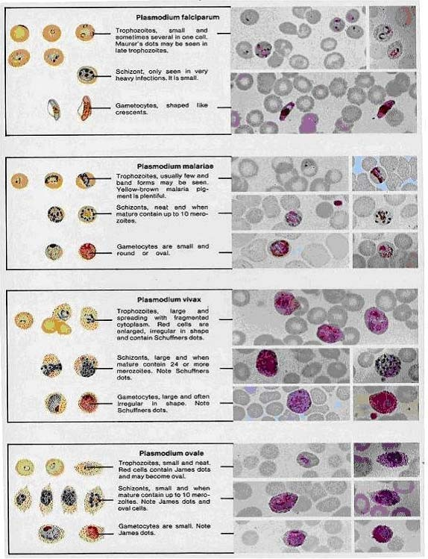

Figure 19; Romanowsky

Plasmodium falciparum
- Ring-form trophozoites of P. falciparum in thick and a thin blood smear.
- Ring-form trophozoites (rings) of Plasmodium falciparum are often thin and delicate, measuring on average 1/5 the diameter of the red blood cell. Rings may possess one or two chromatin dots.
- They may be found on the periphery of the RBC (accolé, appliqué) and multiply-infected RBCs are not uncommon.
- Ring forms may become compact or pleomorphic depending on the quality of the blood or if there is a delay in making smears. There is usually no enlargement of infected RBCs.
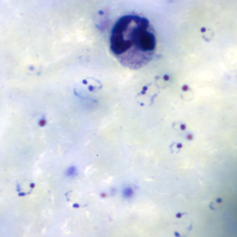
Figure A: Rings of P. falciparum in a thick blood smear.
View Larger
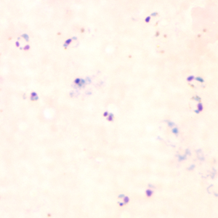
Figure D: Rings of P. falciparum in a thick blood smear.
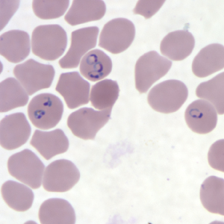
Figure G: Rings of P. falciparum in a thin blood smear.
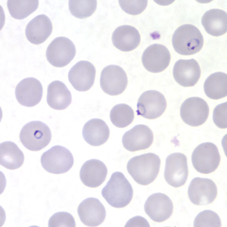
Figure J: Rings of P. falciparum in a thin blood smear.
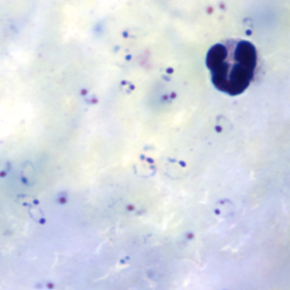
Figure B: Rings of P. falciparum in a thick blood smear.
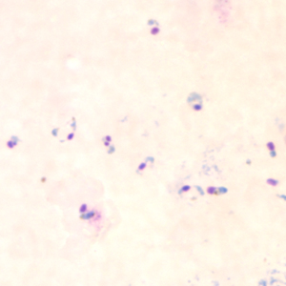
Figure E: Rings of P. falciparum in a thick blood smear.
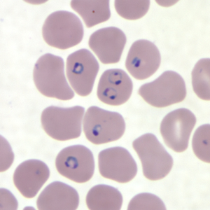
Figure H: Rings of P. falciparum in a thin blood smear.
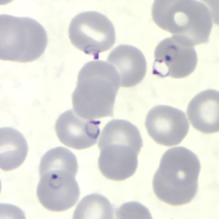
Figure K: Rings of P. falciparum in a thin blood smear.
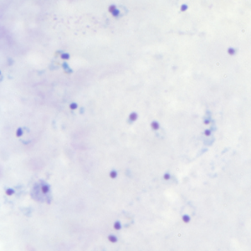
Figure C: Rings of P. falciparum in a thick blood smear.
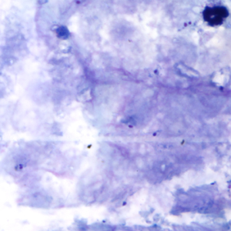
Figure F: Rings of P. falciparum in a thick blood smear.
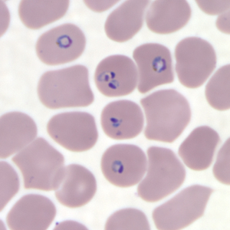
Figure I: Rings of P. falciparum in a thin blood smear.
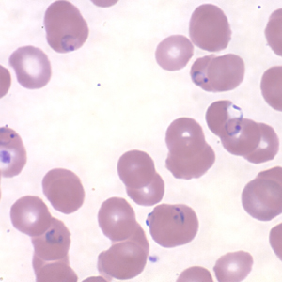
Figure L: Rings of P. falciparum in a thin blood smear.

Ring-form trophozoites of P. falciparum in thin blood smears exhibiting Maurer’s clefts.

- Maurer’s clefts can be seen in P. falciparum infections containing older ring-form trophozoites and asexual stages.
- Maurer’s clefts resemble the Schüffner’s dots seen in P. vivax and P. ovale, but are usually larger and more coarse. Visualization of these structures is dependent on the quality of the smear preparation and the pH of the Giemsa stain. Like Schüffner’s dots, Maurer’s clefts appear to play a role in the metabolic pathways of the infected RBCs.
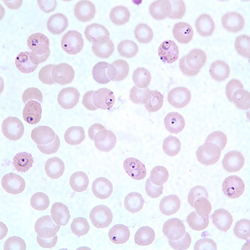
Figure A: Ring-form trophozoites of P. falciparum in a thin blood smear, exhibiting Maurer's clefts.
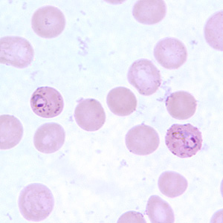
Figure E: Ring-form trophozoites of P. falciparum in a thin blood smear, exhibiting Maurer's clefts.
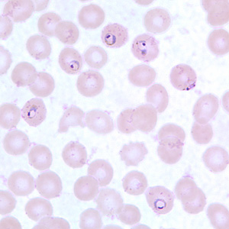
Figure B: Ring-form trophozoites of P. falciparum in a thin blood smear, exhibiting Maurer's clefts.
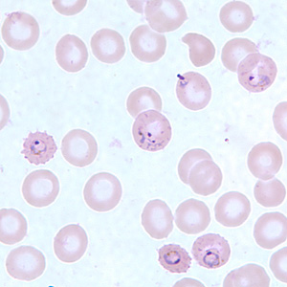
Figure F: Ring-form trophozoites of P. falciparum in a thin blood smear, exhibiting Maurer's clefts.
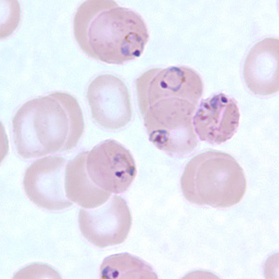
Figure C: Ring-form trophozoites of P. falciparum in a thin blood smear, exhibiting Maurer's clefts.
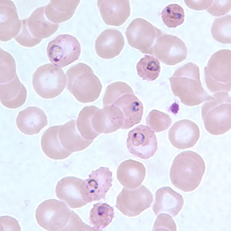
Figure D: Ring-form trophozoites of P. falciparum in a thin blood smear, exhibiting Maurer's clefts.
- Developing and older trophozoites of P. falciparum in thick and a thin blood smear.
- Developing trophozoites of P. falciparum tend to remain in ring form, but may become thicker and more compact. The amount of pigment and chromatin may also increase. Compact or amoeboid forms may be seen in smears where there was a delay in processing the blood.
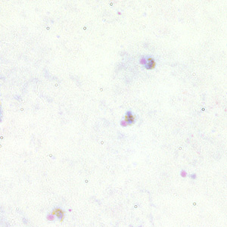
Figure A: Trophozoites of P. falciparum in a thick blood smear.
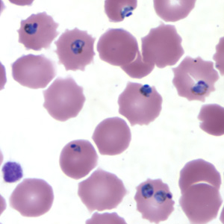
Figure E: Trophozoites of P. falciparum in a thin blood smear.
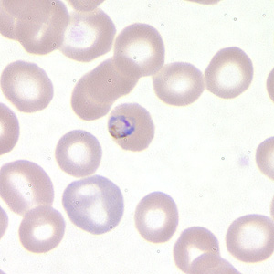
Figure B: Trophozoite of P. falciparum in a thin blood smear.
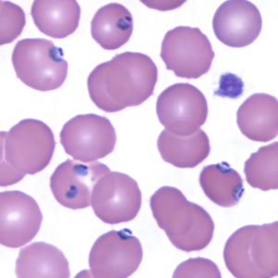
Figure F: Trophozoites of P. falciparum in a thin blood smear.
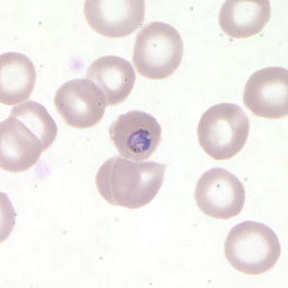
Figure C: Trophozoite of P. falciparum in a thin blood smear.
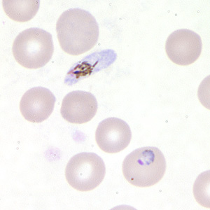
Figure D: Trophozoite of P. falciparum in a thin blood smear. In this figure, a gametocyte can also be seen in the upper half of the image.

Gametocytes of P. falciparum in thick and a thin blood smear.

- Gametocytes of Plasmodium falciparum are crescent- or sausage-shaped, and are usually about 1.5 times the diameter of an RBC in length.
- The cytoplasm of the macrogametocytes (female) are usually a darker, deeper blue; the cytoplasm of the microgametocytes (male) is usually more pale.
- The red chromatin and pigment is more coarse and concentrated in the macrogametocytes than the microgametocytes. Sometimes in thin blood smears, the remnants of the host RBC can be seen; this is often referred to as Laveran’s bib.
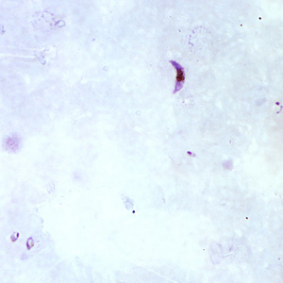
Figure A: Gametocyte of P. falciparum in a thick blood smear. Note also the presence of many ring-form trophozoites.
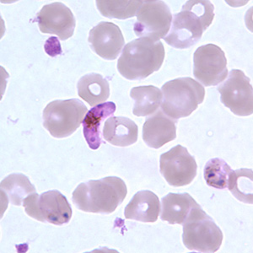
Figure E: Gametocyte of P. falciparum in a thin blood smear. Also seen in this image are ring-form trophozoites exhibiting Maurer's clefts.
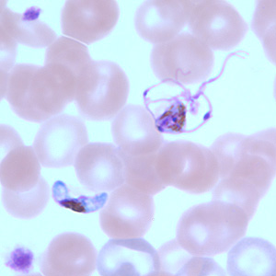
Figure I: Gametocytes of P. falciparum in a thin blood smear. The gametocyte in the upper right is undergoing exflagellation, a process that normally occurs in the mid-gut of the mosquito host. However, it may be observed in human blood specimens when there is a delay in processing the blood.
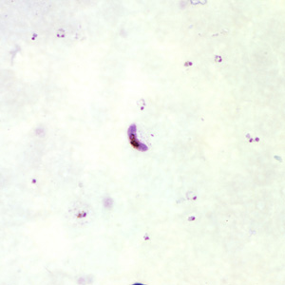
Figure B: Gametocytes of P. falciparum in a thick blood smear. Note also the presence of many ring-form trophozoites.
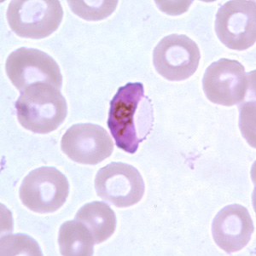
Figure F: Gametocyte of P. falciparum in a thin blood smear. In these specimens, Laveran's bibs can be seen.
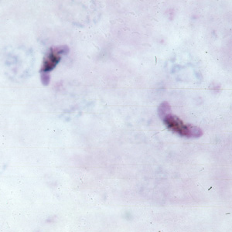
Figure C: Gametocytes of P. falciparum in a thick blood smear.
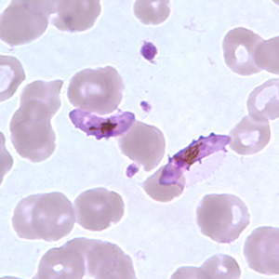
Figure G: Gametocytes of P. falciparum in a thin blood smear. In these specimens, Laveran's bibs can be seen.
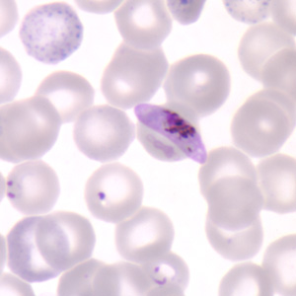
Figure D: Gametocyte of P. falciparum in a thin blood smear. Also seen in this image are ring-form trophozoites and an RBC exhibiting basophilic stippling (upper left).
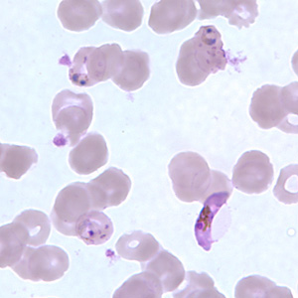
Figure H: Gametocyte of P. falciparum in a thin blood smear, showing Laveran's bib. Also seen in this image are ring-form trophozoites exhibiting Maurer's clefts.

Schizonts of P. falciparum in a thin blood smear.

Schizonts are rarely seen in peripheral blood of Plasmodium falciparum infections, except in severe cases. When seen, schizonts contain anywhere from 8-24 merozoites. A mature schizont usually fills about 2/3 of the infected RBC.
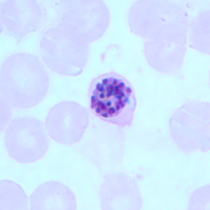
Figure A: Schizont of P. falciparum in a thin blood smear.
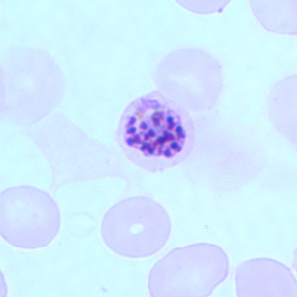
Figure B: Schizont of P. falciparum in a thin blood smear.
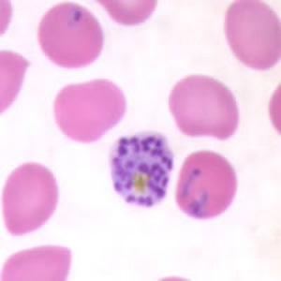
Figure C: Schizont of P. falciparum in a thin blood smear. Trophozoites are also seen in this image.

Toxoplasma gondii – causes toxoplasmosis.
- Toxoplasma gondii is a protozoan parasite that infects most species of warm-blooded animals, including humans, and causes the disease toxoplasmosis.
- The definitive host is the domestic cat and other felines. Humans and other mammals are intermediate hosts. T. gondii is usually acquired by ingestion and transplacental transmission from an infected mother to the fetus can occur. Human–to–human transmission, other than transplacental transmission, does not occur.
- After infection of the intestinal epithelium, the organisms spread to other organs, especially the brain, lungs, liver, and eyes. Most primary infections in immunocompetent adults are asymptomatic. Congenital infection can result in abortion, stillbirth, or neonatal disease with encephalitis, chorioretinitis and hepatosplenomegaly. Fever, jaundice, and intracranial calcifications are also seen.
- For the diagnosis of acute and congenital infections, an immunofluorescence assay for detection of antibody is used. Microscopic examination of Giemsa–stained preparations shows crescent–shaped trophozoite. Cysts may be seen in the tissue.

Summary Disease
Healthy people (nonpregnant)
- Healthy people who become infected with Toxoplasma gondii often do not have symptoms because their immune system usually keeps the parasite from causing illness.
- When illness occurs, it is usually mild with “flu-like” symptoms (e.g., tender lymph nodes, muscle aches, etc.) that last for weeks to months and then go away. However, the parasite remains in the person’s body in an inactive state. It can become reactivated if the person becomes immunosuppressed.
Mother-to-child (congenital)
- Generally, if a woman has been infected before becoming pregnant, the unborn child will be protected because the mother has developed immunity. If a woman becomes newly infected with Toxoplasma during or just before pregnancy, she can pass the infection to her unborn baby (congenital transmission). The damage to the unborn child is often more severe the earlier in pregnancy the transmission occurs. Potential results can be
  - A miscarriage
  - A stillborn child
  - A child born with signs of congenital toxoplasmosis (e.g., abnormal enlargement or smallness of the head)
- Infants infected before birth often show no symptoms at birth but may develop them later in life with potential vision loss, mental disability, and seizures.
Persons with ocular disease
- Eye disease (most frequently retinochoroiditis) from Toxoplasma infection can result from congenital infection or infection after birth by any of the modes of transmission discussed on the epidemiology and risk factors page.
- Eye lesions from congenital infection are often not identified at birth but occur in 20-80% of congenitally-infected persons by adulthood. However, in the U.S. <2% of persons infected after birth develop eye lesions. Eye infection leads to an acute inflammatory lesion of the retina, which resolves leaving retinochoroidal scarring. Symptoms of ocular disease include
    - Eye pain
    - Sensitivity to light (photophobia)
    - Tearing of the eyes
    - Blurred vision
- The eye disease can reactivate months or years later, each time causing more damage to the retina. If the central structures of the retina are involved there will be a progressive loss of vision that can lead to blindness.
Persons with compromised immune systems
- Persons with compromised immune systems may experience severe symptoms if they are infected with Toxoplasma while immune suppressed. Persons who acquire HIV infection and were not infected previously with Toxoplasma are more likely to develop a severe primary infection.
- Immunocompromised persons who were infected with Toxoplasma at some point before they become immunosuppressed are at risk for developing a relapse (reactivation) of toxoplasmosis. For example, a person who is HIV-infected and who has reactivated Toxoplasma infection can have symptoms that include fever, confusion, headache, seizures, nausea, and poor coordination.
- Toxoplasma infection can reactivate in immunocompromised pregnant women who were infected with Toxoplasma before their pregnancy, and this can lead to congenital infection.
Treatment
- is with a combination of sulfadiazine and pyrimethamine.
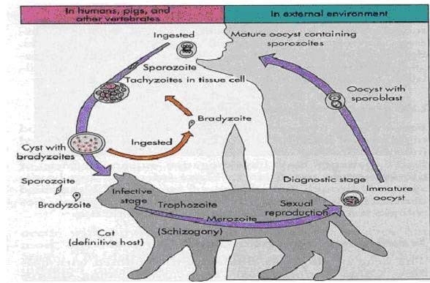
Figure1 ; Life cycle of Toxoplasma gondii

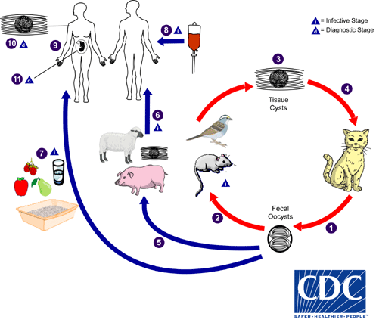

The only known definitive hosts for Toxoplasma gondii are members of family Felidae (domestic cats and their relatives).
- Unsporulated oocysts are shed in the cat’s feces
- . Although oocysts are usually only shed for 1–3 weeks, large numbers may be shed. Oocysts take 1–5 days to sporulate in the environment and become infective. Intermediate hosts in nature (including birds and rodents) become infected after ingesting soil, water or plant material contaminated with oocysts
- . Oocysts transform into tachyzoites shortly after ingestion. These tachyzoites localize in neural and muscle tissue and develop into tissue cyst bradyzoites
- . Cats become infected after consuming intermediate hosts harboring tissue cysts
- . Cats may also become infected directly by ingestion of sporulated oocysts. Animals bred for human consumption and wild game may also become infected with tissue cysts after ingestion of sporulated oocysts in the environment
- . Humans can become infected by any of several routes:
- Eating undercooked meat of animals harboring tissue cysts
- .Consuming food or water contaminated with cat feces or by contaminated environmental samples (such as fecal-contaminated soil or changing the litter box of a pet cat)
- .Blood transfusion or organ transplantation .
- Transplacentally from mother to fetus
- .In the human host, the parasites form tissue cysts, most commonly in skeletal muscle, myocardium, brain, and eyes; these cysts may remain throughout the life of the host. Diagnosis is usually achieved by serology, although tissue cysts may be observed in stained biopsy specimens
- . Diagnosis of congenital infections can be achieved by detecting T. gondii DNA in amniotic fluid using molecular methods such as PCR .

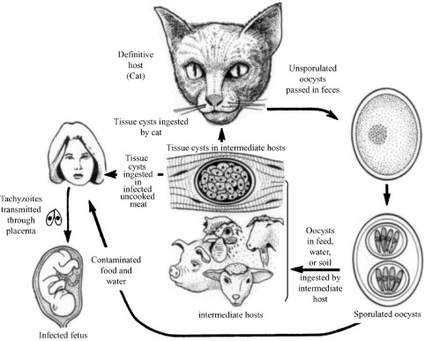
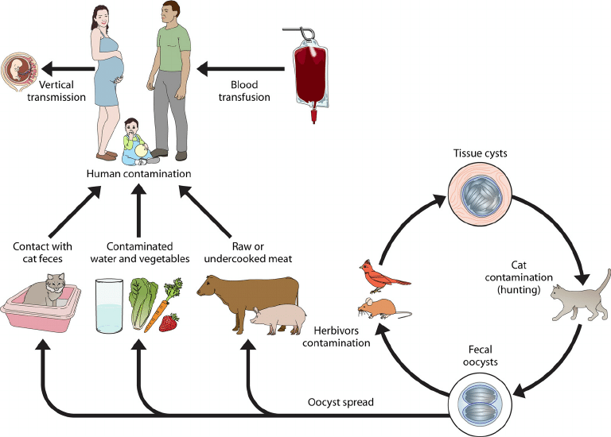
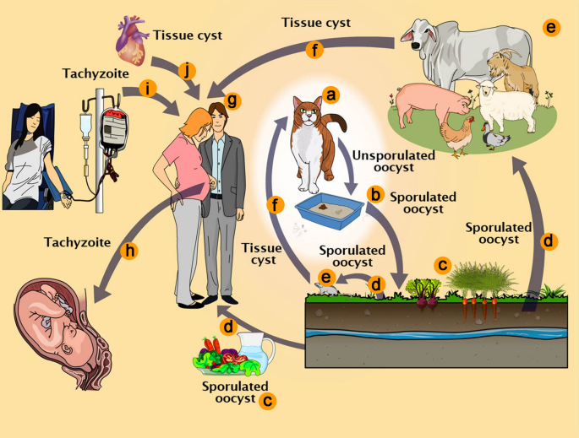

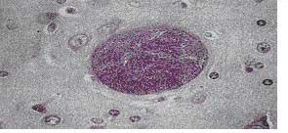

Figure cyst

Cyclospora cayetanensis
- Cyclosporiasis is an intestinal illness caused by the microscopic parasite Cyclospora cayetanensis.
- People can become infected with Cyclospora by consuming food or water contaminated with the parasite. People living or traveling in countries where cyclosporiasis is endemic may be at increased risk for infection.
- Cyclospora cayetanensis - is an intestinal protozoan that causes watery diarrhea in both immunocompetent and immunocompomised individuals.
- It is classified as a member of the Coccidian; the organism is acquired by fecal – oral transmission, especially via contaminated water supplies. There is no evidence for an animal reservoir.
- The diarrhea can be prolonged and relapsing, especially in immunocompromized patients. Infection occurs worldwide.
- The diagnosis is made microscopically by observing the spherical oocysts in a modified acid-fast stain of a stool sample. There are no serologic tests. The treatment of choice is trimethoprim-sulfamethoxazole.
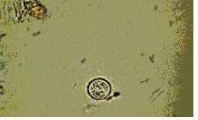
Oocyst of cyclospora cayetanensis

Isospora belli
- Cystoisosporiasis (formerly known as isosporiasis) is an intestinal disease of humans caused by the coccidian parasite Cystoisospora belli (formerly known as Isospora belli).
- It is an intestinal protozoan that causes diarrhea, especially in immunocompromized patients, e.g., those with AIDS. Its life cycle parallels that of other members of the Coccidia. The organism is acquired by fecal-oral transmission of oocysts from either human or animal sources. The oocysts excyst in the upper small intestine and invade the mucosa, causing destruction of the brush border.
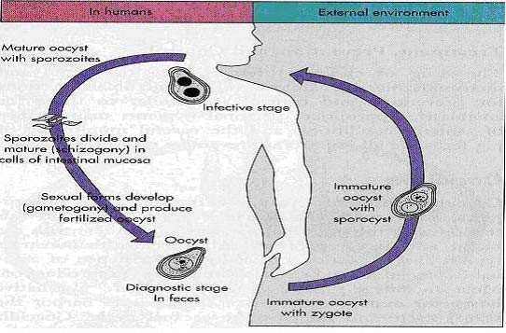
- The disease in immunocompromized patients presents as a chronic, profuse, watery diarrhea. The pathogenesis of the diarrhea is unknown. Diagnosis is made by finding the typical oocysts in fecal specimens. Serologic tests are not available. The treatment of choice is trimethoprim-sulfamethoxazole.
- 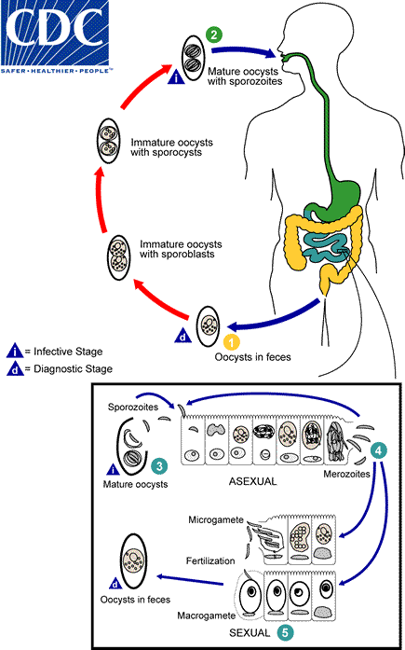
Figure 23; Life cycle of Isospora belli.
At the time of excretion in stool, the oocyst is immature and usually contains just one sporoblast (sometimes, two)
. During further maturation after excretion, the sporoblast divides in two (the oocyst now contains two sporoblasts); the sporoblasts secrete a cyst wall, thus becoming sporocysts; and the sporocysts divide twice, resulting in four sporozoites per each of two sporocysts
- . Infection occurs by ingestion of mature (fully sporulated) oocysts: the sporocysts excyst in the small intestine and release their sporozoites, which invade the epithelial cells and initiate schizogony
- . Upon rupture of the schizonts, merozoites are released, which invade epithelial cells and continue the cycle of asexual multiplication
- . Trophozoites develop into schizonts, which contain multiple merozoites. After a minimum of one week, the sexual stage begins, with the development of male and female gametocytes
- . Fertilization results in the development of oocysts, which are excreted in the stool .

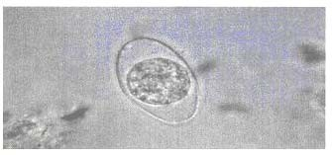
Figure 24; immature Oocyst of isospora species

Cryptosporidium parvum
- Cryptosporidium parvum – causes cryptosporidiosis, the main symptom of which is diarrhea. It is most severe in immunocompromized patients, e.g., those with AIDS, those with inherited diseases that affect the immune system; and cancer and transplant patients who are taking certain immunosuppressive drugs.
- Therefore the risk of developing severe disease may differ depending on each person’s degree of immune suppression.
- The organism is acquired by faecal-oral transmission of Oocysts from either human or animal sources. The oocysts excyst in the small intestine, where the trophozoite (and other forms) attach to the gut wall. Invasion does not occur.
- Symptoms of cryptosporidiosis generally begin 2 to 10 days (average 7 days) after becoming infected with the parasite. The most common symptom of cryptosporidiosis is watery diarrhea. Symptoms include: watery diarrhea, stomach cramps or pain, dehydration, nausea, vomiting, fever, weight loss
- The jejunum is the site most heavily infested. The pathogenesis of the diarrhea is unknown; no toxin has been identified.

- Cryptosporidium causes diarrhea worldwide, for large outbreaks of diarrhea caused by Cryptosporidium are attributed to inadequate purification of drinking water.

- The disease in immunocompromized patients presents primarily as a watery, non-bloody diarrhea causing large fluid loss. Symptoms persist for long periods in immunocompromized patients, whereas self-limite in immunocompetent individuals.

- Although immunocompromized patients usually do not die of cryptosporidiosis, the fluid loss and malnutrition are severely debilitating. Diagnosis is made by finding oocysts in fecal smears when using a modified Kinyoum acid–fast stain. Serological tests are not available. There is no effective drug therapy.
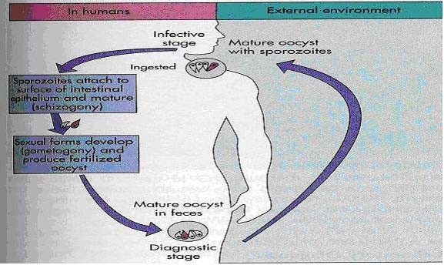
Figure 25; life cycle of Cryptosporidium species.

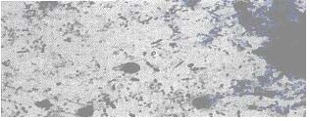
Figure 26; Acid-fast stained Cryptosporidium oocyst.

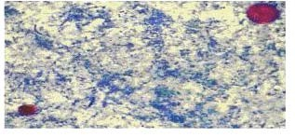

Figure 27; Oocysts of Cryptosporidium parvum (lower left) & Cyclospora cayetanensis (upper right). Both stained red with Ziehl-Neelsen stain.

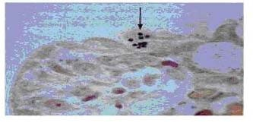
Microsporidia
- They are a group of protozoa characterized by obligate intracellular replication and spore formation.
- Enterocytozoon bienusi and Septata intestinalis are two important microsporidial species that cause severe, persistent, watery diarrhea in AIDS patients. The organisms are transmitted from faecal-oral route. It is uncertain whether an animal reservoir exists.
- Diagnosis is made by visualization of spores in stool samples or intestinal biopsy samples
- Treatment: the drug of choice is albendazole.

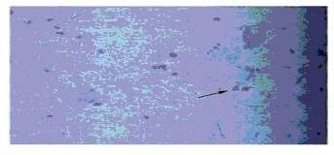
Figure 29; smear of formalin-fixed stool specimen showing pinkish red-stained Microsporidia spores (Chromotrope based stain)

