Malaria
There are four species normally infecting humans, namely,
- Plasmodium falciparum
- Plasmodium vivax
- Plasmodium ovale
- Plasmodium malariae.
- Plasmodium knowlesii

Life cycle
- The life cycle of malaria is passed in two hosts (alternation of hosts) and has sexual and asexual stage (alternation of generations).
- Vertebrate host - man (intermediate host), where the asexual cycle takes place.
- The parasite multiplies by schizogony and there is formation of male and female gametocytes (gametogony). Invertebrate host - mosquito (definitive host) where the sexual cycle takes place.
- Union of male and female gametes ends in the formation of sporozoites (sporogony).
- The life cycle passes in four stages:
Three in man
- Pre - erythrocytic schizogony
- Erythrocytic schizogony
- Exo- erythrocytic schizogony One in mosquito - Sporogony
Introduction into humans - when an infective female Anopheles mosquito bites man, it inoculates saliva containing sporozoites (infective stage).
Pre- Erythrocytic schizogony
- sporozoites reach the blood stream and within 30 minutes enter the parenchymal cells of the liver, initiating a cycle of schizogony. Multiplication occurs in tissue schizonts, to form thousands of tiny merozoites.
- Merozoites are then liberated on rupture of schizonts about 7th – 9th day of the bites and enter into the blood stream.
- These merozoites either invade the RBC’s or other parenchymal liver cells. In case of P. falciparum and possibly
- P. malariae, all merozoites invade RBC’s without re-invading liver cells.
- However, for P. vivax and P. ovale, some merozoites invade RBC’s and some re-invade liver cells initiating further Exo-erythrocytic schizogony, which is responsible for relapses. Some of the merozoites remain dormant (hypnozoites) becoming active later on.
- Erythrocytic schizogony (blood phase) is completed in 48 hrs in P. vivax, P. ovale, and P. falciparum, and 72 hrs in P. malariae. The merozoites reinvade fresh RBC’s repeating the schizogonic cycles
- Erythrocytic merozoites do not reinvade the liver cells. So malaria transmitted by blood transfusion reproduces only erythrocytic cycle

Gametogony
- Some merozoites that invade RBC’s develop into sexual stages (male and female gametocytes). These undergo no further development until taken by the mosquito.

Sporogony (extrinsic cycle in mosquito)
- When a female Anopheles mosquito vector bites an infected person, it sucks blood containing the different stages of malaria parasite.
- All stages other than gametocytes are digested in the stomach.
- The microgametocyte undergoes ex-flagellation. The nucleus divides by reduction division into 6-8 pieces, which migrate to the periphery.
- At the same, time 6-8 thin filaments of cytoplasm are thrust out, in each passes a piece of chromatin.
- These filaments, the microgametes, are actively motile and separate from the gametocyte.
- The macrogametocyte by reduction division becomes a macrogamete. Fertilization occurs by entry of a micro gamete into the macro gamete forming a zygote.
- The zygote changes into a worm like form, the ookinete, which penetrates the wall of the stomach to develop into a spherical oocyst between the epithelium and basement membrane.
- The oocystes increase in size. Thousands of sporozoites develop inside the oocysts. Oocysts rupture and sporozoites are liberated in the body cavity and migrate everywhere particularly to the salivary glands. Now the mosquito is infective
- The sporogonous cycle in the mosquito takes 8-12 days depending on temperature

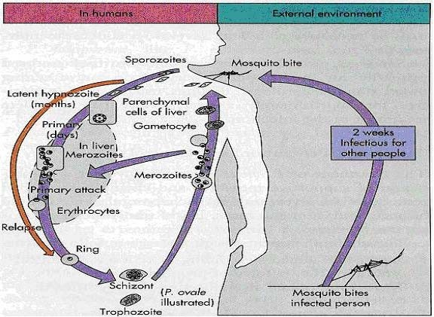
Figure 15; Life cycle of Plasmodium species

In summary
The malaria parasite life cycle involves two hosts.
During a blood meal, a malaria-infected female Anopheles mosquito inoculates sporozoites into the human host . Sporozoites infect liver cells and mature into schizonts , which rupture and release merozoites . (Of note, in P. vivax and P. ovale a dormant stage [hypnozoites] can persist in the liver (if untreated) and cause relapses by invading the bloodstream weeks, or even years later.) After this initial replication in the liver (exo-erythrocytic schizogony ), the parasites undergo asexual multiplication in the erythrocytes (erythrocytic schizogony ). Merozoites infect red blood cells . The ring stage trophozoites mature into schizonts, which rupture releasing merozoites . Some parasites differentiate into sexual erythrocytic stages (gametocytes) . Blood stage parasites are responsible for the clinical manifestations of the disease. The gametocytes, male (microgametocytes) and female (macrogametocytes), are ingested by an Anopheles mosquito during a blood meal . The parasites’ multiplication in the mosquito is known as the sporogonic cycle . While in the mosquito’s stomach, the microgametes penetrate the macrogametes generating zygotes . The zygotes in turn become motile and elongated (ookinetes) which invade the midgut wall of the mosquito where they develop into oocysts . The oocysts grow, rupture, and release sporozoites, which make their way to the mosquito’s salivary glands. Inoculation of the sporozoites into a new human host perpetuates the malaria life cycle.

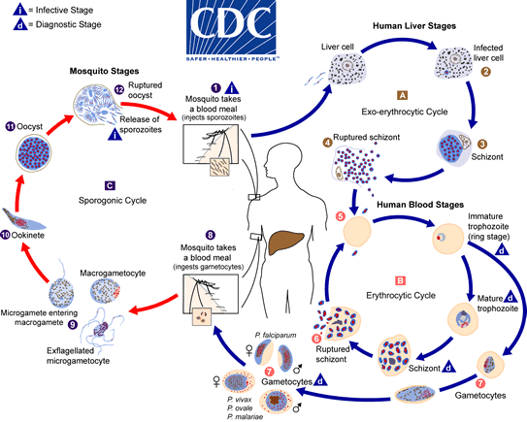Plasmodium falciparum
Plasmodium falciparum demonstrates no selectivity in host erythrocytes, i.e. it invades young and old RBCs cells. The infected red blood cells also do not enlarge and become distorted.
      - Multiple sporozoites can infect a single erythrocyte, and show multiple infections of cells with small ring forms.
      - The trophozoite is often seen in the host cells at the very edge or periphery of cell membrane at accole position.
      - Occasionally, reddish granules known as Maurer’s dots are observed
      - Mature (large) trophozoite stages and schizonts are rarely seen in blood films, because their forms are sequestered in deep capillaries, liver and spleen.
      - Peripheral blood smears characteristically contain only young ring forms and occasionally crescent shaped gametocytes.

Epidemiology
- P.falciparum occurs almost exclusively in tropical and subtropical regions. Weather (rainfall, temperature & humidity) is the most obvious cause of seasonality in malaria transmission.
- To date, abnormal weather conditions are also important causes of significant and widespread epidemics. Moreover, drug-resistant infection of P.falciparum is the commonest challenge in many parts of the world.
- In Ethiopia, even though all the four species of plasmodium infecting man have been recorded, P.falciparum is the one that most causes the epidemic disease and followed by vivax and malariae. P.ovale is rare. Infection rates in Ethiopia are 60%, 40%, 1%, and <1% for P. falciparum, P. vivax, P. malariae, and P. ovale, respectively.

Clinical features
- Of all the four Plasmodia, P. falciparum has the shortest incubation period, which ranges from 7 to 10 days.
- After the early flu-like symptoms, P.falciparum rapidly produces daily (quotidian) chills and fever as well as severe nausea, vomiting and diarrhea.
- The periodicity of the attacks then becomes tertian (36 to 48 hours), and fulminating disease develops.
- Involvement of the brain (cerebral malaria) is most often seen in P. falciparum infection.
- Capillary plugging from an adhesion of infected red blood cells with each other and endothelial linings of capillaries causes hypoxic injury to the brain that can result in coma and death.
- Kidney damage is also associated with P.falciparum malaria, resulting in an illness called “black water” fever.
- Intravascular hemolysis with rapid destruction of red blood cells produces a marked hemoglobinuria and can result in acute renal failure, tubular necrosis, nephrotic syndrome, and death.

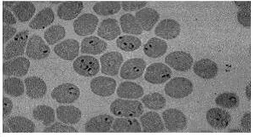
- Liver involvement is characterized by abdominal pain, vomiting of bile, hepatosplenomegally, severe diarrhea, and rapid dehydration.

Ring form of P.falciparum, with multiple infection of an erythrocyte
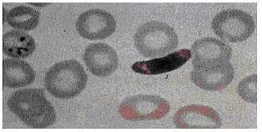
Mature gametocyte of P.falciparum.

Treatment

- Because chloroquine – resistant stains of P.falciparum are present in many parts of the world.
- Infection of P.falciparum may be treated with other agents including;
  - mefloquine, quinine, guanidine, pyrimethamine – sulfadoxine, and doxycycline.
  - If the laboratory reports a mixed infection involving P.falciparum and P.vivax, the treatment must eradicate not only P.falciparum from the erythrocytes but also the liver stages of P.vivax to avoid relapses provided that the person no longer lives in a malaria endemic area.

Plasmodium vivax

P.vivax is selective in that it invades only young immature erythrocytes. Infections of P. vivax have the following characteristics:
- Infected red blood cells are usually enlarged and contain numerous pink granules or schuffner’s dots.
- The trophozoite is ring-shaped but amoeboid in appearance.
- More mature trophozoites and erythrocytic schizonts containing up to 24 merozoites are present.
- The gametocytes are round

Epidemiology
P. Vivax is the most prevalent of the human plasmodia with the widest geographic distribution, including the tropics, subtropics, and temperate regions. However, it is the second most prevalent in Ethiopia following P. falciparum

Clinical features
- After an incubation period (usually 10 to 17 days), the patient experiences vague flu-like symptoms, such as headache, muscle pains, photophobia, anorexia, nausea and vomiting.
- As the infection progresses, increased numbers of rupturing erythrocytes liberate merozoites as well as toxic cellular debris and hemoglobin in to circulation.
- In combination, these substances produce the typical pattern chills, fever and malarial rigors. These paroxysms usually reappear periodically (generally every 48 hours) as the cycle of infection, replication, and cell lyses progresses.
- The paroxysms may remain relatively mild or may progress to severe attacks, with hours of sweating, chills, shaking persistently, high temperatures (103⁰F to 106⁰F) and exhaustion. Since P.vivax infects only the reticulocytes, the parasitemia is usually limited to around 2 to 5% of the available RBCs.

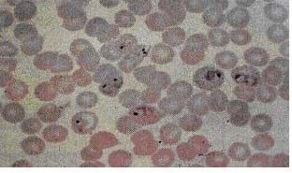
Figure 18; Plasmodium vivax ring form and trophozoites

Treatment
- Chloroquine is the drug of choice for the suppression and therapeutic treatment of P.vivax, followed by premaquine for radical cure and elimination of gamatocytes.

Plasmodium malariae
- In contrast with P.vivax and P.ovale, P.malariae can infect only mature erythrocytes with relatively rigid cell membranes. As a result, the parasite’s growth must conform to the size and shape of red blood cell.
- This requirement produces no red cell enlargement or distortion, but it results in distinctive shapes of the parasite seen in the host cell, “band and bar forms” as well as very compact dark staining forms. The schizont of P.malariae is usually composed of eight merozoites appearing in a rosette.

Epidemiology
- P. malariae infection occurs primarily in the same sub-tropical and temperate regions as infections with the other plasmodia but is less prevalent.

Clinical features
- The incubation period for P. malariae is the longest of the plasmodia, usually 18 to 40 days, but possibly several months to years.
- The early symptoms are flu-like with fever patterns of 72 hours (quartan or malarial) in periodicity.

Treatment

- Treatment is similar to that for P.vivax and P.ovale.

Plasmodium ovale
- P. ovale is similar to P. vivax in many respects, including its selectivity for young, pliable erythrocytes. As a consequence the classical characteristics include:
  - The host cell becomes enlarged and distorted, usually in an oval form.
  - Schiffner’s dots appear as pale pink granules.
  - The infected cell border is commonly fimbriated or ragged
  - Mature schizonts contain about 10 merozoites.

Epidemiology
- P.ovale is distributed primarily in tropical Africa. It is also found in Asia and South America.

Clinical features
- The incubation period for P.ovale is 16-18 days but can be longer. Clinically, ovale malaria resembles vivax malaria with attacks recurring every 48-50 hours. There are however, fewer relapses with P.ovale. Less than 2% of RBCs usually become infected.

Treatment
- The treatment regimen, including the use of primaquine to prevent relapse from latent liver stages is similar to that used for P.vivax infection.

Laboratory diagnosis
- Microscopic examination of thick and thin films of blood is the method of choice for confirming the clinical diagnosis of malaria and identifying the specific species responsible for disease.
- Malaria parasites in thick and thin blood films are best stained at pH 7.1 – 7.2 using a Romanowsky stain (contains azure dyes and eosin).
- The thick film is a concentration method that may be used to detect the presence of organisms. The thin film is most useful for establishing species identification.
- Serologic procedures are available but they are used primarily for epidemiological surveys or for screening blood donors.

Immunity
- There is evidence that antibodies can confer hormonal immunity against malaria infection.

Prevention
- Chemoprophylaxis and prompt diagnosis and treatment.
- Control of mosquito breeding
- Protection of insect bite by screening, netting and protective clothing
- Use of insect repellents.

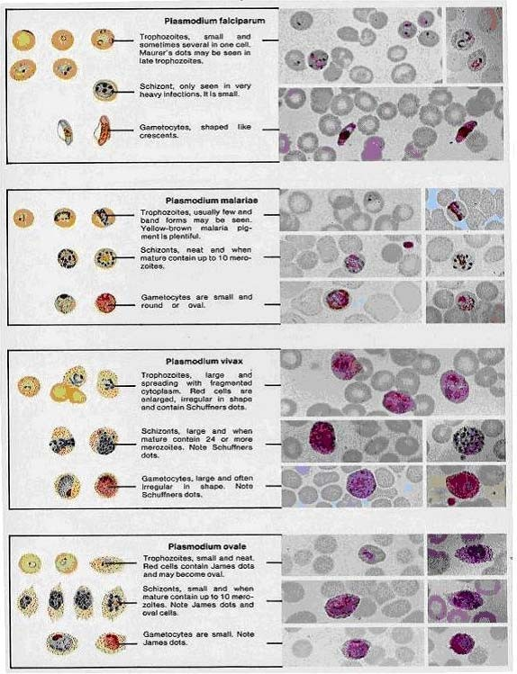

Figure 19; Romanowsky

Plasmodium falciparum
- Ring-form trophozoites of P. falciparum in thick and a thin blood smear.
- Ring-form trophozoites (rings) of Plasmodium falciparum are often thin and delicate, measuring on average 1/5 the diameter of the red blood cell. Rings may possess one or two chromatin dots.
- They may be found on the periphery of the RBC (accolé, appliqué) and multiply-infected RBCs are not uncommon.
- Ring forms may become compact or pleomorphic depending on the quality of the blood or if there is a delay in making smears. There is usually no enlargement of infected RBCs.
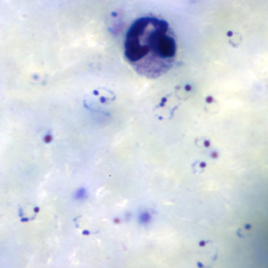
Figure A: Rings of P. falciparum in a thick blood smear.
View Larger
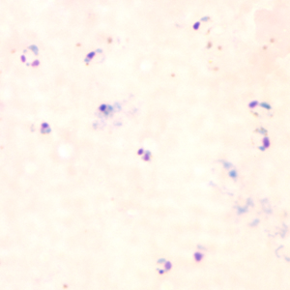
Figure D: Rings of P. falciparum in a thick blood smear.
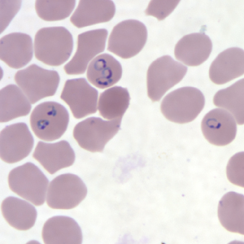
Figure G: Rings of P. falciparum in a thin blood smear.
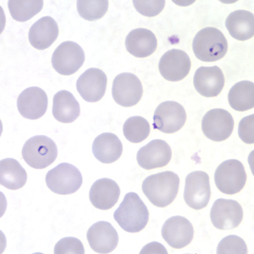
Figure J: Rings of P. falciparum in a thin blood smear.
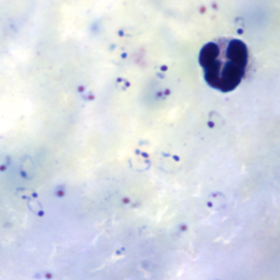
Figure B: Rings of P. falciparum in a thick blood smear.
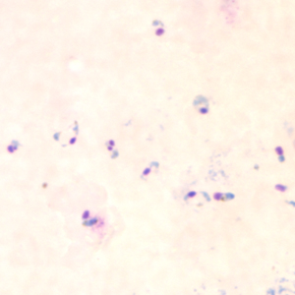
Figure E: Rings of P. falciparum in a thick blood smear.
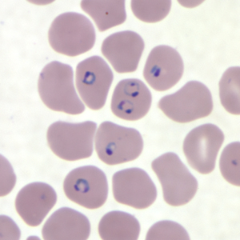
Figure H: Rings of P. falciparum in a thin blood smear.
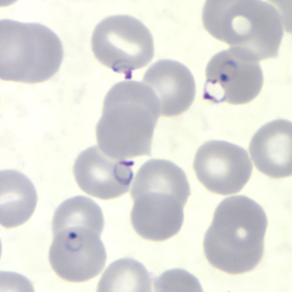
Figure K: Rings of P. falciparum in a thin blood smear.
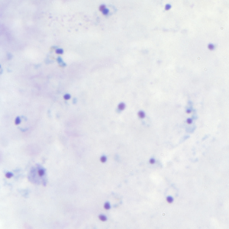
Figure C: Rings of P. falciparum in a thick blood smear.
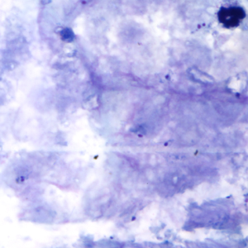
Figure F: Rings of P. falciparum in a thick blood smear.
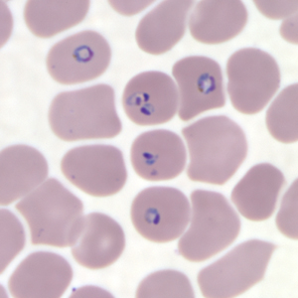
Figure I: Rings of P. falciparum in a thin blood smear.
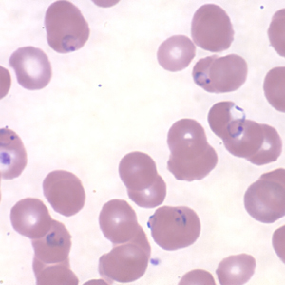
Figure L: Rings of P. falciparum in a thin blood smear.

Ring-form trophozoites of P. falciparum in thin blood smears exhibiting Maurer’s clefts.

- Maurer’s clefts can be seen in P. falciparum infections containing older ring-form trophozoites and asexual stages.
- Maurer’s clefts resemble the Schüffner’s dots seen in P. vivax and P. ovale, but are usually larger and more coarse. Visualization of these structures is dependent on the quality of the smear preparation and the pH of the Giemsa stain. Like Schüffner’s dots, Maurer’s clefts appear to play a role in the metabolic pathways of the infected RBCs.
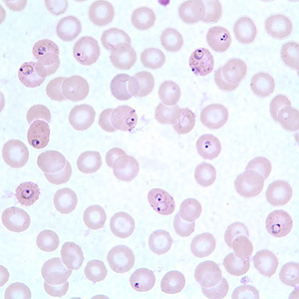
Figure A: Ring-form trophozoites of P. falciparum in a thin blood smear, exhibiting Maurer's clefts.
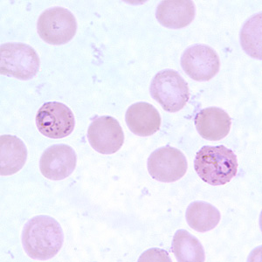
Figure E: Ring-form trophozoites of P. falciparum in a thin blood smear, exhibiting Maurer's clefts.
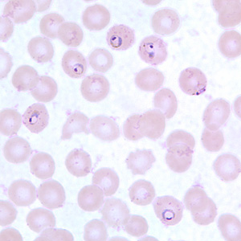
Figure B: Ring-form trophozoites of P. falciparum in a thin blood smear, exhibiting Maurer's clefts.
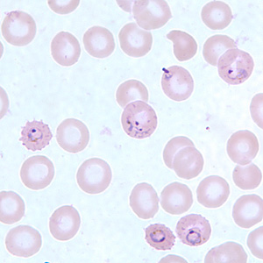
Figure F: Ring-form trophozoites of P. falciparum in a thin blood smear, exhibiting Maurer's clefts.
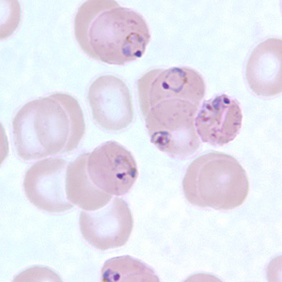
Figure C: Ring-form trophozoites of P. falciparum in a thin blood smear, exhibiting Maurer's clefts.
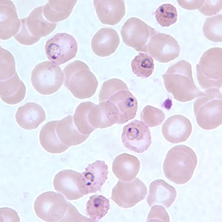
Figure D: Ring-form trophozoites of P. falciparum in a thin blood smear, exhibiting Maurer's clefts.
- Developing and older trophozoites of P. falciparum in thick and a thin blood smear.
- Developing trophozoites of P. falciparum tend to remain in ring form, but may become thicker and more compact. The amount of pigment and chromatin may also increase. Compact or amoeboid forms may be seen in smears where there was a delay in processing the blood.
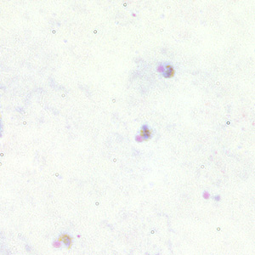
Figure A: Trophozoites of P. falciparum in a thick blood smear.
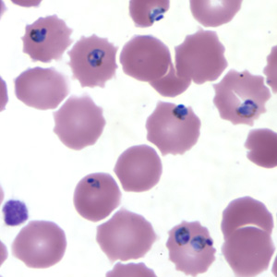
Figure E: Trophozoites of P. falciparum in a thin blood smear.
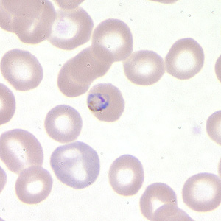
Figure B: Trophozoite of P. falciparum in a thin blood smear.
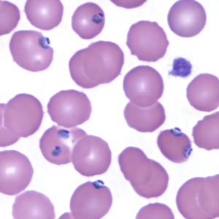
Figure F: Trophozoites of P. falciparum in a thin blood smear.
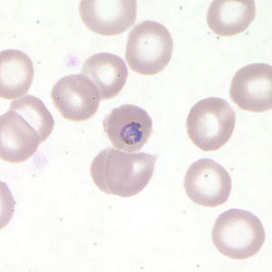
Figure C: Trophozoite of P. falciparum in a thin blood smear.
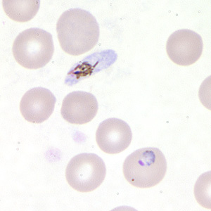
Figure D: Trophozoite of P. falciparum in a thin blood smear. In this figure, a gametocyte can also be seen in the upper half of the image.

Gametocytes of P. falciparum in thick and a thin blood smear.

- Gametocytes of Plasmodium falciparum are crescent- or sausage-shaped, and are usually about 1.5 times the diameter of an RBC in length.
- The cytoplasm of the macrogametocytes (female) are usually a darker, deeper blue; the cytoplasm of the microgametocytes (male) is usually more pale.
- The red chromatin and pigment is more coarse and concentrated in the macrogametocytes than the microgametocytes. Sometimes in thin blood smears, the remnants of the host RBC can be seen; this is often referred to as Laveran’s bib.
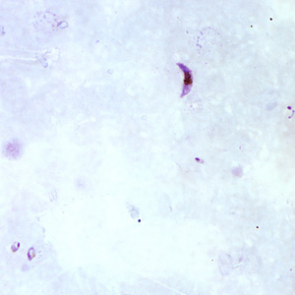
Figure A: Gametocyte of P. falciparum in a thick blood smear. Note also the presence of many ring-form trophozoites.
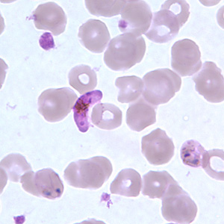
Figure E: Gametocyte of P. falciparum in a thin blood smear. Also seen in this image are ring-form trophozoites exhibiting Maurer's clefts.
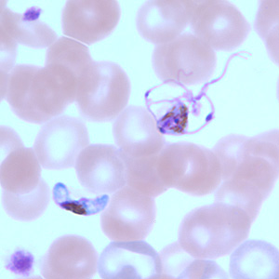
Figure I: Gametocytes of P. falciparum in a thin blood smear. The gametocyte in the upper right is undergoing exflagellation, a process that normally occurs in the mid-gut of the mosquito host. However, it may be observed in human blood specimens when there is a delay in processing the blood.
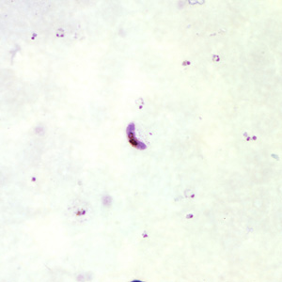
Figure B: Gametocytes of P. falciparum in a thick blood smear. Note also the presence of many ring-form trophozoites.
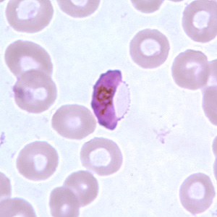
Figure F: Gametocyte of P. falciparum in a thin blood smear. In these specimens, Laveran's bibs can be seen.
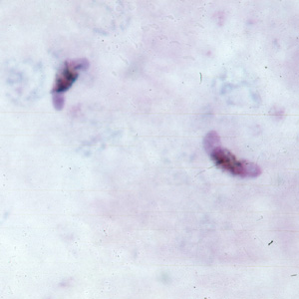
Figure C: Gametocytes of P. falciparum in a thick blood smear.
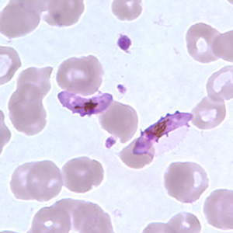
Figure G: Gametocytes of P. falciparum in a thin blood smear. In these specimens, Laveran's bibs can be seen.
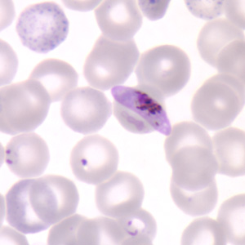
Figure D: Gametocyte of P. falciparum in a thin blood smear. Also seen in this image are ring-form trophozoites and an RBC exhibiting basophilic stippling (upper left).
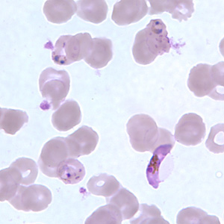
Figure H: Gametocyte of P. falciparum in a thin blood smear, showing Laveran's bib. Also seen in this image are ring-form trophozoites exhibiting Maurer's clefts.

Schizonts of P. falciparum in a thin blood smear.

Schizonts are rarely seen in peripheral blood of Plasmodium falciparum infections, except in severe cases. When seen, schizonts contain anywhere from 8-24 merozoites. A mature schizont usually fills about 2/3 of the infected RBC.
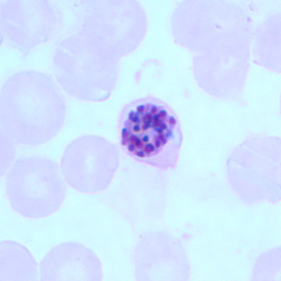
Figure A: Schizont of P. falciparum in a thin blood smear.
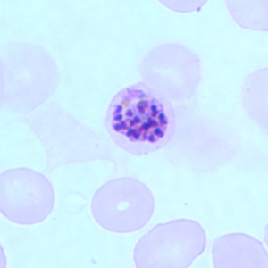
Figure B: Schizont of P. falciparum in a thin blood smear.
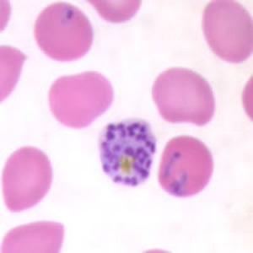
Figure C: Schizont of P. falciparum in a thin blood smear. Trophozoites are also seen in this image.

