Haemoflagelates

Leishmaniasis
- History of this disease:
- In 1900 – Sir William Leishman discovered L. donovani in spleen smears of a soldier who died of fever at Dum-Dum, India.
- The disease was known locally as Dum-Dum fever or kala-azar.
- Charles Donovan also recognized these symptoms in other kala-azar patients and published his discovery a few weeks after Leishman. After examining the parasite using Leishman's stain, these amastigotes were known as Leishman-Donovan bodies
- This one of the neglected disease where it forms one of a globally important but neglected disease, affecting approximately two million people every year.
- For most people, infection results in a slow-to-heal skin ulcer.
- In others, however, the parasite targets the liver, spleen and bone marrow, leading to over 70,000 deaths annually.
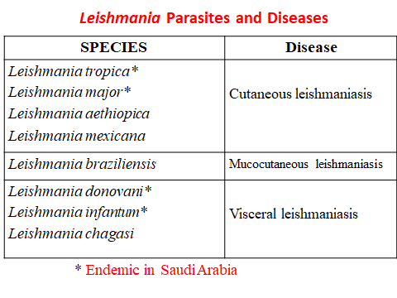

Leishmania Species

Clinical disease - Veseral leishmaniasis
- Cutaneous leishmaniasis
- Mucocutaneous leishmaniasis
- The species of leishmania exist in two forms, amastigote (aflagellar) and promastigote (flagellated) in their life cycle.
- They are transmitted by certain species of sand flies (Genus Phlebotomus & Lutzomyia)
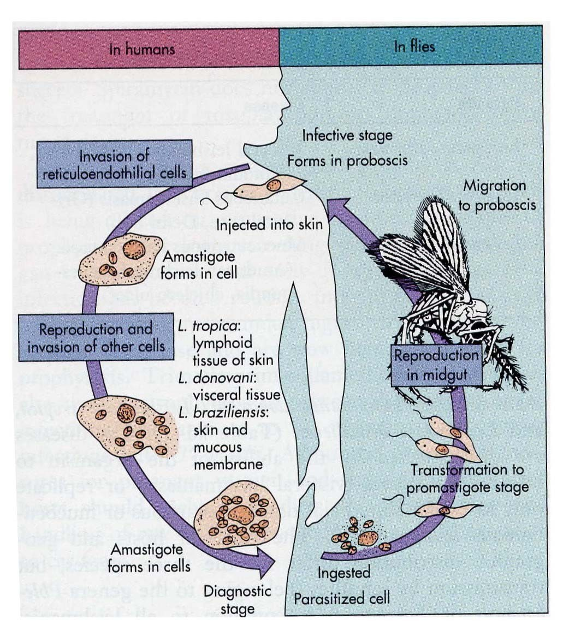
Figure : Life cycle of Leishmania species

Life cycle
- The life-cycle of Leishmania starts when a female phlebotomine sandfly gets infected with the amastigote stage of the parasite through a blood meal of an infected person (see Figures).
- The parasites develop from amastigotes to motile flagellated promastigotes that undergo a complex development in the gut of the sandfly.
- The final phase of development occurs between the anterior midgut and the foregut of the sandfly, at the stomodeal valve, where it transforms into the infective metacyclic form.
- The parasites are then transmitted during a subsequent blood meal taken by the female sandfly when it injects infective promastigotes into the next human victim.
- The promastigotes are taken up by macrophages, where they develop into amastigotes and continue to multiply, rupturing the macrophages and infecting the reticulo-endothelial system organs e.g. spleen, liver and bone marrow
- In Kenya, the sandly transmitting L. donovani is Phlebotomus martini and P. orientalis

Amastigote

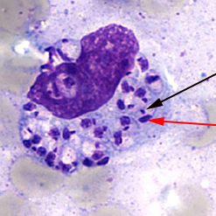

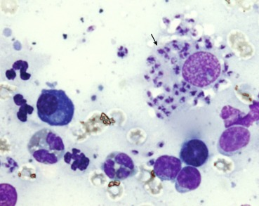

Promastigote

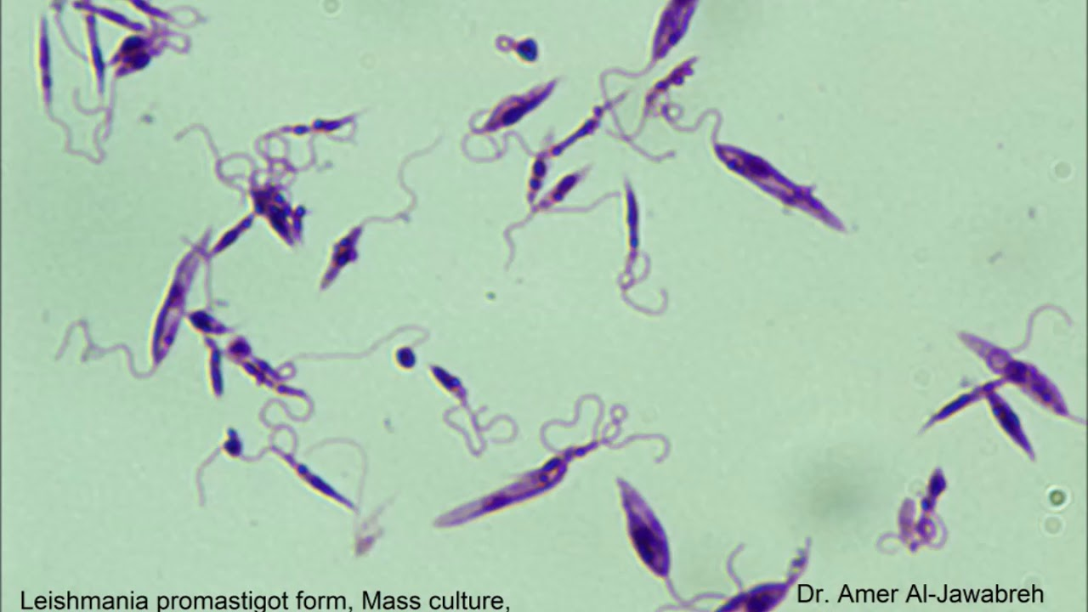

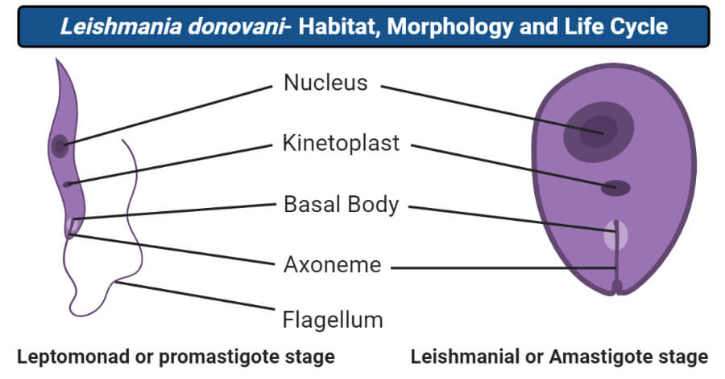

Visceral leishmaniasis Leishmania donovani

Pathogenesis
- After blood meal, the L donovani whose natural habitat in man is the reticuloendothelial system (visceral leishmaniasis); (liver, spleen and bone marrow) are the most severely affected organs, the promastogote is phagocytosed and taken to this organs.
- In the viscera, the promastigote is transformed to amastigote where it multiplies by Simple binary fission until the host cells are destroyed, where upon new macrophages are parasitized.
- In the bone marrow, the bone marrow activity is reduced, coupled with cellular distraction in the spleen, results in anaemia, leukopenia and thrombocytopenia.
- Children and elderly populations are most affected with severe form of the diseases. Therefore in uncomplicated VL patients show hepatosplenomegaly with or without with ascites and edema of the scrotum, There is also paleness of the patients with an extensive bruising.
- Scleral jaundice occurs an now secondary bacterial infections especially with Pseudomonas aeruginosa infection in the face and the ear could also occur.
- Nevertheless the impaired liver could also lead to secondary infections and a tendency to bleeding. The spleen and liver become markedly enlarged, and hypersplenism contributes to the development of anaemia and lymphadenopathy also occurs.
- Increased production of globulin results in hyperglobulinemia, and reversal of the albumin-to-globulin ratio.

Epidemiology
- donovani donovani, infection is the classic kala-azar (“black sickness”) or dumdum fever type that occurs in many parts of Asia, Africa and Southeast Asia. Kala-azar occurs in three distinct epidemiologic patterns.
- In Mediterranean basin (European, Near Eastern, and Africa) and parts of China and Russia, the reservoir hosts are primarily dogs & foxes; in sub-Saharan Africa, rats & small carnivores are believed to be the main reservoirs.
- In India and neighboring countries (and Kenya), kala-azar is anthroponosis, i.e. there is no other mammalian reservoir host other than human. The vector is the Phlebotomus sand fly. Other variants of L. donovani are also recognized: L. donovani infantum with similar geographical distribution, reservoir host and vector; with L. donovani donovani. L. donovani chagasi is found in South America, Central America, especially Mexico, and the West Indies. Reservoir hosts are dogs, foxes, and cats, and the vector is the Lutzomiya sand fly.
In Kenya: Visceral Leishmaniasis is endemic in semi-arid and arid areas of Rift Valley, Eastern and North Eastern regions of Kenya.
- In Rift Valley, the disease is more common and is found in Baringo, Pokot, Turkana, Samburu, Kajiado and Laikipia sub-counties. In the Eastern Region, foci have been documented in Isiolo, Kitui, Machakos, Makueni, Marsabit, Mwingi and Tharaka counties.
- It is estimated that about 2500 (hospitals record estimates) cases occur annually, the majority of whom are children aged >5 years and young adults; some 6.81 million people are at risk of the infection.
- The disease foci may change to areas previously not known to be endemic as a result of climate change and population movements.
- There have been several outbreaks of the disease in Kenya; the most recent was confirmed in Isiolo, Marsabit and Wajir counties in, 2008, 2011, 2013 and 2014, recent 2021 in Baringo

Clinical features
- Symptoms begin with intermittent fever, weakness, and diarrhea; chills and sweating that may resemble malaria symptoms are also common early in the infection.
- As organisms proliferate & invade cells of the liver and spleen, marked enlargement of the organs (liver and spleen-(hepatosplenomegally) , weight loss, anemia, and emaciation occurs. With persistence of the disease, deeply pigmented, granulomatous lesion of skin, referred to as post-kala-azar dermal leishmaniasis, occurs.
- Untreated visceral leishmaniasis is nearly always fatal as a result of secondary infection. Some of the exposed persons ma develop severe disease. factors influencing this being young age, malnutrition, immunosuppressive diseases such as HIV, malignancies and organ transplantation.
- The case fatality rate approximates 100% if the disease is left untreated. Death is mainly due to secondary bacterial infections

Immunity
Host cellular and humoral defence mechanisms are stimulated.
Evasion of immune system
- Leishmania’s attempt to alter the chemokine expression profile in the infected tissue microenvironment will therefore contribute to their ability to evade the host’s immune system.
- For over a decade, Leishmania has been known to induce or inhibit the expression of chemokines to control recruitment of immune cells.
- Leishmania prevents the activation of an effective immune response by inhibiting production of a number of cytokines, particularly those involved in the inflammatory response (IL-1 and tumor necrosis factor alpha [TNF-α]) or in T-lymphocyte activation (IL-12).

Laboratory diagnosis
  - Examination of tissue biopsy, spleen aspiration, bone marrow aspiration or lymph node aspiration in properly stained smear (e.g. Giemsa stain).
  - The amastigotes appear as intracellular & extra cellular L. donovan (LD) bodies.
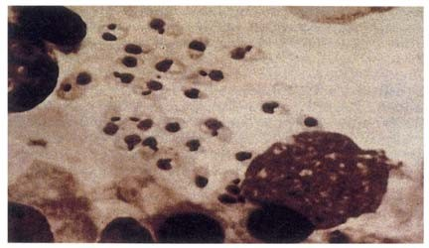
Figure 9; Giemsa-stained amastigotes (LD bodies)

  - Culture of blood, bone marrow, and other tissue often demonstrates the promastigote stage of the organisms.
  - Serologic testing is also available.

CLINICAL CASE DEFINITION
VL should be suspected in a patient from a VL endemic area who presents with following symptoms;
A typical patient will present with several of the following signs and symptoms:
  - fever for 2 weeks or longer
  - splenomegaly
  - weight loss
  - anaemia
  - cough
  - epistaxis
  - hepatomegaly
  - body weakness.
In rare circumstances, some patients will present with:
  - oedema
  - jaundice
  - vomiting
  - joint pains
  - abdominal pains
  - lymphadenopathy
  - diarrhoea.
  - Once a patient meets the clinical case definition, it is important to know if it is a primary VL case or a relapse VL case, as investigation and patient management will differ.
  - Primary kala-azar is a patient in whom KA is diagnosed for the first time. The patient has not been treated for KA before.
  - Initial cure is a patient who successfully completed a course of VL treatment and is discharged with improved clinical condition and no parasites found (negative test of cure).
  - Relapse case is a patient who successfully completed a course of standard VL treatment, and was discharged with initial cure, who returns later with clinical signs of VL and Leishmania parasites are found in the parasitological tests. VL relapses are usually observed within 6 months of completing therapy.

Treatment
- The drug of choice is sodium stibogluconate, a pentavalent antimonial compound.
- Alternative approaches include the addition of allopurinol and the use of pentamidine or amphotericin B.

Prevention
- Prompt treatment of human infections and control of reservoir hosts.
- Protection from sand flies by screening and insect repellents.

Old World Cutaneous Leishmaniasis (Oriental sore)

Clinical disease
- L.tropica minor - dry or urban cutaneous leishmaniasis
- L.tropica major - wet or rural cutaneous
- leishmaniasis L.aethiopica - cutaneous leishmaniasis

Important features

- These are parasites of the skin found in endothelial cells of the capillaries of the infected site, nearby lymph nodes, within large mononuclear cells, in neutrophilic leukocytes, and free in the serum exuding from the ulcerative site.
- Metastasis to other site or invasion of the viscera is rare.

Pathogenesis

- In neutrophilic leukocytes, phagocytosis is usually successful, but in macrophages the introduced parasites round up to form amastigote and macrophages multiply. In the early stage, the lesion is characterized by the proliferation of that contain numerous amastigotes.
- There is a variable infiltration of lymphocytes and plasma cell. The overlying epithelium shows acanthosis and hyperkeratosis, which is usually followed by necrosis and ulceration.

Epidemiology

- Cutaneous leishmaniasis produced by L.tropica complex is present in many parts of Asia, Africa, Mediterranean Europe and the southern region of the former Soviet Union.
- The urban Cutaneous leishmaniasis is thought to be an anthroponosis while the rural cutaneous leishmaniasis is zoonosis with human infections occurring only sporadically.
- The reservoir hosts in L. major are rodents. L.aethopica is endemic in Ethiopia and Kenya. The disease is a zoonosis with rock & tree hyraxes serving as reservoir hosts.
- The vector for the old world cutaneous leishmaniasis is the Phlebotomus sand fly.

Clinical features

- The first sign, a red papule, appears at the site of the fly’s bite. This lesion becomes irritated, with intense itching, and begins to enlarge & ulcerate. Gradually the ulcer becomes hard and crusted and exudes a thin, serous material.
- At this stage, secondary bacterial infection may complicate the disease. In the case of the Ethiopian cutaneous leishmaniasis, there are similar developments of lesions, but they may also give rise to diffuse cutaneous leishmaniasis (DCL) in patients who produce little or no cell mediated immunity against the parasite.
- This leads to the formation of disfiguring nodules over the surface of the body.

Immunity
- Both humoral and cell mediated immunity (CMI) are involved

Treatment

- The drug of choice is sodium stibogluconate, with an alternative treatment of applying heat directly to the lesion.
- Treatment of L.aethopica remains to be a problem as there is no safe and effective drug.

Prevention
- Prompt treatment & eradication of ulcers
- Control of sand flies & reservoir hosts.

New World Cutaneous and Mucocutaneous Leishmaniasis
(American cutaneous leishmaniasis)

Clinical disease:
- Leishmania mexicana complex- Cutaneous leishmaniasis.
- Leishmania braziliensis complex- mucocutaneous or cutaneous leishmaniasis

Important features:

- The American cutaneous leishmeniasis it is the same as oriental sore though some strains tends to invade the mucous membranes of the mouth, nose, pharynx, and larynx either initially by direct extension or by metastasis.
- The metastasis is usually via lymphatic channels but occasionally may be the bloodstream.

Pathogenesis

- The lesions are confined to the skin in cutaneous leishmaiasis and to the mucous membranes, cartilage, and skin in mucocutaneous leishmaniasis.
- A granulomatous response occurs, and a necrotic ulcer forms at the bite site. The lesions tend to become superinfected with bacteria. Secondary lesions occur on the skin as well as in mucous membranes.
- Nasal, oral, and pharyngeal lesions may be polypoid initially, and then erode to form ulcers that expand to destroy the soft tissue and cartilage about the face and larynx. Regional lymphadenopathy is common.

Epidemiology

- Most of the cutaneous & mucocutaneous leishmaniasis of the new world exist in enzootic cycles of infection involving wild animals, especially forest rodents. Leishmania mexicana occurs in south & Central America, especially in the Amazon
- Basin, with sloths, rodents, monkeys, and raccoons as reservoir hosts.
- The mucocutaneous leishmaniasis is seen from the Yucatan peninsula into Central & South America, especially in rain forests where workers are exposed to sand fly bites while invading the habitat of the forest rodents.
- There are many jungle reservoir hosts, and domesticated dogs serve as reservoirs as well. The vector is the Lutzomyia sand fly.

Clinical features

- The types of lesions are more varied than those of oriental sore and include Chiclero ulcer, Uta, Espundia, and Disseminated Cutaneous Leishmaniasis.

Laboratory diagnosis
- Demonstration of the amastigotes in properly stained smears from touch preparations of ulcer biopsy specimen.
- Serological tests based on fluorescent antibody tests.
- Leishman skin test in some species.

Immunity
- The humoral and cellular immune systems are involved

Treatment
- Sodium stibogluconate is the drug of choice.

Prevention
- Avoiding endemic areas especially during times when local vectors are most active.
- Prompt treatment of infected individuals.

TRYPANOSOMIASIS
- Trypanosoma brucei complex – African trypanosomiasis (sleeping sickness)
- Trypanosoma cruzi – American trypanosomiasis (Chagas’ disease)

Important features

- These species may have amastigote, promastigote, epimastigote, and trypomastigote stages in their life cycle. In human trypanosomes of the African form, however, the amastigote and promastigote stages of development are absent.
- Typical trypanosome structure is an elongated spindle-shaped body that more or less tapers at both ends, a centrally situated nucleus, a kinetoplast posterior to nucleus, an undulating membrane arising from the kinetoplast and proceeding forward along the margin of the cell membrane and a single free flagellum at the anterior end.

African trypanosomiasis
- Trypanosoma gambiense & Trypanosoma rhodesiene are causative agents of the African typanosomiasis, transmitted by insect bites.
- The vector for both is the tsetse fly.
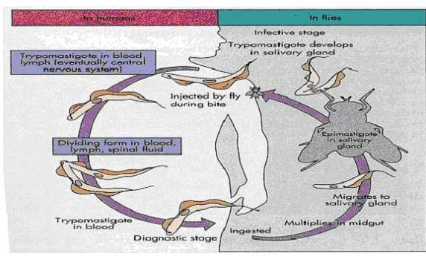
Figure ; Life cycle of Trypanosoma brucei

Pathogenesis

- The trypomastigotes spread from the skin through the blood to the lymph node and the brain. The typical somnolence (sleeping sickness) usually progresses to coma as a result of demyelinating encephalitis.
- In acute form, cyclical fever spike (approximately every 2 weeks) occurs that is related to antigenic variation. As antibody mediated agglutination and lysis of the trypomastigotes occurs, the fever subsides.
- With a few remains of antigenic variants new fever spike occurs and the cycle repeats itself over a long period.

Epidemiology

- T.burcei gambiense is limited to tropical west and central Africa, correlating with the range of the tsetse fly vector.
- The tsetse flies transmitting T.b. gambiense prefer shaded stream banks for reproduction and proximity to human dwellings. People who work in such areas are at greatest risk of infection. An animal reservoir has not been proved for this infection.

- T.burcei rhodeseinse is found primarily in East Africa, especially the cattle-raising countries, where tsetse flies breed in the brush rather than along stream banks.
- T.b. rhodeseines also differs from T.b. gambiense in that domestic animal hosts (cattle and sheep) and wild game animals act as reservoir hosts. This transmission and vector cycle makes the organism more difficult to control than
- T.b. gambiense.

Clinical features

- Although both species cause sleeping sickness, the progress of the disease is different. T.gambiense induced disease runs a low-grade chronic course over a few years. One of the earliest signs of disease is an occasional ulcer at the site of the fly bite. As reproduction of organisms continues, the lymph nodes are invaded, and fever, myalgia, arthralgia, and lymph node enlargement results.
- Swelling of the posterior cervical lymph nodes is characteristic of Gambian sleeping sickness and is called winterbottom’s sign.

- Chronic disease progresses to CNS involvement with lethargy, tremors, meningoencephalitis, mental retardation, and general deterioration. In the final stages, convulsions, hemiplegia, and incontinence occur.

- The patient becomes difficult to arouse or obtain a response from, eventually progressing to a comatose state. Death is the result of CNS damage and other infections, such as pneumonia.

- In T.rhodesiense, the disease caused is a more acute, rapidly progressive disease that is usually fatal. This more virulent organism also develops in greater numbers in the blood. Lymphadenopathy is uncommon, and early in the infection, CNS invasion occurs, resulting in lethargy, anorexia, and mental disturbance.

- The chronic stages described for T.gambiense are not often seen, because in addition to rapid CNS disease, the organism produces kidney damage & myocarditis, leading to death.

Immunity

- Both the humoral and cellular immunity involve in these infections. The immune responses of the host to the presence of these parasites, however, is faced with antigenic variation, in which organisms that have changed their antigenic identity can escape the host immune response and initiate another disease process with increased level of parasitemia.

Laboratory

- Examination of thin and thick films, in concentrated anticoagulated blood preparations, and in aspiration from lymph nodes and concentrated spinal fluid.
- Methods for concentrating parasites in blood may be helpful approaches including centrifugation of heparinized samples and an ion–exchange chromatography.

- Levels of parasitosis vary widely, and several attempts to visualize the organism over a number of days may be necessary.

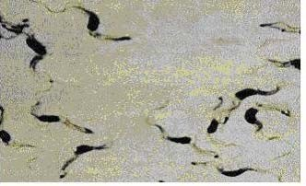
Figure ; Trypomastigote stage of Trypanosoma burcei complex

Treatment

- The same treatment protocol is applied for these parasites.
- For the acute stages of the disease the drug of choice is suramin with pentamidine as an alternative.
- In chronic disease with CNS involvement, the drug of choice is melarsoprol. Alternatives include trypars amide combined with suramin.

Prevention
  - Control of breeding sites of tsetse flies and use of insecticides.
  - Treatment of human cases to reduce transmission to flies.
  - Avoiding insect bite by wearing protective clothing & use of screen, bed netting and insect repellants.

American trypanosomiasis

- Trypanosoma cruzi is a pleomorphic trypanosome that includes an additional form of amastigote in its life cycle.
- The vector for transmission are reduviid bugs.

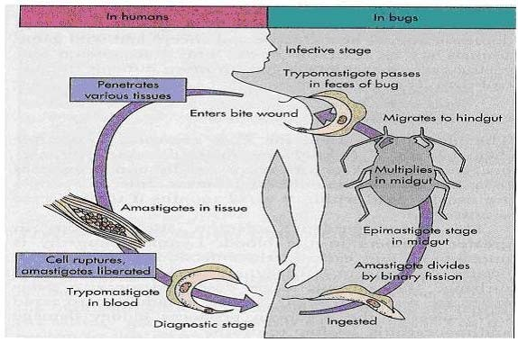
Figure Life cycle of Trypanosoma cruzi

Pathogenesis

- During the acute phase, the organism occurs in blood as a typical trypomastigote and in the reticuloendothelial cells as a typical amastigote.
- The amastigotes can kill cells and cause inflammation, consisting mainly of mononuclear cells. Cardiac muscle is the most frequently and severely affected tissue.
- In addition, neuronal damage leads to cardiac arrhythmias and loss of tone in the colon (megacolon) and esophagus (megaesophagus).
- In the chronic phase, the organism persists in the amastigote form.

Epidemiology

- T.cruzi occurs widely in both reduviid bugs and a broad spectrum of reservoir animals in North, Central, and South America.
- In humans often children are most affected in South and Central America with reservoirs being in infected bugs found in human dwellings.

Clinical features

- Chagas’ disease may be asymptomatic acute or chronic disease. One of the earliest signs is development at the site of the bug bite of an erythematous and indurated area called a chagoma.
- This is often followed by a rash and edema around the eyes and face; in young children frequently an acute process with CNS involvement may occur. Acute infection is also characterized by fever, chills, malaise, myalgia, and fatigue.
- The chronic Chagas’ disease is characterized by hepatosplenomegaly, myocarditis, and enlargement of the esophagus and colon as a result of the destruction of nerve cells (E.g. Auerbach’s plexus) and other tissues that control the growth of these organs.
- Involvement of the CNS may produce granulomas in the brain with cyst formation and a meningoencephalitis.
- Death from chronic Chagas’ disease results from tissue destruction in the many areas invaded by the organisms, and sudden death results from complete heart block and brain damage.

Laboratory diagnosis

- Examine thin or thick stained preparations for trypomastigotes. Wet preparations should also be examined to look for motile organisms that leave the blood stream and become difficult to find.
- Biopsy of lymph nodes, liver, spleen, or bone marrow may demonstrate organisms in amastigote stage.
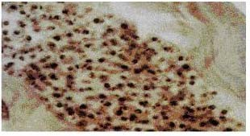
Figure: Amastigote stage of Trypanosoma cruzi in skeletal muscle

- Xenodiagnosis - which consists of allowing an uninfected, laboratory-raised reduviid bug to feed on the patient and, after several weeks, examining the intestinal contents of the bug for the organism.

Immunity

- Unlike African trypanosomiasis, the antigenic variation is less common in T.cruzi infection.
- Therefore, the humoral and cellular immune responses function in the immune system.

Treatment

- The drug of choice is nifurtimox and allopurinol & benzimidazole as alternative drugs.

Prevention
- Bug control, eradication of nests
- Treating infected person & exclusion of donors by screening blood.
- Development of vaccine.

