

KENYATTA UNIVERSITY
DIGITAL SCHOOL OF VIRTUAL AND OPEN LEARNING
IN COLLABORATION WITH
SCHOOL OF CREATIVE & PERFORMING ARTS, FILM AND MEDIA STUDIES
DEPARTMENT OF FASHION DESIGN AND MARKETING

HFD 104 LAUNDRY AND CARE OF TEXTILE PRODUCTS

WRITTEN BY: DR MERCY WANDUARA

VETTED BY: DR BOSIBORI OIGO
INTRODUCTION
Welcome to the module for HFD104 Laundry and Care of Textile Products. This is one of the core units you will take from the department of Fashion Design and Marketing as partial fulfilment of the Bachelor of Science degree. Laundry and care of Textile products has one prerequisite that you must have done and passed before you register. The prerequisite is HFD 100: introduction to Textiles. The knowledge on fibers, fabrics and their care will help you as you study the laundry work course. In this module, we will introduce you to skills that you can use for proper care of your clothes and for other members of your family. You will be expected to study on your own most of the time, therefore, the module contains e-activities that you will be expected to complete. This is an interactive instructional module that uses both action and collaborative learning styles that provide you with diverse online learning experiences and effective learning processes. The purpose of this module is to enable you to understand methods and procedures of laundering textile products according to their type, giving special-care to textile articles depending on fibre origin. This should in turn help you in general care of textile items including methods of repair, storage and care labelling.

LAUNDRY AND CARE OF TEXTILE PRODUCTS
WEEK | TOPIC
WEEK 1 | Introduction to laundry work
WEEK 2 | The nature of soiling matter on fabrics
WEEK 3 | Cleaning materials and additional laundry reagents in laundry work
WEEK 4 | Equipment and apparatus for laundry
WEEK 5 | Washing procedures and processes in laundry work
WEEK 6 | Removal of stains
WEEK 7 | Home dry cleaning, spotting, sponging and pressing
WEEK 8 | Ironing and finishing processes
WEEK 9 | Choice and care of laundry work equipment
WEEK 10 | Care labels and their appropriate use
WEEK 11&12 | EXAMINATION

OVERVIEW OF THE COURSE

Week 0: Introduction (Your Context, Your Goals)
This lesson is intended help you acclimatize to blended learning and to create a community of learners who will motivate each other during the course. You will be required to introduce yourself to your lecturer and colleagues either physically during a face to face session or even online before other academic interactions start. It will be important to also state your context and goals as well as what you think about the course. You can also share any experience that you may have regarding your background and your interests in fashion design and marketing.

Week 1: Introduction to laundry work
This first lesson is intended to provide a background to the study of laundry work by explaining its main purpose and to us today. The benefits of laundry work course and the current trends in care of textile products will be made. A review of textile fibres will be done to help you recap the properties of textile fibres and fabrics in order to be able to take care of textile products appropriately. The purpose of this lesson is therefore to enable you understand the benefits of laundry work and it’s important in the world today and also analyse fibre properties and categories of textile products commonly used.

Week 2: The nature of soiling matter on fabrics
In this lesson, we analyse the nature of soiling mater on fabrics. The way(s) dirt forms on fabrics and other surfaces is highlighted in order to decipher the most appropriate methods of the dirt removal from fabrics. The purpose of this lesson is to identify the various sources of soiling matter on fabrics, describe the nature of these soiling matter and the most appropriate methods of their removal from fabrics.

Week 3: Cleaning materials and additional laundry reagents in laundry work
In this lesson, we explore cleaning materials that are used for effective dirt removal from fabrics and various surfaces around our environment. Apart from the various usual cleaning aids, there are also other additional cleaning materials such as stain removers that are of importance to effective laundry work. The purpose of this lesson is to help you understand the ordinary cleaning aid and additional reagents that are available for successful laundry work of all products.

Week 4: Equipment and apparatus for laundry
In this lesson, we introduce to equipment and apparatus for laundry work. There are various equipment and apparatus at our disposal and appropriate choice of these is important in order to be successful in the laundry process. The purpose of this lesson is to enable you make informed decision of the correct choice of the laundry equipment and apparatus.

Week 5: Washing procedures and processes in laundry work
This lesson focuses on washing procedures and processes in laundry work. In order to be successful in laundry work, the correct procedures and processes are key. Dirty clothes need to be properly sorted out and each item of clothing carefully treated according to the fabric type, soiling matter and cleaning aids. The purpose of this lesson is to enable you outline the procedures and processes of washing clothes in laundry work.

Week 6: Removal of stains
In this 6th lesson, you will learn about stain removal in laundry work. Stains are stubborn dirt marks on clothing that are not likely to come off in the usual laundry process and hence require special aids and processes in their effective removal. The lesson will focus on the types and forms of stains on fabrics and effective methods of their removal.

Week 7: Home dry cleaning, spotting, sponging and pressing
In this lesson, we explore home dry cleaning, spotting, sponging and pressing. These are processes used to refurbish dirty clothes quickly for re-use without necessarily washing the entire article, e.g. suits, trousers or skirts. The purpose of this lesson is to enable you to understand methods of quickly restoring clothes for re-use without washing the whole garment.

Week 8: Ironing and finishing processes
This lesson focuses on ironing and finishing processes. After laundering clothing products, they need to be ironed and finished appropriately before storage in order to maintain their appearance as long as possible. There are various methods of finishing clothing after laundering them such as ironing, pressing and folding. The purpose of this lesson is to equip you with various ways of ironing and finishing clothes in laundry work.

Week 9: Choice and care of laundry work equipment
In this lesson you will learn how to choose and take care of laundry work equipment. There are many types of laundry work equipment in the market today and proper choice is important in order to give you quality tools worth your worth and useful for your laundry work tasks. The purpose of this lesson is to enable you to make informed choice of laundry work equipment and to be able to use and care for them appropriately.

Week 10: Care labels and their appropriate use
In this lesson you will learn about care labels and their appropriate use in laundry work. All ready-made products are affixed a care label that is meant to aid the product user in its care. The care label is meaningless to the product user unless she/he is able to decode the care label information. The purpose of this lesson is to enable you to understand the care label information on ready-made clothing products and to use the information appropriately during the use and care of clothing.

Week 11&12: Examination
These two weeks bring together the work you have been doing to an end through an end of semester examination. This course unit will be examined and will partially contribute to the award of the degree in fashion design and marketing.
Troubleshooting
- If you have problems accessing or logging into the system (LMS):
1. Go to the Student Help Desk -https://support.ku.ac.ke/
2. Chat with us at http://chat.ku.ac.ke/
3. Call the Digital school offices at (See our Contacts here) -http://www.ku.ac.ke/dsvol/contact-us
4. Guides about how to use moodle are available athttp://www.ku.ac.ke/dsvol/students-resources
5. Also use our social media huddles:

Twitter: @KUDigitalSchool
Facebook: @KUDSVOL

MODULE LEARNING OUTCOMES

By the end of this module you should be able to:
- Analyze the nature of soiling matter on fabrics
- Discuss various cleaning materials used in laundry work.
- Apply skills learnt to remove stains, launder or dry-clean different textile products
- Interpret and appropriately use care labels in laundry work
- Evaluate environmental and emerging issues in the life cycle of textile products

COURSE DESCRIPTION
This is a core unit for all students taking B.Sc in Fashion Design and Marketing. The course is designed to equip learners with knowledge and skills of processes used in laundry work. The purpose of the course is to enable you to understand methods and procedures of laundering textile products according to the type, properties and fibre origin as well as home dry cleaning. Environmental and emerging issues in the life cycle of textile products will be explained as well as the appropriate laundry equipment and cleaning aids in relation to product processes and handling. Modern care labelling of textile products will also be addressed. The course will take you 35 instructional hours some of which will be covered face to face and others in online activities. You will therefore be required to set aside about 5 hours per lesson to complete this course successfully.

COURSE REQUIREMENTS
This is a blended learning course that will utilize the flex model. This means that learning materials and instructions will be given online and the lessons will be self-guided with the lecturer being available briefly for face to face sessions and support and also on-site (online) most of the time. Your lecturer will be meeting you face to face to introduce a lesson and put it into perspective and you will actively participate in your search for knowledge by undertaking several online activities. This means that some of the 35 instructional hours of the course will be delivered face to face while other lessons will be taught online through various learner and lecturer activities. It is important for you to note that one instructional hour is equivalent to two online hours. Three instructional hours will be needed per week. Out of these, one will be used for face to face contact with your lecturer (also referred as e-moderator in the online activities) while the other two instructional hours (translating to four online hours) will be used for online activities otherwise referred to as e-tivities in the lessons. This will add up to the 5 hours requirement per lesson earlier mentioned.
You will be required to participate and interact online with your peers and the e-moderator who in this case is your lecturer. Guidelines for the online activities (which we shall keep referring to as e-tivities) will be provided whenever there is an e-tivity. Please note that since the online e-tivities are part of the learning process, they may be graded at the discretion of your e-moderator. Such grading will however be communicated in the e-tivity guidelines and feedback given as soon as possible after the e-tivity. The e-tivities will include but will not be limited to online assessment quizzes, assignments and discussions. There are also assessment questions that you can attempt at the end of every lesson to test your understanding of the lesson. The answers to all the assessment questions are at the end of the module after lesson 10. All the resource that have been used in this module in form of books are available under the resources section after the answers to the questions.

ASSESSMENT
It is important to note that the module has embedded certain learner formative assessment feedback tools that will enable you gauge your own learning progress. The tools include online collaborative discussions forums that focus on team learning and personal mastery and will therefore provide you with peer feedback, lecturer assessment and self- reflection. You will also be required to do one major assignment/project that is meant to assess the application of the skills and knowledge gained during the course. The project score in combination with scores for e-tivities (where graded) will account for 30% of your final examination score with the remaining 70% coming from a face to face sit-in final written examination that will be guided by your university examination policy and procedures.

We wish you the very best of experiences in this course.

Contents
LAUNDRY AND CARE OF TEXTILE PRODUCTS 2
OVERVIEW OF THE COURSE 3
MODULE LEARNING OUTCOMES 5
COURSE DESCRIPTION 6
COURSE REQUIREMENTS 6
ASSESSMENT 7
Lesson 1 Introduction to laundry work 10
1.1 Introduction 10
1.2 Lesson Learning Outcomes 10
1.3 Assessment questions 12
1.4 References 12
Lesson 2 The Nature of Soiling Matter on Fabrics 13
2.1 Introduction 13
2.2 Lesson Learning Outcomes 13
2.3 Assessment questions 15
2.4 References 15
Lesson 3 Cleaning Materials and Additional Laundry Reagents in Laundry Work 16
3.1 Introduction 16
3.2 Lesson Learning Outcomes 16
3.3 Assessment questions 19
3.4 References 19
Lesson 4 Equipment and Apparatus for Laundry work 20
4.1 Introduction 20
4.2 Lesson Learning Outcomes 20
4.3 Assessment questions 24
4.4 References 24
Lesson 5 Washing Procedures and Processes in Laundry Work 25
5.1 Introduction 25
5.2 Lesson Learning Outcomes 25
5.3 Assessment questions 29
5.4 References 29
Lesson 6 Removal of Stains 30
6.1 Introduction 30
6.2 Lesson Learning Outcomes 30
General Precautions on Stain Removal 32
6.3 Assessment questions 33
6.4 References 33
Lesson 7 Home Dry Cleaning, Spotting, Sponging and Pressing 34
7.1 Introduction 34
7.2 Lesson Learning Outcomes 34
7.3 Assessment questions 37
7.4 References 37
Lesson 8 Ironing and Finishing Processes 38
8.1 Introduction 38
8.2 Lesson Learning Outcomes 38
8.3 Assessment questions 41
8.4 References 41
Lesson 9 Choice and Care of Laundry Work Equipment 42
9.1 Introduction 42
9.2 Lesson Learning Outcomes 42
9.3 Assessment questions 46
9.4 References 46
Lesson 10 Care Labels and their Appropriate Use 47
10.1 Introduction 47
10.2 Lesson Learning Outcomes 47
10.3 Assessment questions 49
10.4 References 49
Lesson 11&12 EXAMINATION 50
11.0 ANSWERS TO LESSON ASSESSMENT QUESTIONS 50

Lesson 1 Introduction to laundry work

1.1 Introduction
In this first lesson, we provide a background to the study of laundry work by explaining its main purpose and to us today. It is important to know the benefits of the laundry work course and the current trends in care of textile products. There are many new textile materials today, some of which are “easy-care” and which you need to know about. A review of textile fibres will be done to help you recap the properties of textile fibres and fabrics in order to be able to take care of textile products appropriately. The purpose of this lesson is therefore to enable you understand the benefits of laundry work and it’s important in the world today and also analyse fibre properties and categories of textile products commonly used. A knowledge of the types of textile products under our care will help you know how to care for them.

1.2 Lesson Learning Outcomes
By the end of this lesson, you will be able to:
1.2.1 Outline the reasons for studying laundry work and its benefits
1.2.2 Analyze properties of textile products commonly used today

1.2.1 Reasons and Benefits for Studying Laundry Work Course
In the last few years there has been a greater development in the industry than ever before.
The emphasis in laundry work has changed and while the labour of washing and ironing has decreased, the need to know more about new materials, the nature of detergents and modern equipment has increased. When so many women now have a career and much less time is spent in the home, easy care fabrics are an advantage. Much less time is now available for starching and ironing, but the easy care finishes must be looked after.

To be successful at laundry work, one must know:-
- How to operate the washing machine or to handle fabrics if hand washed.
- The detergents most suitable for the available water and the fibre and the finish and its optimum concentration.
- The temperatures required for the detergent solution.
- The time that the fabric should undergo treatment.
- How to remove surplus water from the fabric to avoid creases which should require tedious ironing to remove.
- Correct ironing temperatures and technique for ironing.
- The best results come when the right process for the right fabric is used. And this can be done only if you have the right information.

E-tivity 1.2.1 Reasons and Benefits for Studying Laundry Work Course
Numbering, pacing and sequencing | 1.2.1
Title | Reasons and Benefits for Studying Laundry Work Course
Purpose | The purpose of this E-tivity is to enable learners to outline the reasons for studying laundry work and its benefits
Brief summary of overall task | Use the resources and library links provided to help you identify various benefits of the laundry work course
Spark | 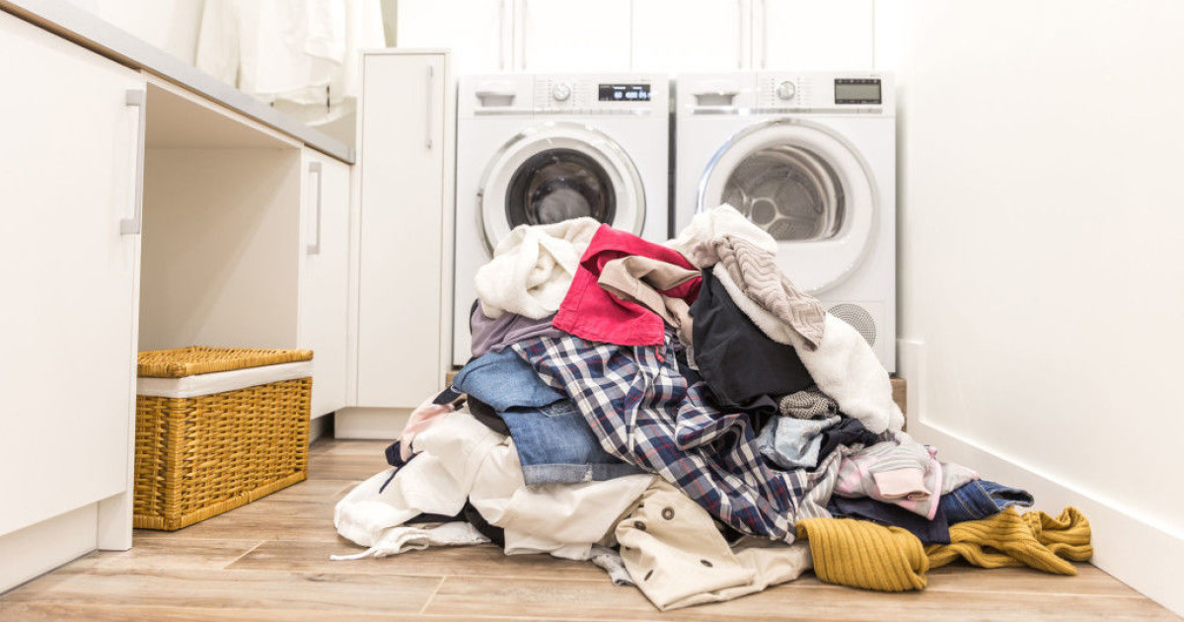
Individual task | - Explain what you consider your benefits for studying laundry work.  - Your answers should be posted in the discussion 1.2.1
Interaction begins | Post your responses on the discussion forum 1.2.1.
E-moderator interventions | a) Ensure that learners are focused on the contents and context of discussion and discourage plagiarism and copying.  b) Stimulate further learning and generation of new ideas.  c) Provide feedback on the learning progress
Schedule and time | This task should take two hours
Next | Properties of and Textile Products Commonly Used Today

1.2.2 Properties of and Textile Products Commonly Used Today
Whatever their origin fibres are spun into threads which are made up into an article for use.
The article is either washable or non-washable. Whichever it is, it has to be put to some useful purpose, and with wear and tear it eventually disintegrates. Its life spun depends on the quality of manufacture, the use and care given to in conditions of storage and cleaning agents used on it. In plant and naturally grown fibres the yarn is usually of staple length. Silk is the only natural fibre produced in a continuous yarn filament.

Textile material falls into six groups;
Accessories such as interfacings, lining and trimmings (lace ribbon etc).
Furnishings: carpets, chair-covers and curtains.
Household linen: bed linen, table linen and toweling.
Industrial textiles: filter cloths, machine padding, parachutes, tents etc
Personal clothing: foundation garment underwear, and outer wear.
Top or protective garments are more accurately differentiated by their structural features and properties than by appearance.

E-tivity 1.2.2 Properties of and Textile Products Commonly Used Today
Numbering, pacing and sequencing | 1.2.2
Title | Properties of and Textile Products Commonly Used Today
Purpose | The purpose of this E-tivity is to enable learners to analyze the properties of textile products commonly used today
Brief summary of overall task | Use the resources provided and library links to identify and explain textile products in use today. Explain the properties of the products identified.
Spark | 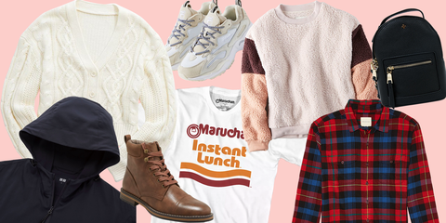
Individual task | - Make a list of all textile products under your care.  - Note down the fibre properties of these products  - Your answers should be posted in the discussion 1.2.2
Interaction begins | Post your notes on the discussion forum 1.2.2.
E-moderator interventions | a) Ensure that learners are focused on the contents and context of discussion and discourage plagiarism and copying.  b) Stimulate further learning and generation of new ideas.  c) Provide feedback on the learning progress
Schedule and time | This task should take two hours
Next | Lesson 2 The Nature of Soiling Matter on Fabrics

1.3 Assessment questions
- Give four reasons as to why it is important to study laundry work?
- State four categories of textile products

1.4 References
- file:///C:/Users/AKN0WH~1/AppData/Local/Temp/train.pdf

Lesson 2 The Nature of Soiling Matter on Fabrics

2.1 Introduction
In this second lesson, we will look at and analyse how soiling mater comes onto fabrics in order to effectively remove it. It is important to know how dirt forms on fabrics and other surfaces so as to decipher the most appropriate methods of the dirt removal from fabrics. The purpose of this lesson is to identify the various sources of soiling matter on fabrics, describe the nature of these soiling matter and the most appropriate methods of their removal.

2.2 Lesson Learning Outcomes
By the end of this lesson, you will be able to:
2.2.1 Identify various sources of soiling matter on fabrics
2.2.2 Describe the nature of dirt on fabrics

2.2.1 Sources of Soiling Matter on Fabrics
The types of soil and the way they form on fabrics can be explained under the following categories:
Dirt- consists of organic substances such as ash, dust from various sources, mud and sand.
Atmospheric Pollution- Most of the dirt comes from smoky fires, from incomplete combustion of oil in heaters and from internal combustion engines, while soot may fall down a chimney which has not been swept for some time.
Ourselves- Personal clothing and bed linen absorbs soiling matter from the body, skin secretes perspiration and oils.
Mildew- This is a destructive fungus which is liable to appear on any type of garment particularly those that contain starch. Storing damp clothes or even dry ones in warm damp places favours the rapid growth of mildew.
Food Stains- These many spoils the appearance of table clothes personal clothing and carpets. Fats, proteins gravies, sauces, fruit juices and beverages all respond best to immediate treatment.
Accidental Soiling- These consist of soiling other than food stains e.g. from paints from walls, tar from roads oil from beaches or machinery, rust, mud, splashes, chemicals, medicines.
Deposits- These may be left on fabrics due to poor washing techniques e.g. lime soap is deposited when articles containing soap are rinsed in hard water.
Old Starch- On collars or tablecloths it should be treated as soiling matter to be removed before re-washing, by steeping and rubbing.
Static Electricity-The lack of attraction for water in textile fibers gives rise to discoloration on white nylon when grease penetrates inside the fibre carrying dirt with it.
E-tivity 2.2.1 Sources of Soiling Matter on Fabrics
Numbering, pacing and sequencing | 2.2.1
Title | Sources of Soiling Matter on Fabrics
Purpose | The purpose of this E-tivity is to enable learners to identify various sources of soiling matter on fabrics
Brief summary of overall task | Use the resources provided and library links to identify various sources of dirt on clothing
Spark | 
Individual task | - Pick up your dirty clothing and examine the dirty places carefully.  - List down sources of dirt on your clothing.  - Your answers should be posted in the discussion 2.2.1
Interaction begins | Post your list on the discussion forum 2.2.1
E-moderator interventions | a) Ensure that learners are focused on the contents and context of discussion and discourage plagiarism and copying.  b) Stimulate further learning and generation of new ideas.  c) Provide feedback on the learning progress
Schedule and time | This task should take two hours
Next | The Nature of Dirt on Fabrics

2.2.2 The Nature of Dirt on Fabrics
Dirt that occurs on fabrics may either be fixed or loose dirt. The fixed dirt is one that has been imbedded on the fibres of fabrics by either water, oil or other substances. It is difficult to remove fixed dirt hence special aids are required to remove them. The fixed dirt must have the grease removed from the fabric first by means of absorption, solution or emulsification. When removing fixed dirt, you should first identify the nature of the dirt in order to successfully remove it without damaging the fabric. You also require special aids or a strong detergent to remove fixed dirt.
Loose dirt is one that is loosely held on the surface of the fabric and hence can be removed easily using plain water or water and the detergent. It may be in the form of dust or loose soils that have settled on a surface for a short time only. The loose dirt can be removed by mechanical methods, such as brushing and shaking or by the action of pedesis in steeping.
E-tivity 2.2.2 The Nature of Dirt on Fabrics
Numbering, pacing and sequencing | 2.2.2
Title | The Nature of Dirt on Fabrics
Purpose | The purpose of this E-tivity is to enable learners to d  escribe the nature of dirt on fabrics
Brief summary of overall task | Use the resources and links provided to describe dirt that occurs on fabrics.
Spark | 
Individual task | - Make your notes on the differences between loose dirt and fixed dirt.  - Your answers should be posted in the discussion 2.2.2
Interaction begins | Post your notes on the discussion forum 2.2.2
E-moderator interventions | a) Ensure that learners are focused on the contents and context of discussion and discourage plagiarism and copying.  b) Stimulate further learning and generation of new ideas.  c) Provide feedback on the learning progress
Schedule and time | This task should take two hours
Next | Lesson 3 Cleaning Materials and Additional Laundry Reagents in Laundry Work

2.3 Assessment questions
- Explain the difference between loose dirt and fixed dirt.
- Why is it important to wash clothes immediately they get soiled?

2.4 References
- file:///C:/Users/AKN0WH~1/AppData/Local/Temp/train.pdf

Lesson 3 Cleaning Materials and Additional Laundry Reagents in Laundry Work

3.1 Introduction
In this lesson, we explore cleaning materials that are used for effective dirt removal from fabrics and various surfaces around our environment. Apart from the various usual cleaning aids, there are also other additional cleaning materials such as stain removers that are of importance to effective laundry work. In this lesson we will learn about the many ordinary cleaning aids available to us and also other additional reagents that may be used for successful laundry work.

3.2 Lesson Learning Outcomes
By the end of this lesson, you will be able to:
3.2.1 Describe different types of cleaning materials used in laundry work
3.2.2 Explain the use of laundry agents other than water, soap and detergents.

3.2.1 Cleaning Materials Used in Laundry Work
The different types of cleaning materials available can be classified under the following categories; Water- Water is the most useful cleaning material. Water may be obtained from various sources such as rain, water supply through taps, streams, rivers, wells, dams and lakes. Good water supply is still not always available even in some large towns yet with improved methods of living the demand for good water has increased.

Tap water is collected by arrangement of the local authorities usually from a lake or river. Water runs in pipes from the water works to homes, schools, offices and factories. Tap water is first stored in reservoir tanks where some of the impurities sink with the aid of sedimentation materials. Then it may be filtered through fine sand so that particles of dirt and some bacteria are removed. Sometimes water is chlorinated by adding some amount of chemical material to kill harmful bacteria. This makes water safe to drink. The water is carried to high reservoirs near to the town and from these into pipes to houses.

Cleaning Action of Water
There is a certain adhesion between fabrics and water. Thus the water is able to penetrate the fibres and cause wetting.
- The particles of non-grease dirt are oscillated away from the fabric into the water.
- Thus a fabric will be partially cleaned by steeping and friction. It is agreed that “wetting out” of soiled fabrics will dissolve water soluble matter release dirt particles to some extent, but in the absence of a suspending agent, such as soap, the particles are likely to aggregate whether the water is soft or hard.
- Water is an excellent solvent therefore much soluble dirt and stain will be removed during the steeping process.
- Cold water is the best solvent for aluminous matter hot water will tend to melt and soften grease but other cleansing agents are necessary to emulsify and remove greasy matter.
Soap
The chief purpose of soap in laundry is to make a lather which loosens dirt from clothes and is then easily washed out. This is done by lowering the surface tension in the water and emulsifying the grease. The chief ingredients are fat or oils and an alkali usually caustic soda.
Detergents
The dictionary defines “detergent” as a cleaning agent and as something which aids the removal of dirt. It is therefore right a call any cleansing agent a detergent.
In fact water itself is a detergent. Soap is a detergent but the term has come to generally be used in reference to liquid and soapless cleaners.
General cleansing action of detergents may be explained as follows:
- The detergent on dissolving lowers the surface tension of the water.
- This allows more intimate contact between the water and the fabric to be cleaned and enables the solution to penetrate the fabric and the particles of dirt.
- The solution emulsifies any grease or oil present

E-tivity 3.2.1 Cleaning Materials Used in Laundry Work
Numbering, pacing and sequencing | 3.2.1
Title | Cleaning Materials Used in Laundry Work
Purpose | The purpose of this E-tivity is to enable learners to3.2.1 describe different types of cleaning materials used in laundry work
Brief summary of overall task | Use the resources and library links provided to describe as many cleaning materials for laundry work as you can get.
Spark | 
Individual task | - Make a list of all laundry materials in your home.  - Visit the nearest supermarket and make a list of all cleaning materials you can see on the laundry section of the shop.  - Your answers should be posted in the discussion 3.2.1
Interaction begins | Post your lists on the discussion forum 3.2.1
E-moderator interventions | a) Ensure that learners are focused on the contents and context of discussion and discourage plagiarism and copying.  b) Stimulate further learning and generation of new ideas.  c) Provide feedback on the learning progress
Schedule and time | This task should take two hours
Next

3.2.2 Additional Laundry Reagents in Laundry Work
There are substances besides water and detergents that play an important role in producing a satisfactory result to laundry work. These are substances such as:
Stiffening Agents
These provide a smooth finish and a dirt resisting surface as well as giving body to the fabric. Examples are ordinary starch, and plastic starch.
Laundry Blues- these include blue which comes in form of a cube and may be used in the last rinse for bleached cotton and linen fabrics. However with careful washing and outdoor drying little blueing is necessary. Blue is the complementary colour to yellow to produce whiteness. A blue agent absorbs some of the light so that less yellow is reflected and the fabric looks whiter. (In fact less light is reflected from a blued fabric so that it becomes less bright.) Ultra marine blue is the type generally used and it is manufactured from soda ash, sodium sulphate, charcoal, sulphuric and clay.
Optical Whiteners
These are fluorescent powders which are now available in detergents. They normally adhere to fibres of fabrics and in the presence of ultra-violent light and reflect bluish light from the surface. This has the effect of counteracting yellowness and brightening the whiteness. Since there is no chemical action, the fabrics are not weakened and the powders are not removed in rinsing. Many washing powders incorporate this type of powder, to whiten white fabrics and to brighten colours.
Whitening Agents
These are also sold as powders for use in washing white nylon in order to counteract the graying that this fabric develops during wear. This powder is based on optical brightness and is recommended to be used only occasionally.
E-tivity 3.2.2 Additional Laundry Reagents in Laundry Work
Numbering, pacing and sequencing | 3.2.2
Title | Additional Laundry Reagents in Laundry Work
Purpose | The purpose of this E-tivity is to enable learners to3.2.2 explain the use of other laundry agents other than water, soap and detergents.
Brief summary of overall task | Use the resources and library links provided to explain laundry aids other than water, soap and detergents.
Spark | 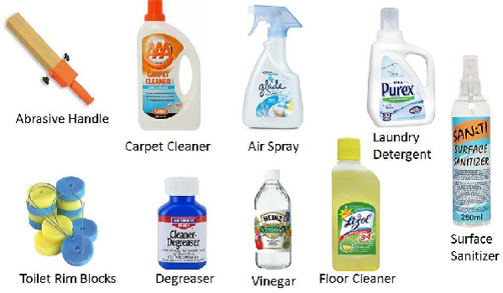
Individual task | - Visit a supermarket near you and make a list of the various cleaning aid displayed. Read the instruction manuals and make your own notes.  - Your answers should be posted in the discussion 3.2.2
Interaction begins | Post your notes on the discussion forum 3.2.2
E-moderator interventions | a) Ensure that learners are focused on the contents and context of discussion and discourage plagiarism and copying.  b) Stimulate further learning and generation of new ideas.  c) Provide feedback on the learning progress
Schedule and time | This task should take two hours
Next | Lesson 4 Equipment and Apparatus for Laundry work

3.3 Assessment questions
- Giving reasons, explain the three most important cleaning aids in laundry work.
- Why is warm water better for laundry of very dirty clothes?

3.4 References
- file:///C:/Users/AKN0WH~1/AppData/Local/Temp/146251733025et.pdf

Lesson 4 Equipment and Apparatus for Laundry work

4.1 Introduction
In this fourth lesson, we will introduce you to equipment and apparatus for laundry work. Equipment are considered to be the larger gadgets such as washing machines and driers while the apparatus are the smaller tools such as bowl, basins, pegs and soap dishes, etc. There are various equipment and apparatus at our disposal and appropriate choice of these is important in order to be successful in the laundry process. The purpose of this lesson is to enable you make informed decision of the correct choice of the laundry equipment and apparatus.

4.2 Lesson Learning Outcomes
By the end of this lesson, you will be able to:
4.2.1 Identify different categories of laundry work equipment
4.2.2 Appropriately use available laundry work equipment

4.2.1 Different Categories of Laundry Work Equipment
Laundry equipment may be discussed under the following categories:
Storage
Linen Cupboards
A special cupboard is the ideal place for storing clean household linen. It should have ample shelf accommodation, so that the linen can be arranged in several piles. Soiled linen should be stored for short periods only before washing.
Linen Baskets and Bins
Baskets preferably with a washable cotton lining, and metal, wood, or plastic bins are suitable for storing soiled household linen.
Linen Bag
These are only suitable for small amounts of soiled personal garments and are usually kept in the bedroom.
A small store cupboard should be kept for laundry stores, jars or bottles of reagents should be labelled and anything poisonous should have a red “poison” label attached and should be kept out of reach of children.
Steeping
Portable or fixed washing machine; for large articles.
Sink or small bowls; of enamel or plastic for small quantities of clothes.
Household bucket: It is most important not to steep clothes in any metal bowl unless its rust-proof coating is intact.
Plastic bowls are quite common and they can be bought in several colours. They are light in weight, strong and easy to clean. They must be handled with care, since rigid plastic may crack if dropped and intensive heat will melt plastic. Plastic of the very flexible type is not recommended for the transport of heavy contents.
Washing
The type of washing apparatus required by the household depends upon the amount of washing undertaken. The principle of cleaning need to been applied with certain modification to different fibres and these modifications apply mainly to water temperature amount of agitation and method of water extraction. There must be suitable and adequate apparatus if all washing is to be done at home.
Sinks- These should be of such a height that the worker can stand with her back straight when working. They should not be too deep as this necessitates waste of water. For worker of average height the top rim of the sink should be 36” from the ground. A wooden rack can be used to correct the height of the sink for short people. There should be adequate draining board space to each sink so that damp clothes can be put down near the worker. The sink should be supplied with hot and cold water and have an overflow pipe. A “mixer” tap or hose pipe enables water of correct temperature to be obtained more easily. Sinks should have a smooth surface that will be easy to clean.
Enamel Bowls- These are useful for small amounts of washing. They need to be handled carefully so that the enamel is not chipped and the metal under it exposed. When this happens the metal may rust. They should be kept dry when not in use and any dripped places coated with white enamel paint.
Plastic Bowls- Plastic bowls obtainable in household sizes. They have a smooth surface and are resistant to grease and dirt. They are not harmed by hot water or any cleaning agents. They should not be placed over a hot surface.
Laundry Brush-This is a kind of soft bristled brush or rubber brush for friction washing of clothes. It is very useful. Laundry brushes are cheap and durable. Rinse well with clean hot water after use and hang on a wall hook to dry.
Rubbing Boards-These are useful when large articles have to be washed in a sink or small bath. They are made of congregated wood or zinc. They have to be washed with clean hot water after use and kept dry when not in use.
Drying Equipment
These include out-door drying equipment such as clothes cord /Line, clothes prop, rotary clothes driers, clothes pegs and clothes basket for carrying wet and clothes. In door drying equipment include ceiling clothes racks, radial clothes drier and drying cabinets.
Finishing Equipment include irons of various types, iron boards and stands, iron blankets and sheets and sleeve boards.
E-tivity 4.2.1 Different Categories of Laundry Work Equipment
Numbering, pacing and sequencing | 4.2.1
Title | Different Categories of Laundry Work Equipment
Purpose | The purpose of this E-tivity is to enable learners to identify different categories of laundry work equipment
Brief summary of overall task | Use the library links and resources provided to identify categories of laundry work equipment.
Spark | 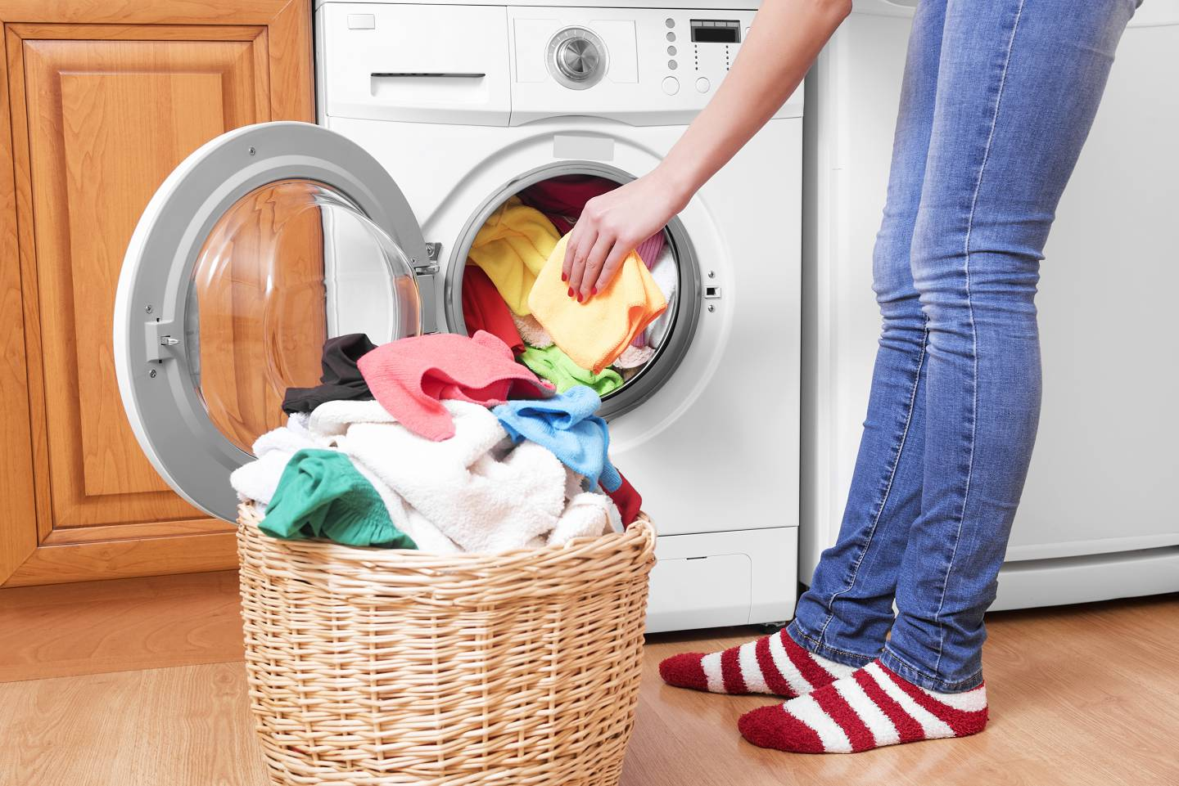
Individual task | - List down all the laundry equipment at your disposal.  - Your list should be posted on the discussion forum 4.2.1
Interaction begins | a) Ensure that learners are focused on the contents and context of discussion and discourage plagiarism and copying.  b) Stimulate further learning and generation of new ideas.  c) Provide feedback on the learning progress
E-moderator interventions | Post your lists on the discussion forum 4.2.1
Schedule and time | This task should take two hours
Next | Appropriate use of available laundry work equipment

4.2.2 Appropriate use of available laundry work equipment
Large Washing Equipment
The large washing equipment includes;
Washing Machines
There are many kinds of washing machines varying in price according to size and type. The electrical driven machines are expensive to install, but they are reliable, efficient and cheap in use. All are made of non-rusting metal and their cleaning action depends on a winged metal agitation on a pulsator which moves the clothes through soapy water.
Choice and use of a Washing Machine
The machine must be suitable in size and cleaning action for the work it is expected to do. The initial cost and the running cost must be studied. The energy requirement of hand operated washer must be compared with their work out put. It must be possible to move the machine easily so that it can be near the sink, or placed over a floor drain as required or be moved into a cupboard for storage. An overhead water supply of both hot and cold water should be available, and where this is not possible a hose attached to the tap over the sink can be substituted. A washing machine should have some type of wringing apparatus; either a wringer or spin extractor. The top rim of a washing machine should be 36” from the ground. This means that the worker will have no unnecessary bending in filling the machine with clothes or employing it.
Use of a Washing Machine
The user should be well acquitted with the construction and mechanization of the machine. Directions for the use of a particular type of machine must be followed with regard to weight or quantity of load and method of filling to the water line before use. Use a machine at full capacity so that the maximum is obtained for mining costs. The washer in all top loading machines must have permanent lather before clothes are put in for washing.
General directions for use of semi-automatic washing machines
- Agitate the water for 1 minute to make certain that the lather is permanent.
- There should be a permanent lather throughout the whole washing process.
- Bleached cottons and linens should be agitated in a washing machine for varying lengths of time according to the speed of the cleaning mechanism of the washer.
- The time may vary from 5-15 min
- Woolen should be agitated for 1 minute, allowed to rest for 1 minute then agitated again for I minute.
- Colored fabrics should be agitated for 2-5 min, according to dirtiness.
- The temperature of the water is regulated according to the fabric.
- Clean the machine after use with hot water dry thoroughly.Cover while not in use

E-tivity 4.2.2 Appropriate use of available laundry work equipment
Numbering, pacing and sequencing | 4.2.2
Title | Appropriate use of available laundry work equipment
Purpose | The purpose of this E-tivity is to enable learners to appropriately use available laundry work equipment
Brief summary of overall task | Use the library links and the resources provided to explain how various washing equipment are used.
Spark | 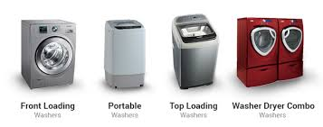
Individual task | - Make notes on how to use a semi-automatic washing machine.  - Your notes should be posted on the discussion forum 4.2.2
Interaction begins | Post your notes on the discussion forum 4.2.2
E-moderator interventions | a) Ensure that learners are focused on the contents and context of discussion and discourage plagiarism and copying.  b) Stimulate further learning and generation of new ideas.  c) Provide feedback on the learning progress
Schedule and time | This task should take two hours
Next | Lesson 5 Washing Procedures and Processes in Laundry Work

4.3 Assessment questions
- State four types of apparatus that you require for outdoor drying of clothes.
- State the type of improvised apparatus that you require for storage of dirty clothes.

4.4 References
- file:///C:/Users/AKN0WH~1/AppData/Local/Temp/146251733025et.pdf

Lesson 5 Washing Procedures and Processes in Laundry Work

5.1 Introduction
In this lesson we will focus on the washing procedures and processes in laundry work. Procedures are step by step guided on the washing of clothes while the process is the treatment given to individual pieces of each article. In order to be successful in laundry work, the correct procedures and processes are key. Dirty clothes need to be properly sorted out and each item of clothing carefully treated according to the fabric type, soiling matter and cleaning aids. The purpose of this lesson is to enable you outline the procedures and processes of washing clothes in laundry work.

5.2 Lesson Learning Outcomes
By the end of this lesson, you will be able to:
5.2.1 Appropriately sort out and prepare clothes for washing
5.2.2 Wash clothes correctly according to the type of fabric

5.2.1 Sort Out and Prepare Clothes for Washing
Washing of clothes is a tedious process, hence in order to make it easier, it is important to follow the correct procedure, which entails the following steps; sorting, preparation of the clothes and steeping.
Sorting is the separation of clothes into groups according to the kind of treatment they will require during washing e.g. white cottons and linens, colour fast cottons and linens, overalls, jeans, children rompers, white and paste /shade , woolen mixtures, and articles requiring gentle handling or hand washing e.g. fine silk articles, woolen jerseys, pleated garments.
Preparation of the clothes for washing also involves checking for;
- Stains and treat them separately,
- Tears – draw or mend properly,
- Pins—remove them because they are dangerous and can cause iron mould, empty pockets and pull up al zip fasteners
Steeping is unnecessary when using a full or semi-automatic washing machine. If using any other type or if doing the work by hand it is advisable to steep the strong fabrics. Rub soap on to dirty paints such as collars and cuffs. Steep handkerchief in salty water and launder separately

E-tivity 5.2.1 Sort Out and Prepare Clothes for Washing
Numbering, pacing and sequencing | 5.2.1
Title | Sort Out and Prepare Clothes for Washing
Purpose | The purpose of this E-tivity is to enable learners to a  appropriately sort out and prepare clothes for washing
Brief summary of overall task | Use the resources and library links provided to enable you sort and prepare clothes for washing. Practice to do the same at home.
Spark | 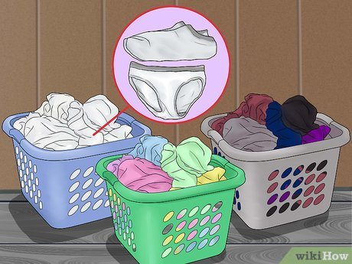
Individual task | - Sort your dirty clothes and those of your family. Make notes on the procedure and the categories of clothes that you have sorted.  - Your notes should be posted on the discussion forum 5.2.1
Interaction begins | Post your notes on the discussion forum 4.2.1
E-moderator interventions | a) Ensure that learners are focused on the contents and context of discussion and discourage plagiarism and copying.  b) Stimulate further learning and generation of new ideas.  c) Provide feedback on the learning progress
Schedule and time | This task should take two hours
Next | Correctly Wash Clothes according to the Type of Fabric

5.2.2 Correctly Wash Clothes according To the Type of Fabric
There are different principles of of washing clothes which are applied according to the type of fabric being washes. For example;
Friction washing
This method is suitable for very soiled articles made of unbleached or bleached cotton and linen. It can be carried out in any of the following ways:
- Hand Friction- This is suitable for small articles that are lightly soiled. Hot water and well dried soap is required or hot water in which a strong detergent has been dissolved. Wring the article out of the steeping water. Place in the hot water and saturate it. Squeeze out a part of the article, holding the material between the hands, rub one part of the soaped or lathery material on another soaped or lathery part. Rinse soiled lather into the washing water. Squeeze out another part of the article, and repeat the process. Continue until the entire article is cleaned. Rinse out lather with hot water.
- Friction by the use of laundry brush -This method is suitable for small article of any strong fabric that are very soiled. Hot water, well dried soap or strong detergent and a soft bristled brush are required. Wring the article from steeping water. Saturate with the hot washing water and wring out. Spread on a flat surface. If using soap, rub over with the wetted cake of soap. Scrub the material in one direction, causing permanent lather in the fabric as it is scrubbed. Work over the whole article in this way. Rinse the soiled lather into the washing water
Kneading and squeezing washing
This is the most useful method of washing by hand. It does not damage any of the textile fibres nor to the texture, weave or colour of any fabric. It is very suitable for fabrics to which hand friction in any of its forms cannot be applied i.e. wool silk, rayon, coloured fabrics of any fibre and all synthetic. No special apparatus is needed, hence no outlay to the housewife. It can be carried out in washing bowl or basin. The cleaning agent is soap solution or soap flakes or soapless detergent, and water of the correct temperature for the fabric being treated.
Application
Prepare water of the correct temperature for the fabric being treated knead and squeeze the soiled fabric in warm lathered water; the passage of this water through the fabric cleans it. Use as much lathered water as required to clean. Very soiled parts should be placed flat on the palm of the left hand and have additional lather patted through them, or have the additional lather very thoroughly squeezed through the use of thumbs and the first fingers. Rinse thoroughly according to fabric.
Washing Using Large- Scale Apparatus
Suitable apparatus must be employed for cleaning large quantities of clothes. Such apparatus may be hand operated or electrically driven. The selection of such apparatus depends upon many factors such as:
- initial outlay (cost)
- Running costs
- Availability of water, gas, electricity.
- Amount of washing to be done and frequency with which the apparatus will be used.
- The type of washing to be done. A machine with a cleaning action suitable for all fabric is the type required for the household.
- Space in which the apparatus has to be used and stored.
- Cleaning Action- The cleaning action of all large –scale washing apparatus depends upon the movement of soiled fabric in soapy water so that the soiled matter is transferred into the water.
Different types of apparatus are used to bring about this movement of fabric. The principle involves;
1. Tumbler or rotary washer; - In this a perforated metal drum carrying the clothes rotates inside a metal cylinder carrying the soapy water. The outer cylinder is half-filled with the soapy water; the perforated drum revolves making the clothes rise and fall through the water.
2. Central agitator washer- This is a very general type of washer for household use.
The agitator is fixed to the lid of the washer in hand operated models and to the base of the washer in electrically driven models. All models are fitted with either a wringer or a spin extractor; they are of household size and fit into very little space. The cleaning action is suitable for all fabrics and the machines are sufficiently large to take any household article.
3. Pulsator type washer- for this model, a metal or bakelite pulsator is fixed into the base of the washing compartment. This pulsator is rotated by a small motor fixed under the machine the pulsator moves the clothes and the water and so effects cleaning.
Other laundry processes include;
- Rinsing- This is done in warm water to remove the hot washing water. Rinse several times in cold water to keep the fabrics clean.
- Blueing- Use this in the last rinse for white fabrics.
- Starching- Some cottons and linen fabrics are starched to give a glossy surface that will not soil easily. The materials are often improved in appearance by stiffening with starch. Blue can be added to the starch for all white fabric then the separate bluing process can be omitted.
- Wringing- Fold the articles evenly wring well so that moisture is removed and they will dry quickly. This is especially absorbent fabrics. Drip dry (especially man-made) fabrics do not require wringing.
- Drying- After clothes have been washed rinsed blued and starched as necessary much of the moisture is extracted by squeezing in the hands or by mechanical means. Care should be exercised in dealing with delicate fabrics. Delicate articles should never be twisted on their own. They should be folded neatly lengthwise in a towel held in both hands while the wrist gives a slight twist. Woolen should be rolled in a towel and kneaded slightly. Wringing helps reduce the length of time in which articles are subject to sunlight since it hates drying. Drying can be done outdoors or indoors as the weather permits, although it is desirable to dry clothes outdoors as far as possible.
Finishing
The appearance of washed fabric is judged by the finish given to it. The method of finishing depends on the nature of the fabric.

E-tivity 5.2.2 Correctly Wash Clothes according To the Type of Fabric
Numbering, pacing and sequencing | 5.2.2
Title | Correctly Wash Clothes according To the Type of Fabric
Purpose | The purpose of this E-tivity is to enable learners to wash clothes correctly according to the type of fabric
Brief summary of overall task | Use the library links and resources provided to enable you wash clothes correctly.
Spark | 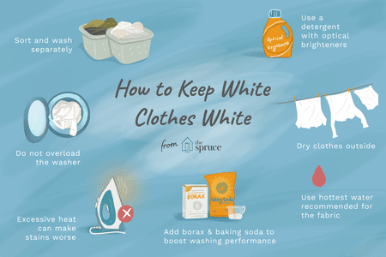
Individual task | - Wash the dirty clothes according the procedure outlined in your module notes.  - Make observations on the procedure and take your notes as you wash.  - Your notes should be posted on the discussion forum 5.2.2
Interaction begins | Post your notes on the discussion forum 5.2.2
E-moderator interventions | a) Ensure that learners are focused on the contents and context of discussion and discourage plagiarism and copying.  b) Stimulate further learning and generation of new ideas.  c) Provide feedback on the learning progress
Schedule and time | This task should take two hours
Next | Lesson 6 Removal of Stains

5.3 Assessment questions
- Give reasons why it is important to sort clothes in laundry work
- Explain the three common principles of washing machines

5.4 References
- file:///C:/Users/AKN0WH~1/AppData/Local/Temp/146251733025et.pdf

Lesson 6 Removal of Stains

6.1 Introduction
In this lesson, you will learn about stain removal in laundry work. Stains are stubborn dirt marks on clothing that are not likely to come off in the usual laundry process and hence require special aids and processes in their effective removal. It is important to establish the nature of stain and how it was formed before embarking on the removal. It is also vital to choose appropriate removal aids for specific stains and types of fabric in order to protect the article from harm by the stain removal aids. The lesson will focus on the types and forms of stains on fabrics and effective methods of their removal.

6.2 Lesson Learning Outcomes
By the end of this lesson, you will be able to:
6.2.1 Identify different stains as they form on fabrics
6.2.2 Remove different stains from fabrics using appropriate removal agents

6.2.1 Types of Stains
Most dirt can be removed from fabrics by usual cleaning methods. Some discolouration may be present which does not yield readily to these methods and requires special treatment according to its nature. Such discolouration is termed as a stain. A stain is a patch of colours different from the rest of the surface. It can be divided into four main groups, namely;
- Vegetable Stains- These are stains resulting from food such as fruits beverages, grass, and berries.
- Animal Stains- These stains generally contain albumen which is hardened or fixed by heat, e.g. blood, egg, urine, etc.
- Grease Stains- These can be either of vegetable animal or mineral origin, e.g. palm oil, ground nut oil, cod liver oil, lard, and motor oil.
- Mineral Stains- These are of ink, paint and enamel, medicine, iron rust, coal, tar, shoe polish etc. It is easier to remove stains when they are fresh than after they are dried, and fixed removed stains as quickly as possible.
Types of Stains
Stains come onto clothes in three forms;
- Absorbent stains-These are caused by liquid which penetrate the garment easily such as tea, coffee, beer or medicines
- Built up stains-these tend to stay on the surface and do not flow into the fibres of the garment as do absorbed stains.
- Compound stains- these are stains which are absorbed into the fabric and also leave a residue on the surface as do built up stains. E.g. blood and certain food stains.
E-tivity 6.2.1 Types of Stains
Numbering, pacing and sequencing | 6.2.1
Title | Types of Stains
Purpose | The purpose of this E-tivity is to enable learners to identify different stains as they form on fabrics
Brief summary of overall task | Use the library links and resources provided to identify various forms of stains on your clothes and those of your family members.
Spark | 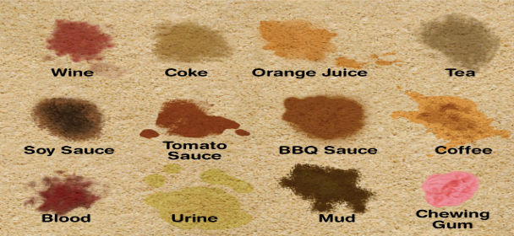
Individual task | - Observe your dirty clothes and note any form of staining on them. Record your observations.  - Your notes should be posted on the discussion forum 6.2.1
Interaction begins | Post your notes on the discussion forum 6.2.1
E-moderator interventions | a) Ensure that learners are focused on the contents and context of discussion and discourage plagiarism and copying.  b) Stimulate further learning and generation of new ideas.  c) Provide feedback on the learning progress
Schedule and time | This task should take two hours
Next | Removing Stains from Fabrics

6.2.2 Removing Stains from Fabrics
General Information Regarding Removal of Stains
All stains are mostly removed when fresh. Unknown stains should be treated by the least harmful method first e.g. cold water steep, hot or boiling water steep according to the fabric steeping for a short time in a detergent solution is often effective on tea and fruit stains. This can be followed by a mild finally by bleach. Known stains should be treated by their specific reagents.
Several applications of a weak reagent are less harmful to fabric than one application of a strong reagent. Bleaches should be used carefully and only after other methods have been tried. Reagent may be spread on the white cottons, linen fabrics and boiling water may be poured through the fabric. Reagents must be made into a solution when used on coloured cotton and linen, wool, silk, rayon and synthetic fabrics. The fabric should stay in the reagent until the stain is removed. It should be taken out t once and washed to prevent any possibility of reagent drying into the fabric and damage it. An acid stain removal agent should be naturalized by an alkaline rinse.

General Precautions on Stain Removal

The first rule is to act quickly. If you leave a stain to dry out and set in the fabric it will be much more difficult to remove. Do not rub stain into the fabric. Blot off what you can, using a clean cloth. If you cannot do anything to the stain immediately do not forget it, because some stains can damage fabrics or dyes by being left in. Always start with mild treatment and work to the stronger ones. If you are not sure whether the garment or dye can withstand a particular chemical try it out first in some inconspicuous part e.g. on the edge of an inside seam.
E-tivity 6.2.2 Removing Stains from Fabrics
Numbering, pacing and sequencing | 6.2.2
Title | Remove Different Stains from Fabrics
Purpose | The purpose of this E-tivity is to enable learners to remove different stains from fabrics using appropriate removal agents.
Brief summary of overall task | Use the library links and the resources provided to guide you in removing stains from fabrics.
Spark | 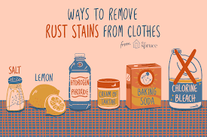
Individual task | - Remove any form of stains from your dirty clothes using the appropriate removal aids guidelines provided in this module.  - Note and record your observations on the process.  - Your notes should be posted on the discussion forum 6.2.2
Interaction begins | Post your notes on the discussion forum 6.2.2
E-moderator interventions | a) Ensure that learners are focused on the contents and context of discussion and discourage plagiarism and copying.  b) Stimulate further learning and generation of new ideas.  c) Provide feedback on the learning progress
Schedule and time | This task should take two hours
Next | Lesson 7 Home Dry Cleaning, Spotting, Sponging and Pressing

6.3 Assessment questions
- Explain the four types of stains.
- Why is it important to remove stains immediately they occur on clothes and surfaces?

6.4 References
- file:///C:/Users/AKN0WH~1/AppData/Local/Temp/train.pdf
- file:///C:/Users/AKN0WH~1/AppData/Local/Temp/146251733025et.pdf

Lesson 7 Home Dry Cleaning, Spotting, Sponging and Pressing

7.1 Introduction
In this lesson, we will explore home dry cleaning, spotting, sponging and pressing. These are processes used to refurbish dirty clothes quickly for re-use without necessarily washing the entire article, e.g. suits, trousers or skirts. The purpose of this lesson is to enable you to understand methods of quickly restoring clothes for re-use without washing the whole garment and saving on time and resources.

7.2 Lesson Learning Outcomes
By the end of this lesson, you will be able to:
7.2.1 Identify different methods and agents of dry cleaning
7.2.2 Explain the process of home dry cleaning
7.2.1 Methods and Agents of Dry Cleaning
Dry cleaning is cleaning done without getting the fabric wet. Fabrics that will shrink or loose shape in washing should be dry cleaned. This treatment is suitable for skirts, blazers or suits made of wool, velvet and other delicate fabrics and fabric constructions.
Spotting
Spots should be removed as soon as they are noticed. If left to fix they are more difficult to remove. Spots may be divided into;
Non-grease spots- These can be removed by sponging with warm water or a suitable sponging solution. For dark coloured fabrics use 1tbs of vinegar to one pint of water. For light coloured fabrics use 1tbs salt or ammonia to one pint of water. Place the spot over a folded towel on pad. Use cotton wool to sponge it and absorb the moisture with a dry towel or cloth. Dry and press with a cool iron
Grease spots-If thick scrape off with a blunt object. Place the spot over blotting paper and press with a warm iron on the wrong side. Grease that has spread into the fabric must be absorbed with a powder or grease solvent. Spread a thick layer of French chalk, fuller’s earth, powdered starch or bran on the spot. Rub lightly leave for half an hour and brush off. Dirty grease marks have to be spotted off with warm soapy water. If a solvent is used, work near, an open window to avoid inhaling the fumes.

Sponging and Pressing
Much can be done to fabrics that cannot be washed. A small hand vacuum cleaner is useful for thick garments and furs. Brushing, sponging the surface with warm water and allowing to dry and then pressing will revive garments of good fabric that look shabby. A sponge will hold moisture for the sponging e.g. flannel or small sponge and will only damp the surface of the fabric. Press when dry, on the wrong side, or under a thick cloth where, right side pressing must be done.
E-tivity 7.2.1 Methods and Agents of Dry Cleaning
Numbering, pacing and sequencing | 7.2.1
Title | Methods and Agents of Dry Cleaning
Purpose | The purpose of this E-tivity is to enable learners to identify different methods and agents of dry cleaning
Brief summary of overall task | Use the library links and resources provided to identify different methods and agents of dry cleaning.
Spark | 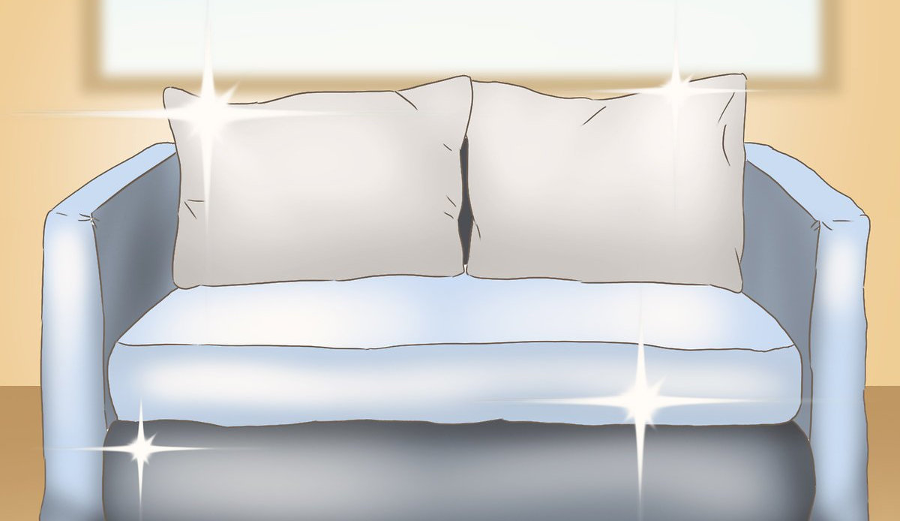
Individual task | - Write down the agents of dry cleaning that you may have come across in your reading of this lesson.  - Distinguish the different methods of dry cleaning  - Your notes should be posted on the discussion forum 7.2.1
Interaction begins | Post your notes on the discussion forum 7.2.1
E-moderator interventions | a) Ensure that learners are focused on the contents and context of discussion and discourage plagiarism and copying.  b) Stimulate further learning and generation of new ideas.  c) Provide feedback on the learning progress
Schedule and time | This task should take two hours
Next

7.2.2 Home Dry Cleaning
Since commercial dry cleaning is too expensive for many people some of the following cleaning methods can be tried at home:
Surface rubbing
Leather gloves, belts and felt hats can be cleansed by special rubber cleaners. These can be bought in the form of e.g. a sheet of this rubber with a rough surface which picks up dirt as the sheet is passed over a soiled article. They are useful for cleaning coloured leather. They are useful for cleaning coloured leather. They are rubbed evenly over the surface of the material and. They remove surface dirt only. The sheet have to be washed in cool soapy water when dirty and then dried
Powder cleaning
This done by use of absorbing agents such as French chalk. It can be used for cleaning whit fabrics, white felt and white fur. It is useful for the surface cleaning of dresses made from fabrics with a white background. The method requires that you rub the french chalk into the fabric, leave for several hours shake and brush out. Other powders can be used in the same way e.g bleached fuller’s earth and powdered magnesia. Bran is useful for cleaning dark furs teddy bean cloth and camel hair cloth. To clean heat the bran in an old pan stirring to prevent it burning or in a tin is an oven rub in to material leave for ½ hours, shake and brush out.
Immersion
Garments can be put completely into liquids that will dissolve grease. The liquids are such as grease solvents. This is the most satisfactory way to clean garments that cannot be washed and yet are soiled by greasy dirt. Carbon tetra chloride and benzene are suitable grease solvents for immersion cleaning.
The Process of Dry Cleaning
All solvents used are also grease solvents.The act by dissolving the grease in dirt and this loosens the dirt particles. Commercial dry cleaning is carried out in special machinery similar to washing machines. These machines consist of rotating drums. The clothes are out into the drums containing the solvent. The clothes are moved about in the solvent by slow rotation of the drum. After a suitable period of time, the excess solvent is removed by fast spinning of the drum.
The clothes are then rinsed in a second of clean solvent which is also drained away. The remaining solvent is evaporated by tumbling the clothes in a stream of warm air. Not all the dirt in the clothes is grease dirt. Some is water soluble which can be removed by sorting before or after dry cleaning. This involves spraying such dirt with water to loosen it. Other treatments are then applied to give body to the fabric. This involves passing the fabric through a solvent which contains dissolved resin.
E-tivity 7.2.2 Home Dry Cleaning
Numbering, pacing and sequencing | 7.2.2
Title | Home Dry Cleaning
Purpose | The purpose of this E-tivity is to enable learners to explain the process of home dry cleaning
Brief summary of overall task | Use the resources and library links provided to help you to explain the process of home dry cleaning.
Spark | 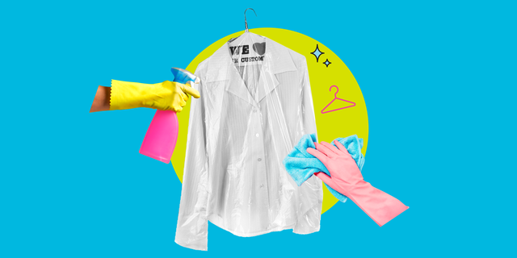
Individual task | - Write down the step by step procedure for home dry cleaning.  - Your notes should be posted on discussion forum 7.2.2
Interaction begins | Post your notes on the discussion forum 7.2.2
E-moderator interventions | a) Ensure that learners are focused on the contents and context of discussion and discourage plagiarism and copying.  b) Stimulate further learning and generation of new ideas.  c) Provide feedback on the learning progress
Schedule and time | This task should take two hours
Next | Lesson 8 Ironing and Finishing Processes

7.3 Assessment questions
- State three advantages of dry cleaning.
- Give two disadvantages of dry cleaning.

7.4 References
- file:///C:/Users/AKN0WH~1/AppData/Local/Temp/train.pdf

Lesson 8 Ironing and Finishing Processes

8.1 Introduction
Welcome to lesson eight. So far you have learnt how to identify dirt, cleaning aids and materials and the actual washing of clothes including stain removal. This lesson focuses on ironing and finishing processes which is almost the last step in laundry work before storage of clothes. After laundering clothing products, they need to be ironed and finished appropriately before storage in order to maintain their appearance as long as possible. There are various methods of finishing clothing after laundering them such as ironing, pressing and folding. The purpose of this lesson is to equip you with various ways of ironing and finishing clothes in laundry work.

8.2 Lesson Learning Outcomes
By the end of this lesson, you will be able to:
8.2.1 Identify different conditions and methods of finishing clothes in laundry work
8.2.2 Iron and finish different clothes according to the type of fabric

8.2.1 Conditions and Methods of Finishing Clothes in Laundry Work
The objective in washing and finishing fabrics is to make them clean and restore their original appearance. The finishing can be done in various ways, but there is often one particular method that is most satisfactory for every fabric. Nearly all materials should be evenly damp for ironing. When they are in this condition they should be folded and rolled tightly to keep in the moisture. If they cannot be ironed at once, they should be allowed to dry completely and then dampened later.
Conditions for finishing
The following conditions should be met before finishing clothes in laundry work.
- Cleanliness
The fabrics should be absolutely clean before finishing. Never begin the finishing if any article or garment that is not completely clean.
- Stiffening
Fabrics that require stiffening should be stiffened before ironing.

- Moisture
There should be some moisture in the fabric before finishing and the amount of moisture varies widely depending on the type of fabric. No fabric is finished wet, many finish best when evenly damp, others almost dry and some when quit dry. It saves time if the correct condition is known especially for man-made fabrics.

E-tivity 8.2.1 Conditions and Methods of Finishing Clothes in Laundry Work
Numbering, pacing and sequencing | 8.2.1
Title | Conditions and Methods of Finishing Clothes in Laundry Work
Purpose | The purpose of this E-tivity is to enable learners to identify different conditions and methods of finishing clothes in laundry work
Brief summary of overall task | Use the resources and library links provided to identify various conditions and methods of finishing clothes in laundry work.
Spark | 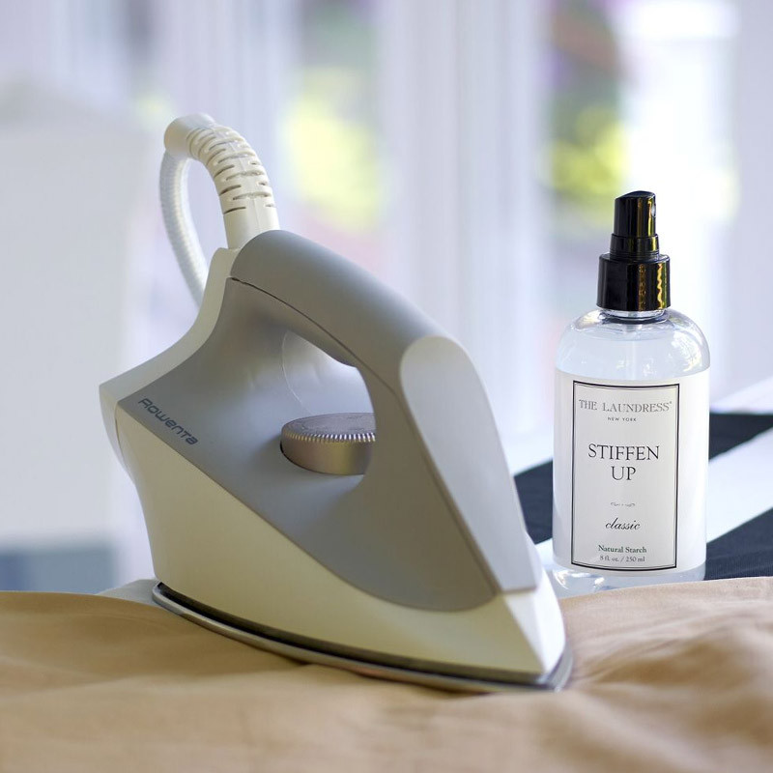
Individual task | - List down the conditions of finishing clothes in laundry work.  - Note down various methods of finishing clothes.  - Your notes should be posted on discussion forum 8.2.1
Interaction begins | Post your notes on the discussion forum 8.2.1
E-moderator interventions | a) Ensure that learners are focused on the contents and context of discussion and discourage plagiarism and copying.  b) Stimulate further learning and generation of new ideas.  c) Provide feedback on the learning progress
Schedule and time | This task should take two hours
Next | Ironing and Finishing Different Clothes

8.2.2 Ironing and Finishing Different Clothes
Finishing fabrics with even dampness
This is the general condition for finishing of woven fabrics. When starched cotton and linens will finish more easily if they are allowed to dry completely then are dampened and rolled up tightly for half an hour before being finished. Damping can be done by hand. Cold or warm water spreads more quickly. It is most important that articles should be damp and not wet. The following methods are suggested for damping large articles;
- A bottle of water fitted with a sprinkler top.
- A laundry brush dipped into water and brushed quickly over the surface.
- Small articles e.g. handkerchief can be damped quickly by wetting some completely and folding dry and wet one alternately against each other. After damping stretch the damped material into shape. Fold straight, put plain articles through a wringer, and then fold up tightly to assist dampness to spread.
Finishing fabrics almost dry
This is the condition for all types of knitted fabrics where a very good finished appearance is required. It is also the condition for finishing flannel, woven mixtures of cotton and wool, and flannelette. Take articles down when in this condition and finish at once. If some parts are too dry at others too damp fold one against the other and roll up tightly for some time before finishing.
Finishing fabrics dry
This condition is for knitted fabrics that are satisfactory with a quicker finish than n almost dry state. Knitted wool shantung silk and some kinds of rayon, nylon and Terylene are finished dry. Stretch into shape to rid of creases while still damp and allow to dry straight. This makes the finish easier.
Finishing Crease Resistant Fabrics
These should be taken from the last rinse water and hang to drip dry. They should straight until quite dry. Iron on the right or wrong side, according to colour and surface finish using a moderately hot iron if necessary.
Finishing By Ironing
This is the most general method of finishing fabrics as it restores their natural surface finish. Fabrics are ironed evenly damp, almost dry, or dry according to their type.
Pressing
This is a quicker method of finishing than ironing and it is suitable for many fabrics. Place the fabric in position place the iron on top, press lift and replace on the next part of the garment. The iron is not moved over the surface of the fabric as in ironing.

Steam Pressing
This is done to fabrics that require moisture weight and heat to straighten the yarns as in the case will all thick woolen fabrics. The most moisture is supplied by a piece of damp cotton cloth stretched over the dry fabric on the wrong side. The iron is placed and replaced on top of this cloth. A steam iron is most useful for finishing any thick fabrics and all crepe fabrics.

E-Tivity 8.2.2 Ironing and Finishing Different Clothes
Numbering, pacing and sequencing | 8.2.2
Title | Ironing and Finishing Different Clothes
Purpose | The purpose of this E-tivity is to enable learners to Iron and finish different clothes according to the type of fabric
Brief summary of overall task | Use the library links and resources provided to help you iron and finish different clothes.
Spark | 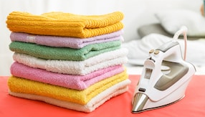
Individual task | - Iron and different washed clothes according to the types of fabric.  - Make brief notes on the procedure you have followed for each article.  - Your notes should be posted on discussion forum 8.2.2.
Interaction begins | Post your notes on discussion forum 8.2.2
E-moderator interventions | a) Ensure that learners are focused on the contents and context of discussion and discourage plagiarism and copying.  b) Stimulate further learning and generation of new ideas.  c) Provide feedback on the learning progress
Schedule and time | This task should take two hours
Next | Lesson 9 Choice and care of laundry work equipment

8.3 Assessment questions
- State three conditions of finishing clothes in laundry work.
- Explain the difference between ironing and pressing

8.4 References
- file:///C:/Users/AKN0WH~1/AppData/Local/Temp/train.pdf

Lesson 9 Choice and Care of Laundry Work Equipment

9.1 Introduction
Congratulations for accomplishing all the important steps in laundry work to completion. In this ninth lesson you will learn how to choose and take care of laundry work equipment. There are many types of laundry work equipment in the market today and proper choice is important in order to give you quality tools worth your worth and useful for your laundry work tasks. The purpose of this lesson is to enable you to make informed choice of laundry work equipment and to be able to use and care for them appropriately

9.2 Lesson Learning Outcomes
By the end of this lesson, you will be able to:
9.2.1 Choose and appropriately use and care of laundry apparatus
9.2.2 Appropriately use and care of large laundry equipment
9.2.1 Choice, Use and Care of Laundry Apparatus
Equipment for laundry work varies greatly. Some people have all the latest models of washing machines spin driers, and ironers while others have only equipment which has been used for generations. Some useful utensils in laundry work are described below.
Clothes Brush
This is for light scrubbing and where washing delicate fabrics. Do not leave in the water and never boil. Rinse thoroughly after use and dry before storing.
Soap Dish
They come in attractive colours and sizes. They are quite light to handle. Do not use abrasives on them and put near fire. Never pour boiling water directly into plastic receptacles containers.
Plastic Pegs
These come in attractive colours and are light in weight and easy to use. Store in clean, dry containers.
Towel
It is essential to keep one towel especially for laundry work. This is used for extracting moisture from delicate fabrics.

E-tivity 9.2.1 Choice, Use and Care of Laundry Apparatus
Numbering, pacing and sequencing | 9.2.1
Title | Choice, Use and Care of Laundry Apparatus
Purpose | The purpose of this E-tivity is to enable learners to choose and appropriately use and care of laundry apparatus
Brief summary of overall task | Use the resources and library links provided to help you choose, use and care for laundry apparatus.
Spark | 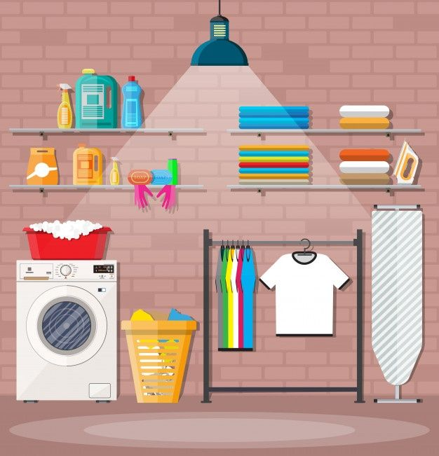
Individual task | - List down all the laundry apparatus in your home.  - Make brief notes on how you routinely take care of each of the laundry apparatus at home.  - Your notes should be posted on discussion forum 9.2.1
Interaction begins | Post your notes on discussion forum 9.2.1
E-moderator interventions | a) Ensure that learners are focused on the contents and context of discussion and discourage plagiarism and copying.  b) Stimulate further learning and generation of new ideas.  c) Provide feedback on the learning progress
Schedule and time | This task should take two hours
Next | Use and Care of Large Laundry Equipment

9.2.2 Use and Care of Large Laundry Equipment
Washing Machines
A washing machine is a labour saving device worth investing in if a lot of washing is done at once and it can be afforded. The quality of service given by a machine depends to a great extent on the care given to it. The maker’s instructions should be followed when using a washing machine. Washing machines can be operated by electricity or gas. There are three main types and they vary in size and price. Take time over your choice to see which machine will suit your particular home conditions.
Agitator Machines
These machines can be found as a single tub with or without a wringer as a twin tub machine or fully automatic. The agitator machine has an agitator usually like a metal dolly, which is flat or raised and attached to the base of the tub. The agitator oscillates at half turns. When the current is switched on the effect of the motion is to drive the soapy water through the clothes in order to clean them. In the case of a machine with wringer power is used through a housing at the side of the machine to operate the winger. The wringer may be used either independently or simultaneously with the washer.

Use of the Machine
Always fill the machine with water to cover the agitation or to the water line for a full load. Add water softener if needed and leave for 15 min. Add enough soap or detergent to produce a good lather. Switch on the machine for 20min and gradually add the clothes when the soap is dissolved. The clothes should be opened out, shaken and dropped in while the agitator is on as this will make it easy to tell when the correct amount of clothes has been added. The water should circulate through the clothes and there must be freedom of movement for this is the only way that clothes are cleaned.
Rinsing
In the sink -Wring in much soapy water out of the garments as possible. Be careful with delicate and man-made fabrics. Rinse thoroughly in clean water until all the suds have been removed i.e. till the water is clear.
In the machine- After washing is finished wring the clothes out to remove as much soapy water as possible. Pump out the soapy water out of the machine. And refill with cold water to the correct level.
Replace the clothes and agitate for a few moments. Allow a few minutes to soak and then wring the clothes out. Repeat if necessary until all the suds have been removed.
Rinsing in the spin drier for twin-tubs
Transfer the clothes pressing them down firmly in the spin-drier. Place the spin can mat properly in position (this it to prevent the clothes rising out of the spin can getting caught on the lid or other parts of the spin drier. Spin the soapy water off cotton linen, viscose and woolen articles returning the water to the wash tub.
Before spinning nylon, terylene, and acrylics, cool the load by pouring in cold water to prevent creasing. Do not return the water to the wash tub this time spin for 15-20 seconds. Run cold water slowly through the clothes for about 30 seconds. Spin off again for about 15-20 seconds. Repeat this procedure until the water runs clear. Give a final spin of 4-5 minutes for cotton, linen, and viscose rayon. Easy care cottons and all other man-mades should have only 15-20 seconds final spin.
Caution
When using a spinner DO NOT TOUCH the spin can or its contents until they have completely stopped spinning because this can be dangerous.

Automatic Washer with Spin Drier
This does not form actions of steeping, washing, rinsing and part drying by automatic control.
The machine has to be fixed to the floor and permanently connected to the house water supply and drainage.
Use of the Machine
Put the clothes in and set the switch to the “soak” position. When the washer is filled with water add soap through the trap in the top of the cabinet. The clothes pass through the various processes in the requisite time without any further attention as the switch turns to the succeeding position automatically. Avoid washing small articles with large heavy ones. If they must be washed tag, put the very tiny ones in a laundry bag before putting in the machine. Do not fill the bag so that soapy water can circulate through the articles. When the last rinsing water has been drawn of the speed of the spinner is grately increased for part-drying of clothes. The small articles are ready for ironing. Dry the other clothes to the required state for finishing.
The Pulsator
This type is not as common as the agitator type but it is quicker in action. It is most suitable for small family washing. The pulsator is on one side of the machine and it revolves when the current is switched on moves through sorter effecting washing.
Use of the Machine
Fill the machine with water to the water line. Add the detergent. Switch the current on for a minute to dissolve the detergent then switch off. Feed the clothes in from one side very carefully avoiding trapping off air and splashing. Cover up the machine and switch on again. The movement of the water caused by the pulsator moves the clothes quickly about in the tub, and this makes cleaning quicker and easier. When clean wring out rinse finish in the usual way. Clean out the machine thoroughly after use.
Care of Machines
Whatever type of machine is used it needs to be serviced at regular intervals. The following are some of the things to be done to keep machines in good condition. The flex and plugs have to be properly maintained and no chances should be taken with electrical appliances. Follow the maker’s instruction for all loading capacity and operation to preserving the life of the machine. Most important is that the machine should be connected to the earth and so a three-pin plug should be used. The non-automatic washer requires more attention than the automatic ones. Remove all the removable parts wash, rinse and dry them after each use replace them and cover with the lid or completely from the hose and store the machine with the open to air.

E-Tivity 9.2.2 Use and Care of Large Laundry Equipment
Numbering, pacing and sequencing | 9.2.2
Title | Use and Care of Large Laundry Equipment
Purpose | The purpose of this E-tivity is to enable learners to appropriately use and care of large laundry equipment
Brief summary of overall task | Use the resources and library links provided to help you use and care of large laundry equipment such as washing machines, driers and ironers.
Spark | 
Individual task | - Write down the considerations that you have to make before purchasing a washing machine.  - Your notes should be posted on discussion forum 9.2.2
Interaction begins | Post your notes on discussion forum 9.2.2
E-moderator interventions | a) Ensure that learners are focused on the contents and context of discussion and discourage plagiarism and copying.  b) Stimulate further learning and generation of new ideas.  c) Provide feedback on the learning progress
Schedule and time | This task should take two hours
Next | Lesson 10 Care labels and their appropriate use

9.3 Assessment questions
- Explain how you should take care of a wooden laundry brush
- Give six considerations that you should make when buying a washing machine

9.4 References
- file:///C:/Users/AKN0WH~1/AppData/Local/Temp/146251733025et.pdf

Lesson 10 Care Labels and their Appropriate Use

10.1 Introduction
In this lesson you will learn about care labels and their appropriate use in laundry work. All ready-made products are affixed a care label that is meant to aid the product user in its care. The care label is meaningless to the product user unless she/he is able to decode the care label information. The purpose of this lesson is to enable you to understand the care label information on ready-made clothing products and to use the information appropriately during the use and care of clothing.

10.2 Lesson Learning Outcomes
By the end of this lesson, you will be able to:
10.2.1 Interpret care labels on clothes correctly
10.2.2 Wash/treat different clothing items using care label information

10.2 Correct Interpretation of Care Labels on Clothes
This is the information on how the garment should be washed, dry cleaned and ironed. The information is necessary throughout the life of the garment; therefore the labels should be sewn onto the garment. There is an international textile care labeling code that became effective in 1974. The code was developed as a result of co-operation of several organizations interested in textile care. They are ASTM (American Society for Testing and Materials) and FTC. The care label symbol system is based on five basic symbols which represent five basic care operations. These are:
A washtub with a water wave for the washing process

A triangle for bleaching

An iron for ironing

A square for drying

A circle for dry cleaning

The international textile care symbols always presented in the same order.

E-tivity 10.2.1 Correct Interpretation of Care Labels on Clothes
Numbering, pacing and sequencing | 10.2.1
Title | Correct Interpretation of Care Labels on Clothes
Purpose | The purpose of this E-tivity is to enable learners to interpret care labels on clothes correctly
Brief summary of overall task | Use the resources and library links provided to help you interpret care labels on clothes.
Spark | 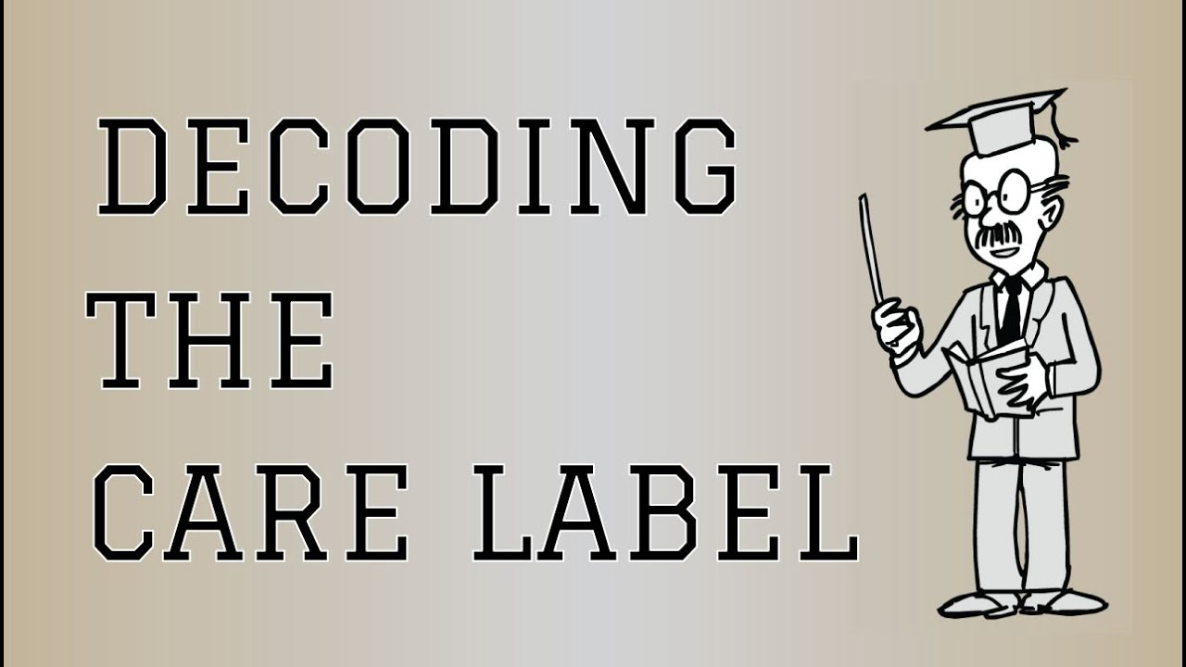
Individual task | - Look at the various ready-made clothes under your care and observe the care labels on them.  - Record all the information on the care label in a table.  - Your table should be posted on discussion forum 10.2.1
Interaction begins | Post your table of care label information on discussion forum 10.2.1
E-moderator interventions | a) Ensure that learners are focused on the contents and context of discussion and discourage plagiarism and copying.  b) Stimulate further learning and generation of new ideas.  c) Provide feedback on the learning progress
Schedule and time | This task should take two hours
Next | Wash/treat different clothing items using care label information

10.2. Washing/treating different clothing items using care label information
Care labels provide helpful information that can save you time and money. Cleaner, fresher clothes means longer-wearing apparel. Clothes that are bleachable are easier to get clean. When a care label doesn’t mention bleach or says "Bleach when needed," it means it is safe to use chlorine based liquid bleach. When the label says "Non-chlorine bleach when needed" use a non-chlorine (color-safe) bleach.

E-tivity 10.2.2 Washing/treating different clothing items using care label information
Numbering, pacing and sequencing | 10.2.2
Title | Washing/treating different clothing items using care label information
Purpose | The purpose of this E-tivity is to enable learners to correctly treat different clothing items using care label information
Brief summary of overall task | Use the library links and resources provided to help you wash and treat various clothes according to the care label information.
Spark | 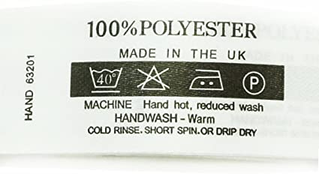
Individual task | - Select any four items of your clothing with care labels. Explain each care label briefly.  - Wash/treat the clothing item according to the care label information and record your obsrvations.  - Your notes should be posted on discussion forum 10.2.2.
Interaction begins | Post your notes on discussion forum 10.2.2
E-moderator interventions | a) Ensure that learners are focused on the contents and context of discussion and discourage plagiarism and copying.  b) Stimulate further learning and generation of new ideas.  c) Provide feedback on the learning progress
Schedule and time | This task should take two hours
Next | EXAMINATIONS

10.3 Assessment questions
- State the 5 basic care labels.
- Give 3 reasons as to why it is important to observe care labels when washing clothes.

10.4 References
- file:///C:/Users/AKN0WH~1/AppData/Local/Temp/train.pdf

Lesson 11&12 EXAMINATION

11.0 ANSWERS TO LESSON ASSESSMENT QUESTIONS
1.3 Answers
- Due to rapid change rapid changes in technology which affect all consumers, there is a need to create awareness for effective use of these technological changes, such as;
- Development of new fabrics with easy care finishes,
- Modern detergents and other cleaning materials,
- Modern equipment such as washing machines, and
- Modern finishing equipment and dry cleaning facilities.
- Categories of textile products include; Accessories, furnishings, household linen, industrial textiles, personal clothing and top or protective garments.
2.3 Answers
- Fixed dirt is one that has been imbedded on the fibres of fabrics by either water, oil or other substances; while loose dirt is one that is in the form of dust or loose soils that have settled on a surface for a short time only and hence can be removed easily using plain water or water and the detergent.
- It is important to wash clothes immediately they get soiled so that dirt does not get fixed on to the fabric thereby becoming more difficult to remove and possible causing damage to fibres.
3.3 Answers
- The three most important cleaning aids are;
- Water- Water is the most useful cleaning material. It dissolve non soluble dirt and causes partial cleaning. It is used in conjunction with other cleaning aids.
- Soap- The chief purpose of soap in laundry is to make a lather which loosens dirt from clothes and is then easily washed out.
- Detergents- referred to as soapless cleaners and useful for dissolving and emulsifying all forms of dirt
- Warm water better for laundry of very dirty clothes because it helps soften the dirt and fibres making it easier to remove.
4.3 Answers
- Types of apparatus required for outdoor drying of clothes include; clothes cord /line, clothes prop (or pulley arrangement for adjusting height of clothes), rotary clothes driers, clothes pegs and clothes basket.
- Improvised apparatus for storage of dirty clothes include empty clean cartons, broken clean basins or buckets, clean empty cooking fat buckets, empty clean paint buckets, halved clean drums.
5.3 Answers
- Reasons for sorting out clothes in laundry work
- To give clothes appropriate care during washing according to the type of fabric and amount of soiling.
- To preserve and maintain colours of clothes.
- To save time, energy and detergents.
- Three common principles of washing machines are:
- Tumbler or rotary washer- common in automatic washing machines.
- Central agitator washer- common in semi-automatic washing machines.
- Pulsator type washer- common in semi-automatic washing machines.
6.3 Answers
- The four types of stains are: vegetable stains, animal stains, grease stains and mineral stains.
- It is important to remove stains immediately they occur on clothes and surfaces so that they don’t get fixed and become impossible to remove or ruin the clothes or surfaces by creating permanent marks.
7.3 Answers
- Three advantages of dry cleaning are;
- Articles especially those made of wool do not shrink.
- Dyes do not run.
- Clothes need little or no ironing and pressing after cleaning.
- Some finishes such as stiffening often removed during washing are not removed by dry cleaning.
- Two disadvantages of dry cleaning are;
- Dry cleaning is expensive
- Clothes may pick up dirt and stains from dry cleaning fluid.
- There are risks of fire and suffocation during dry cleaning because the liquids used are flammable and toxic.
8.3 Answers
- Three conditions of finishing clothes in laundry work are;
- Cleanliness- the fabrics should be absolutely clean before finishing.
- Stiffening- fabrics that require stiffening should be stiffened before ironing.
- Moisture- there should be some moisture in the fabric before finishing.
- The difference between ironing and pressing is that: in ironing is the most general method of finishing fabrics where a hot iron is moved to and fro on the garment to remove creases; while in pressing the iron is placed on the garment, pressed and lifted and then replaced on the next part of the garment. The iron is not moved over the surface of the fabric as in ironing.
9.3 Answers
- A wooden laundry brush should be washed and rinsed after every use and dried on its side so as not to destroy the bristles and not to rot the wood.
- Six considerations that you should make when buying a washing machine are;
- Size-the machine must be suitable in size and cleaning action for the work it is expected to do.
- The initial cost and the running cost must be studied.
- The energy requirement and the availability of electricity.
- Mobility of the machine- tt must be possible to move the machine easily so that it can be near the sink, or placed over a floor drain as required or be moved into a cupboard for storage.
- Water supply of both hot and cold water should be available, and where this is not possible a hose attached to the tap over the sink can be substituted.
- A washing machine should have some type of wringing apparatus; either a wringer or spin extractor.
- The top rim of a washing machine should be 36” from the ground. This means that the worker will have no unnecessary bending in filling the machine with clothes or employing it.
10.3 Answers
- The 5 basic care labels are; the washing, bleaching, ironing, drying and dry cleaning symbols.
- It is important to observe care labels when washing clothes so as to give clothes appropriate care and maintain their lifespan.

