Project Database Foundations
Assignment Documentation: Bank

Name: Emmanouela Zapanti
Faculty No: 23221030
Email: emmaz102005@gmail.com
Contents
- The assignment
- Stages of development and Screenshots
  - Models (Oracle Data Modeler)
  - Sample Data
  - SQL Developer – DDL,DML
  - Results of the queries and PL/SQL implementation

The assignment
------------------------------------------------------------------
Design and implement a Bank database to store the following information:
- Customer – name, personal ID(EGN), address, phone
- Employee – name, position, phone
- Account – number, customer, currency, interest rate, balance
- Transaction – type, customer, employee, account, amount

Rules:
- Each customer can have multiple accounts.
- Each customer can perform different types of transactions.

The database must be normalized and allow:
- Data entry and updates
- Search accounts by customer account, number, EGN
- Reports on:
    - Customers with >=2 accounts in different currency.
    - Largest incoming transactions by employee.
    - Top 10 customers by average daily balance.
    - Accounts with no transactions in the last 90 days.
    - Number of outgoing transactions per account and customer.
Documentation should include:
- Data models (Oracle Data Modeler) – week 4
- Sample Data
- SQL commands – DDL, DML – week 6
- Query results – week 7
- PL/SQL procedures, triggers, cursors – week 12

Stages of Development
------------------------------------------------------------------

  - Models(Oracle Data Modeler)
The purpose of this stage is to create the base for the structure of the Database. Here we organize the data and normalize the database We name each table and its columns to which we assign a proper type. Then we make the connections.
The relational model looks like this:
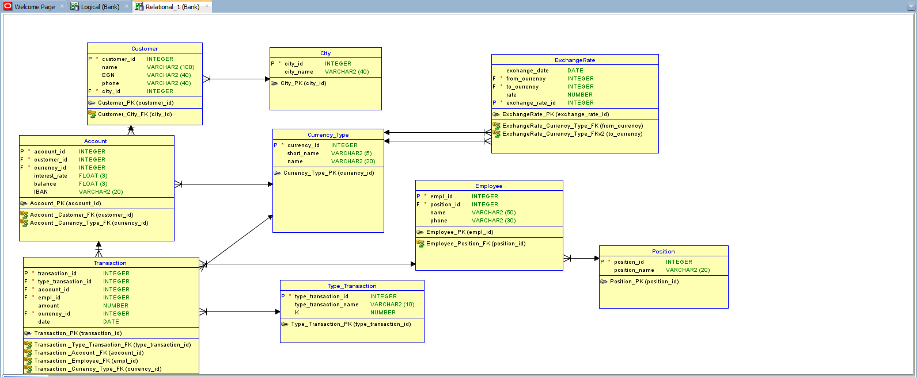

The logical model looks like this:
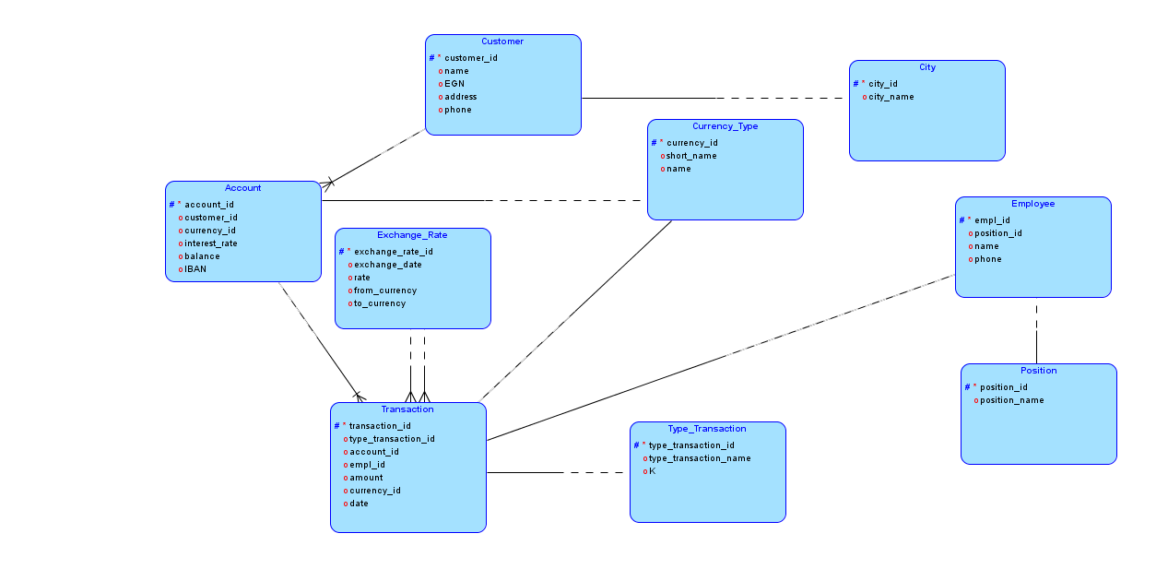

  - Sample Data
The data used for the Bank Project Database are the following:

-For the Account table
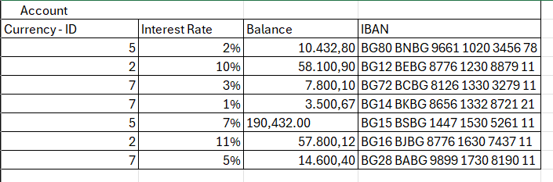

-For the City table
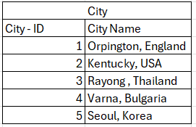

-For the Customer table
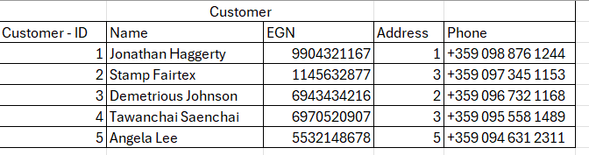

-For the CurrencyType table
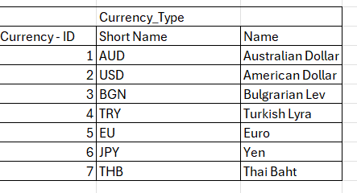

-For the Employee table
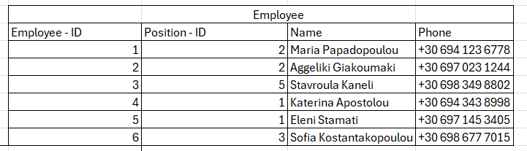

-For the Position table
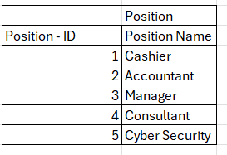

-For the Transaction table
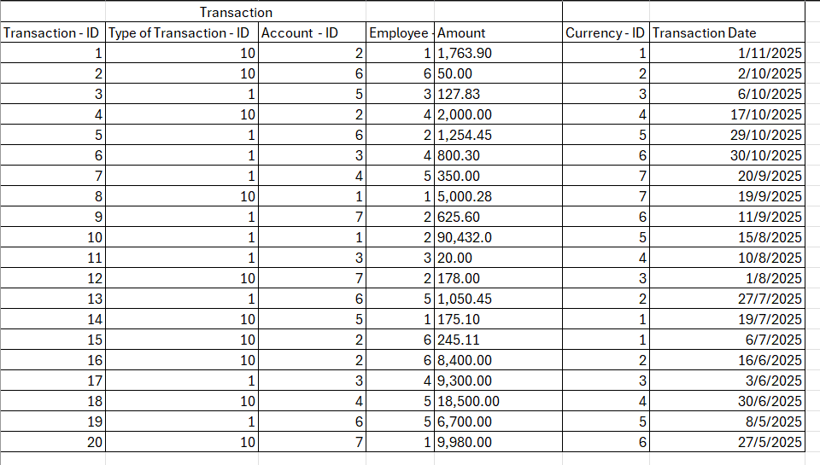
-For the TypeTransaction table
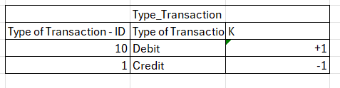
-For the ExchangeRate table
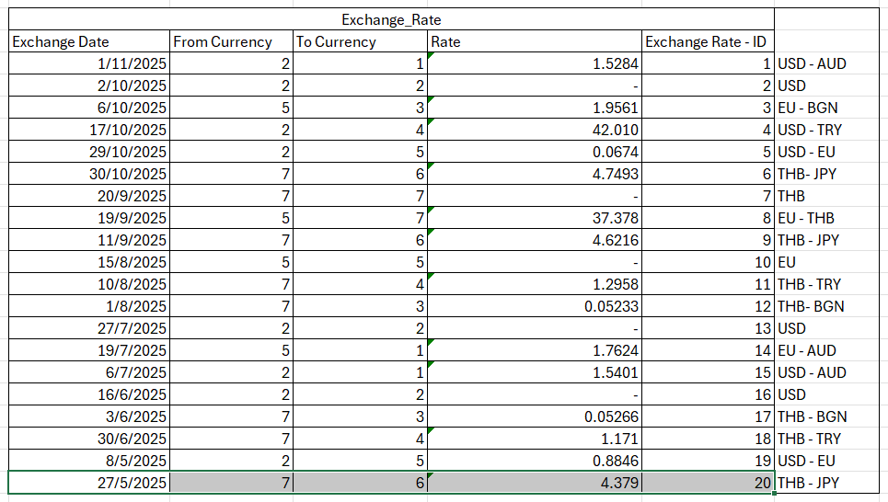

  - SQL Developer – DDL,DML
In this stage we created the sql script and ran it in the active Database. This script written in SQL creates the tables that we formed in the Relational Model. Basically, we convert the form of the tables and their connections to code. This is the DDL, DML SQL part. Then we fill these tables with the actual data, the rows. That’s the DML part of the assignment. On the final step using SQL commands we manipulate the data, entering, deleting, editing. And using commands like ‘select’ , ‘group by’ and more we print the data we want in each situation.

Here we create the tables Customer, City, BankAccount, CurrencyType, Employee, BankTransaction, BankPosition, TypeTransaction and ExchangeRate. Their columns and primary keys.
/*Create Tables with Primary Keys*/

create table Customer(
customer_id integer not null,
customer_name varchar2(100),
EGN varchar2(40),
phone varchar2(40),
city_id integer
);

alter table Customer add constraint Customer_PK primary key(customer_id);

create table City(
city_id integer not null,
city_name varchar2(40)
);

alter table City add constraint City_PK primary key(city_id);

create table BankAccount(
account_id integer not null,
customer_id integer,
currency_id integer,
interest_rate float(3),
balance float(3),
IBAN varchar2(20)
);

alter table BankAccount add constraint BankAccount_PK primary key(account_id);

create table CurrencyType(
currency_id integer not null,
short_name varchar2(5),
long_name varchar2(20)
);

alter table CurrencyType add constraint CurrencyType_PK primary key(currency_id);

create table Employee(
employee_id integer not null,
position_id integer,
employee_name varchar2(50),
phone varchar2(30)
);

alter table Employee add constraint Employee_PK primary key(employee_id);

create table BankTransaction(
transaction_id integer not null,
type_transaction_id integer,
account_id integer,
employee_id integer ,
amount number ,
currency_id integer,
transaction_date date
);

alter table BankTransaction add constraint BankTransaction_PK primary key(transaction_id);

create table BankPosition(
position_id integer not null,
position_name varchar2(20)
);

alter table BankPosition add constraint BankPosition_PK primary key(position_id);

create table TypeTransaction(
type_transaction_id integer not null,
type_transaction_name varchar2(10),
K number
);

alter table TypeTransaction add constraint TypeTransaction_PK primary key(type_transaction_id);

create table ExchangeRate(
exchange_date date,
from_currency int,
to_currency int,
rate number,
exchange_rate_id integer not null
);

alter table ExchangeRate add constraint ExchangeRate_PK primary key(exchange_rate_id);

Here we create the Foreign Keys:

/*Connections - Foreign Keys*/
alter table Customer add constraint Customer_FK foreign key (city_id) references City(city_id);
alter table BankAccount add constraint BankAccountCustomer_FK foreign key (customer_id) references Customer(customer_id);
alter table BankAccount add constraint BankAccountCurrency_FK foreign key (currency_id) references CurrencyType(currency_id);
alter table Employee add constraint Employee_FK foreign key (position_id) references BankPosition(position_id);
alter table BankTransaction add constraint BankTransactionType_FK foreign key (type_transaction_id) references TypeTransaction(type_transaction_id);
alter table BankTransaction add constraint BankTransactionAcount_FK foreign key (account_id) references BankAccount(account_id);
alter table BankTransaction add constraint BankTransactionEmployee_FK foreign key (employee_id) references Employee(employee_id);
alter table ExchangeRate add constraint ExchangeRateFrom_FK foreign key (from_currency) references CurrencyType(currency_id);
alter table ExchangeRate add constraint ExchangeRateTo_FK foreign key (to_currency) references CurrencyType(currency_id);
alter table BankTransaction add constraint BankTransactionCurrency_FK foreign key (currency_id) references CurrencyType(currency_id);

Data Insertion:

insert into Customer (customer_id, customer_name, EGN, phone, city_id) values (1, 'Jonathan Haggerty', '9904321167', '+359 098 876 1244', 1);
insert into Customer (customer_id, customer_name, EGN, phone, city_id) values (2, 'Stamp Fairtex', '1145632877', '+359 097 345 1153', 3);
insert into Customer (customer_id, customer_name, EGN, phone, city_id) values (3, 'Demetrious Johnson', '6943434216', '+359 096 732 116',2);
insert into Customer (customer_id, customer_name, EGN, phone, city_id) values (4,'Tawanchai Saenchai', '6970520907', '+359 095 558 1489', 3);
insert into Customer (customer_id, customer_name, EGN, phone, city_id) values (5, 'Angela Lee','532148678', '+359 094 631 2311',5);

insert into CurrencyType(currency_id, short_name, long_name) values (1, 'AUD', 'Australian Dollar');
insert into CurrencyType(currency_id, short_name, long_name) values (2, 'USD', 'American Dollar');
insert into CurrencyType(currency_id, short_name, long_name) values (3, 'BGN', 'Bulgarian Lev');
insert into CurrencyType(currency_id, short_name, long_name) values (4, 'TRY', 'Turkish Lyra');
insert into CurrencyType(currency_id, short_name, long_name) values (5, 'EU', 'Euro');
insert into CurrencyType(currency_id, short_name, long_name) values (6, 'JPY', 'Japanese Yen');
insert into CurrencyType(currency_id, short_name, long_name) values (7, 'THB', 'Thai Baht');

insert into BankAccount(account_id, customer_id, currency_id, interest_rate, balance , IBAN) values (1, 1, 5, 2/100, 10432.80, 'BG80 BNBG 9661 1020');
insert into BankAccount(account_id, customer_id, currency_id, interest_rate, balance , IBAN) values (2, 5, 2, 10/100, 58100.90, 'BG12 BEBG 8776 1230');
insert into BankAccount(account_id, customer_id, currency_id, interest_rate, balance , IBAN) values (3, 2, 7, 3/100, 7800.10, 'BG72 BCBG 8126 1330');
insert into BankAccount(account_id, customer_id, currency_id, interest_rate, balance , IBAN) values (4, 4, 7, 1/100, 3500.67, 'BG14 BKBG 8656 1332');
insert into BankAccount(account_id, customer_id, currency_id, interest_rate, balance , IBAN) values (5, 1, 5, 7/100, 190432.0, 'BG15 BSBG 1447 1530');
insert into BankAccount(account_id, customer_id, currency_id, interest_rate, balance , IBAN) values (6, 3, 2, 11/100, 57800.12, 'BG16 BJBG 8776 1630');
insert into BankAccount(account_id, customer_id, currency_id, interest_rate, balance , IBAN) values (7, 4, 7, 5/100, 14600.40, 'BG28 BABG 9899 1730');

insert into Employee(employee_id, position_id, employee_name, phone) values (1, 2, 'Maria Papadopoulou', '+30 694 123 6778');
insert into Employee(employee_id, position_id, employee_name, phone) values (2, 2, 'Aggeliki Giakoumaki', '+30 697 023 1244');
insert into Employee(employee_id, position_id, employee_name, phone) values (3, 5, 'Stavroula Kaneli', '+30 698 349 8802');
insert into Employee(employee_id, position_id, employee_name, phone) values (4, 1, 'Apostolou', '+30 694 343 8998');
insert into Employee(employee_id, position_id, employee_name, phone) values (5, 1, 'Eleni Stamati', '+30 697 145 3405');
insert into Employee(employee_id, position_id, employee_name, phone) values (6, 3, 'Sofia Konstantopoulou', '+30 698 677 7015');

insert into TypeTransaction(type_transaction_id, type_transaction_name, K) values(10, 'Debit', +1);
insert into TypeTransaction(type_transaction_id, type_transaction_name, K) values(1, 'Credit', -1);

insert into City(city_id, city_name) values (1, 'Orpington, England');
insert into City(city_id, city_name) values (2, 'Kentucky, USA');
insert into City(city_id, city_name) values (3, 'Rayong, Thailand');
insert into City(city_id, city_name) values (4, 'Varna, Bulgaria');
insert into City(city_id, city_name) values (5, 'Seoul, Korea');

insert into BankPosition(position_id, position_name) values (1, 'Cashier');
insert into BankPosition(position_id, position_name) values (2, 'Accountant');
insert into BankPosition(position_id, position_name) values (3, 'Manager');
insert into BankPosition(position_id, position_name) values (4, 'Consultant');
insert into BankPosition(position_id, position_name) values (5, 'Cyber Security');

insert into BankTransaction(transaction_id, type_transaction_id, account_id, employee_id, amount, currency_id, transaction_date) values(1, 10, 2, 1, 1763.90,1,'01/11/25');
insert into BankTransaction(transaction_id, type_transaction_id, account_id, employee_id, amount, currency_id, transaction_date) values(2,10, 6, 6, 50.0,2,'02/10/25');
insert into BankTransaction(transaction_id, type_transaction_id, account_id, employee_id, amount, currency_id, transaction_date) values(3, 1, 5, 3, 127.83,3,'06/10/25');
insert into BankTransaction(transaction_id, type_transaction_id, account_id, employee_id, amount, currency_id, transaction_date) values(4, 10, 2, 4, 2000.0,4,'17/10/25');
insert into BankTransaction(transaction_id, type_transaction_id, account_id, employee_id, amount, currency_id, transaction_date) values(5, 1, 6, 2, 1254.45,5,'29/10/25');
insert into BankTransaction(transaction_id, type_transaction_id, account_id, employee_id, amount, currency_id, transaction_date) values(6, 1, 3, 4, 800.30,6,'30/10/25');
insert into BankTransaction(transaction_id, type_transaction_id, account_id, employee_id, amount, currency_id, transaction_date) values(7, 1, 4, 5, 350.0,7,'20/09/25');
insert into BankTransaction(transaction_id, type_transaction_id, account_id, employee_id, amount, currency_id, transaction_date) values(8, 10, 1, 1, 5000.28,7,'19/09/25');
insert into BankTransaction(transaction_id, type_transaction_id, account_id, employee_id, amount, currency_id, transaction_date) values(9, 1, 7, 2, 625.6,6,'11/09/25');
insert into BankTransaction(transaction_id, type_transaction_id, account_id, employee_id, amount, currency_id, transaction_date) values(10, 1, 1, 2, 90432.0,5,'15/08/25');
insert into BankTransaction(transaction_id, type_transaction_id, account_id, employee_id, amount, currency_id, transaction_date) values(11, 1, 3, 3, 20.0,2,'10/08/25');
insert into BankTransaction(transaction_id, type_transaction_id, account_id, employee_id, amount, currency_id, transaction_date) values(12, 10, 7, 2, 178.0,3,'01/08/25');
insert into BankTransaction(transaction_id, type_transaction_id, account_id, employee_id, amount, currency_id, transaction_date) values(13, 1, 6, 5, 1050.45,2,'27/07/25');
insert into BankTransaction(transaction_id, type_transaction_id, account_id, employee_id, amount, currency_id, transaction_date) values(14, 10, 5, 1, 175.1,1,'19/07/25');
insert into BankTransaction(transaction_id, type_transaction_id, account_id, employee_id, amount, currency_id, transaction_date) values(15, 10, 2, 6, 245.11,1,'06/07/25');
insert into BankTransaction(transaction_id, type_transaction_id, account_id, employee_id, amount, currency_id, transaction_date) values(16, 10, 2, 6, 8400.0,2,'16/06/25');
insert into BankTransaction(transaction_id, type_transaction_id, account_id, employee_id, amount, currency_id, transaction_date) values(17, 1, 3, 4, 9300.0,3,'03/06/25');
insert into BankTransaction(transaction_id, type_transaction_id, account_id, employee_id, amount, currency_id, transaction_date) values(18, 10, 4, 5, 18500.0,1,'30/06/25');
insert into BankTransaction(transaction_id, type_transaction_id, account_id, employee_id, amount, currency_id, transaction_date) values(19, 1, 6, 5, 6700.0,5,'08/05/2025');
insert into BankTransaction(transaction_id, type_transaction_id, account_id, employee_id, amount, currency_id, transaction_date) values(20, 10, 7, 1, 9980.0,6,'27/05/25');

insert into ExchangeRate (exchange_date, from_currency, to_currency, rate) values('01/11/25',2,1,1.5284);
insert into ExchangeRate (exchange_date, from_currency, to_currency, rate) values('02/10/25',2,2,0);
insert into ExchangeRate (exchange_date, from_currency, to_currency, rate) values('06/10/25',5,3,1.9561);
insert into ExchangeRate (exchange_date, from_currency, to_currency, rate) values('17/10/25',2,4,42.010);
insert into ExchangeRate (exchange_date, from_currency, to_currency, rate) values('29/10/25',2,5,0.0674);
insert into ExchangeRate (exchange_date, from_currency, to_currency, rate) values('30/10/25',7,6,4.7493);
insert into ExchangeRate (exchange_date, from_currency, to_currency, rate) values('20/09/25',7,7,0);
insert into ExchangeRate (exchange_date, from_currency, to_currency, rate) values('19/09/25',5,7,37.378);
insert into ExchangeRate (exchange_date, from_currency, to_currency, rate) values('11/09/25',7,6,4.6216);
insert into ExchangeRate (exchange_date, from_currency, to_currency, rate) values('15/08/25',5,5,0);
insert into ExchangeRate (exchange_date, from_currency, to_currency, rate) values('10/08/25',7,4,1.2958);
insert into ExchangeRate (exchange_date, from_currency, to_currency, rate) values('10/08/25',7,3,0.05233);
insert into ExchangeRate (exchange_date, from_currency, to_currency, rate) values('27/07/25',2,2,0);
insert into ExchangeRate (exchange_date, from_currency, to_currency, rate) values('19/07/25',5,1,1.7624);
insert into ExchangeRate (exchange_date, from_currency, to_currency, rate) values('06/07/25',2,1,1.5401);
insert into ExchangeRate (exchange_date, from_currency, to_currency, rate) values('16/06/25',2,2,0);
insert into ExchangeRate (exchange_date, from_currency, to_currency, rate) values('03/06/25',7,3,0.05266);
insert into ExchangeRate (exchange_date, from_currency, to_currency, rate) values('30/06/25',7,4,1.171);
insert into ExchangeRate (exchange_date, from_currency, to_currency, rate) values('08/05/25',2,5,0.8846);
insert into ExchangeRate (exchange_date, from_currency, to_currency, rate) values('27/05/25',7,6,4.379);

  - Results of the queries

The following are the results of the Queries.
For Searching Accounts by Customer
select customer.customer_name,bankaccount.interest_rate,bankaccount.balance,CurrencyType.short_name,bankaccount.iban
from BankAccount
join Customer on BankAccount.customer_id = Customer.customer_id
join CurrencyType on BankAccount.currency_id = CurrencyType.currency_id
where Customer.customer_name = 'Jonathan Haggerty';
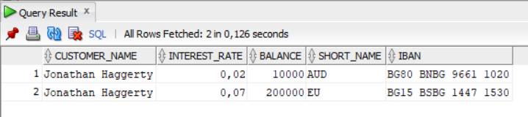

For Searching by Account Number
select customer.customer_name, bankaccount.interest_rate,bankaccount.balance, currencytype.short_name,bankaccount.iban
from BankAccount
join Customer on BankAccount.customer_id = Customer.customer_id
join CurrencyType on BankAccount.currency_id = CurrencyType.currency_id
where iban='BG28 BABG 9899 1730';
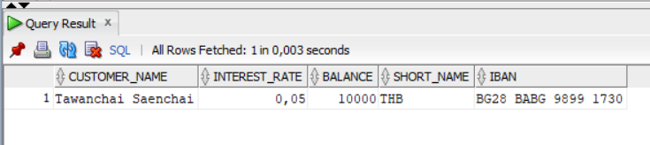

For Searching by EGN
select customer.customer_name,bankaccount.interest_rate,bankaccount.balance,CurrencyType.short_name,bankaccount.iban
from BankAccount
join Customer on BankAccount.customer_id = Customer.customer_id
join CurrencyType on BankAccount.currency_id = CurrencyType.currency_id
where Customer.EGN='9904321167';
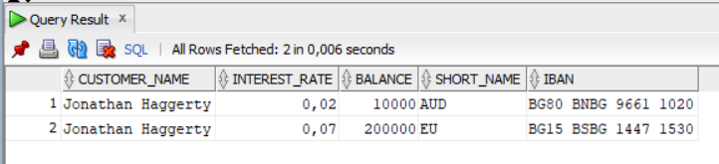

Report on Customer with one or more accounts in different currencies.
select r.total_accounts, r.different_currencies, c.customer_name, c.egn
from (
select BankAccount.customer_id,
count(bankaccount.customer_id)as total_accounts,
count(distinct bankaccount.currency_id) AS different_currencies
from BankAccount
group by BankAccount.customer_id
having count(bankaccount.account_id) >= 2 and count(distinct bankaccount.currency_id) >= 2
order by BankAccount.customer_id) r
join customer c on r.customer_id= c.customer_id
order by customer_name;

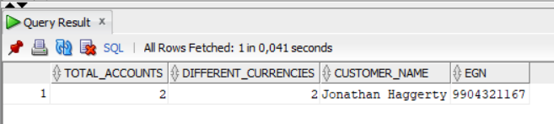

Report on the largest incoming transactions based on Employees.
select employee.employee_id, employee.employee_name,MAX(banktransaction.amount) AS largest_incoming_amount
from Employee
join BankTransaction on employee.employee_id = banktransaction.employee_id
where banktransaction.type_transaction_id = 10
group by employee.employee_id, employee.employee_name
order by largest_incoming_amount desc;

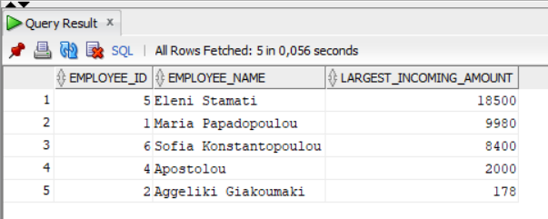

Report on top 10 customers with daily balance.
select r.transaction_date, r.avg_daily_balance,c.customer_name from (
select bt.transaction_date,ba.customer_id, ROUND(AVG(bt.amount), 2) AS avg_daily_balance

from BankTransaction bt join bankaccount ba on bt.account_id=ba.account_id
group by bt.transaction_date ,ba.customer_id order by avg_daily_balance desc
) r
join customer c on r.customer_id=c.customer_id
where rownum<=10
order by c.customer_name,r.transaction_date;

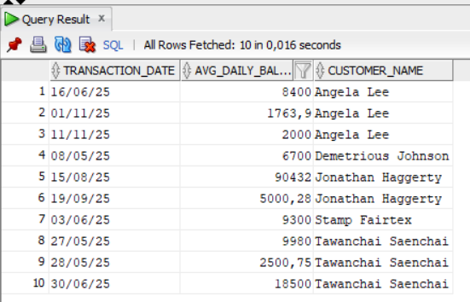

Report on Accounts with no transactions in the last 90 days.
select ba.iban , ba.balance, c.customer_name,cu.short_name from BankAccount ba
join customer c on ba.customer_id = c.customer_id
join currencytype cu on ba.currency_id = cu.currency_id
where ba.account_id
not in
(
select bt.account_id from banktransaction bt where transaction_date < CURRENT_DATE -90
)order by ba.iban;
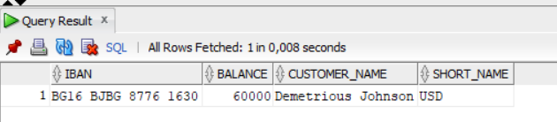

Report on Number of Outgoing Transactions per Account.
select c.customer_name, ba.iban,cu.short_name, r.number_or_transactions
from
(
select bt.account_id, ba.customer_id, count(bt.transaction_id) as number_or_transactions
from banktransaction bt
join typetransaction tr on tr.type_transaction_id = bt.type_transaction_id
join bankaccount ba on bt.account_id = ba.account_id
where tr.K = -1

group by bt.account_id, ba.customer_id

) r
join customer c on r.customer_id=c.customer_id
join bankaccount ba on r.account_id=ba.account_id
join currencytype cu on ba.currency_id = cu.currency_id
order by c.customer_name, ba.iban

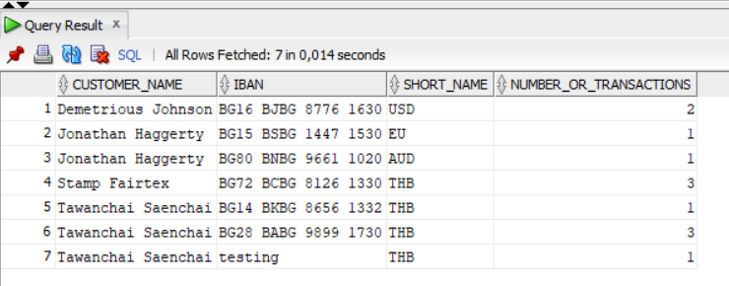

PL/SQL ->procedure call/insert

We begin with a sequence for auto-increment
create sequence Exchange_Seq start with 1 nocache order;

create or replace trigger Tr_Exchange_Rate
before insert on ExchangeRate
for each row
when(new.exchange_rate_id is null)
begin
:new.exchange_rate_id:=Exchange_Seq.nextval;
end;

Next are some examples for Updating the Tables.
update BankAccount set balance=10500 where account_id=1;
update BankAccount set currency_id = 1 where customer_id =1 and account_id =1;
update BankPosition set position_name='Assistant Manager' where position_id=3;
update BankTransaction set employee_id=1 where transaction_id=20;
update BankTransaction set transaction_date='11/11/2025' where transaction_id =4;

Here we create a procedure for each table on our database for Inserting data and Updating, respectively.

--BankPosition
create or replace procedure pos_ins(
v_pos_id BankPosition.position_id%type,
v_pos_name BankPosition.position_name%type
)as
begin
insert into BankPosition(position_id, position_name)
values (v_pos_id,v_pos_name);
end;

begin
pos_ins(6, 'Executive');
end;

create or replace procedure pos_upd(
v_pos_id BankPosition.position_id%type,
v_pos_name BankPosition.position_name%type
)
as
begin
update BankPosition set
position_name=v_pos_name
where position_id=v_pos_id;
end;

begin
pos_upd(6,'test');
end;

--TypeTransaction
create or replace procedure pos_ins2(
v_pos_id TypeTransaction.type_transaction_id%type,
v_pos_name TypeTransaction.type_transaction_name%type,
v_pos_k TypeTransaction.K%type
)as
begin
insert into TypeTransaction(type_transaction_id, type_transaction_name, K)
values (v_pos_id,v_pos_name,v_pos_k);
end;

begin
pos_ins2(20, 'test',0);
end;

create or replace procedure pos_upd2(
v_pos_id TypeTransaction.type_transaction_id%type,
v_pos_name TypeTransaction.type_transaction_name%type,
v_pos_k TypeTransaction.K%type
)
as
begin
update TypeTransaction set
type_transaction_name=v_pos_name,k = v_pos_k
where type_transaction_id=v_pos_id;
end;

--ExchangeRate
create or replace procedure exch_rate_ins(
v_pos_date ExchangeRate.exchange_date%type,
v_pos_from ExchangeRate.from_currency%type,
v_pos_to ExchangeRate.to_currency%type,
v_pos_rate ExchangeRate.rate%type
)as
begin
insert into ExchangeRate(exchange_date, from_currency, to_currency, rate)
values (v_pos_date,v_pos_from,v_pos_to,v_pos_rate);

end;

begin
exch_rate_ins('28/05/25',6,5,4.000);
end;

create or replace procedure exch_rate_upd(
v_pos_from ExchangeRate.from_currency%type,
v_pos_to ExchangeRate.to_currency%type,
v_pos_rate ExchangeRate.rate%type
)
as
begin
update ExchangeRate set
rate=v_pos_rate
where from_currency=v_pos_from and to_currency=v_pos_to;
end;

begin
exch_rate_upd(6,5,0);
end;

--Employee
create or replace procedure empl_ins(
v_empl_id Employee.employee_id%type,
v_empl_pos_id Employee.position_id%type,
v_empl_name Employee.employee_name%type,
v_empl_phone Employee.phone%type
)as
begin
insert into Employee(employee_id, position_id, employee_name, phone)
values (v_empl_id,v_empl_pos_id,v_empl_name,v_empl_phone);
end;

begin
empl_ins(7, 2, 'test', '+30 694 123 6778');
end;

create or replace procedure empl_upd(
v_empl_id Employee.employee_id%type,

v_empl_name Employee.employee_name%type

)
as
begin
update Employee set
employee_name=v_empl_name
where employee_id=v_empl_id;
end;
begin
empl_upd(7,'testing');
end;

--Customer
create or replace procedure cust_ins(
v_cust_id Customer.customer_id%type,
v_cust_name Customer.customer_name%type,
v_cust_egn Customer.EGN%type,
v_cust_phone Customer.phone%type,
v_cust_city Customer.city_id%type
)as
begin
insert into Customer(customer_id, customer_name, EGN, phone, city_id)
values (v_cust_id,v_cust_name,v_cust_egn,v_cust_phone,v_cust_city);
end;

begin
cust_ins(6, 'test', '9904321167', '+359 098 876 1244', 1);
end;

create or replace procedure cust_upd(
v_cust_id Customer.customer_id%type,
v_cust_name Customer.customer_name%type
)
as
begin
update Customer set
customer_name=v_cust_name
where customer_id=v_cust_id;
end;

begin
cust_upd(6,'testing');
end;

--CurrencyType
create or replace procedure curr_ins(
v_curr_id CurrencyType.currency_id%type,
v_curr_sname CurrencyType.short_name%type,
v_curr_lname CurrencyType.long_name%type
)as
begin
insert into CurrencyType(currency_id, short_name, long_name)
values (v_curr_id,v_curr_sname,v_curr_lname);
end;

begin
curr_ins(8, 'TS', 'test');
end;

create or replace procedure curr_upd(
v_curr_id CurrencyType.currency_id%type,

v_curr_lname CurrencyType.long_name%type
)
as
begin
update CurrencyType set
long_name = v_curr_lname
where currency_id=v_curr_id;
end;

begin
curr_upd(8,'testing');
end;

--City
create or replace procedure city_ins(
v_city_id City.city_id%type,
v_city_name City.city_name%type
)as
begin
insert into City(city_id, city_name)
values (v_city_id,v_city_name);
end;

begin
city_ins(6, 'test');
end;

create or replace procedure city_upd(
v_city_id City.city_id%type,
v_city_name City.city_name%type
)
as
begin
update City set
city_name = v_city_name
where city_id=v_city_id;
end;

begin
city_upd(6,'testing');
end;

--BankTransaction
create or replace procedure transaction_ins(
v_tr_id BankTransaction.transaction_id%type,
v_tr_type BankTransaction.type_transaction_id%type,
v_tr_account BankTransaction.account_id%type,
v_tr_employee BankTransaction.employee_id%type,
v_tr_amount BankTransaction.amount%type,
v_tr_currency BankTransaction.currency_id%type,
v_tr_date BankTransaction.transaction_date%type
)as
begin
insert into BankTransaction(transaction_id, type_transaction_id, account_id, employee_id, amount, currency_id, transaction_date)
values (v_tr_id,v_tr_type,v_tr_account,v_tr_employee,v_tr_amount,v_tr_currency,v_tr_date);
end;
begin
transaction_ins(21, 10, 7, 1, 9980.0,6,'30/05/25');
end;

create or replace procedure transaction_upd(
v_tr_id BankTransaction.transaction_id%type,
v_tr_amount BankTransaction.amount%type
)
as
begin
update BankTransaction set
amount = v_tr_amount
where transaction_id=v_tr_id;
end;
begin
transaction_upd(21,0);
end;

--BankAccount
create or replace procedure acc_ins(
v_acc_id BankAccount.account_id%type,
v_acc_customer BankAccount.customer_id%type,
v_acc_currency BankAccount.currency_id%type,
v_acc_rate BankAccount.interest_rate%type,
v_acc_balance BankAccount.balance%type,
v_acc_iban BankAccount.IBAN%type
)as
begin
insert into BankAccount(account_id, customer_id, currency_id, interest_rate, balance , IBAN)
values (v_acc_id, v_acc_customer,v_acc_currency,v_acc_rate,v_acc_balance,v_acc_iban);
end;
begin
acc_ins(8, 4, 7, 5/100, 14600.40, 'test');
end;

insert into BankAccount(account_id, customer_id, currency_id, interest_rate, balance , IBAN) values (7, 4, 7, 5/100, 14600.40, 'BG28 BABG 9899 1730');

create or replace procedure acc_upd(
v_acc_id BankAccount.account_id%type,
v_acc_iban BankAccount.IBAN%type
)
as
begin
update BankAccount set
IBAN = v_acc_iban
where account_id = v_acc_id;
end;
begin
acc_upd(8,'testing');
end;

Specialty Trigger
In this section we create a trigger. Its purpose lies in the case where we want to make a new transaction. If it is incoming then the BankAccount table should be updated with the new amount. If it is outgoing then we have to make sure the balance is not 0, then we update the BankAccount with the new amount.

create or replace trigger before_transaction
before insert on BankTransaction
for each row
declare
koef number;
bal number;
begin
Select K into koef from typeTransaction where type_transaction_id = :new.type_transaction_id;
select balance into bal from BankAccount where account_id = :new.account_id;
if koef <0
then
if :new.amount > bal
then
Raise_application_error(-20103, 'Not enough balance in your bank account.');
END IF;
END IF;
end;

create or replace trigger after_transaction
after insert on BankTransaction
for each row
declare
koef number;
begin
select K into koef from TypeTransaction where type_transaction_id = :NEW.type_transaction_id;
--if (koef=1)
--then
DBMS_OUTPUT.put_line(koef ||' '||:new.amount*koef||' '||:new.account_id);
update BankAccount
set balance = balance + (:new.amount*koef) where account_id=:new.account_id ;
--else
-- update BankAccount
-- set balance = balance - :new.amount where :new.account_id = account_id;
--End if;

end;
The BankAccount table before some transaction.
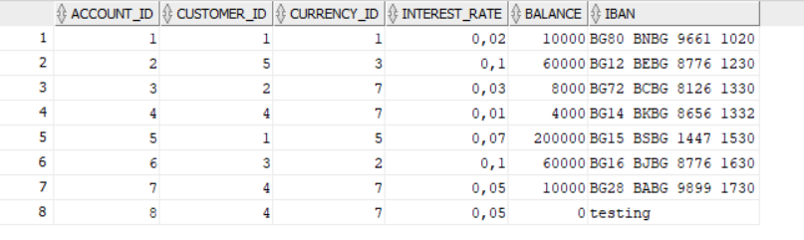

We execute:
insert into BankTransaction(transaction_id, type_transaction_id, account_id, employee_id, amount, currency_id, transaction_date) values(27, 10, 8, 1, 1000,6,’27/05/25’);
The updated BankAccount after the incoming transaction is:
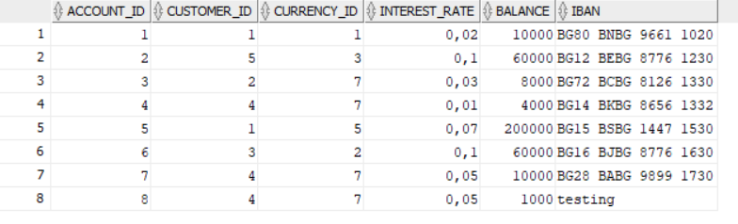

If we try to attempt a credit transaction with insufficient balance:
insert into BankTransaction(transaction_id, type_transaction_id, account_id, employee_id, amount, currency_id, transaction_date) values(28, 1, 8, 1, 2000,6,’27/05/25’);
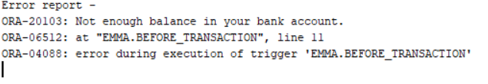

We attempt a debit transaction.
insert into BankTransaction(transaction_id, type_transaction_id, account_id, employee_id, amount, currency_id, transaction_date) values(43, 1, 8, 1, 50,6,'27/05/25');

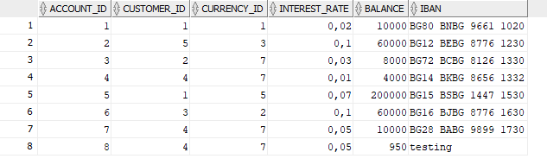

Thank you!

