TechTrade Decision Tree
Benjii Costa | Assignment 9: Decisions & Loops | November 8, 2026

A. Decision Tree
TechTrade uses a decision process to recommend whether a customer should trade in, repair, upgrade, or sell a device. The process evaluates the device selected by the customer and its reported physical condition. It uses three decision nodes, each evaluating a Boolean condition.

Decision Node 1: Warranty Case
Question: Is the selected device a Google Pixel 11 AND is its condition marked Defective?
Yes branch: Recommend Trade-in and direct the customer to contact the seller or manufacturer for warranty assistance. This branch is used because the sample Pixel 11 case represents a recently purchased defective device, and warranty coverage should be checked before paying for a repair.
No branch: Continue to Decision Node 2 because the device does not match the sample warranty-replacement scenario.

Decision Node 2: Repair Candidate
Question: Is the selected device a Samsung Galaxy Book6 Pro AND is its condition marked Broken?
Yes branch: Recommend Repair. The sample laptop is relatively new and the reported trackpad issue may be limited to a component or cable, so obtaining a repair diagnosis is more appropriate than immediately replacing the entire computer.
No branch: Continue to Decision Node 3 because the device does not match the sample repair-candidate scenario.

Decision Node 3: Upgrade Candidate
Question: Is the device a Samsung Galaxy S9 OR is it an iPhone 15 in Poor condition?
Yes branch: Recommend Upgrade. The Galaxy S9 is beyond its software-support period, while the iPhone 15 sample is in poor condition. In these cases, spending heavily on repairs may be less worthwhile than moving to a newer device.
No branch: Use the existing device-specific recommendation stored in the TechTrade sample data. For example, the MacBook Pro 2021 is recommended for Sale because it is in excellent condition, while the Galaxy Watch 7 retains its Upgrade recommendation.

B. Flowchart
The flowchart uses diamonds for decision nodes, rounded rectangles for terminal outcomes, and labeled arrows for Yes/No branches, following the conventions in the assignment.
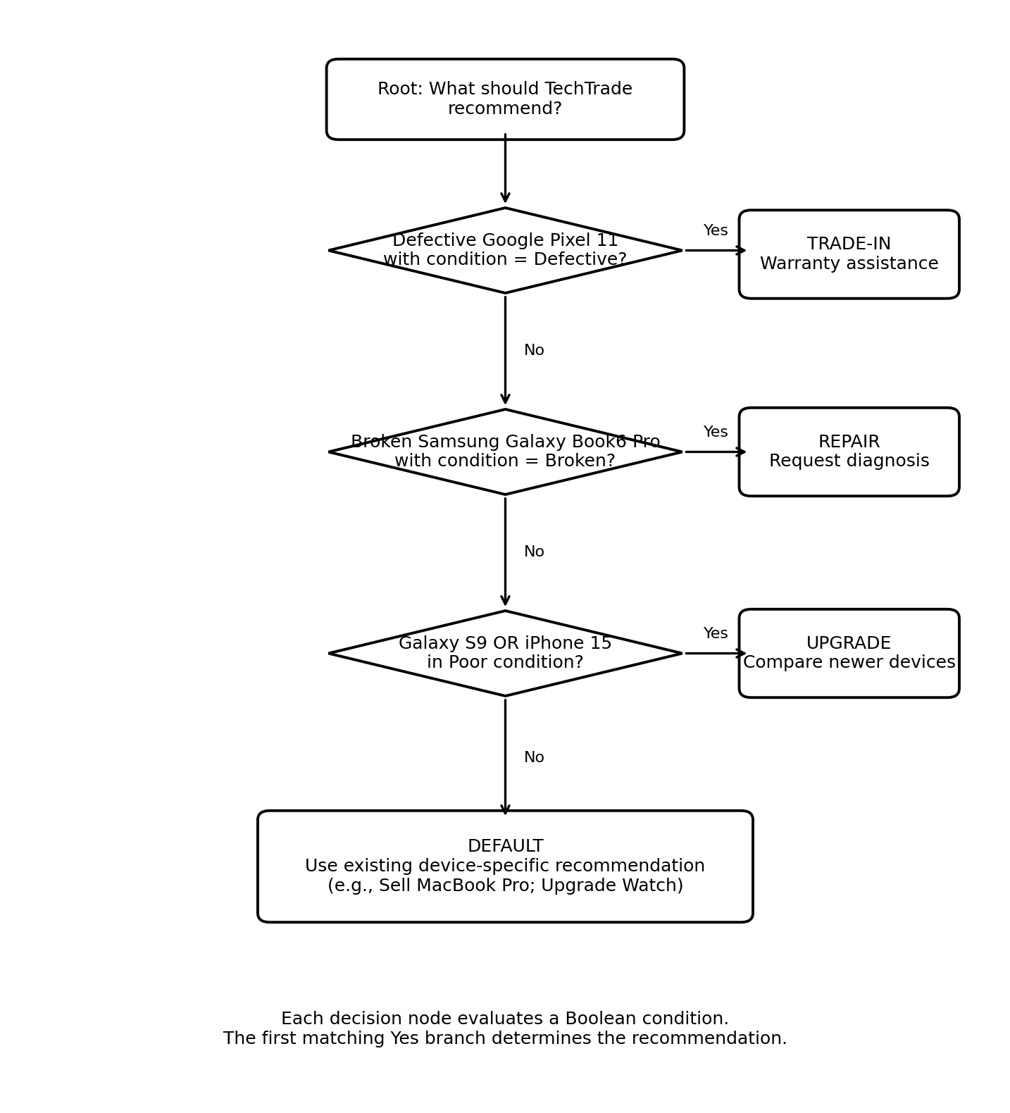

Implementation Notes
The decision tree is implemented in the external js/techtrade.js file. The three Boolean variables are isWarrantyCase, isRepairCandidate, and isUpgradeCandidate. The if / else if / else structure evaluates them in the same order as the flowchart. The final else preserves the existing device-specific recommendation.

