**Lab 2: Using Basic Linux Commands**

**Create a directory: mkdir**

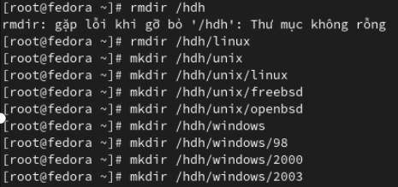

**View the directory or file: ls or ll**

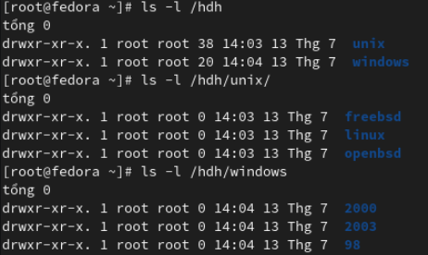

**Create a file: there are many ways to create a file**



**View the file content: using any command as cat, more,less, tail,**



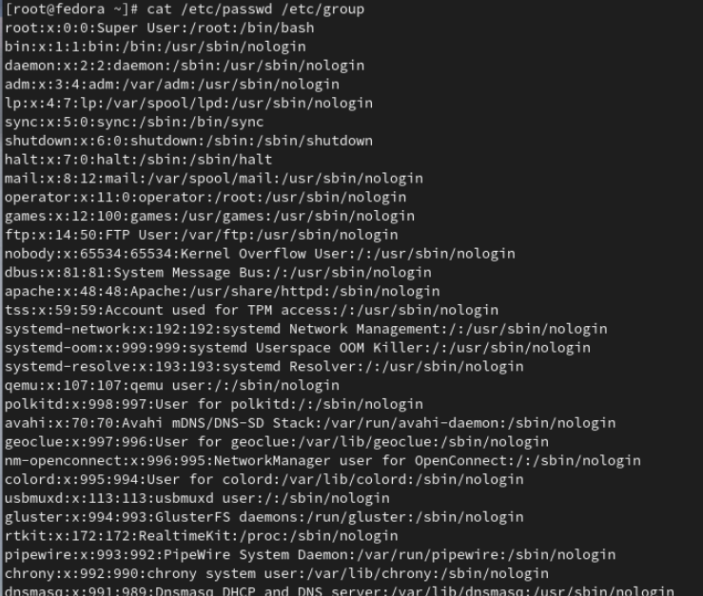

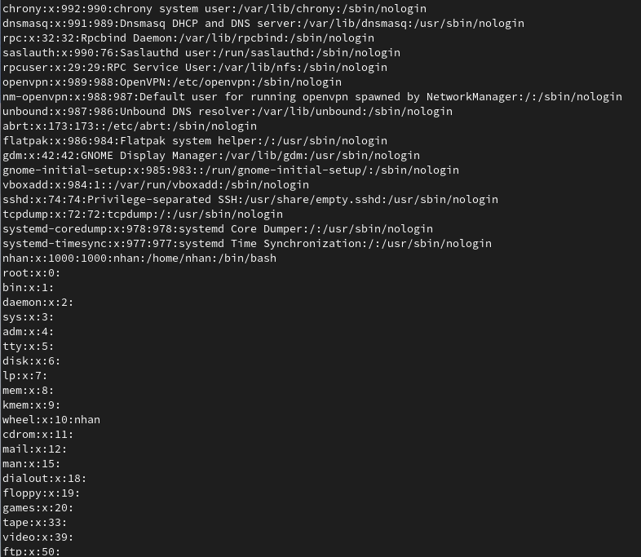

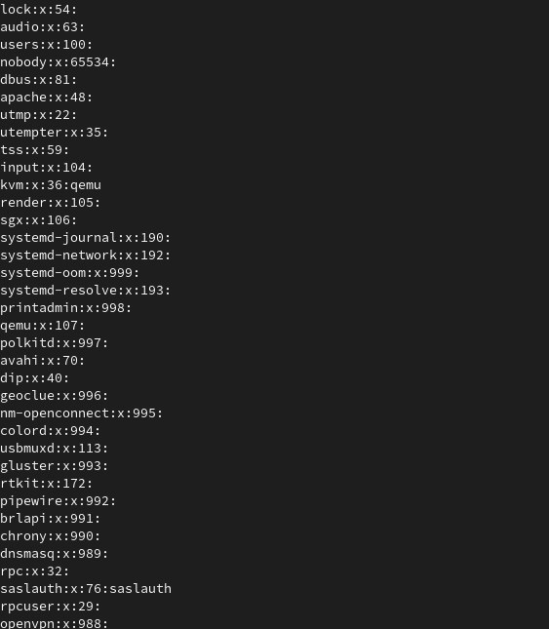

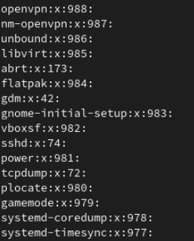

**Copy a file/ directory: cp**

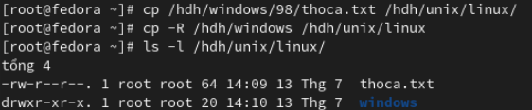

**Move objects: mv**



**Rename: mv**

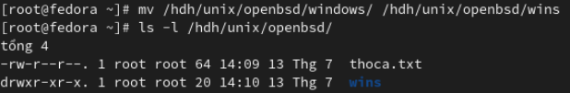

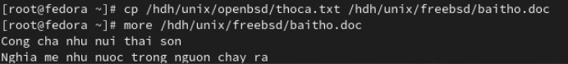

**Delete a file: rm**

**Delete the empty directory: rmdir**



**Change to the directory: cd**

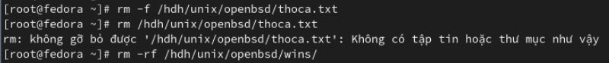

**View the current directory: pwd**

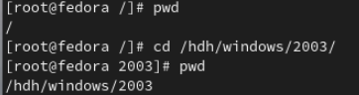

**Searching: find, grep, whereis, which**

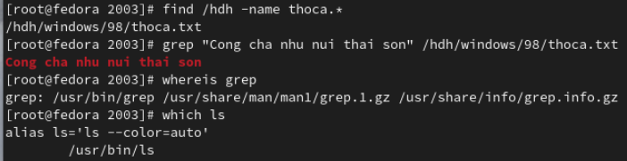

**Zip or unzip: gzip/ gunzip, zip/unzip, tar**

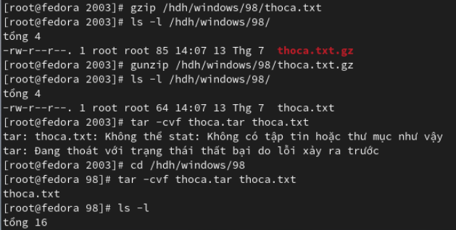

**Lab 3: System Attributes and Using Word Processor**

**Process Management:**

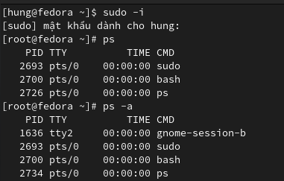

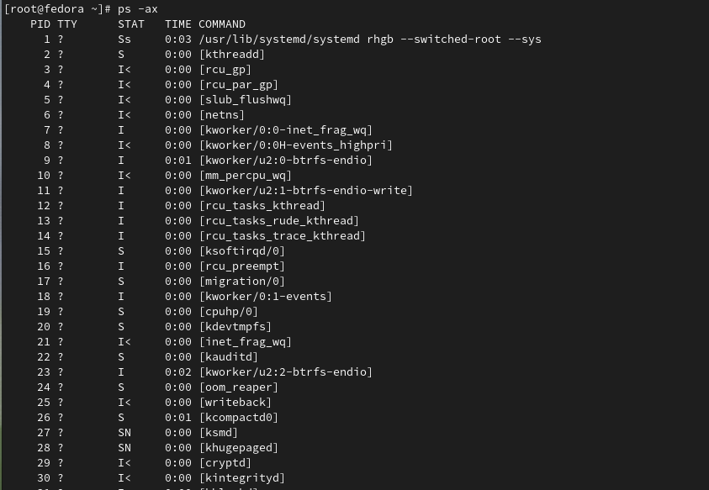

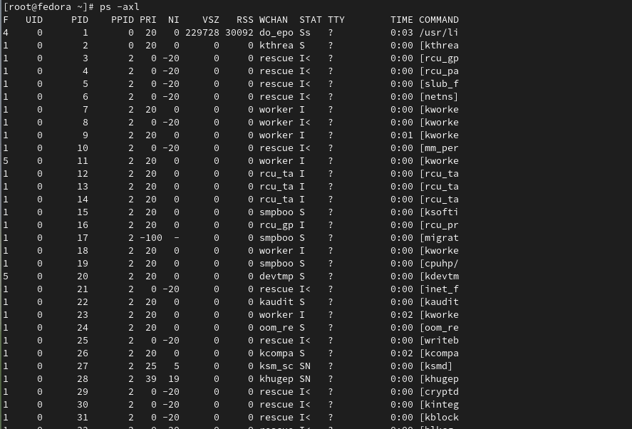

**Some System Commands:**

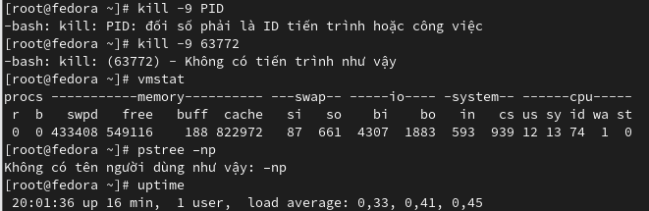

**Using the basic Editor Program vi**

