**PART 01: A UML class diagram is used to represent the Guitar class**

|  |
| --- |
| Guitar |
| - serialNumber: String  - price: int  - builder: String  - model: String  - backWood: String  - topWood: String |
| + Guitar()  + Guitar(String, int, String, String, String, String)  + getserialNumber(): String  + setserialNumber(String): void  + getprice(): int  + setprice(int): void  + getbuilder(): String  + setbuilder(String): void  + getmodel(): String  + setmodel(String): void  + getbackWood(): String  + setbackWood(String): void  + gettopWood(): String  + settopWood(String): void  + createSound(): void |

|  |
| --- |
| Inventory |
| - guitars: List<Guitar> |
| + addGuitar(guitar: Guitar): void  + searchGuitar(serialNumber: String): Guitar |

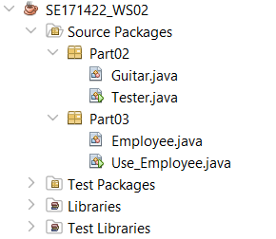

**PART 02:**

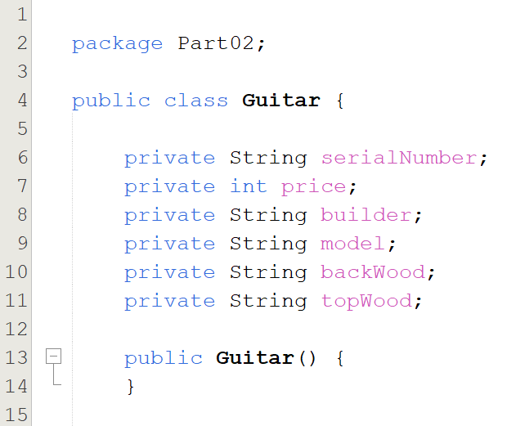

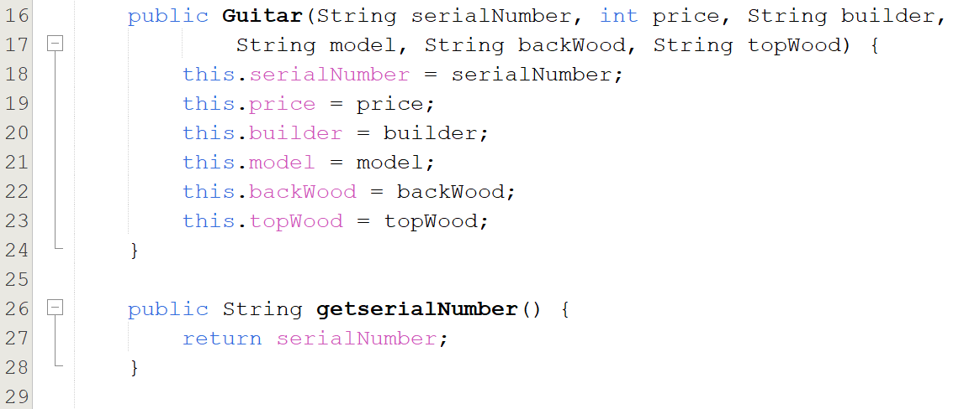

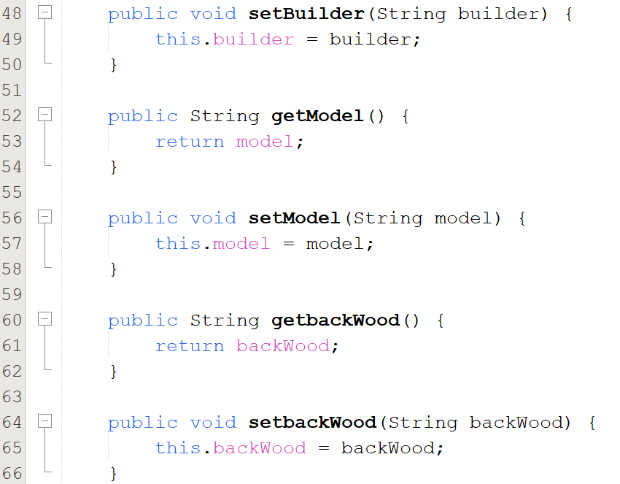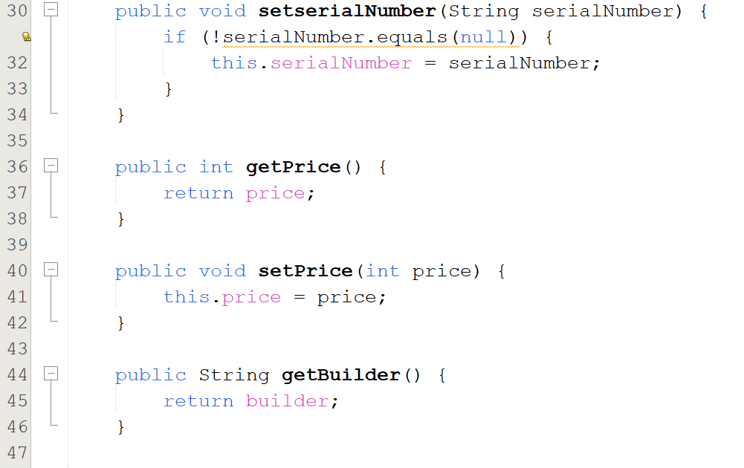

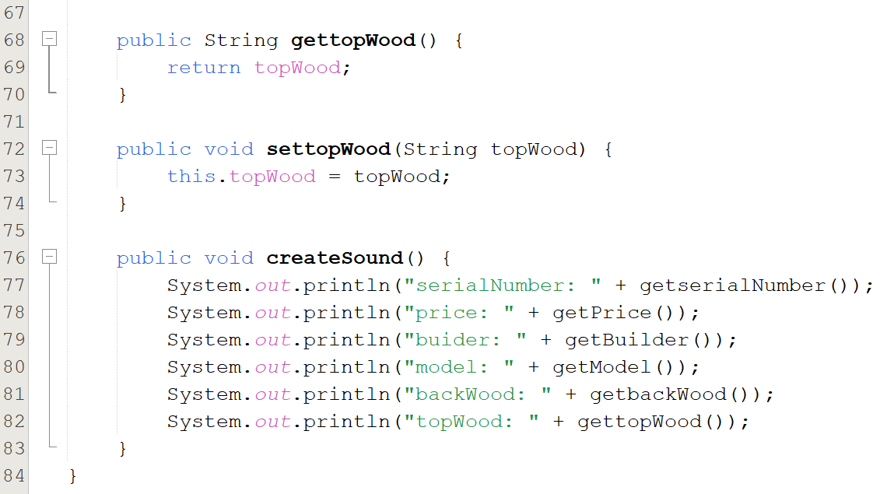

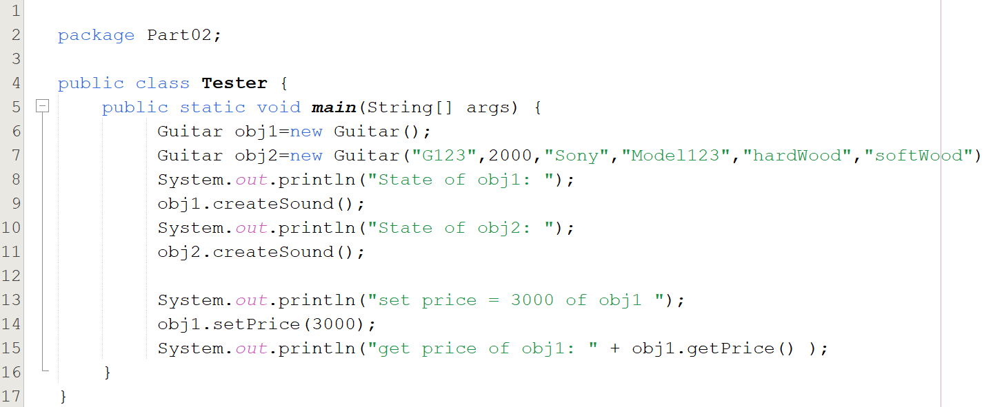

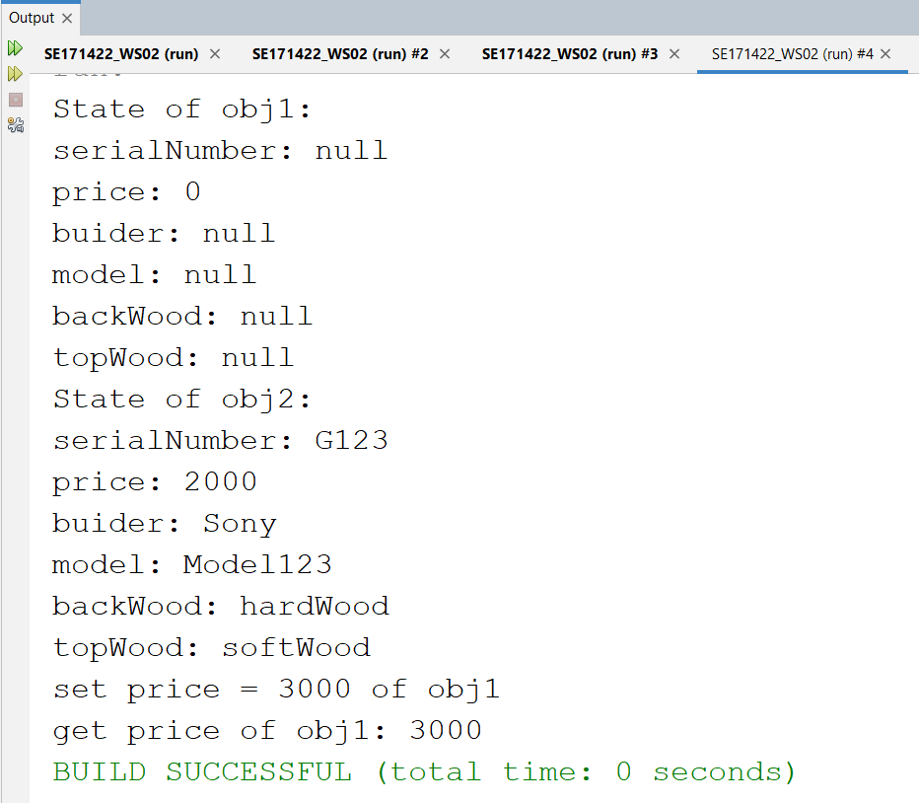

**PART 03:**

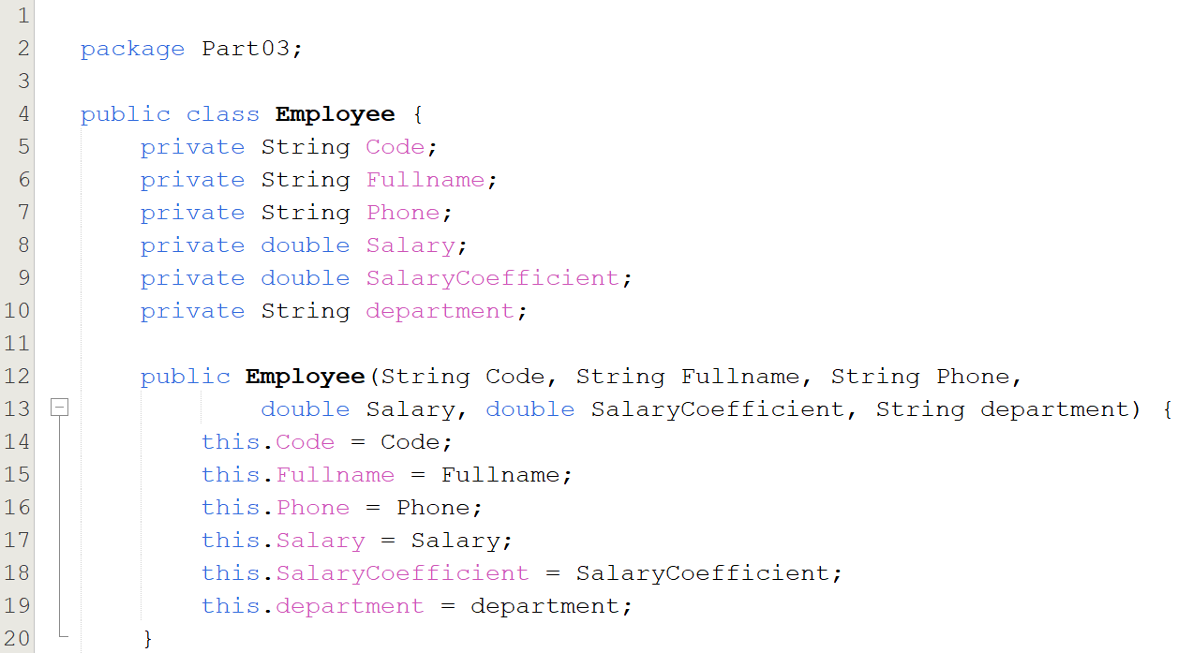

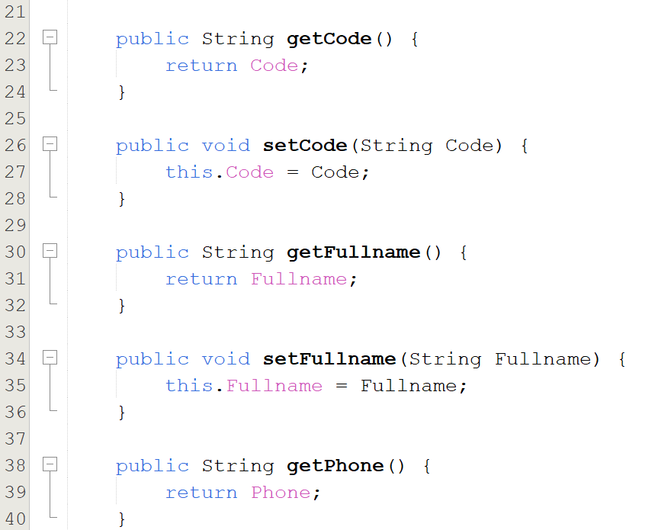

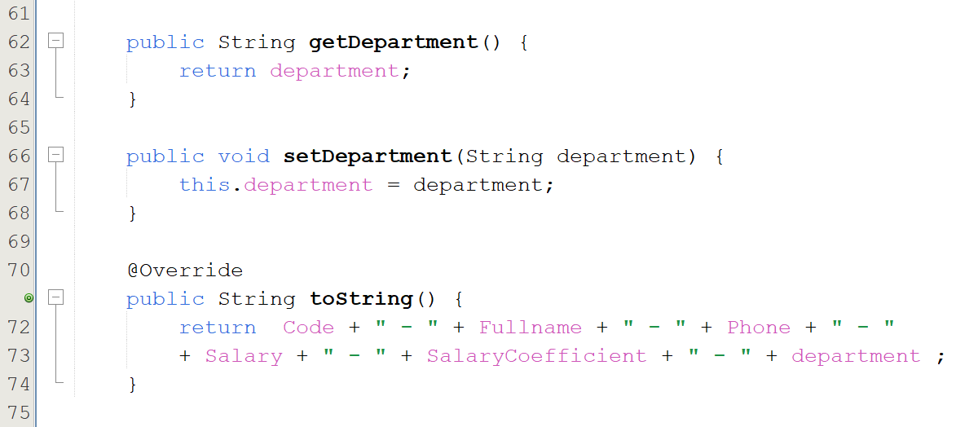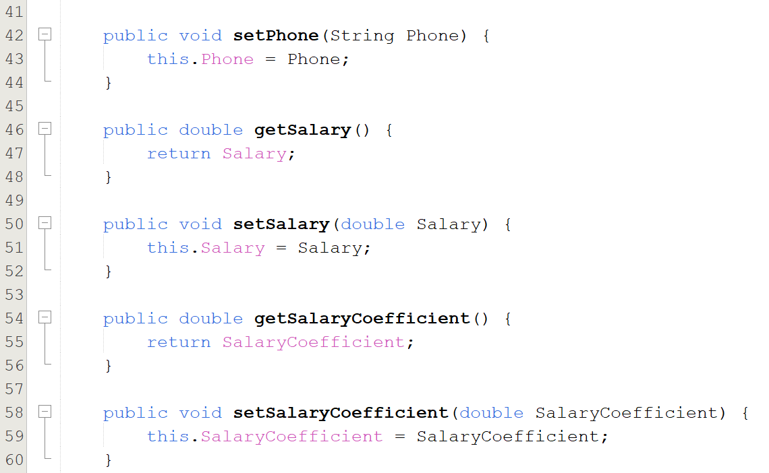

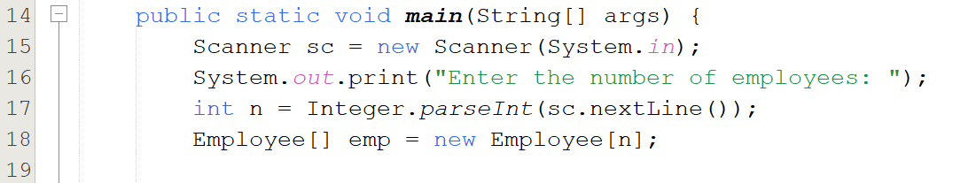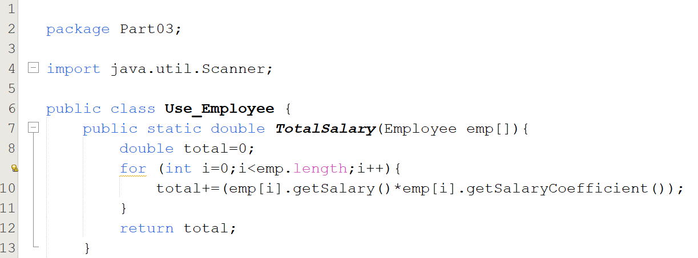

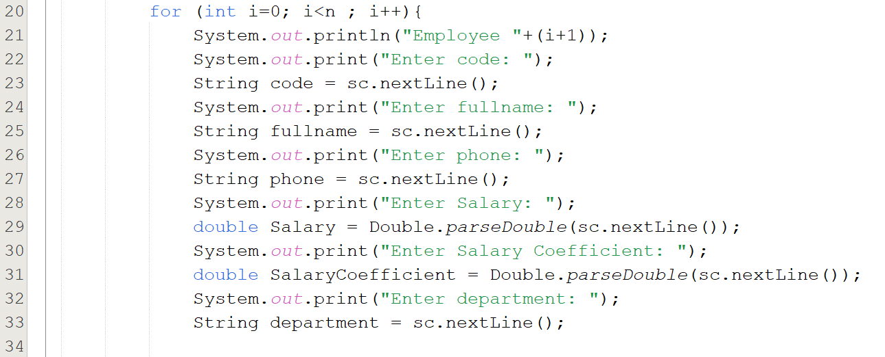

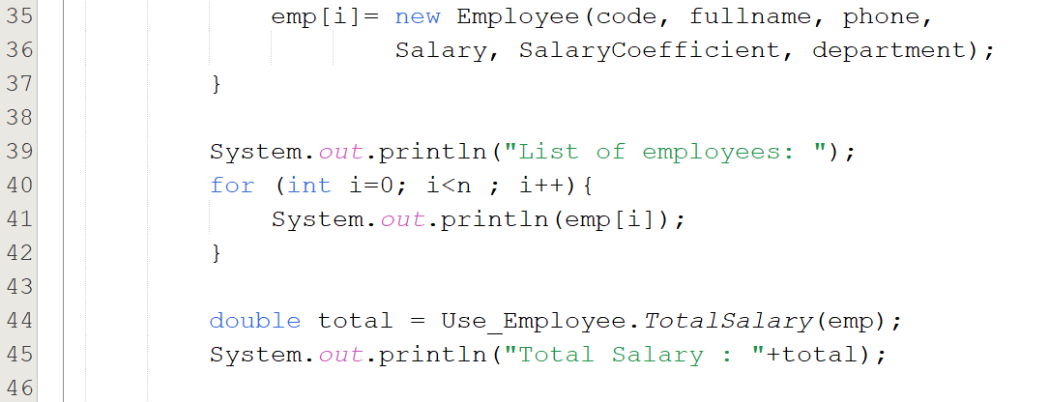

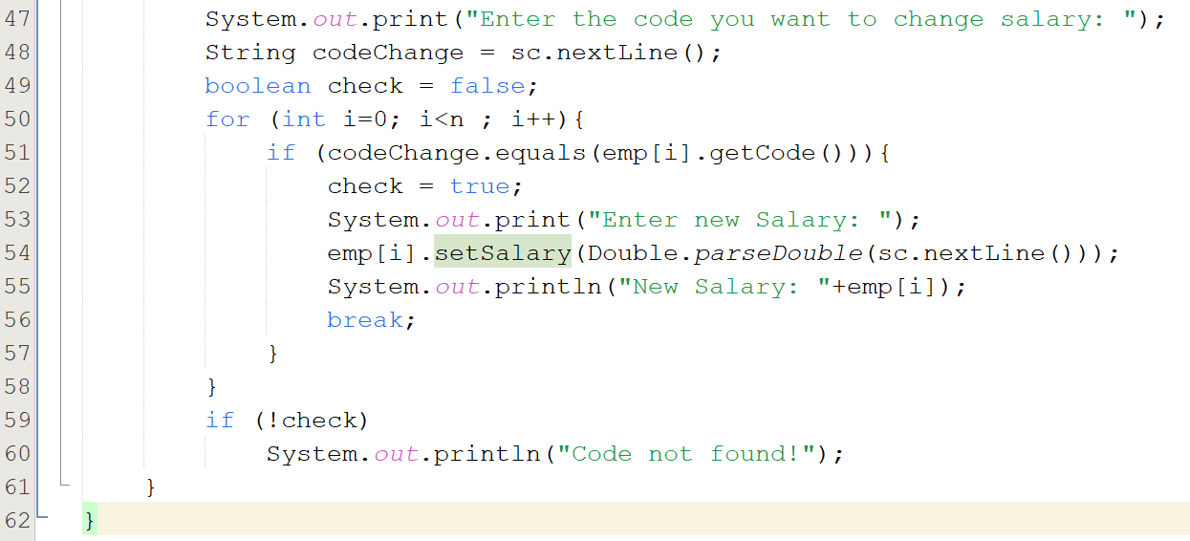

**CASE 1:**

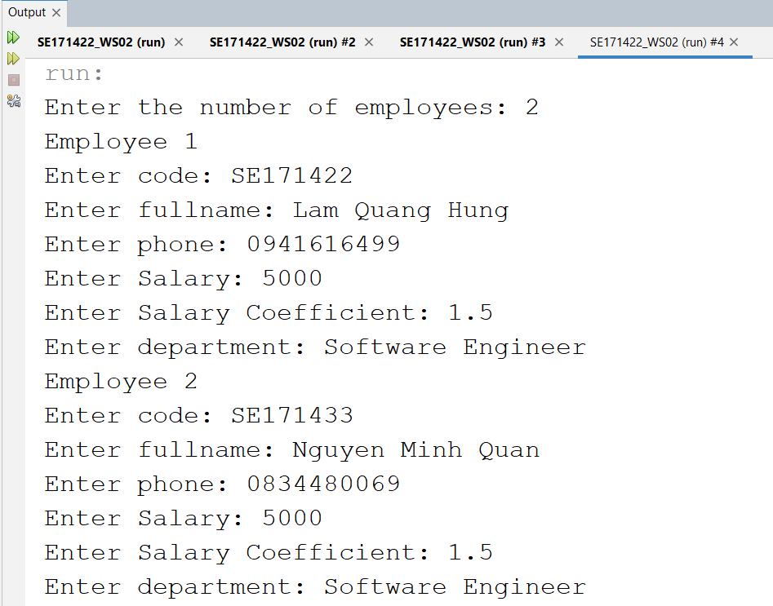

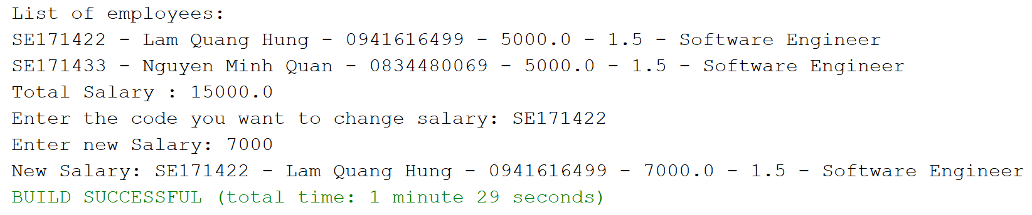

**CASE 2:**



