Hypothesis:

We have combined Donald Trump’s tweets database with the approval/disapproval ratings based on the dates. This way we have created a more insightful database where we could query the tweets based on the approval rating for a specific day. We could also visualize if there exists any correlation between the number of retweets and the highest approval/disapproval ratings given a specific date. Therefore, we have asked ourselves:

1. Which are the most frequent words found in the tweets based on the top 10 approvals?
2. Which are the most frequent words found in the tweets based on the top 10 disapprovals?
3. What is the correlation between the number of retweets and the approval ratings for the top 10 approvals?
4. What is the correlation between the number of retweets and the disapproval ratings for the top 10 approvals?

After combining the data, we observed no correlation between the number of retweets and the approval/disapproval ratings given a specific day. Although, the most frequent words found as per the highest approval/disapproval rates come as no surprise.

**MOST FREQUANT WORDS FOUND IN TWEETS AS PER TOP 10 APPORVALS IN THE “VOTERS” SUBGROUP**

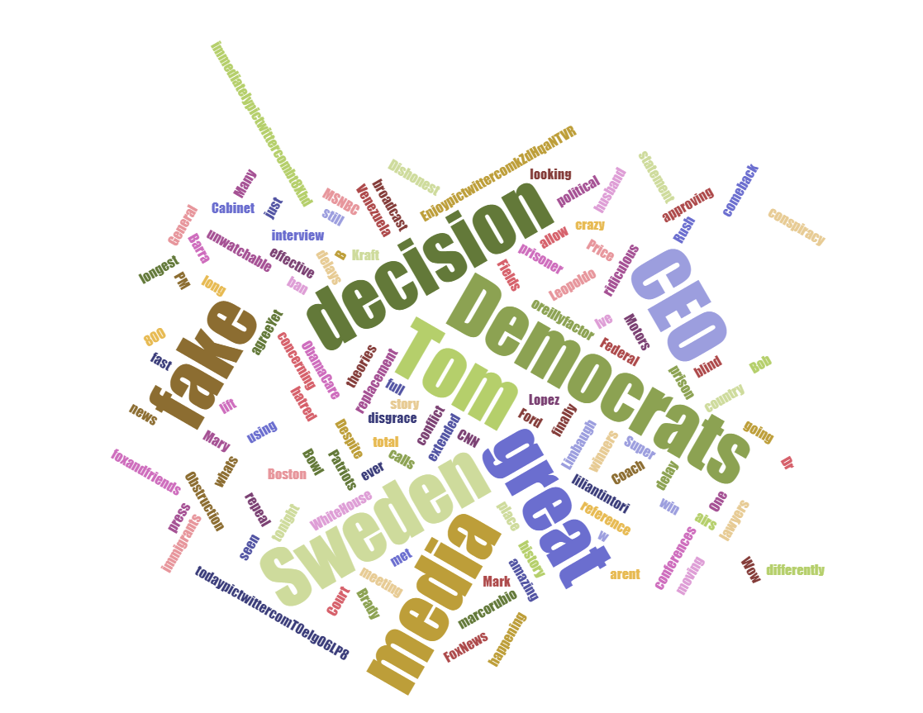

**MOST FREQUANT WORDS FOUND IN TWEETS AS PER TOP 10 APPORVALS IN THE “ALL POLLS” SUBGROUP**



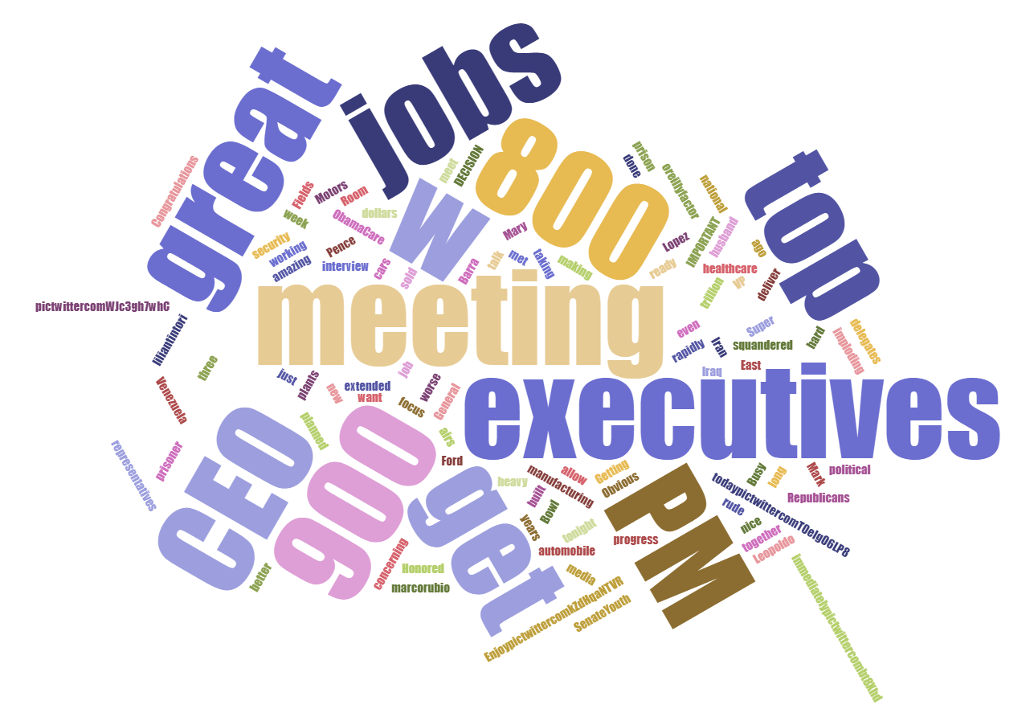

**MOST FREQUANT WORDS FOUND IN TWEETS AS PER TOP 10 DISAPPORVALS IN THE “ALL POLLS” SUBGROUP**



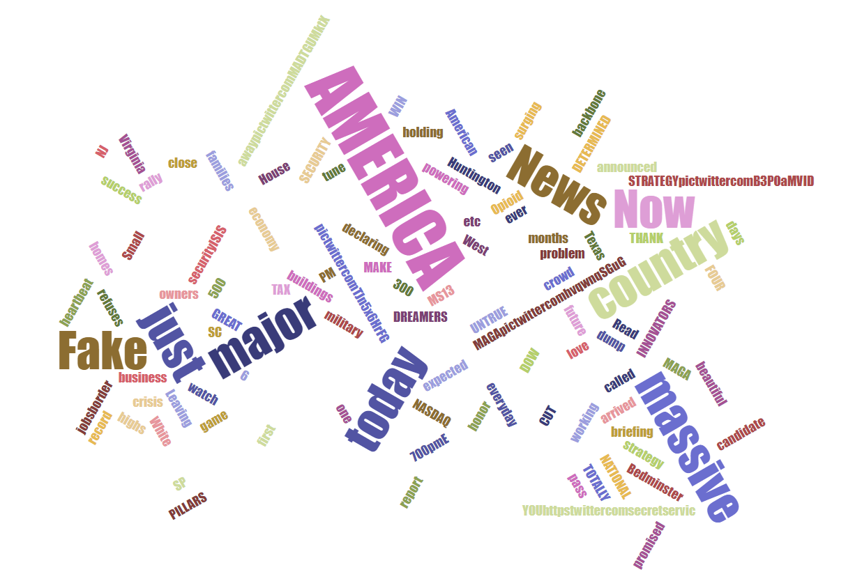

**MOST FREQUANT WORDS FOUND IN TWEETS AS PER TOP 10 DISAPPORVALS IN THE “VOTERS” SUBGROUP**



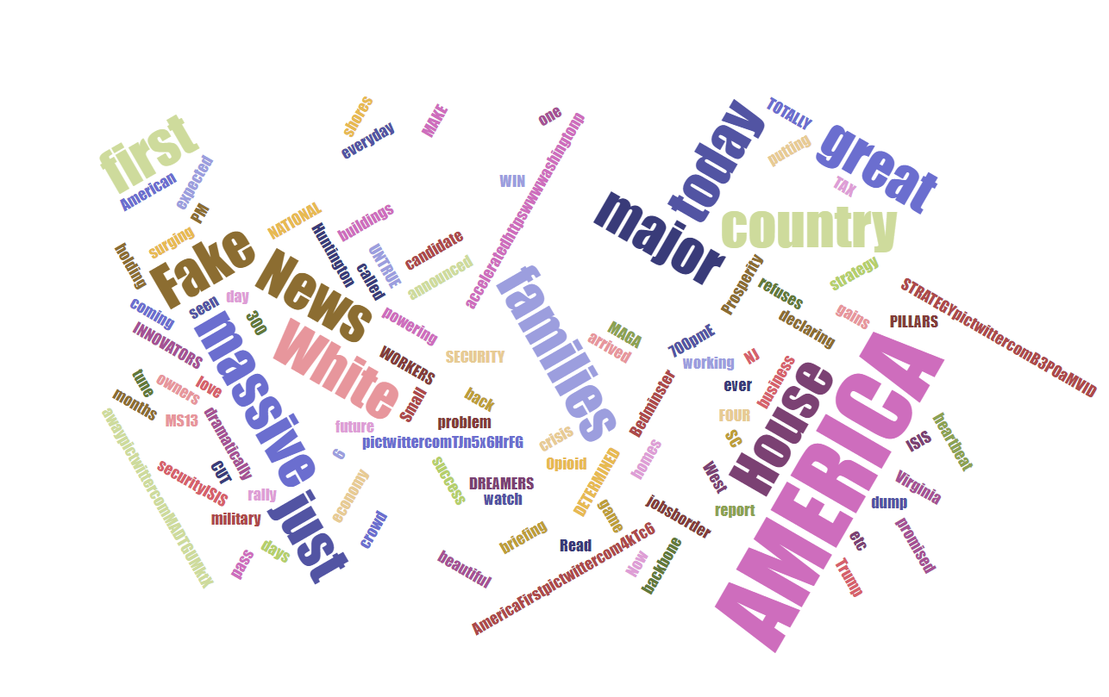

<https://www.jasondavies.com/wordcloud/>