William Adepitan
Gmail: demi.adepitan@gmail.com, Phone: 07445193804

About Me
I am a Level 3 Games Design (Programming) student with a strong interest in game development, game testing, and technology.
My current focus is learning Unity and C#, building game prototypes, and understanding the systems that make games work. I enjoy experimenting with mechanics, solving programming problems, and learning how different components come together to create an engaging player experience.
Before moving into game development, I spent time learning web development and created several projects, including a personal portfolio website. Although game development is now my primary focus, that experience gave me a strong foundation in version control, debugging, deployment, and programming concepts.
I am currently seeking opportunities to gain practical experience, continue developing my technical skills, and contribute to projects while studying.

Education
Level 3 Games Design (Programming)
Northampton College, Booth Lane, Northampton
Currently studying.
Relevant Areas of Study
- Unity Game Development
- C# Programming
- Functions and Coroutines
- Health and Gameplay Systems
- Maya Fundamentals
- Game Design Principles
- Problem Solving Through Programming

Projects
Unity Learning Projects
Completed projects and guided exercises through Unity Essentials and Junior Programmer pathways.
Areas explored include:
- Rigid body physics
- Unity Input System
- Object interaction systems
- Scene organization
- s3D object positioning
- Gameplay scripting in C#
- Testing different movement approaches
During these projects, I often modified sections of the exercises to better understand how systems behaved and interacted.

Web Development Projects (Previous Experience)
Before focusing on game development, I created and deployed several web development projects, including a personal portfolio website.
Through these projects I developed experience with:
- HTML
- CSS
- JavaScript
- SQL
- Bootstrap
- GitHub
- Website deployment and hosting
While web development is no longer my primary focus, these projects helped build valuable technical foundations that continue to support my game development journey.
Projects
Idle Clicker Prototype (College Project)
Developed an idle clicker game featuring:
- Currency progression system
- Purchaseable upgrades
- Auto-clicking functionality
- Rebirth/prestige mechanism
The aim of the game is to increase progression speed through upgrades while reaching higher levels and unlocking greater earning potential.
Assets include royalty-free resources alongside simple assets created using Canva.
Gameplay Video: https://youtu.be/AJYLd3-L9kc

Skills
Programming & Development
- Unity
- C#
- HTML
- CSS
- JavaScript
- SQL
- GitHub
- Bootstrap
Additional Skills
- Troubleshooting
- Debugging
- Version Control
- Problem Solving
- Technical Research
- Attention to Detail

Why I Want Industry Experience
I enjoy both the creative and technical aspects of game development and want to learn how professional teams create games in a real production environment.
I'm particularly interested in understanding development pipelines, collaboration between departments, testing processes, and practical workflows used within the industry.
Working alongside experienced developers would allow me to build on my current knowledge while contributing positively to a team and continuing to grow as a developer.
Achievements
STEM Certificate awarded by The Smallpeice Trust during STEM Day
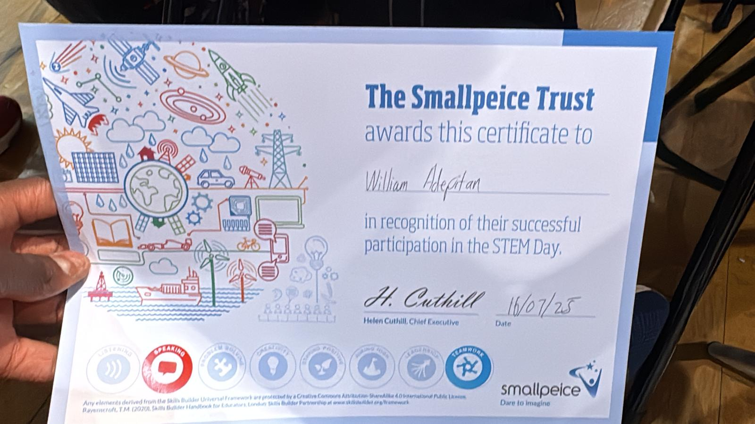

Interests & Hobbies
- Playing and analyzing games
- Learning about game mechanics and design
- Creating small game prototypes
- Listening to music
- Reading technology and gaming articles
- Exploring how games and software systems are built

Availability
Available Thursdays, Fridays and Saturdays for part-time work alongside college. I can cycle to work in Wellingborough on all three days. For locations farther away, my travel range is limited to Earls Barton and Northampton, and I’m available Fridays and Saturdays only.
Portfolio
Portfolio Website:
https://myportfolio-seven-swart.vercel.app/
GitHub repositories and project source code can be accessed through the portfolio.

Final Note
I enjoy learning new technologies, solving technical challenges, and building projects that help me improve my skills. Whether through education, personal projects, or professional opportunities, I am always looking for ways to gain experience and continue developing both technically and creatively.
My goal is to keep learning, contribute positively to projects and teams, and build a career within the games industry.

