Exercise 1: Data Entry Form

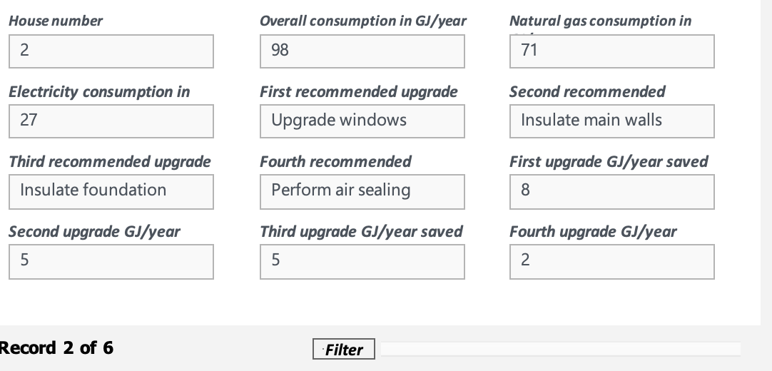

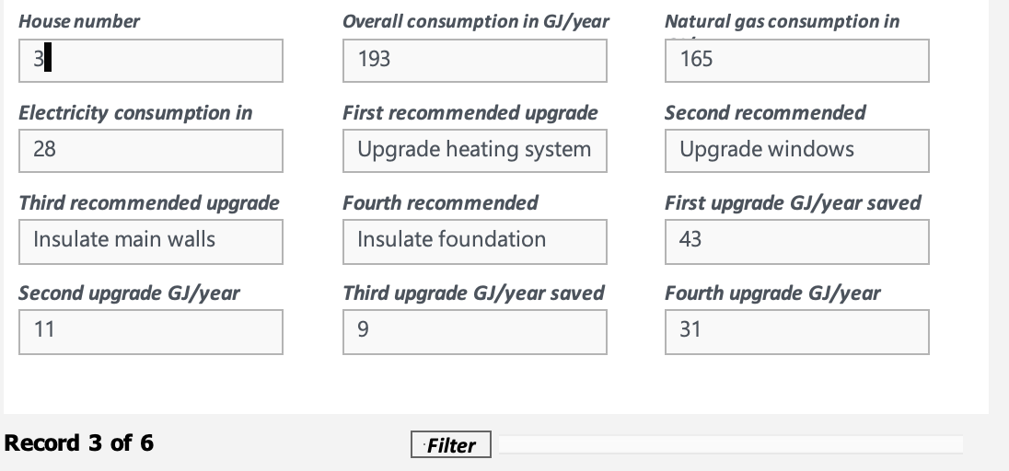
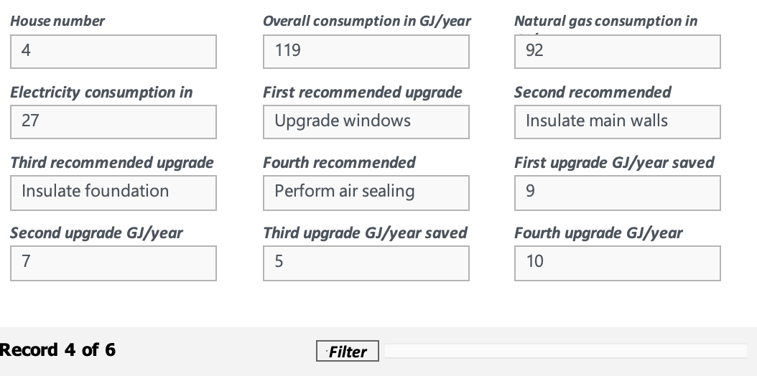

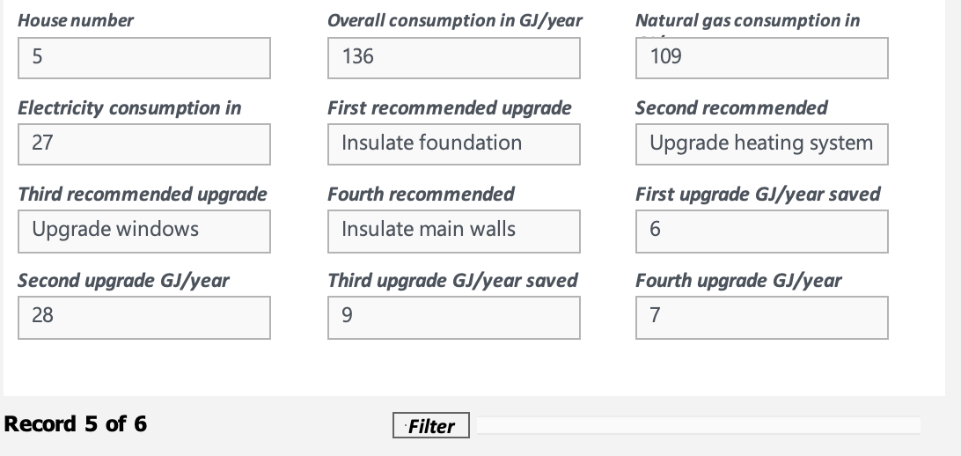

Exercise 2: Words as Data

Word Cloud
This is how the cloud looked before I changed the settings
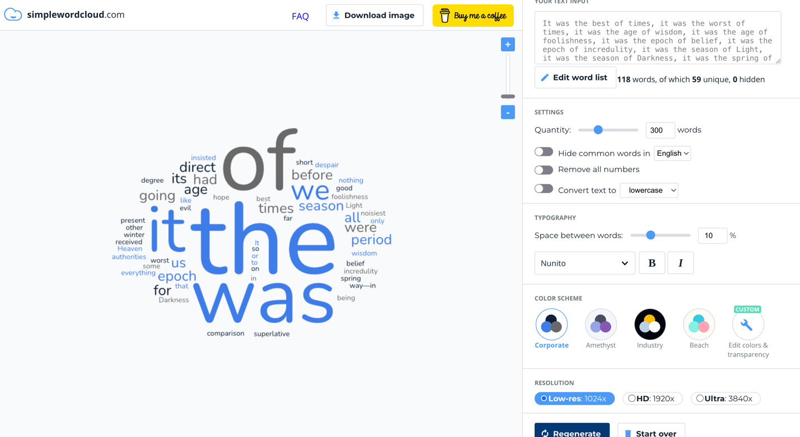
This is how the cloud looked after I changed the settings
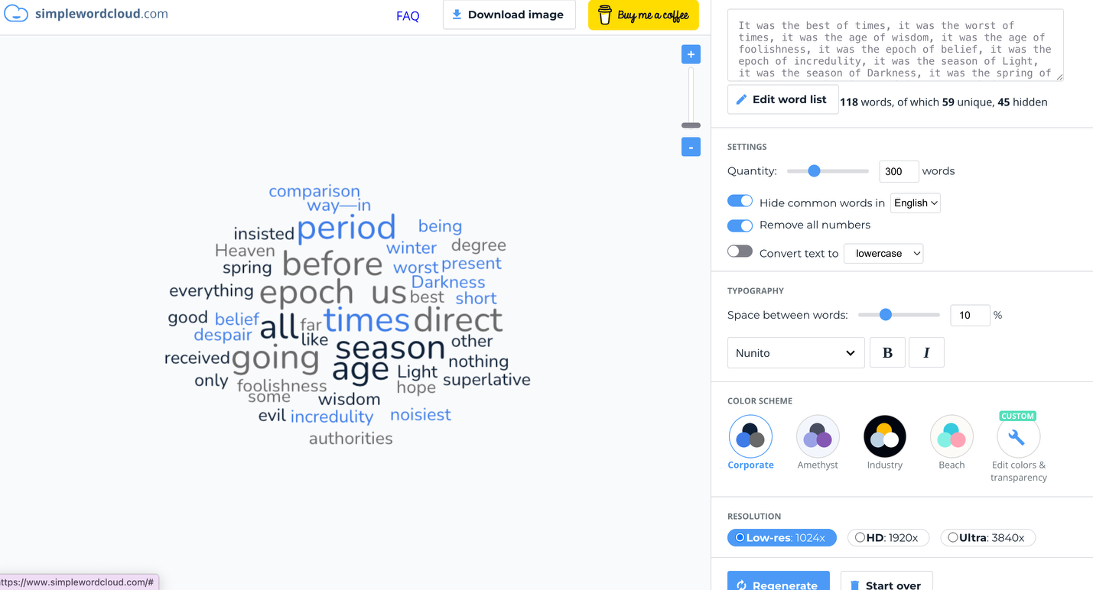
Every time I change the settings, the variation in the words change. In the first picture, (eg. Of, It, The, Was) were the bigger words because it was grouped together but when I turned off the group similar words selection, the words that repeated were the bigger words instead. Behind the scenes, the cloud wordle is using a structured system to make the data clearer and readable.

