

**Assignment 4 – Generative Adversarial Network**

Report

**HOZANA GUIMARAES REIS**

**Table of Contents**

**Data Sample Images** 3

**Data Preprocessing** 4

**CNN for Generator Architecture** 5

**CNN for Discriminator Architecture** 7

**GAN training Step Function** 8

**Train the Model** 8

**Image prediction** 9

**Conclusion** 9

# **Data Sample Images**

The dataset used is the data fashion_mnist, below is a sample of the images that contains in the data followed by the code used. The data is stored ds1_hozana and ds2_hozana.

The images contained in the dataset and the separated in classes as the images below:

# **Data Preprocessing**

To ensure consistent and efficient model training, the pixel values of the images in both the training and testing datasets are normalized. This process involves scaling the pixel values to a range between -1 and 1. See below the code and shape output.

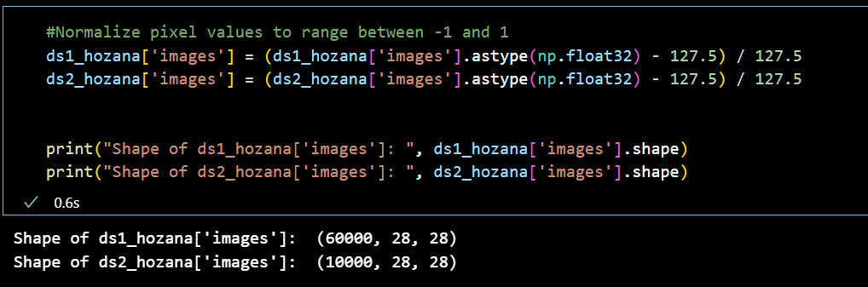

After Normalizing the data, I selected only pants images which is class 1 as per the previous class image. After selecting only pants the dataset has a shape if 7000,28,28. Check the code and Image demonstration.

# **CNN for Generator Architecture**

In the figure below is the generator architecture summary and diagram.

# **CNN for Discriminator Architecture**

In the figure below is the discriminator architecture summary and diagram.

# **GAN training Step Function**

Basically what the function does is :

1. Generate Random Noise: Creates random noise to feed into the generator.
2. Forward Pass: Uses the noise to generate fake images with the generator, and predicts realness of both real and fake images with the discriminator.
3. Calculate Losses: Computes three types of losses:

* gen_loss: Measures how well the generator fools the discriminator.
* real_loss: Gauges how accurately the discriminator identifies real images.
* fake_loss: Assesses the discriminator's ability to detect fake images.

1. Compute Gradients: Finds out how much each parameter should change to reduce the losses.

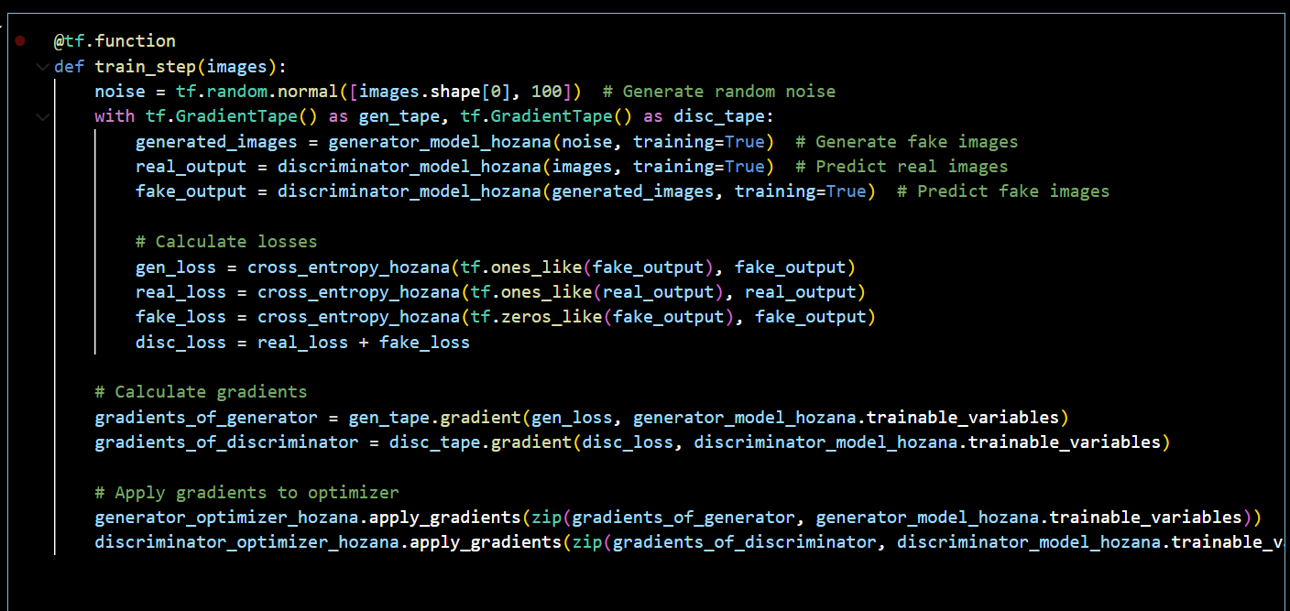

# **Train the Model**

After the function I trained the model and displayed the epochs duration, see below the seconds taken for each epoch.

# **Image prediction**

Below is the image using the model, I also added the original image to compare.

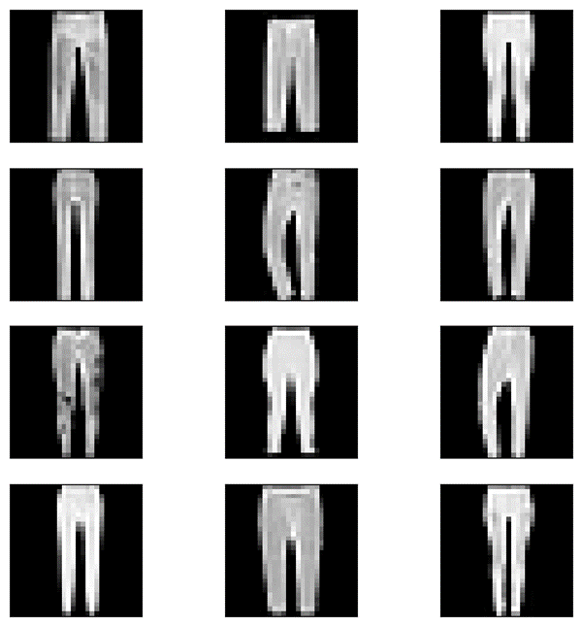

Original

Predicted

# **Conclusion**

After looking at the predicted images next to the real ones, I noticed they're not exactly the same. The generated images mostly show clothes like pants or skirts, but they're not perfect. To make them better, I need to work on improving the GAN. This will helps create images that look more like the original ones.