This is your first assignment. It is **5%** of your final mark. You need to do it as a group. And you will upload ONE SINGLE FILE PER GROUP.

1. **Write a program that asks the user to enter the following: (3%)**

An integer representing the number of cents. You may assume that the number of cents entered is greater than or equal to zero. The program should then display how to provide that change to the user.

In Canada:

1 dollar is 100 cents

1 quarter is 25 cents

1 dime is 10 cents

1 nickel is 5 cents, and

1 penny is 1 cent.

Here is a sample run:

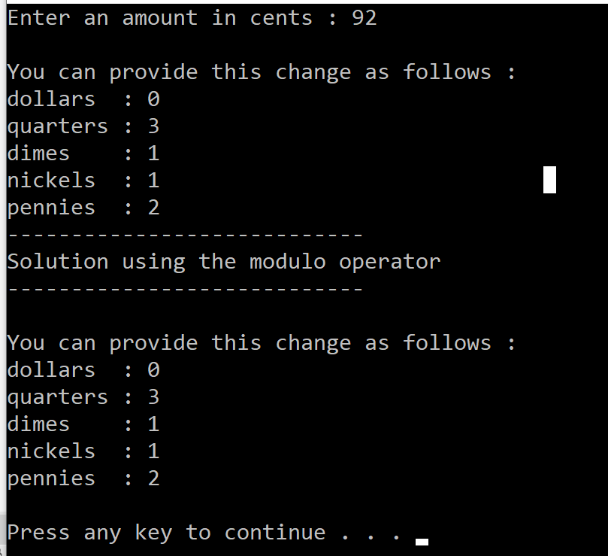

**2) Solve the same problem using the modulo operator.** **(2%)**