1.
a)
for(int i=0;i< H->m ; i++){
chain* p = H->table[i];
While(p!=NULL){
elem e = p->data;
if(e == NULL || abs(hash(elem_key(e))%H->m)!=i) return false;

nodecount++;
if(nodecount>H->n) return false;
p= p->next;
}
}
if(nodecount != H->n) return false;
return true;

b)
/*
@ensures \result == NULL ||
Key_equal(k,elem_key(\result));@
*/

2.
- 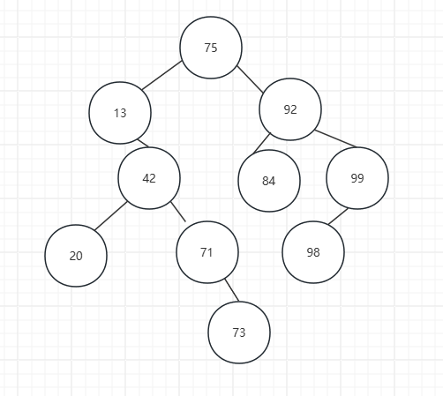
- 42

int tree_height(tree* T) //@requires is_ordered(T, NULL, NULL); {
If(T==NULL) return 0;//一个空的树祂的高度wei0
int left = tree_height(T->left);
int right = tree_height(T->right);
return 1 + (left>right? left : right);//深的那个子树的深度+1} int bst_height(bst B) //@requires is_bst(B); //@ensures is_bst(B); {
return tree_height(B->root);}

d)
tree* tree_delete(tree* T,key k){
if(T == NULL) return NULL;
if(key_compare(k,elem_key(T))<0)
{
- >left = tree_delete(T->left,k);
return T;
}
else if(key_compare(k,elem_key(T->data))>0)
{
T>right = tree_delete(T->right,k);
return T;
}
else
{
if(T->left->right == NULL)
{
T->data = T->left->data;
T->left = T->left->left;
}
else
{
T->data = largest_child(T->left);
}
return T;
}
}Elem largest_child(tree* T)
//@requires T!= NULL && T->right != NULL;
{
if(T->right->right == NULL)
{
elem e = T->right->data;
T->right = T->right->left;
Return e;
}
return largest_child(T->right);
}

