**How to setup your SolidWorks templates**

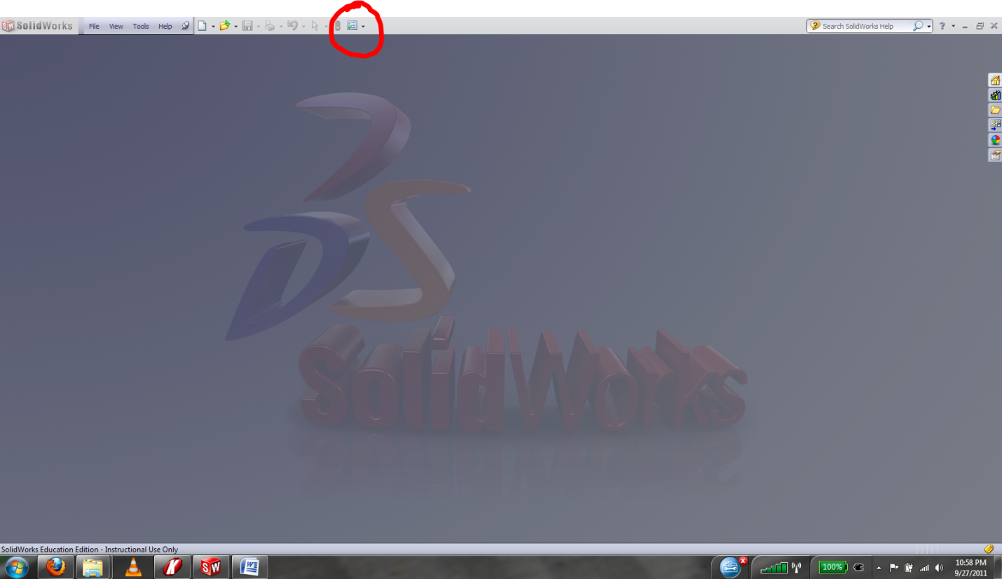1. Click *System Options*

2. Select *File Locations*

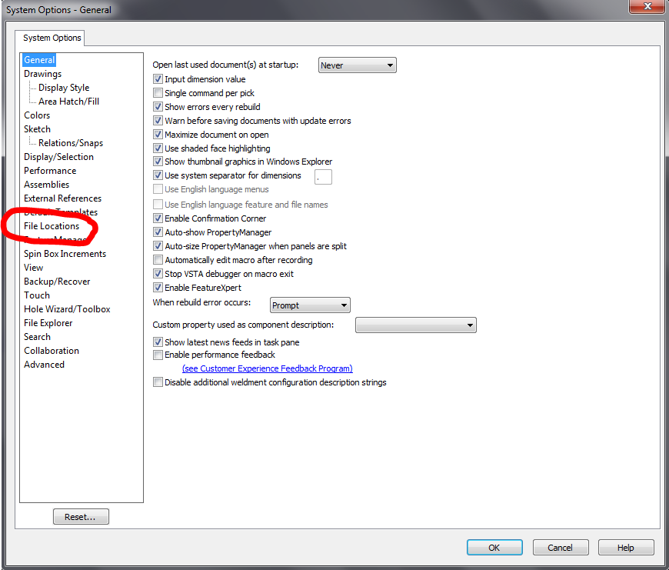

3. Click *Add*, browse to *Subversion/General/Solidworks Templates*, and click *OK*.

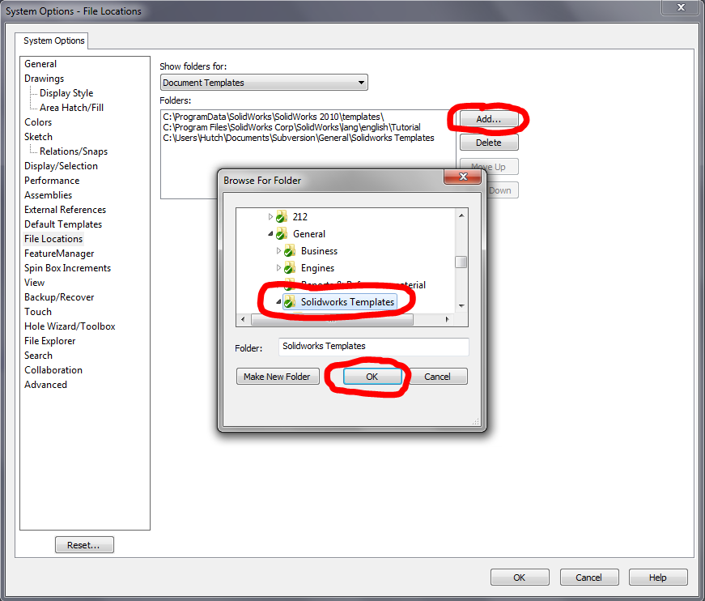

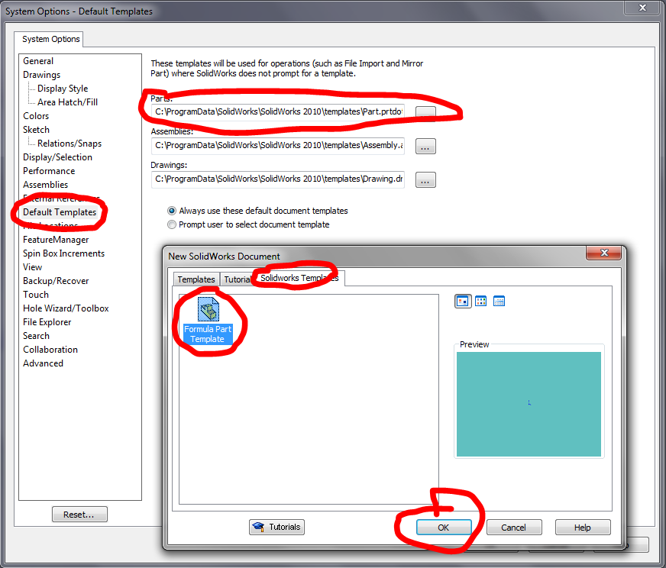4. Go to *Default Templates*, click *...* next to *Parts*, select the *Solidworks Templates* tab, select *Formula Part Template* and hit *OK*.

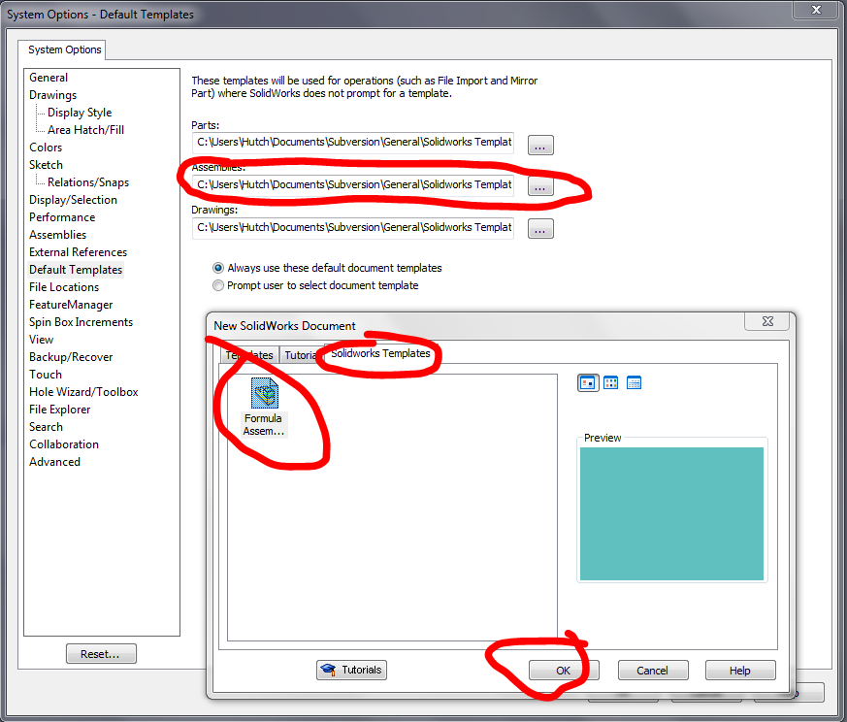5. Repeat for assemblies. Go to *Default Templates*, click *...* next to *Assemblies*, select the *Solidworks Templates* tab, select *Formula Assembly Template* and hit *OK*.

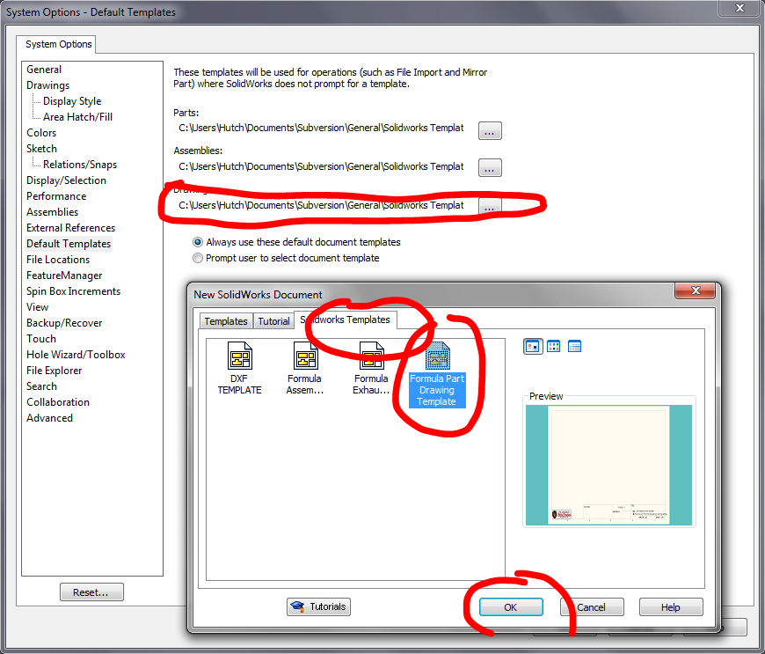6. Repeat for Drawings. Go to *Default Templates*, click *...* next to *Drawings*, select the *Solidworks Templates* tab, select *Formula Part Drawing Template* and hit *OK*. You'll know who you are if you need to use the other templates.