TrustRestore: A Preliminary Self-Supervised Trust-Aware Framework for Compound Image Restoration
Pasindu Harsha
Department of Electronic and Telecommunication Engineering
General Sir John Kotelawala Defence University , Sri Lanka
Abstract - This paper presents TrustRestore, a preliminary trust-aware framework for restoring compound-degraded images under limited-data conditions. A lightweight U-Net is trained using masked-patch self-supervision without requiring a large paired dataset. The proposed method estimates a per-pixel Trust Map from data consistency, Sobel-gradient structural consistency and Monte Carlo dropout prediction stability. Low-trust regions receive edge-preserving bilateral refinement. Controlled synthetic degradation provides clean reference images for PSNR, SSIM and Trust-versus-error analysis. An optional image-upload web interface demonstrates qualitative use on real photographs. The proposed method is presented as a proof of concept rather than a state-of-the-art restoration benchmark.

Index Terms - image restoration, self-supervised learning, uncertainty estimation, Monte Carlo dropout, trust map, U-Net, computer vision.
- INTRODUCTION
Images captured by smartphones, embedded cameras, drones and surveillance systems are often degraded by low illumination, sensor noise, motion blur, defocus blur and compression artifacts. These degradations may occur simultaneously, making restoration difficult. Classical image-processing methods, including spatial filtering, histogram equalization and deconvolution, can reduce specific degradations; however, they may oversmooth important structures or perform poorly when the image contains multiple unknown degradations.
Deep-learning-based restoration methods can produce visually plausible results, but they commonly require large paired datasets containing clean and degraded image samples. In low-data or image-specific scenarios, such datasets may be unavailable. Self-supervised restoration methods address this limitation by learning from the observed degraded image itself or from internally generated training samples. Deep Image Prior demonstrated that the structure of a convolutional network can act as an image prior, while blind-spot approaches such as Noise2Void avoid requiring clean training targets.
However, restoration quality alone is not sufficient for trustworthy deployment. A restored image can appear sharp or visually convincing while containing altered, oversmoothed, or unsupported details. This is especially important for low-cost cameras, surveillance systems, drones and embedded vision applications, where downstream decisions may depend on the restored image.
This work investigates whether a lightweight self-supervised restoration system can also estimate where its output is reliable. The proposed TrustRestore framework restores compound-degraded images and generates a per-pixel Trust Map. The Trust Map combines data consistency with the observed image, Sobel-gradient structural consistency and prediction stability estimated using Monte Carlo dropout. Low-trust regions are refined using edge-preserving bilateral filtering.

A. Contributions
The main contributions of this work are as follows:
1.A lightweight masked-patch self-supervised U-Net for compound image restoration under limited-data conditions, without requiring a large external paired training dataset.
2.A Triple-Consistency Trust Score that combines data consistency, structural consistency and Monte Carlo prediction stability to estimate per-pixel restoration reliability.
3.A per-pixel Trust Map that identifies reliable restoration regions and highlights areas where the model is uncertain or potentially unsupported by the observed image.
4.A trust-guided refinement strategy that applies edge-preserving bilateral filtering only to low-trust regions while preserving the learned restoration output in high-trust regions.
5.A reproducible Google Colab research workflow that generates synthetic compound degradations, performs PSNR and SSIM evaluation, Trust-versus-Error correlation analysis, ablation studies, paper-ready figures, CSV result tables and an interactive image-upload web interface.
II. RELATED WORK AND RESEARCH GAP
Image restoration has traditionally relied on methods such as Gaussian filtering, median filtering, bilateral filtering, histogram equalization, deconvolution and non-local similarity methods. These techniques are generally computationally efficient and interpretable; however, they are often designed for specific degradation types and may oversmooth important image details when applied to compound degradations.
Deep-learning-based restoration methods have demonstrated strong performance for denoising, deblurring, low-light enhancement and compression-artifact removal. Many of these methods are trained in a supervised manner using large datasets of clean and degraded image pairs. However, paired clean targets are difficult or expensive to obtain in many practical settings, including surveillance imaging, low-cost embedded cameras, drones and scientific imaging.
Self-supervised restoration reduces the dependence on clean targets. Noise2Noise learns from independently corrupted image pairs, while Noise2Void uses masking or blind-spot training to learn directly from individual noisy images. Deep Image Prior further demonstrates that convolutional-network structure can serve as an image prior for restoration without an external training dataset. These approaches demonstrate that useful image restoration can be achieved when clean training targets are unavailable.openaccess.
However, restoration quality alone does not reveal whether individual restored pixels are reliable. A restored output can appear visually convincing while containing altered, oversmoothed, or unsupported image details. This limitation is important in applications where the restored image may affect human interpretation or an automated decision.
The research gap addressed in this work is therefore a lightweight restoration framework that not only restores an image under limited-data conditions, but also generates an interpretable per-pixel reliability estimate. TrustRestore addresses this gap by combining restoration with data consistency, structural consistency and Monte Carlo prediction stability to form a per-pixel Trust Map.
- PROPOSED TRUSTRESTORE FRAMEWORK
TrustRestore consists of four main stages:
- Controlled compound degradation generation for quantitative evaluation.
- Masked-patch self-supervised U-Net training.
- Monte Carlo dropout prediction and Trust Map generation.
- Trust-guided bilateral refinement for low-trust regions.
A. Observation Model
The observed degradation model is:
Y = f(X) + N
where:
- X denotes the unknown clean image.
- Y denotes the observed degraded image.
- f( . ) represents the image degradation process, including illumination loss, motion blur, and JPEG compression.
- N represents additive sensor noise.
For the controlled experiment, clean images are artificially degraded using random low illumination, Gaussian noise, motion blur and JPEG compression. The clean image is retained as ground truth, allowing objective evaluation using PSNR and SSIM.
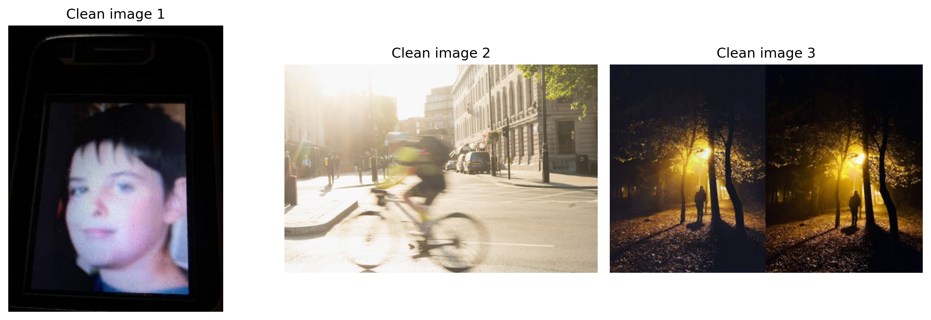
Fig. 1. Examples of clean input images and their corresponding controlled compound-degraded versions. The degradation process includes low illumination, Gaussian noise, motion blur and JPEG compression.
B. Self-Supervised Restoration
TrustRestore uses a lightweight U-Net architecture trained with masked-patch self-supervision. During training, a random subset of pixels in each input patch is masked. The network receives the masked input and predicts the missing pixel values using information from surrounding pixels.
The masked reconstruction loss is:
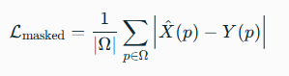
Where:
- Ω is the set of randomly masked pixel locations.
- {X^}(p) is the predicted restored pixel value.
- Y(p) is the observed degraded pixel value.
An edge-preservation loss is introduced to reduce excessive smoothing.
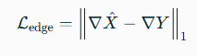
The final training objective is:
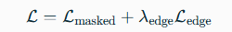
- Triple-Consistency Trust Score
After training, Monte Carlo dropout is used to estimate prediction stability. Dropout remains active during inference, and the model produces K stochastic restoration predictions:
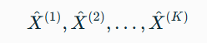
The final deep-restored image is calculated as the mean prediction:
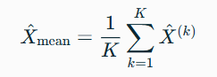
The prediction variance at pixel p is:
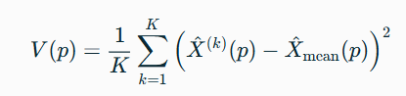
High variance indicates that repeated stochastic predictions disagree, suggesting lower model confidence.
- Data-Consistency Trust Score
The proposed Trust Score for each pixel p is defined as:
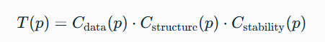
where Cdata , Cstructure and Cstability represent the data-consistency, structural-consistency and prediction-stability components, respectively.
- Structural-Consistency Trust
Data consistency measures whether the restored image remains compatible with the observed degraded image:
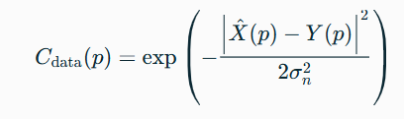
where σ_{n} is an estimated noise level. A large unsupported difference between the restored and observed pixel produces lower data trust.
- Structural-Consistency Trust
Structural consistency measures whether the restoration preserves local edge structure:
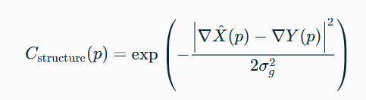
where ∇ denotes the Sobel-gradient magnitude and σ_{g} is a gradient-error scale. Large differences between restored and observed gradients reduce structural trust.
- Prediction-Stability Trust
Prediction stability is calculated from the variance across Monte Carlo dropout predictions:
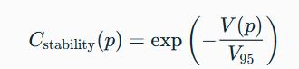
where V₉₅ is the 95th-percentile variance used for normalization.
The final Trust Map is normalized to the interval [0,1]. Brighter regions indicate higher estimated trust, while darker regions indicate lower trust.
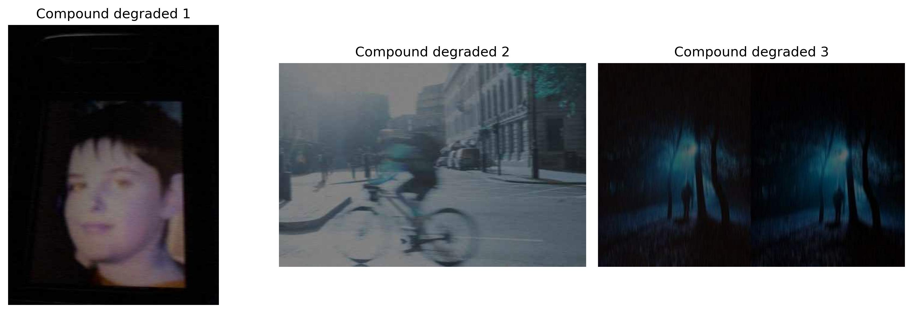
Fig. 2. Overview of TrustRestore. A masked-patch self-supervised U-Net restores the compound-degraded image. Monte Carlo dropout generates multiple restoration predictions, from which data consistency, structural consistency and prediction stability are combined into a per-pixel Trust Map. Low-trust regions are refined using bilateral filtering.
- Triple-Consistency Trust Score
A low-trust mask is produced by thresholding the Trust Map:
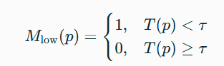
where τ is the selected low-trust threshold.
An edge-preserving bilateral filter B(.) is applied only in low-trust regions:
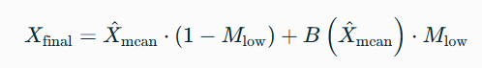
This refinement strategy preserves the learned restoration in high-trust regions and applies a conservative classical filtering operation only in uncertain regions.
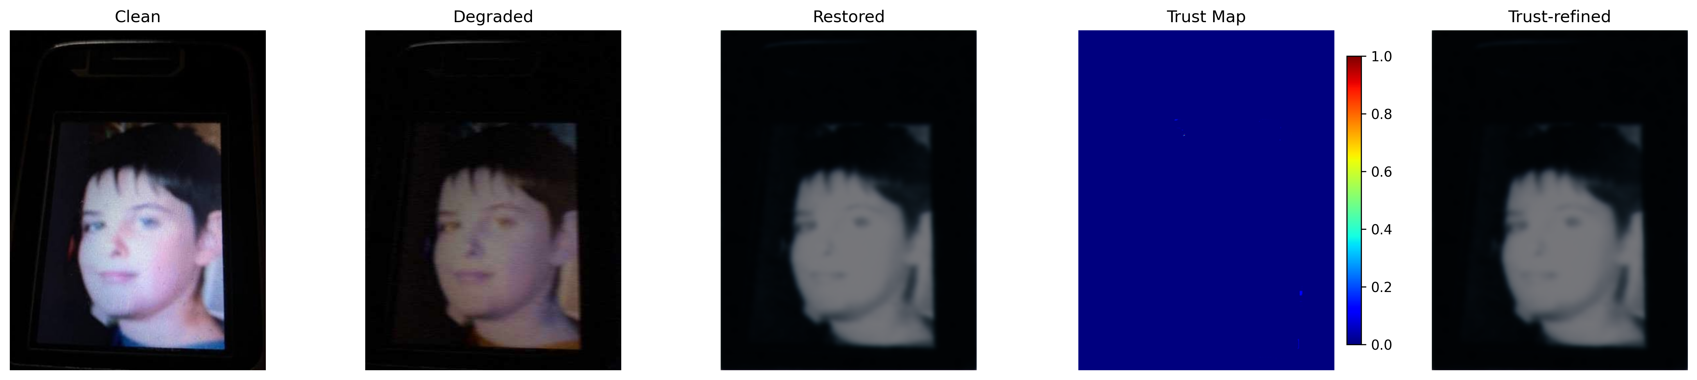
Fig. 3.a Qualitative results for three controlled test images. Each row shows the clean reference image, compound-degraded input, deep restoration, per-pixel Trust Map and Trust-refined output of image 1
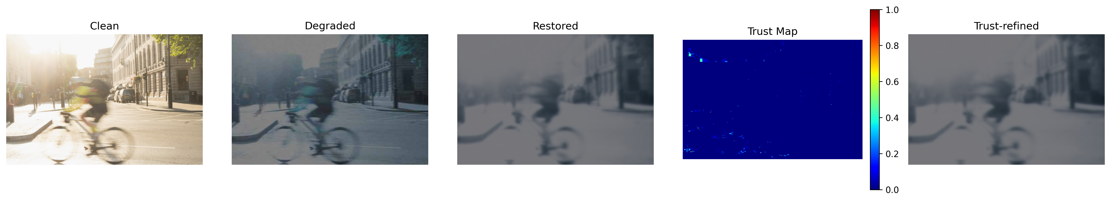
Fig. 3.b Qualitative results for three controlled test images. Each row shows the clean reference image, compound-degraded input, deep restoration, per-pixel Trust Map and Trust-refined output of image 2
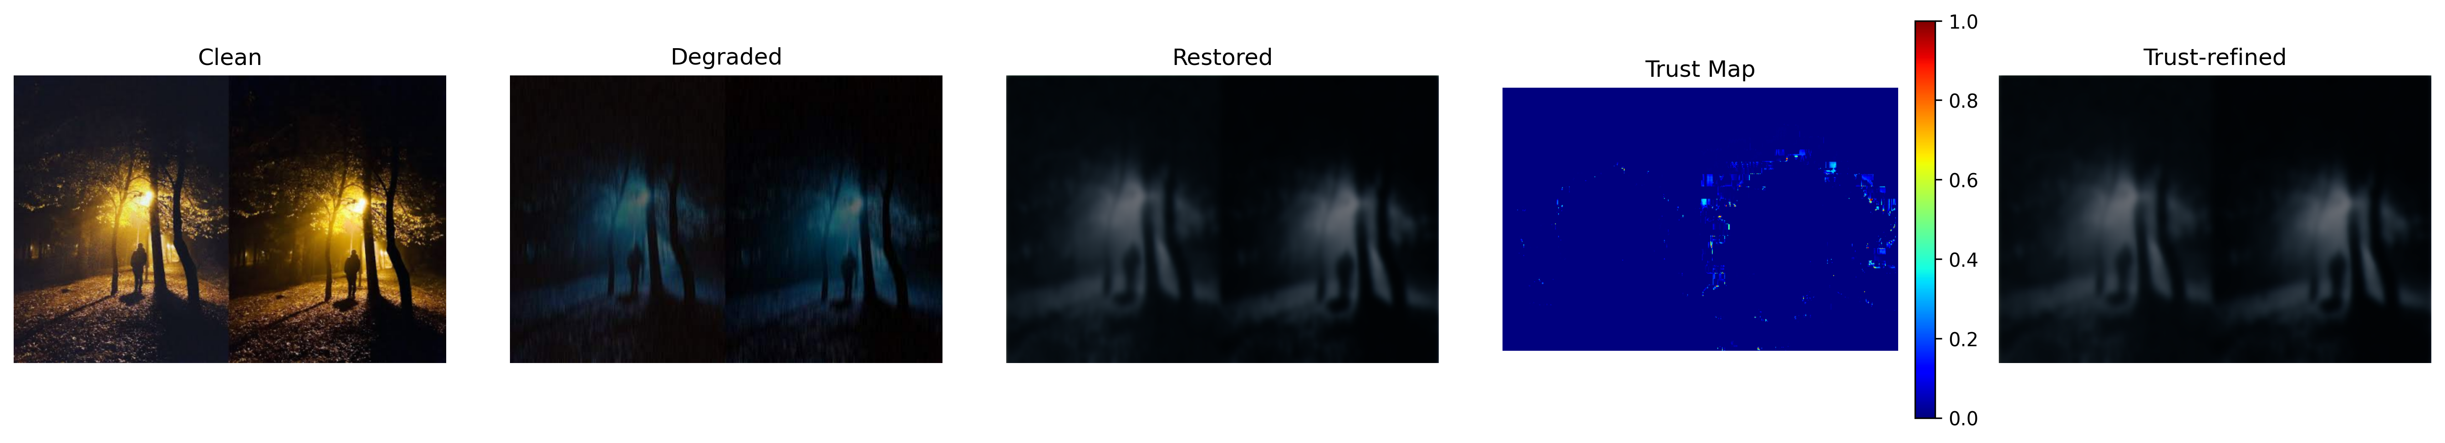
Fig. 3.c Qualitative results for three controlled test images. Each row shows the clean reference image, compound-degraded input, deep restoration, per-pixel Trust Map and Trust-refined output of image 3

IV. EXPERIMENTAL METHODOLOGY
A. Controlled Evaluation
A controlled synthetic evaluation protocol was used to obtain valid quantitative metrics. Each clean input image was degraded using four operations:
- Low illumination through intensity scaling.
- Gaussian noise to simulate sensor noise.
- Horizontal or vertical motion blur.
- JPEG compression to simulate transmission or storage artifacts.
The clean source image was retained as the ground-truth reference. This allows PSNR and SSIM to be computed correctly for the degraded input, deep restoration output and Trust-refined output.
Real low-light, blurry, and noisy photographs may also be used in the Gradio web interface for qualitative demonstration. However, since clean references are unavailable for those images, PSNR and SSIM are not reported for real uploaded images.
- Implementation Details
The implementation was developed in Google Colab using Python, PyTorch, OpenCV, NumPy, Matplotlib, pandas, scikit-image and Gradio. The lightweight U-Net was trained using random image patches of size 96×96 pixels. Random masking was applied to 8% of pixels in each patch. The model was trained with the AdamW optimizer and a cosine learning-rate schedule.
The default experiment used 300 training epochs, a batch size of 8, a learning rate of 2×10⁻⁴, and 20 Monte Carlo dropout predictions for uncertainty estimation. These settings can be adjusted depending on available Colab GPU resources.
- Evaluation Metrics
The following metrics were used:
- PSNR (Peak Signal-to-Noise Ratio): Measures pixel-level reconstruction fidelity between the restored image and the clean reference image.
- SSIM (Structural Similarity Index): Evaluates structural similarity between the restored image and the clean reference image.
- Laplacian Variance: Used as a supplementary sharpness indicator. It is not considered a standalone quality metric because image noise can artificially increase its value.
- Pearson Correlation: Measures the relationship between the pixel-level Trust Score and the absolute restoration error.
- Inference Time and Model Parameters: Evaluate computational efficiency and indicate the suitability of the proposed method for lightweight deployment.
PSNR is defined as:
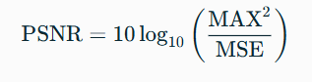
where MAX = 1 for normalized images.
The Trust-error correlation is:
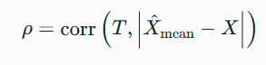
A negative value of ρ indicates that high-trust pixels generally have lower restoration error.
D. Baselines and Ablation Settings
Variant | Description
Degraded input | No restoration
Deep restoration | U-Net output
A Full TrustRestore | All trust components plus refinement
B No data trust | Data term removed
C No structural trust | Structural term removed
D No stability trust | Stability term removed
E No refinement | No bilateral refinement

TABLE I. Baselines and ablation configurations.
V. RESULTS AND ANALYSIS

A. Controlled Restoration Results
TrustRestore was evaluated on three images subjected to controlled compound degradation. Each clean source image was degraded using reduced illumination, Gaussian noise, motion blur and JPEG compression. The original clean images were retained as references for calculating PSNR and SSIM.
Table II compares the degraded input, mean deep-restoration output, and Trust-refined output for each evaluation image. PSNR measures pixel-level reconstruction fidelity, while SSIM measures structural similarity to the clean reference. Laplacian variance is reported as a supplementary sharpness indicator; however, it is not interpreted as a standalone measure of restoration quality because noise can increase its value.
The same degraded images were used for self-supervised training and subsequent evaluation. Consequently, these results describe image-specific reconstruction behavior rather than generalization to unseen images. With only three evaluation images, the experiment provides a preliminary assessment of the proposed framework.
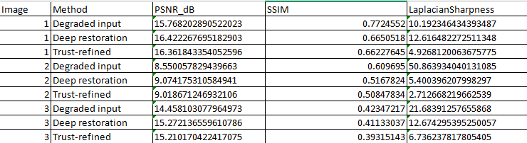
Table II. Controlled restoration results of three pictures

B. Trust Map Analysis
Fig. 4 shows the data-consistency, structural-consistency and prediction-stability components, together with the final fused Trust Map.
Data-consistency trust measures agreement between the restored output and the observed degraded image. Structural-consistency trust compares Sobel-gradient magnitudes to assess changes in local edge structure. Prediction-stability trust measures agreement among repeated Monte Carlo dropout predictions. Greater prediction variance reduces the stability score.
The final Trust Map combines these three signals. High scores identify regions that remain consistent with the observation, preserve measured edge structure and exhibit relatively stable predictions. Low scores identify regions with larger observation residuals, greater structural differences or higher prediction variability.
These scores are heuristic reliability indicators, not probabilities that a restored pixel is correct. In particular, consistency with a degraded observation does not necessarily imply consistency with the unknown clean image.
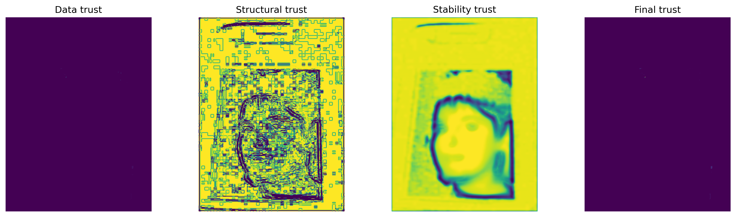
Fig. 4.a Data, structural, stability, and final Trust Maps.
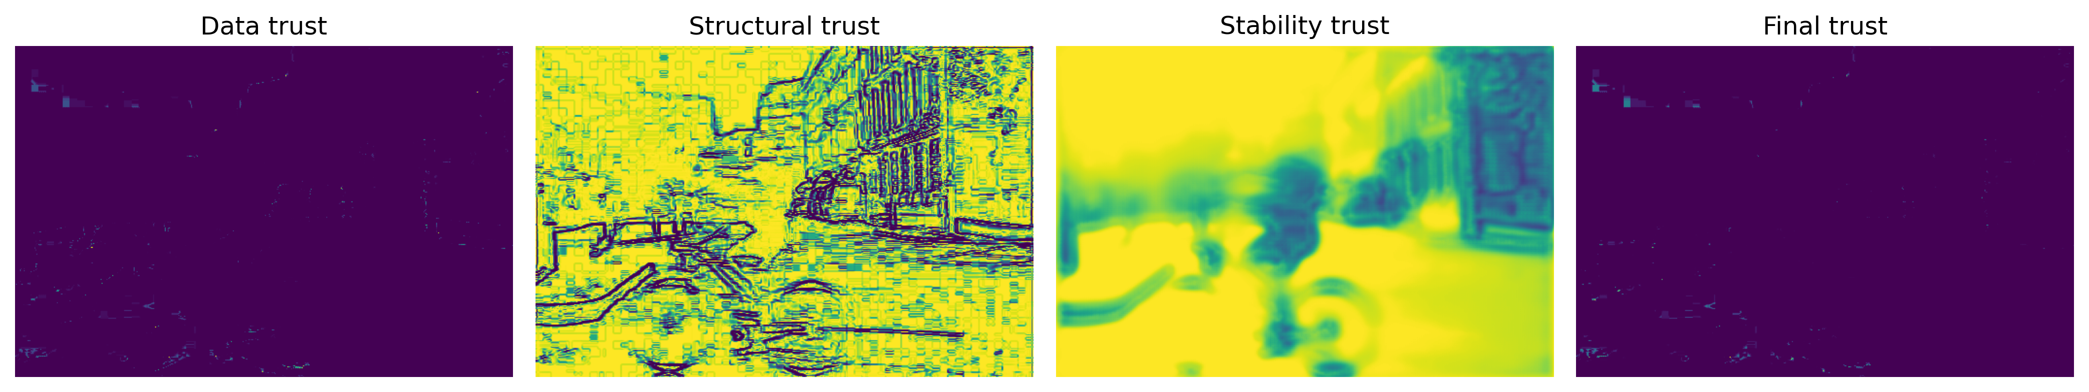
Fig. 4.b Data, structural, stability, and final Trust Maps.
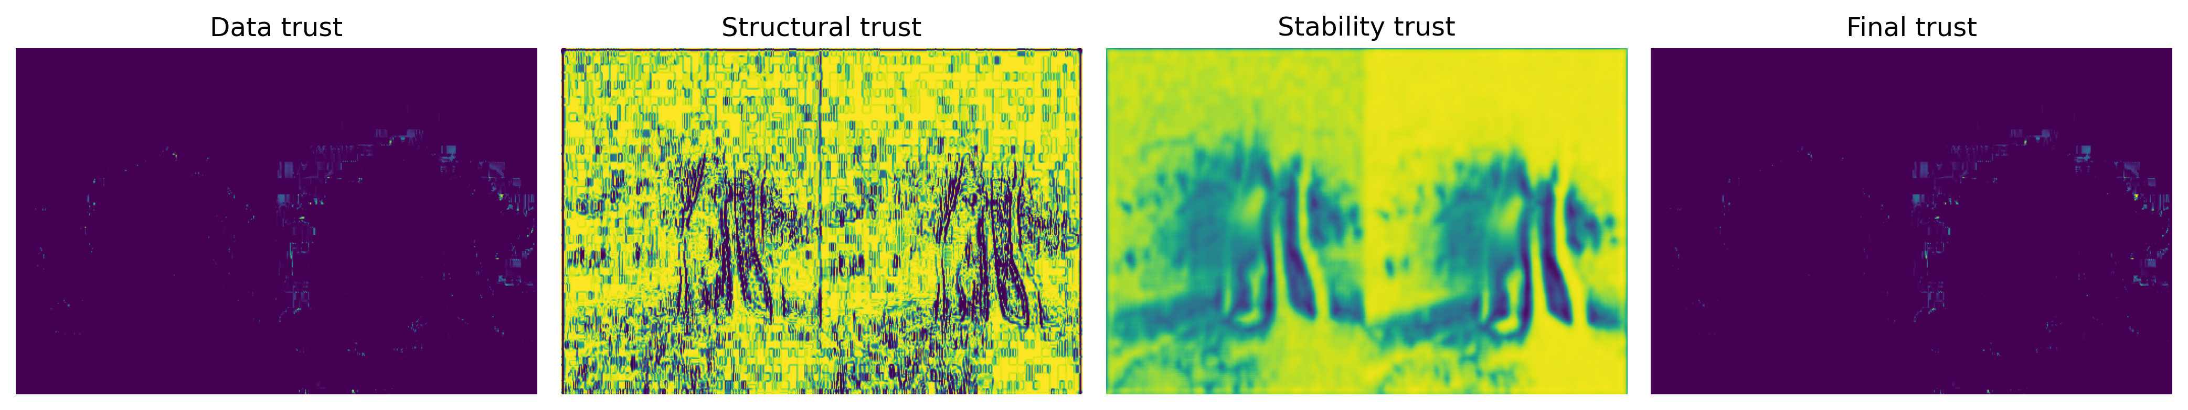
Fig. 4.c Data, structural, stability, and final Trust Maps.

C. Trust Score and Restoration Error
The relationship between predicted trust and reconstruction accuracy was examined using the known clean reference images. Pixel-wise restoration error was calculated as the mean absolute difference across the RGB channels between the mean deep-restoration output and the clean reference.
Fig. 5 presents scatter plots of Trust Score against restoration error. Pearson correlation coefficients are reported in Table III. The hypothesis is that higher Trust Scores should be associated with lower reconstruction errors, producing a negative correlation.
A negative correlation supports an inverse association within the evaluated image, but does not establish calibrated confidence or guarantee pixel-level correctness. Weak or positive correlations indicate that the proposed trust formulation does not reliably rank restoration errors for that image and should be reported without modification.
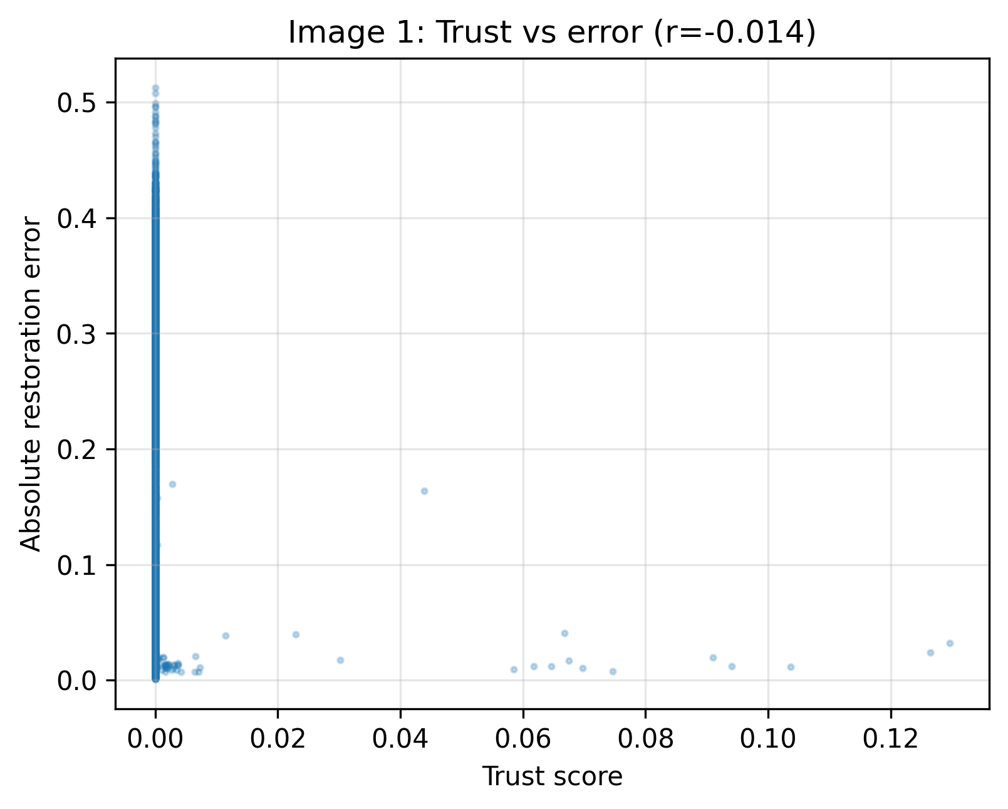
Fig. 5.a Trust Score versus absolute restoration error. A negative correlation supports the reliability hypothesis.
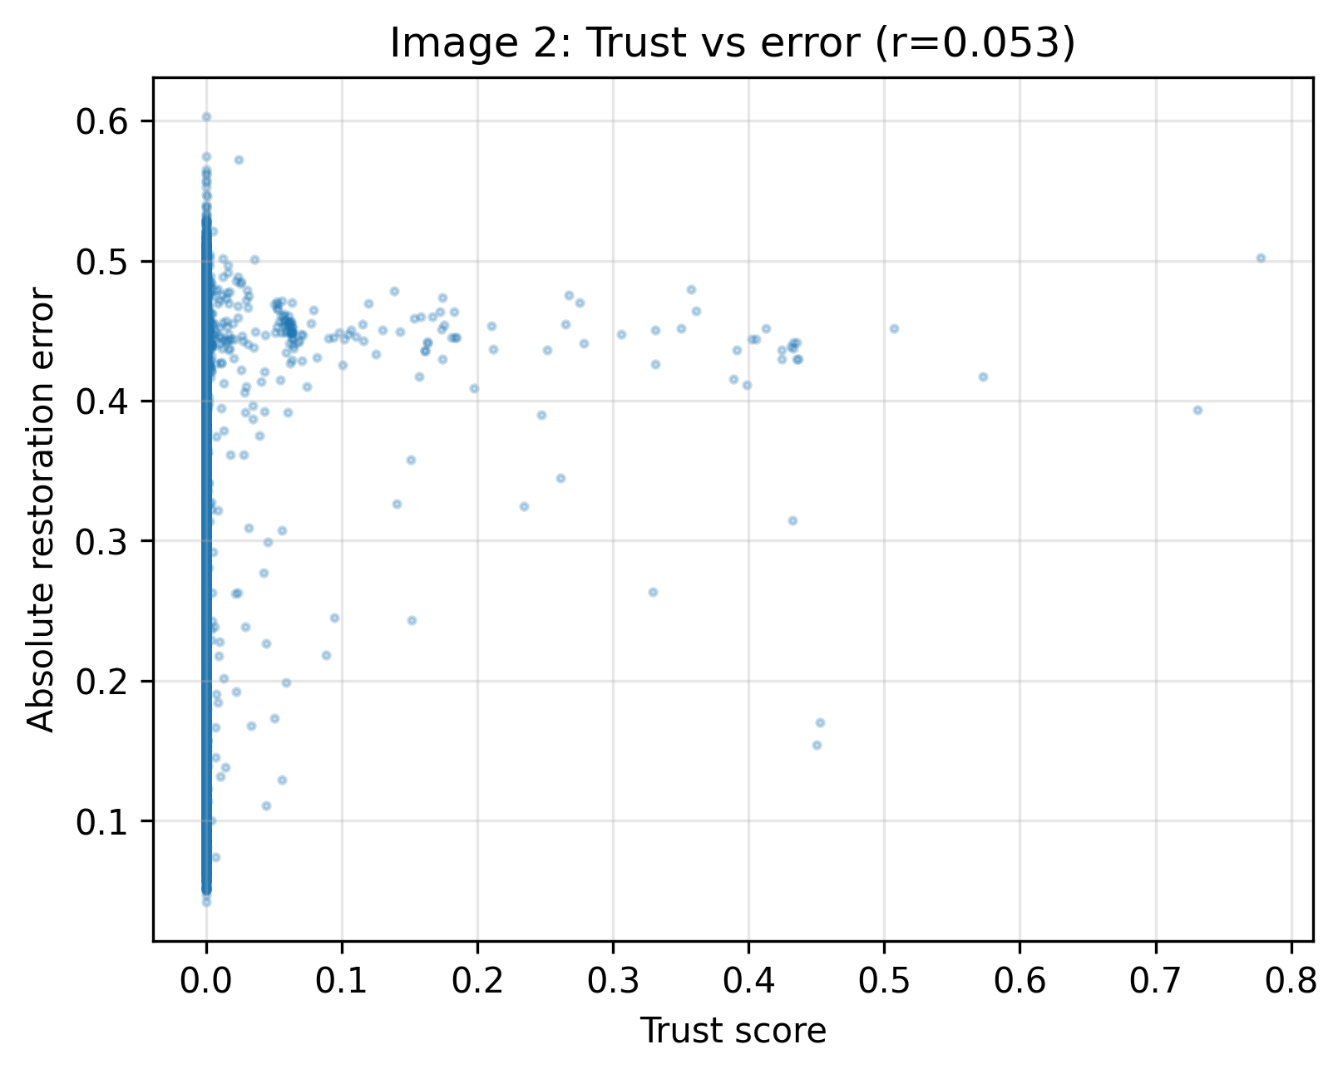
Fig. 5.b Trust Score versus absolute restoration error. A negative correlation supports the reliability hypothesis.
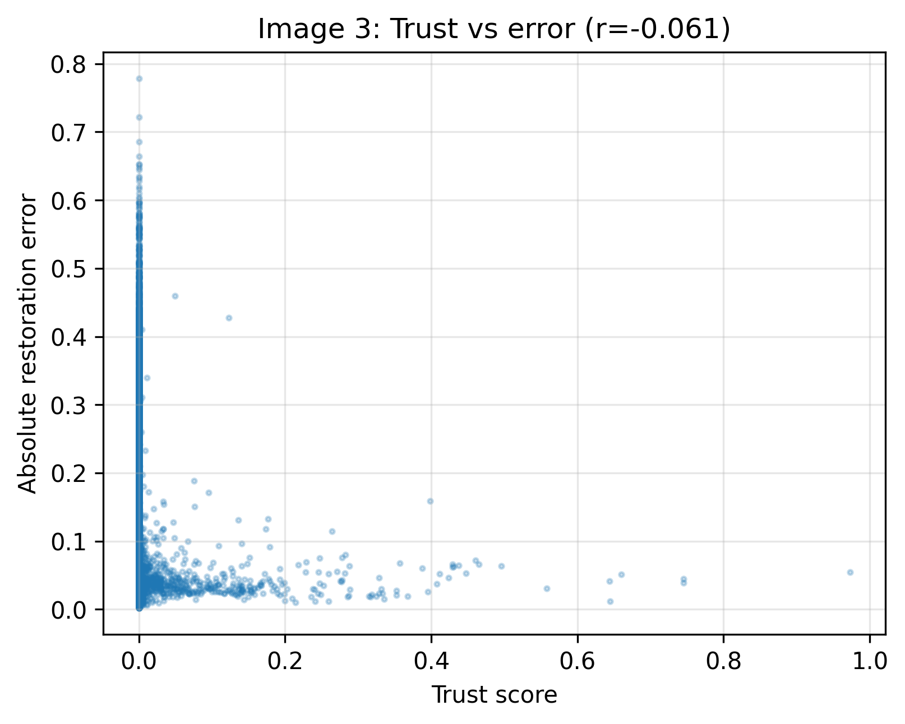
Fig. 5.c Trust Score versus absolute restoration error. A negative correlation supports the reliability hypothesis.
VI. ABLATION STUDY
An inference-stage ablation study was conducted to examine how the trust components influence the refinement output. The trained restoration model and its Monte Carlo predictions were kept fixed. The full framework was compared with variants that exclude data-consistency trust, structural-consistency trust, prediction-stability trust or trust-guided refinement.
Removing data-consistency trust excludes the observation-residual score from the fused Trust Map. Removing structural-consistency trust excludes the gradient-based score. Removing prediction-stability trust excludes the variance-based score. These changes affect the Trust Map and the selection of regions receiving bilateral filtering; they do not remove constraints from the U-Net training objective.
The no-refinement variant retains the mean deep-restoration output without applying bilateral filtering. Table IV reports mean PSNR, SSIM, and Laplacian variance across the three evaluation images. Fig. 6 summarizes the corresponding comparisons.
This experiment evaluates the behavior of the trust-guided post-processing stage. It does not independently establish that each component improves uncertainty calibration or that the restoration network outperforms an independently trained baseline. Differences between configurations should therefore be interpreted within the limited scope of this proof-of-concept study.
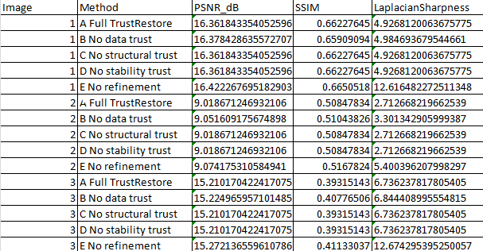
TABLE IV ABLATION RESULTS FOR TRUSTRESTORE COMPONENTS
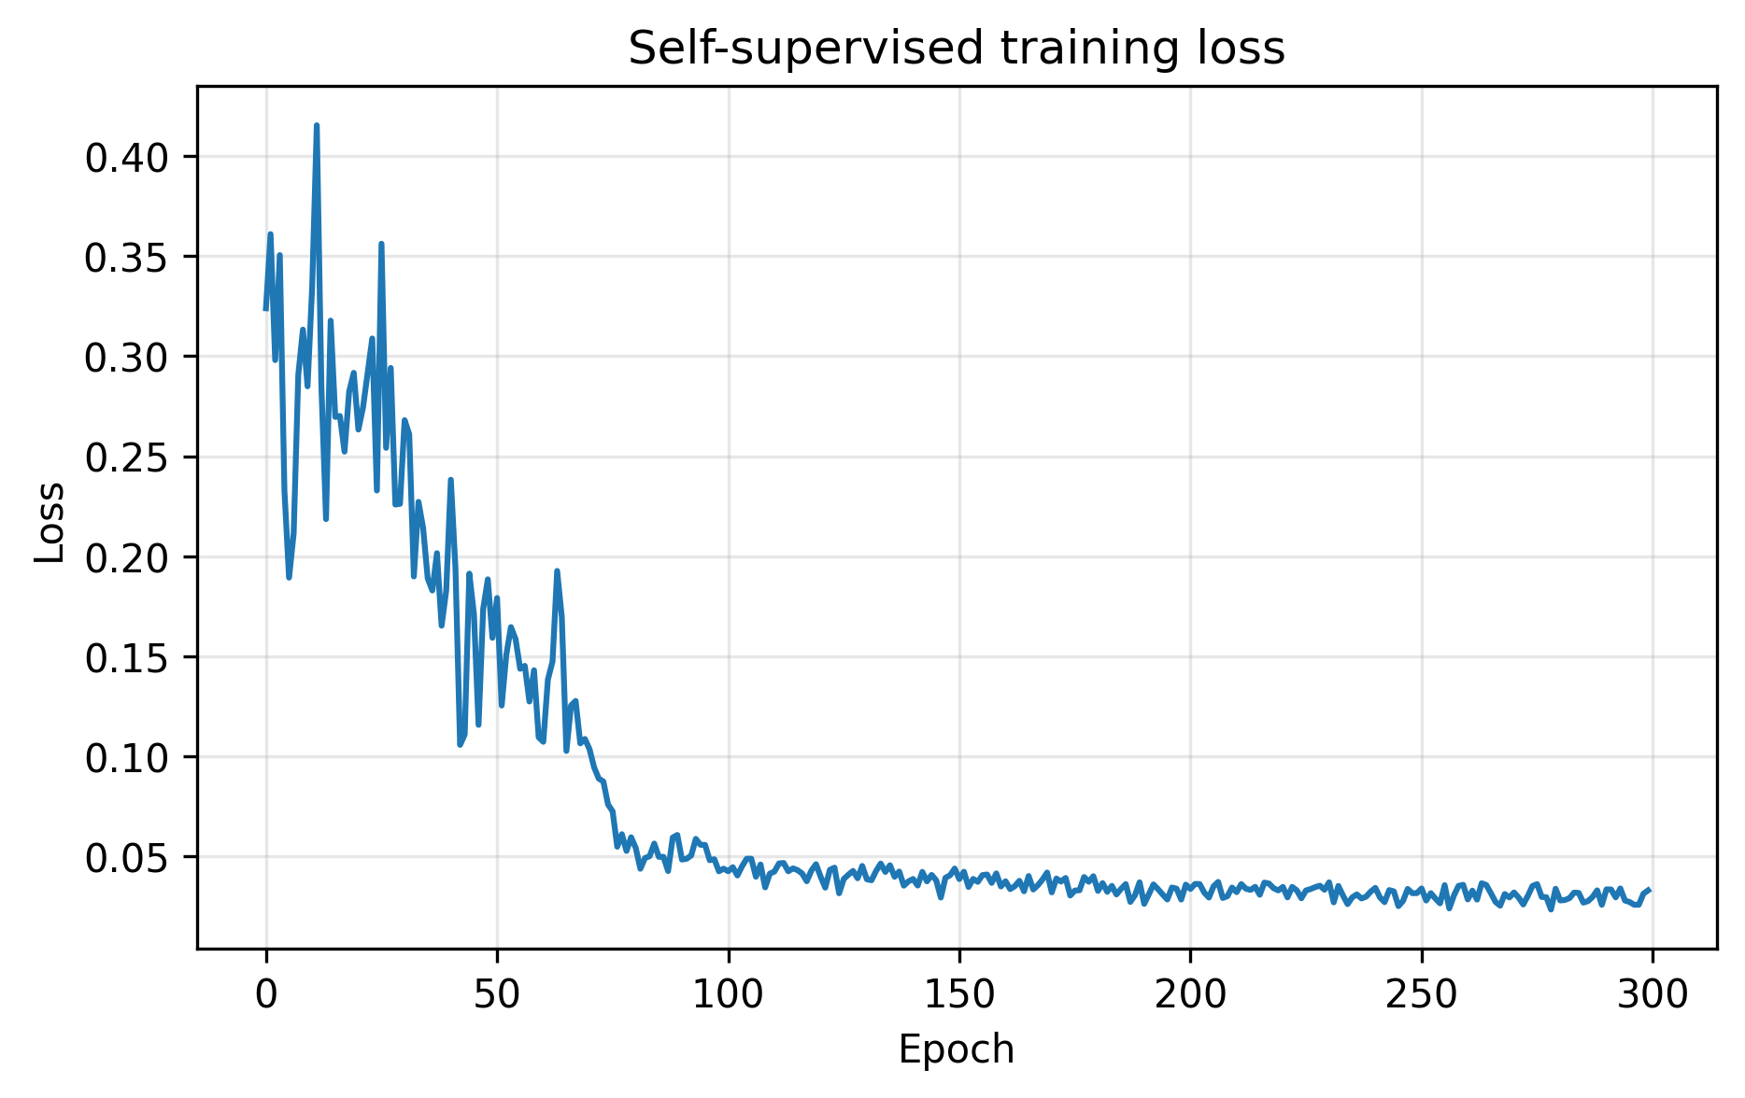
. 6. Mean inference-stage ablation results across the three evaluation images: (a) PSNR, (b) SSIM, and (c) Laplacian variance. All configurations use the same trained restoration model and Monte Carlo predictions.
VII. INTERACTIVE WEB DEMONSTRATION
A Gradio-based interface was developed to demonstrate the TrustRestore workflow. Users upload an image and receive three outputs: the mean deep-restoration result, a colorized per-pixel Trust Map and the Trust-refined output. The interface also provides a threshold control for selecting low-trust regions.
Uploaded images are resized when necessary to limit computational requirements. The interface supports qualitative inspection of the restoration and its associated trust estimates. However, accepting an arbitrary image does not establish that the model generalizes reliably to that image or its degradation.
PSNR and SSIM are not reported for arbitrary real-world uploads because corresponding clean references are unavailable. The interface is therefore presented as a research demonstration rather than a validated production restoration service.
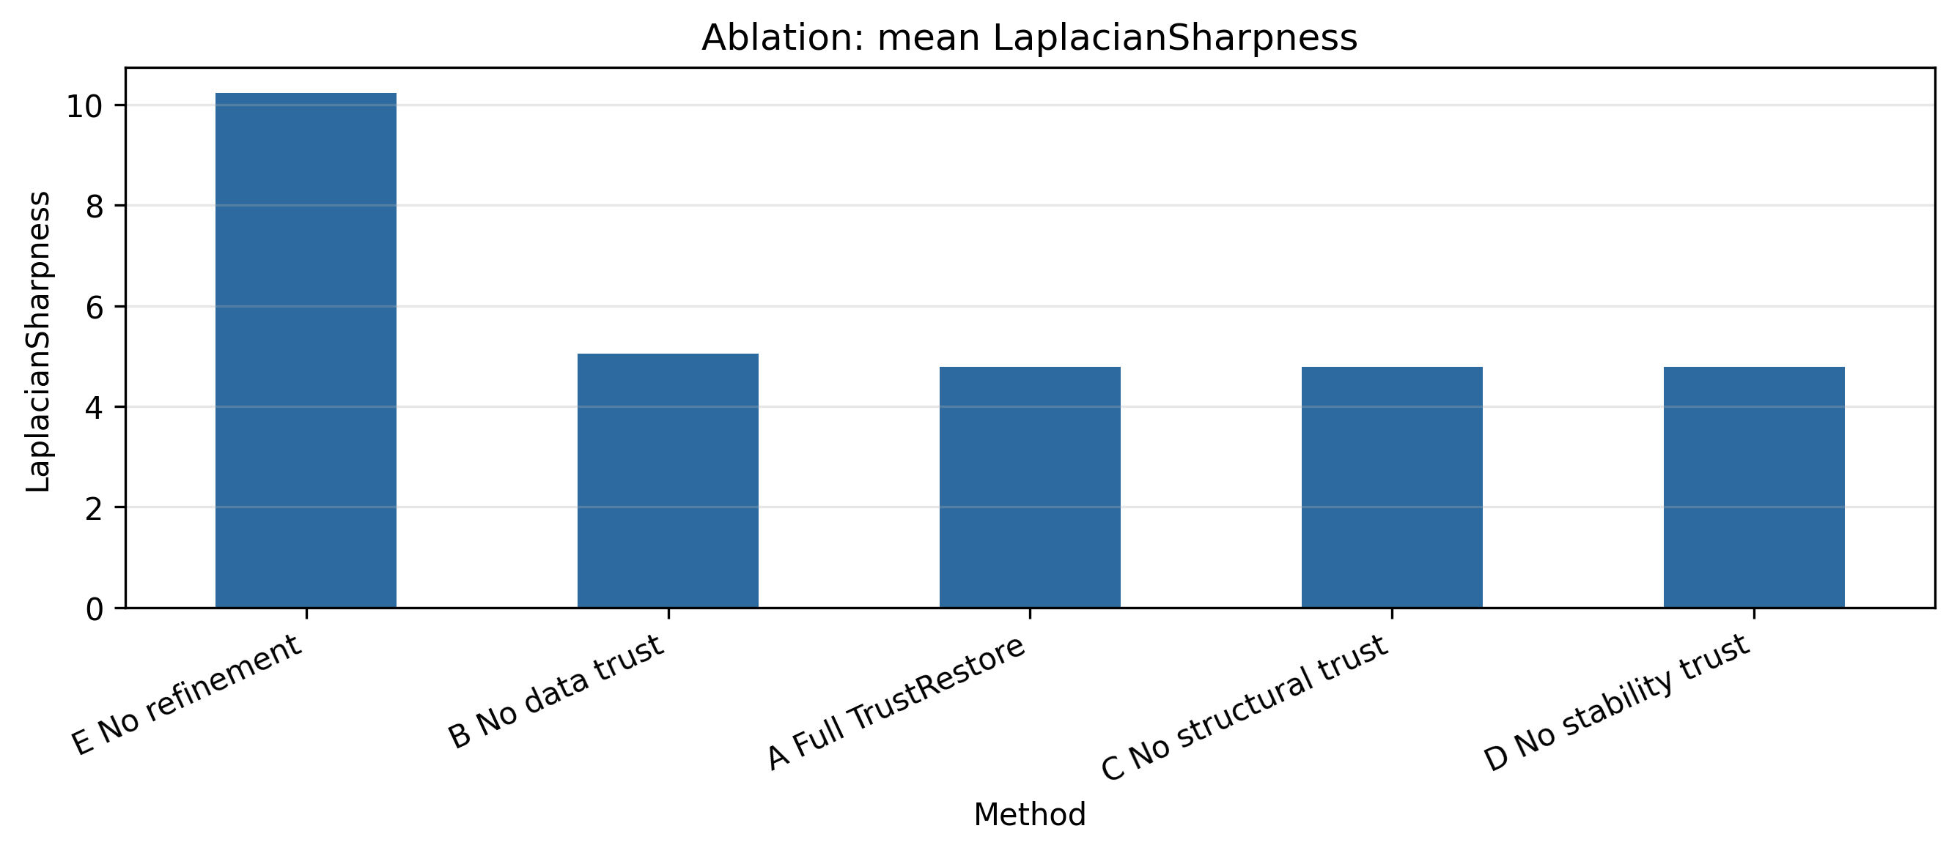
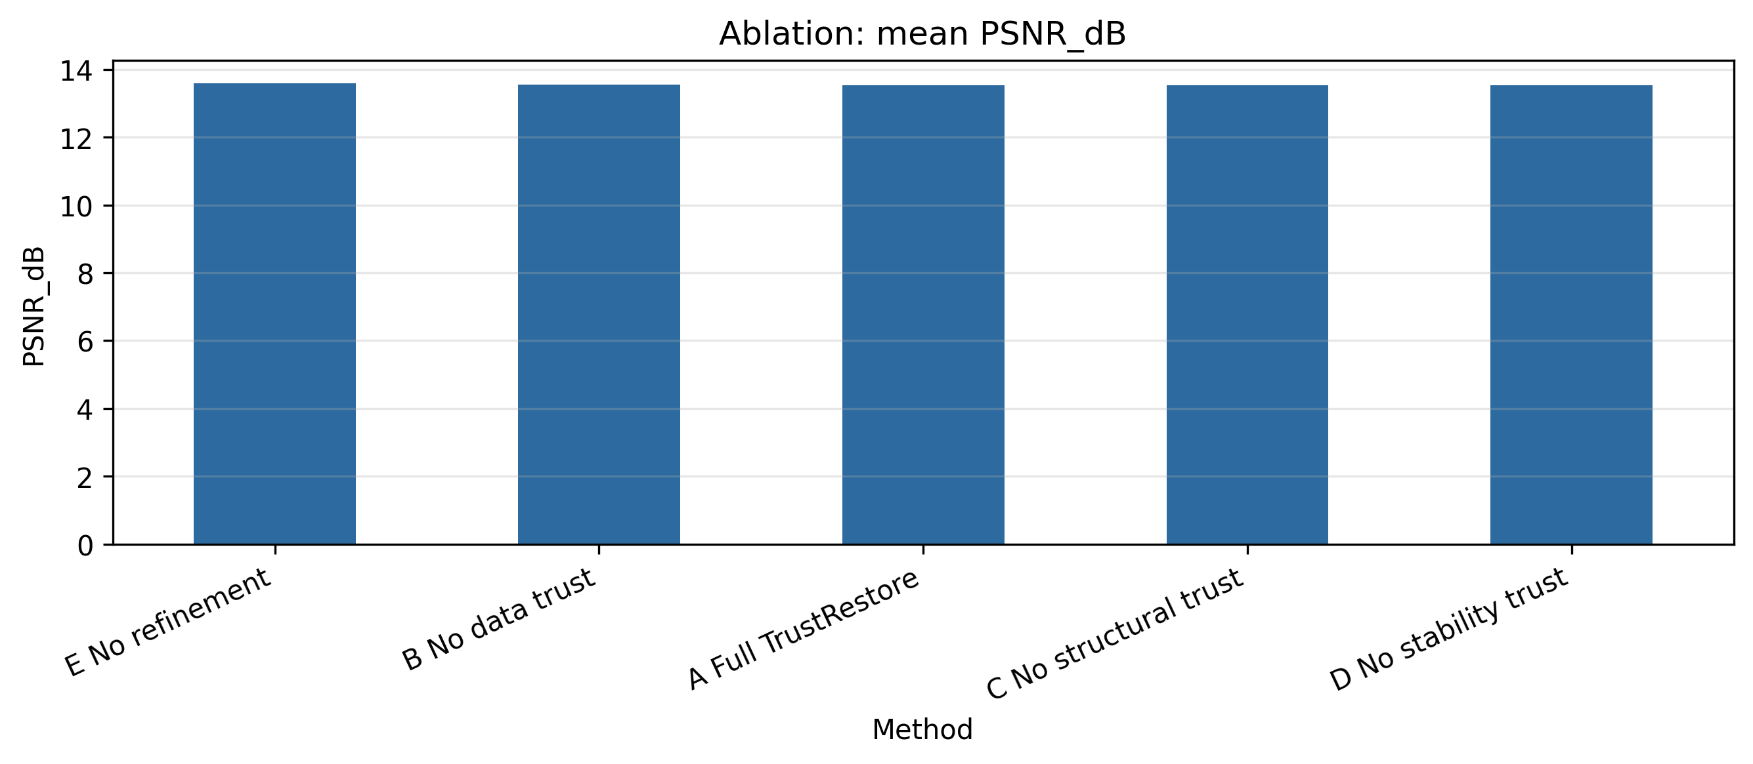
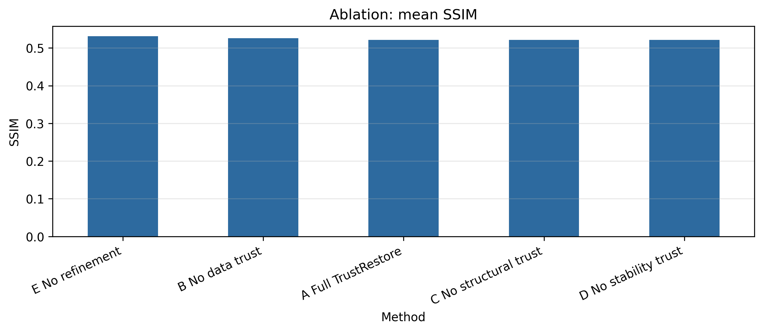
Fig. 7. TrustRestore interactive web interface. The user uploads an image and receives the deep-restored output, per-pixel Trust Map, and trust-refined output.
VIII. LIMITATIONS
This study has several limitations. First, the controlled evaluation contains only three images with synthetic compound degradation. Although clean references permit objective fidelity measurement, this small experiment does not represent the diversity of real-world camera degradation.
Second, the same degraded images are used for training and evaluation. The reported results therefore do not demonstrate generalization to unseen images. A separate evaluation on previously unseen images is required to support that claim.
Third, masked-pixel prediction uses degraded observations as training targets. The current objective does not explicitly invert motion blur, illumination loss or JPEG compression. Consequently, the model should not be assumed to recover all components of the synthetic degradation, and its output may retain degradation or oversmooth fine details.
Fourth, the Trust Map is an uncalibrated heuristic estimate. A model can produce stable but incorrect predictions, while agreement with noisy or blurred observations can favor incorrect content. Per-image normalization also limits direct comparison of Trust Scores across different images.
Fifth, the ablations assess trust-guided refinement using a fixed restoration model; they do not evaluate independently trained architectural or loss-function variants. Monte Carlo dropout additionally increases inference cost by requiring repeated forward passes.
Future work should evaluate more diverse images, separate image-specific adaptation from unseen-image testing, include established restoration baselines,examine noise-model assumptions, and assess uncertainty calibration. Deployment on embedded systems should be investigated only after restoration quality and computational requirements have been measured.
IX. CONCLUSION
This paper presented TrustRestore, a preliminary self-supervised framework for exploring image restoration and pixel-level reliability under limited-data conditions.A lightweight U-Net is trained using masked-patch prediction, and a Triple-Consistency Trust Score combines observation agreement, structural consistency and Monte Carlo prediction stability.
The resulting Trust Map guides bilateral refinement in low-trust regions. Controlled synthetic experiments provide clean references for PSNR, SSIM, restoration-error correlation and inference-stage ablation analysis. A Gradio interface demonstrates the image-upload workflow and visualizes the restoration alongside its trust estimates.
The study should be interpreted as an exploratory proof of concept. Conclusions about restoration improvement and trust-score usefulness must follow the measured results.Larger evaluations, independent baselines, unseen-image testing and calibrated reliability estimates are needed before claiming general effectiveness.
REFERENCES
- D. Ulyanov, A. Vedaldi, and V. Lempitsky, “Deep image prior,” in Proc. IEEE/CVF Conf. Comput. Vis. Pattern Recognit. (CVPR), 2018, pp. 9446–9454.
https://openaccess.thecvf.com/content_cvpr_2018/html/Ulyanov_Deep_Image_Prior_CVPR_2018_paper.html
- D. Ulyanov, A. Vedaldi, and V. Lempitsky, “Deep image prior,” in Proc. IEEE/CVF Conf. Comput. Vis. Pattern Recognit. (CVPR), 2018, pp. 9446–9454. https://proceedings.mlr.press/v80/lehtinen18a.html
- A. Krull, T.-O. Buchholz, and F. Jug, “Noise2Void—Learning denoising from single noisy images,” in Proc. IEEE/CVF Conf. Comput. Vis. Pattern Recognit. (CVPR), 2019, pp. 2129–2137.
https://openaccess.thecvf.com/content_CVPR_2019/html/Krull_Noise2Void_-Learning_Denoising_From_Single_Noisy_Images_CVPR_2019_paper.html
- Y. Gal and Z. Ghahramani, “Dropout as a Bayesian approximation: Representing model uncertainty in deep learning,” in Proc. 33rd Int. Conf. Mach. Learn. (ICML), vol. 48, 2016, pp. 1050–1059
https://proceedings.mlr.press/v48/gal16.html
- Z. Wang, A. C. Bovik, H. R. Sheikh, and E. P. Simoncelli, “Image quality assessment: From error visibility to structural similarity,” IEEE Trans. Image Process., vol. 13, no. 4, pp. 600–612, Apr. 2004, doi: 10.1109/TIP.2003.819861.
https://doi.org/10.1109/TIP.2003.819861
[6] C. Tomasi and R. Manduchi, “Bilateral filtering for gray and color images,” in Proc. 6th Int. Conf. Comput. Vis. (ICCV), 1998, pp. 839–846, doi: 10.1109/ICCV.1998.710815.
https://doi.org/10.1109/ICCV.1998.710815

