**Report**

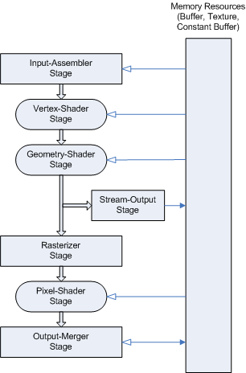Computer shaders are programmes used to render scenes and they run on the GPU. With the help of shaders, the stages of the graphics pipeline can be controlled. They can be programmed in assembly language or shading languages, like HLSL. Graphics APIs, like DirectX and OpenGL support shaders. Before shaders there was a fixed function pipeline, which wasn’t possible to program. It was based on user provided configuration and lacked flexibility. (Heergarden, 2011; OpenGL)

Figure 1: Fixed function pipeline (Bailey and Cunningham, 2009)

Figure 2: Programmable pipeline (Microsoft, 20218)

There are three main types of shaders: vertex shader, pixel shader and geometry shader. (Heergarden, 2011)

Vertex shaders operate on each vertex. It is used to transform the vertex’s 3D position into 2D viewport space. Normal mapping, manipulating textures and the position of the vertices can be done in the vertex shader too. (OpenGL, Bailey and Cunningham, 2009, Heergarden, 2011)

Pixel shaders (or fragment shaders) operate on each pixel. It can calculate the colour and transparency of each pixel, calculate lighting, shadows, and depth of field. (Bailey and Cunningham, 2009)

Geometry shaders can generate new primitives from the primitives that were sent to it. It is optional. (OpenGL) It was introduced in DirectX 10. (Anguelov, 2011)

**Techniques used in my shaders:**

**Lighting**

**References**

Anguelov, B. (2011*) DirectX10 Tutorial 9: The Geometry Shader*. Available at: <https://takinginitiative.wordpress.com/2011/01/12/directx10-tutorial-9-the-geometry-shader/>. [Accessed: 28 Apr 2020]

Bailey, M., Cunningham, S. (2009) *Graphics Shaders: Theory and Practice.* CRC Press. Boca Raton

Diard, F. (2007) GPU Gems 3 ch. 41.

Heergarden, M. (2011). *Graphics shaders*. Available at: <https://www.cs.vu.nl/~eliens/download/literatuur-shaders.pdf>. [Accessed: 28 Apr 2020]

OpenGL (n.d.) *Fixed Function Pipeline.* Available at: <https://www.khronos.org/opengl/wiki/Fixed_Function_Pipeline>. [Accessed: 28 Apr 2020]

OpenGL (n.d.) *Geometry Shader.* Available at: <https://www.khronos.org/opengl/wiki/Geometry_Shader>. [Accessed: 28 Apr 2020]

OpenGL (n.d.) *Vertex Shader.* Available at: <https://www.khronos.org/opengl/wiki/Vertex_Shader> [Accessed: 28 Apr 2020]

Microsoft (2018) *Pipeline Stages (Direct3D 10).* Available at: <https://docs.microsoft.com/en-gb/windows/win32/direct3d10/d3d10-graphics-programming-guide-pipeline-stages?redirectedfrom=MSDN>. [Accessed: 28 Apr 2020]