Computing Project Technical Plan

Name: Lili Veszeli
Course: Computer Games Development
Supervisory Team: Games Team

Title
Cross Stitch Pattern Generator

Summary
I will create a computer application that will generate a cross stitch pattern based on an image. The user would be able to modify the pattern, for example change colours, change stitch location, change overall size. The pattern can be saved and printed. I will also have to a make a User Interface.
The difficult part in this project will be figuring out how to edit the pattern, making sure that the pattern looks right and uses the correct colours. I will need to research different methods to create these features. Working with C# will also be challenging since I am more familiar with C++.
I will use the Waterfall model as my development methodology, since we have set deadlines and once we submitted the required material we can’t change it. Some tools from Agile will be used too, like Moscow; this can make sure that all the essential features will be complete (Waters, 2009).Testing will be done too to make sure the program works as expected.

Deliverables
The main product of this project will be a Windows based computer software that will be able to generate a cross stitch pattern from a picture. Other deliverables will be the report and poster.

Constraints
The most serious constraint is the deadlines. It might be the case that the application won’t have all the features because of the limited time available for development.
Another constraint could be lack of resources. I might not find specific enough resources about how to create different features for my project.
The methodology used in my project could be a constraint. Using the Agile methodology is not possible since we can’t change our project after submitting the proposal. This might not be flexible enough for the project.

Key Problems

The main difficulties will be
- to figure out how to edit the generated cross stitch pattern. I am not familiar enough with WPF to know how it could be done, so I will need to research it more.
- to design an efficient and clean user interface. I will need to research examples for it and experiment with my UI.
- to figure out how to work with pixels in WPF.

System and Work Outline

The project will be developed will be developed using WPF in C# and XAML. The UI component will be made using WPF’s built in drag and drop UI editor. This can be further customized with XAML. The behaviour of the UI and the backend will be programmed in C#. Visual Studio will be used for the development environment. GitHub will be used for version control and backup.

Features of the program using Moscow prioritization:

Must have:

A Windows application that can convert a picture’s pixels to bigger squares.

Basic UI.

A grid over the picture/pattern.

The ability to save it and print it.

Should have:

The ability to resize the pattern.

More advanced UI.

Saving it in a PDF.

The ability to edit the pattern.

The ability to reduce the number of colours used in the pattern.

Could have:

The ability to use real thread colours.

Zoom in while editing.

Won’t have (but Would like in the future):
- Other types of stitches.
- Representation of how the pattern will look once finished.
- Blended colours.

(Agile Business Consortium, 2019)

Regarding WPF, I will need to research how images could be loaded in, how to make a modern UI and how to manipulate graphics (Sells & Griffiths, 2007).
I will also need to research how to navigate Windows folders, save and print files (Microsoft Docs., 2020).

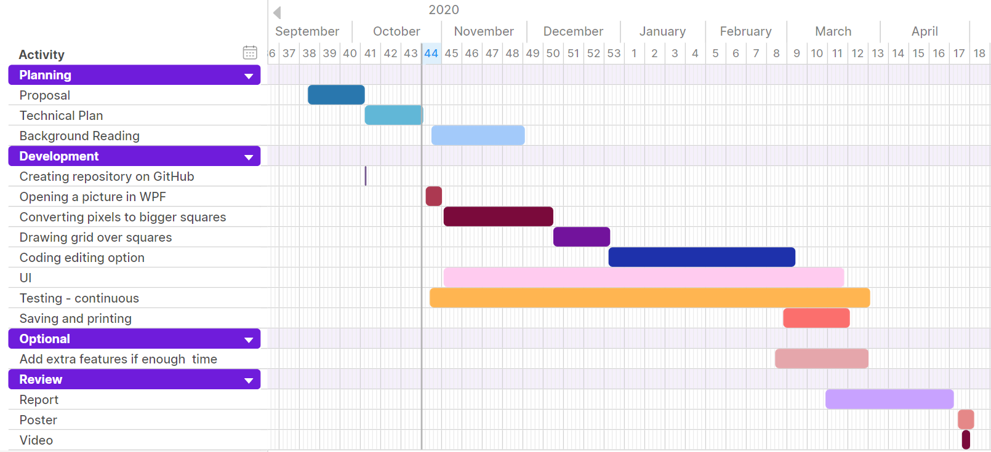
Project Activities

Risk Analysis

Risk | Severity | Likelihood | Action
My computer breaks | Severe | Small | Get it fixed – would hinder development by a few days.  Alternatively, work in the games lab – good solution, but might be difficult because of the limited availability this year.
Not being able to implement every planned feature. | Low | High | To be able to demonstrate my program it only needs the most important features, which are highly likely to be implemented. Using Moscow will help to ensure this.
Loss of data | Severe | Low | Making copies of the project every time I add to it, and storing it on a cloud based server.

Options

As an alternative to the Waterfall method, Agile could be used. However, because the deadlines for the deliverables are already set it makes the development less flexible. Main features cannot be changed either. Since I know what kind of features I want, I won’t have to do major changes to the program. It is also harder to use agile techniques if developing alone. Because of these constraints the best suited project management methodology for this project is Waterfall (Balaji & Murugaiyan ,2012).

An alternative I considered to develop the program in was Windows forms. However, WPF is a more modern and more flexible version of Windows forms, with more customization options (“WPF vs. WinForms”, 2020). In WPF the UI editor is in XAML, with a drag and drop menu.
Another option could be DirectX 11. It would need a Windows library to be able to make the UI and it would be unnecessarily complicated to make the pattern using shaders.

Windows is the target environment. This program can be used most effectively on a computer, in a mobile app version the user wouldn’t be able to use the features properly. Later on, the project could be expanded to macOS and Linux, but this is not part of the objectives now because of the time limitation.

Potential Ethical or Legal Issues
Legal issues might arise regarding the copyright law (Copyright, Designs and Patents Act 1988). If the program turns out to be too similar to one previously made, it could be a problem. However, this can be avoided by writing original code, not copying code that isn’t allowed to be freely used, and designing my own UI and mechanics of the application.

Commercial Analysis

Factor name | Description | Is this a cost or a benefit | Estimated Amount | Estimate of when paid
Hardware | Computer to develop the project on. | Cost | Cost of my laptop - £900 | Start of the project
Software | Windows operating system | Cost | Cost of Windows 10 Pro - £220 | Start of the project
Salary | Salary for developing the program | Benefit | Salary for 30 weeks (academic year) based on average junior games developer salary - £12750  (Prospects, 2020) | Every month
Advertisement | Cost to advertise the product to the targeted audience | Cost | Facebook advertisement for 2 months –  £600 | End of project
Price | Price of the product | Benefit | £15 every time it’s purchased | End of project

Employability Contribution
This project will help me get a better understanding of making software for the public. It will improve my skill at UI design and my coding abilities in C# and XAML. I will gain experience in programming a Windows application. After writing the report I will be better at written communication.
The project can be expanded with a lot more features and could be marketed.

References

Agile Business Consortium. (2019). Chapter 10: Moscow Prioritisation. Retrieved from: https://www.agilebusiness.org/page/ProjectFramework_10_MoSCoWPrioritisation

Balaji, S., & Murugaiyan, M. S. (2012). Waterfall vs. V-Model vs. Agile: A comparative study on SDLC. International Journal of Information Technology and Business Management, 2(1), 26-30.

Copyright, Designs and Patents Act 1988, c.3. Retrieved from: https://www.legislation.gov.uk/ukpga/1988/48/

Game developer job profile | Prospects.ac.uk. (2020). Retrieved October 26, 2020, from https://www.prospects.ac.uk/job-profiles/game-developer

PrintDocument.Print Method (System.Drawing.Printing) | Microsoft Docs. (2020). Retrieved October 26, 2020, from https://docs.microsoft.com/en-us/dotnet/api/system.drawing.printing.printdocument.print?view=dotnet-plat-ext-3.1

Sells, C., & Griffiths, I. (2007). Programming WPF: Building Windows UI with Windows Presentation Foundation. " O'Reilly Media, Inc.".

Waters, K. (2009). Prioritization using moscow. Agile Planning, 12, 31.

WPF vs. WinForms - The complete WPF tutorial. (2020). Retrieved October 26, 2020, from https://www.wpf-tutorial.com/about-wpf/wpf-vs-winforms/

