**Assignment 6 Deliverables ------ Henry & Jiachen**

* A short report with:
  + Evidence that your tutor can handle *all* solutions to the two problems provided (foxglove and lupine). I.e., for each problem, show two screenshots of completed problems, including at least one solution for each problem that is not in the behavior graphs that are provided.

**For the foxglove problem:**

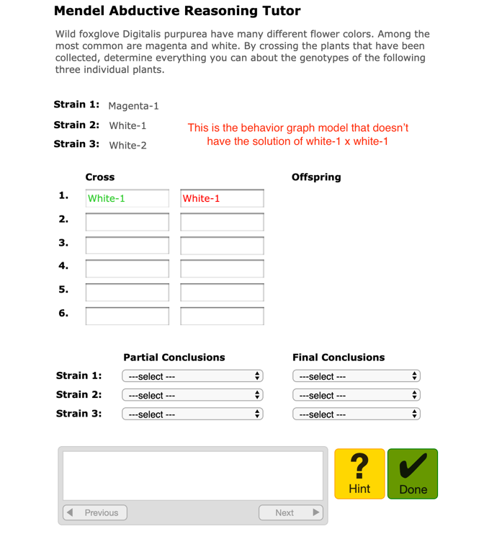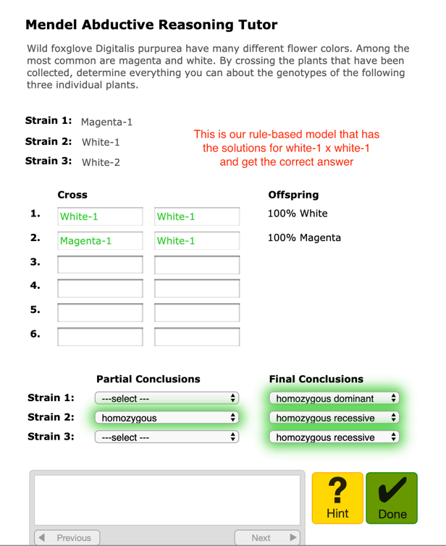

**For the lupine problem:**

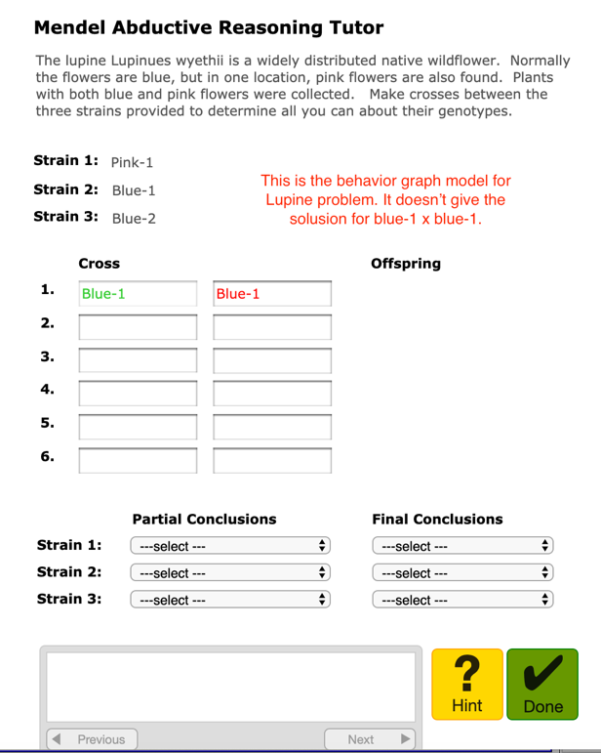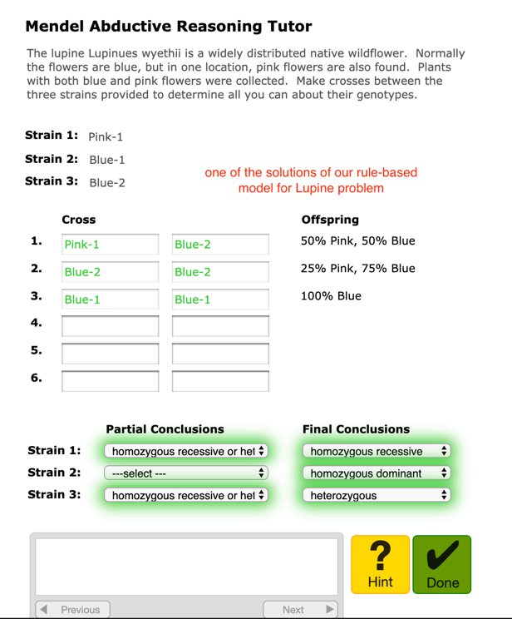

* + Documentation for the model
* Lo-fi diagram that shows working memory structure

**Lo-fi diagram for working memory structure:**

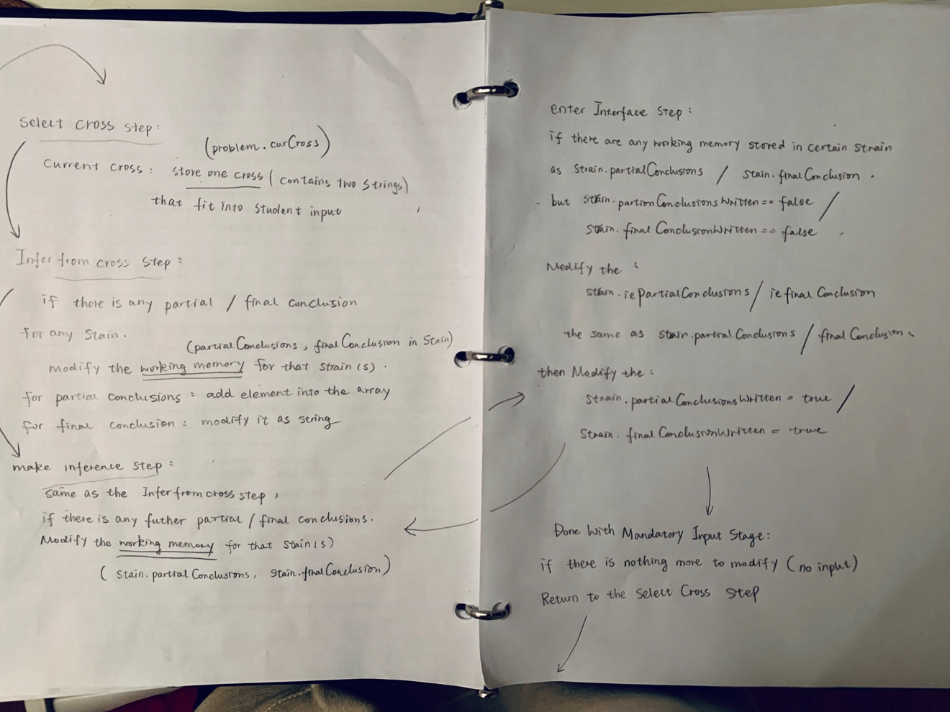

Lo-fi diagram for rules:

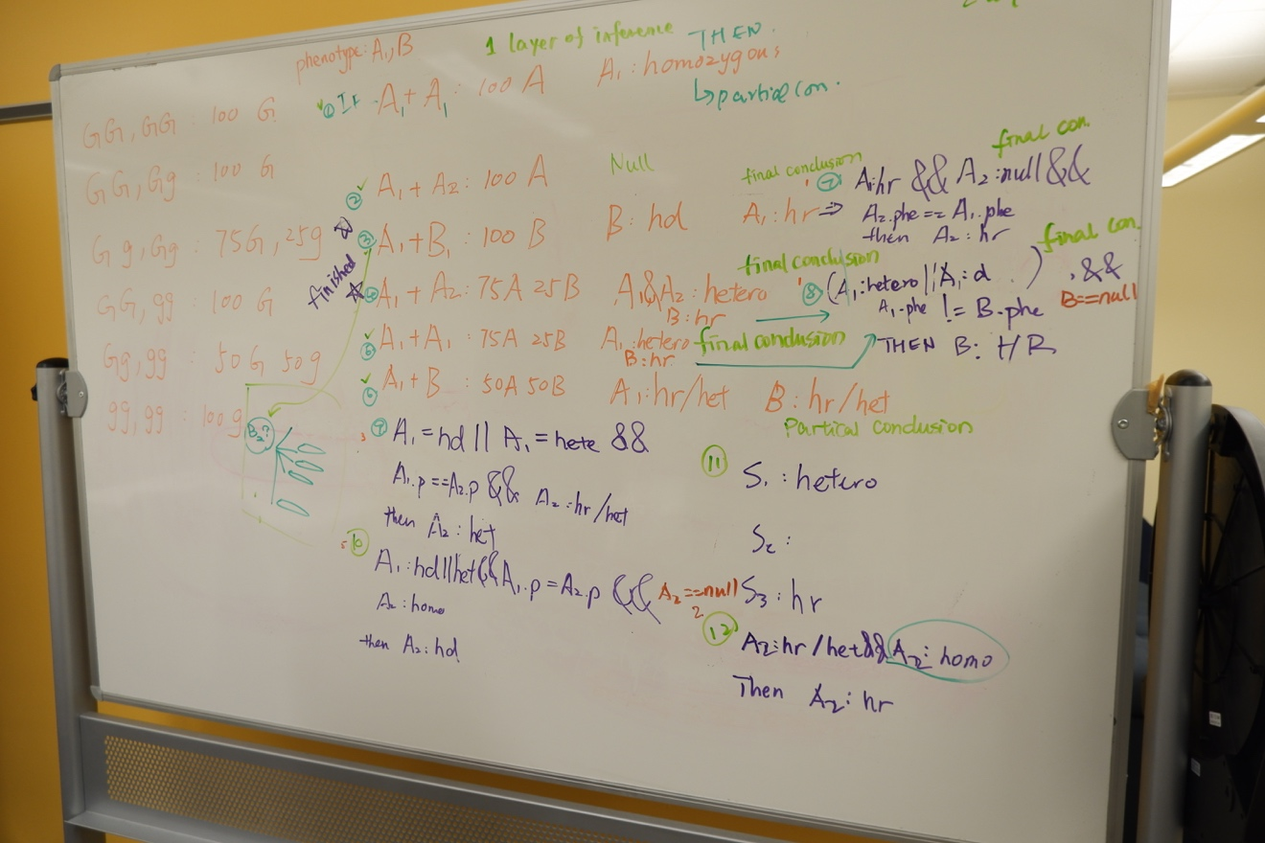

* English versions of all rules, included with the rules themselves in the rules file

**Nools Code in English**

NOTE: RULE 1-6 ARE infer_from_cross RULES

RULE 7-13 ARE make_further_inference RULES

**RULE 1**

**inferFromS1xS1_100A**

**IF** there is a goal to determine the gene type of S

And S1’s partial conclusion is not defined

And S1’s final conclusion is not defined

And the two strains are the identical plant

And the cross for S1xS1 result is equal to 100 percent of phenotype A

**THEN**

Write S1’s partial conclusion as Homozygous

**RULE 2 – No Conclusion**

**inferFromS1xS2_100A**

**IF** there is a goal to determine the gene type of S

And S1’s partial conclusion is not defined

And S1’s final conclusion is not defined

And S2’s partial conclusion is not defined

And S2’s final conclusion is not defined

And the cross for S1xS2 result is equal to 100 percent of phenotype A

**THEN**

We cannot draw any conclusion

Do not change anything to the working memory

**RULE 3**

**inferFromS1xS3_100B**

**IF** there is a goal to determine the gene type of S

And S1’s partial conclusion is not defined

And S1’s final conclusion is not defined

And S3’s partial conclusion is not defined

And S3’s final conclusion is not defined

And the phenotype of S1 is different from the phenotype of S3

And the cross for S1xS3 result is equal to 100 percent of phenotype B

**THEN**

Write S1’s final conclusion as Homozygous Recessive

Write S3’s final conclusion as Homozygous Dominant

**RULE 4**

**inferFromS1xS2_75A**

**IF** there is a goal to determine the gene type of S

And S1’s partial conclusion is not defined

And S1’s final conclusion is not defined

And S2’s partial conclusion is not defined

And S2’s final conclusion is not defined

And the phenotype of S1 is the same as the phenotype of S2

And the cross for S1xS2 result is equal to 75 percent of phenotype A, and 25 percent of phenotype B

**THEN**

Write S1’s final conclusion as Heterozygous

Write S2’s final conclusion as Heterozygous

**RULE 5 – the same as RULE 4**

**inferFromS1xS1_75A**

**IF** there is a goal to determine the gene type of S

And S1’s partial conclusion is not defined

And S1’s final conclusion is not defined

And the two strains are the identical plant

And the cross for S1xS1 result is equal to 75 percent of phenotype A, and 25 percent of phenotype B

**THEN**

Write S1’s final conclusion as Heterozygous

**RULE 6**

**inferFromS1xS3_50B**

**IF** there is a goal to determine the gene type of S

And S1’s partial conclusion is not defined

And S1’s final conclusion is not defined

And S3’s partial conclusion is not defined

And S3’s final conclusion is not defined

And the phenotype of S1 is different from the phenotype of S3

And the cross for S1xS3 result is equal to 50 percent of phenotype A, and 50 percent of phenotype B

**THEN**

Write S1’s partial conclusion as “Heterozygous or Homozygous recessive”

Write S3’s partial conclusion as “Heterozygous or Homozygous recessive”

**RULE 7**

**makeInferenceFromS1xS2_HR**

**IF** there is a goal to determine the gene type of S

And S1’s final conclusion is Homozygous Recessive

And the phenotype of S1 is the same as the phenotype of S2

**THEN**

Write S2’s final conclusion as Homozygous Recessive

**RULE 8**

**makeInferenceFromS1xS3_HR**

**IF** there is a goal to determine the gene type of S

And S1’s final conclusion is Heterozygous or Homozygous Dominant

And the phenotype of S1 is the different from the phenotype of S3

**THEN**

Write S3’s final conclusion as Homozygous Recessive

**RULE 9**

**makeInferenceFromS1xS2_HET**

**IF** there is a goal to determine the gene type of S

And S1’s final conclusion is Heterozygous or Homozygous Dominant

And the phenotype of S1 is the same as the phenotype of S2

And S2’s partial conclusion is “Heterozygous or Homozygous recessive”

**THEN**

Write S2’s final conclusion as Heterozygous

**RULE 10**

**makeInferenceFromS1xS2_same_HD**

**IF** there is a goal to determine the gene type of S

And S1’s final conclusion is Heterozygous or Homozygous Dominant

And the phenotype of S1 is the same as the phenotype of S2

And S2’s partial conclusion is “Homozygous”

**THEN**

Write S2’s final conclusion as Homozygous Dominant

**RULE 11**

**makeInferenceFromS1xS2_HD**

**IF** there is a goal to determine the gene type of S

And S1’s final conclusion is Heterozygous

And S3’s final conclusion is Homozygous Recessive

And the phenotype of S1 is the same as the phenotype of S2

And the cross for S1xS2 result is equal to 100 percent of phenotype A

**THEN**

Write S2’s final conclusion as Homozygous Dominant

**RULE 12**

**makeInferenceFromS1xS1_HR**

**IF** there is a goal to determine the gene type of S

And S1’s partial conclusion is “Heterozygous or Homozygous recessive”

And the two strains are the identical plant

And the cross for S1xS1 result is equal to 100 percent of phenotype A

**THEN**

Write S1’s final conclusion as Homozygous Recessive

**RULE 13**

**makeInferenceFromTwoPartial**

**IF** there is a goal to determine the gene type of S

And S1 has two partial conclusions

And S1 has no final conclusion

**THEN**

Write S1’s final conclusion as Homozygous recessive

* + Reflection on the strengths and limitations (in a pedagogical sense) of the tutor you built.

For Strengths:

For limitations:

* + A few sentences on how you worked together as a team
  + What was hard about this assignment?
  + What was good and bad about CTAT including the tools for Nools modeling
* Please include all screen shots and diagrams within the report file, not in separate files.