Sisteme de Gestiune a Bazelor de Date

Informatică an II

Tufă Liliana-Ionela, Grupa 234

PROIECT

1. **Prezentați pe scurt baza de date (utilitatea ei).**

Baza de date va gestiona informaţii legate de funcționarea unui spital. Sunt stocate informații despre angajați, pacienți, dar și procedurile prin care aceștia trec, cum ar fi consultații sau operații.

1. **Realizați diagrama entitate-relație (ERD).**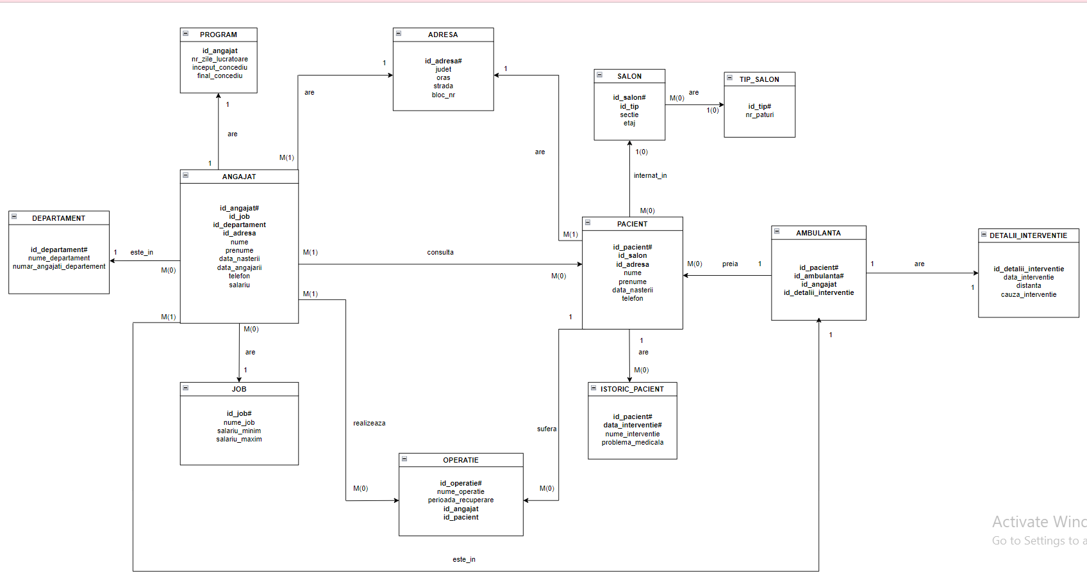

1. **Pornind de la diagrama entitate-relație realizați diagrama conceptuală a modelului propus, integrând toate atributele necesare.**

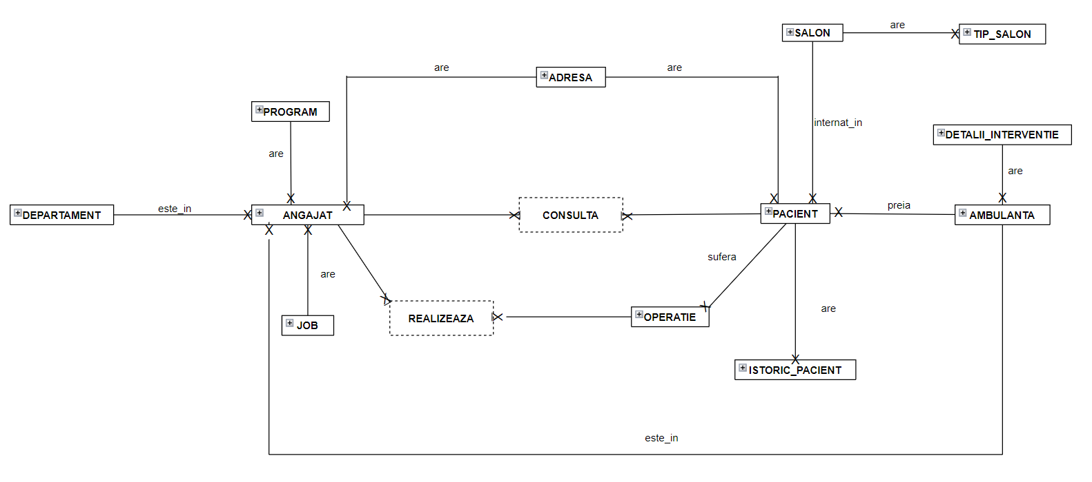

1. **Implementați în Oracle diagrama conceptuală realizată: definiți toate tabelele, implementând toate constrângerile de integritate necesare (chei primare, cheile externe etc).**

CREATE TABLE JOB(

id_job NUMBER(5) PRIMARY KEY NOT NULL,

nume_job VARCHAR(25) NOT NULL,

salariu_minim NUMBER(6) NOT NULL,

salariu_maxim NUMBER(6) NOT NULL

);

CREATE TABLE TIP_SALON (

id_tip NUMBER(1) PRIMARY KEY NOT NULL,

nr_paturi NUMBER(2) NOT NULL

);

CREATE TABLE ADRESA (

id_adresa NUMBER(5) PRIMARY KEY NOT NULL,

judet VARCHAR(25) NOT NULL,

oras VARCHAR(25) NOT NULL,

strada VARCHAR(25) NOT NULL,

bloc_nr NUMBER(3) NOT NULL

);

CREATE TABLE DEPARTAMENT (

id_departament NUMBER(5) PRIMARY KEY NOT NULL,

nume_departament VARCHAR(50) NOT NULL,

numar_angajati_departament NUMBER(3)

);

CREATE TABLE ANGAJAT (

id_angajat NUMBER(5) PRIMARY KEY NOT NULL,

id_job NUMBER(5) REFERENCES JOB(id_job) ON DELETE SET NULL,

id_departament NUMBER(5) REFERENCES DEPARTAMENT(id_departament) ON DELETE SET NULL,

id_adresa NUMBER(5) REFERENCES ADRESA(id_adresa) ON DELETE SET NULL,

nume VARCHAR(25) NOT NULL,

prenume VARCHAR(25) NOT NULL,

data_angajarii DATE NOT NULL,

telefon VARCHAR(10) NOT NULL,

salariu NUMBER(6) NOT NULL

);

CREATE TABLE SALON(

id_salon NUMBER(3) PRIMARY KEY NOT NULL,

id_tip NUMBER(1) REFERENCES TIP_SALON(id_tip) ON DELETE SET NULL,

sectie VARCHAR(50) NOT NULL,

etaj NUMBER(2) NOT NULL

);

CREATE TABLE PROGRAM(

id_angajat NUMBER(5) REFERENCES ANGAJAT(id_angajat) ON DELETE SET NULL,

nr_zile_lucratoare NUMBER(3) NOT NULL,

inceput_concediu DATE NOT NULL,

final_concediu DATE NOT NULL

);

CREATE TABLE PACIENT (

id_pacient NUMBER(5)PRIMARY KEY NOT NULL,

id_salon NUMBER(3) REFERENCES SALON(id_salon),

id_adresa NUMBER(5) REFERENCES ADRESA(id_adresa) ON DELETE SET NULL,

nume VARCHAR(25) NOT NULL,

prenume VARCHAR(25) NOT NULL,

data_nasterii DATE NOT NULL,

telefon VARCHAR(10) NOT NULL

);

CREATE TABLE DETALII_INTERVENTIE(

id_detalii_interventie NUMBER(5) PRIMARY KEY NOT NULL,

data_interventie DATE NOT NULL,

distanta NUMBER(2) NOT NULL,

cauza_interventie VARCHAR(50) NOT NULL

);

CREATE TABLE OPERATIE(

id_operatie NUMBER(5) PRIMARY KEY NOT NULL,

nume_operatie VARCHAR(50) NOT NULL,

perioada_recuperare NUMBER(3) NOT NULL,

id_pacient NUMBER(5) REFERENCES PACIENT(id_pacient) ON DELETE SET NULL

);

CREATE TABLE ISTORIC_PACIENT(

id_pacient NUMBER(5) REFERENCES PACIENT(id_pacient) NOT NULL,

data_interventie DATE NOT NULL,

CONSTRAINT PK_ISTORIC_PACIENT PRIMARY KEY(id_pacient, data_interventie),

nume_interventie VARCHAR(50) NOT NULL,

problema_medicala VARCHAR(50) NOT NULL

);

CREATE TABLE AMBULANTA(

id_pacient NUMBER(5) REFERENCES PACIENT(id_pacient) NOT NULL,

id_ambulanta VARCHAR(10) NOT NULL,

CONSTRAINT PK_AMBULANTA PRIMARY KEY(id_pacient, id_ambulanta),

id_angajat NUMBER(5) REFERENCES ANGAJAT(id_angajat) NOT NULL,

id_detalii_interventie NUMBER(5) REFERENCES DETALII_INTERVENTIE(id_detalii_interventie)

);

CREATE TABLE CONSULTA(

id_pacient NUMBER(5) REFERENCES PACIENT(id_pacient) NOT NULL,

id_angajat NUMBER(5) REFERENCES ANGAJAT(id_angajat) NOT NULL,

data_consultatie DATE NOT NULL,

diagnostic VARCHAR(50),

CONSTRAINT PK_CONSULTA PRIMARY KEY (id_pacient, id_angajat)

);

CREATE TABLE REALIZEAZA(

id_angajat NUMBER(5) REFERENCES ANGAJAT(id_angajat) NOT NULL,

id_operatie NUMBER(5) REFERENCES OPERATIE(id_operatie) NOT NULL,

data_operatie DATE NOT NULL,

CONSTRAINT PK_REALIZEZA PRIMARY KEY (id_operatie, id_angajat)

);

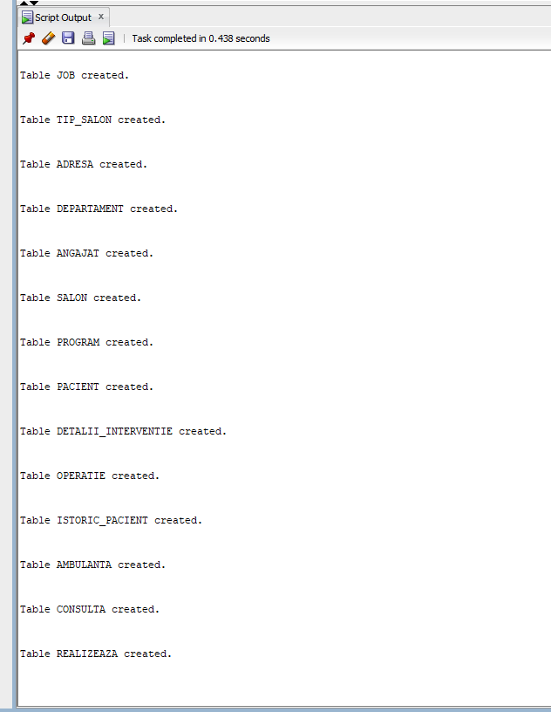

1. **Adăugați informații coerente în tabelele create (minim 5 înregistrări pentru fiecare entitate independentă; minim 10 înregistrări pentru tabela asociativă)**

INSERT INTO ADRESA (id_adresa, judet, oras, strada, bloc_nr)

VALUES(14711, 'Teleorman', 'Rosiorii de Vede', 'Aleaa CFR', '5');

INSERT INTO ADRESA (id_adresa, judet, oras, strada, bloc_nr)

VALUES(12323, 'Ilfov', 'Bucuresti', 'Serban Voda', '102');

INSERT INTO ADRESA (id_adresa, judet, oras, strada, bloc_nr)

VALUES (1041, 'Ilfov', 'Chiajna', 'Tineretului', 31);

INSERT INTO ADRESA (id_adresa, judet, oras, strada, bloc_nr)

VALUES (2121, 'Teleorman', 'Videle', 'Republicii', 23);

INSERT INTO ADRESA (id_adresa, judet, oras, strada, bloc_nr)

VALUES (14119, 'Suceava', 'Suceava', 'Libertatii', 14);

INSERT INTO ADRESA (id_adresa, judet, oras, strada, bloc_nr)

VALUES(564, 'Giurgiu', 'Magura', 'Tineretului', 12);

INSERT INTO ADRESA (id_adresa, judet, oras, strada, bloc_nr)

VALUES(23, 'Dambovita', 'Merisor', 'Salcamului', 250);

INSERT INTO ADRESA (id_adresa, judet, oras, strada, bloc_nr)

VALUES(67, 'Ilfov', 'Bucuresti', 'Ateneului', 20);

INSERT INTO ADRESA (id_adresa, judet, oras, strada, bloc_nr)

VALUES(78, 'Ilfov', 'Bucuresti', 'Cupolei', 23);

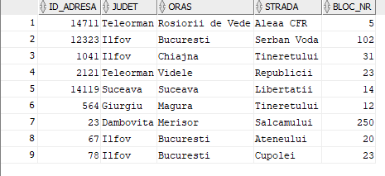

INSERT INTO TIP_SALON (id_tip, nr_paturi)

VALUES (1, 1);

INSERT INTO TIP_SALON (id_tip, nr_paturi)

VALUES(2, 2);

INSERT INTO TIP_SALON (id_tip, nr_paturi)

VALUES(3, 5);

INSERT INTO TIP_SALON (id_tip, nr_paturi)

VALUES(4, 8);

INSERT INTO TIP_SALON (id_tip, nr_paturi)

VALUES(5, 10);

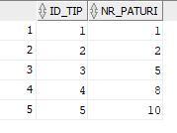

INSERT INTO JOB (id_job, nume_job, salariu_minim, salariu_maxim)

VALUES(5, 'Doctor', 10000, 150000);

INSERT INTO JOB (id_job, nume_job, salariu_minim, salariu_maxim)

Values(3, 'Asistent', 2500, 5500);

INSERT INTO JOB (id_job, nume_job, salariu_minim, salariu_maxim)

VALUES(1, 'Personal curatenie', 1400, 2200);

INSERT INTO JOB (id_job, nume_job, salariu_minim, salariu_maxim)

VALUES(10, 'Sofer ambulanta', 1900, 3000);

INSERT INTO JOB (id_job, nume_job, salariu_minim, salariu_maxim)

VALUES(11, 'Infirmier', 1900, 3000);

INSERT INTO JOB (id_job, nume_job, salariu_minim, salariu_maxim)

VALUES(14, 'Paznic', 1400, 2200);

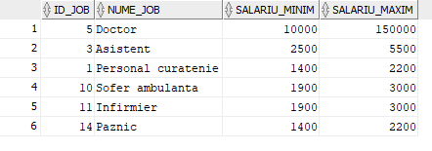

INSERT INTO DEPARTAMENT (id_departament, nume_departament, numar_angajati_departament)

VALUES(1, 'Pediatrie', 3);

INSERT INTO DEPARTAMENT (id_departament, nume_departament, numar_angajati_departament)

VALUES(2, 'Cardiologie', 2);

INSERT INTO DEPARTAMENT (id_departament, nume_departament, numar_angajati_departament)

VALUES(3, 'Neurologie', 2);

INSERT INTO DEPARTAMENT (id_departament, nume_departament, numar_angajati_departament)

VALUES(4, 'Chirurgie plastica', 1);

INSERT INTO DEPARTAMENT (id_departament, nume_departament, numar_angajati_departament)

VALUES(5, 'General', 3);

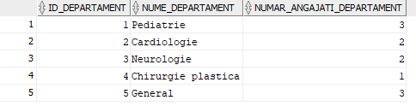

INSERT INTO ANGAJAT (id_angajat, id_job, id_departament, id_adresa, nume, prenume, data_angajarii, telefon, salariu)

VALUES(3, 5, 1, 14711, 'Olteanu', 'Ana', TO_DATE ('2015/10/16', 'YYYY/MM//DD'), '0756482944', 15000);

INSERT INTO ANGAJAT (id_angajat, id_job, id_departament, id_adresa, nume, prenume, data_angajarii, telefon, salariu)

VALUES(5, 5, 1, 14711, 'Olteanu', 'Alexandru', TO_DATE('2015/03/21', 'YYYY/MM/DD'), '076351623', 15000);

INSERT INTO ANGAJAT (id_angajat, id_job, id_departament, id_adresa, nume, prenume, data_angajarii, telefon, salariu)

VALUES(7, 5, 1, 12323, 'Toader', 'Catalin', TO_DATE('2000/11/23', 'YYYY/MM/DD'), '0762536284', 45000);

INSERT INTO ANGAJAT (id_angajat, id_job, id_departament, id_adresa, nume, prenume, data_angajarii, telefon, salariu)

VALUES(2, 5, 2, 2121, 'Popovici', 'Ioan', TO_DATE('2003/03/11', 'YYYY/MM/DD'), '0763456782', 40000);

INSERT INTO ANGAJAT (id_angajat, id_job, id_departament, id_adresa, nume, prenume, data_angajarii, telefon, salariu)

VALUES(4, 3, 2, 1041, 'Delcescu', 'Mihai', TO_DATE('2010/05/11', 'YYYY/MM/DD'), '0789035627', 4000);

INSERT INTO ANGAJAT (id_angajat, id_job, id_departament, id_adresa, nume, prenume, data_angajarii, telefon, salariu)

VALUES(10, 5, 3, 14119, 'Untesu', 'Stefan', TO_DATE('2005/01/14', 'YYYY/MM/DD'), '0762943123', 150000);

INSERT INTO ANGAJAT (id_angajat, id_job, id_departament, id_adresa, nume, prenume, data_angajarii, telefon, salariu)

VALUES(20, 10, NULL, 1041, 'Popescu', 'Ion', TO_DATE('2014/11/25', 'YYYY/MM/DD'), '0783647282', 2500);

INSERT INTO ANGAJAT (id_angajat, id_job, id_departament, id_adresa, nume, prenume, data_angajarii, telefon, salariu)

VALUES(21, 10, NULL, 1041, 'Popescu', 'Mircea', TO_DATE('2017/11/25', 'YYYY/MM/DD'), '0783657282', 2200);

INSERT INTO ANGAJAT (id_angajat, id_job, id_departament, id_adresa, nume, prenume, data_angajarii, telefon, salariu)

VALUES(30, 14, NULL, 78, 'Boicea', 'Serban', TO_DATE('2019/11/9', 'YYYY/MM/DD'), '0784289423', 2000);

INSERT INTO ANGAJAT (id_angajat, id_job, id_departament, id_adresa, nume, prenume, data_angajarii, telefon, salariu)

VALUES(31, 14, NULL, 67, 'Dolveac', 'Alin', TO_DATE('2000/11/23', 'YYYY/MM/DD'), '078923342', 2200);

INSERT INTO ANGAJAT (id_angajat, id_job, id_departament, id_adresa, nume, prenume, data_angajarii, telefon, salariu)

VALUES(41, 1, NULL, 23, 'Celeapca', 'Angi', TO_DATE('2009/10/18', 'YYYY/MM/DD'), '0723456789', 2200);

INSERT INTO ANGAJAT (id_angajat, id_job, id_departament, id_adresa, nume, prenume, data_angajarii, telefon, salariu)

VALUES(51, 11, NULL, 564, 'Ionete', 'Alexandra', TO_DATE('2020/03/21', 'YYYY/MM/DD'), '0765361792', 1900);

INSERT INTO ANGAJAT (id_angajat, id_job, id_departament, id_adresa, nume, prenume, data_angajarii, telefon, salariu)

VALUES(61, 11, 5, 14119, 'Darie', 'Dana', TO_DATE('2000/03/21', 'YYYY/MM/DD'), '0764561792', 50000);

INSERT INTO ANGAJAT (id_angajat, id_job, id_departament, id_adresa, nume, prenume, data_angajarii, telefon, salariu)

VALUES(100, 5, 4, 564, 'Nedelcu', 'Roxana', TO_DATE('2001/03/21', 'YYYY/MM/DD'), '0723561792', 51000);

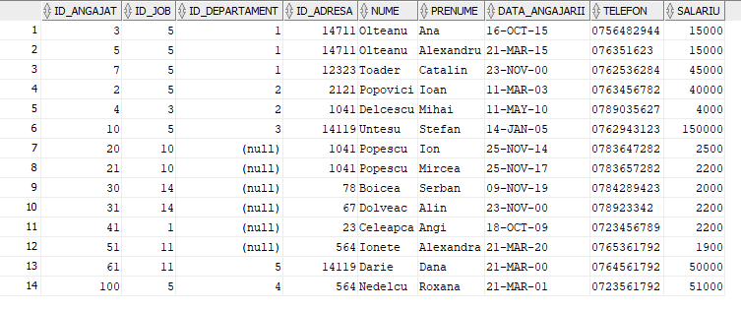

INSERT INTO PROGRAM (id_angajat, nr_zile_lucratoare, inceput_concediu, final_concediu)

VALUES(3, 262, TO_DATE('2021/07/20', 'YYYY/MM/DD'), TO_DATE('2021/08/04', 'YYYY/MM/DD'));

INSERT INTO PROGRAM (id_angajat, nr_zile_lucratoare, inceput_concediu, final_concediu)

VALUES(5, 262, TO_DATE('2021/07/20', 'YYYY/MM/DD'), TO_DATE('2021/08/04', 'YYYY/MM/DD'));

INSERT INTO PROGRAM (id_angajat, nr_zile_lucratoare, inceput_concediu, final_concediu)

VALUES(7, 262, TO_DATE('2021/08/20', 'YYYY/MM/DD'), TO_DATE('2021/09/04', 'YYYY/MM/DD'));

INSERT INTO PROGRAM (id_angajat, nr_zile_lucratoare, inceput_concediu, final_concediu)

VALUES(4, 270, TO_DATE('2021/07/10', 'YYYY/MM/DD'), TO_DATE('2021/07/24', 'YYYY/MM/DD'));

INSERT INTO PROGRAM (id_angajat, nr_zile_lucratoare, inceput_concediu, final_concediu)

VALUES(2, 260, TO_DATE('2021/08/30', 'YYYY/MM/DD'), TO_DATE('2021/09/14', 'YYYY/MM/DD'));

INSERT INTO PROGRAM (id_angajat, nr_zile_lucratoare, inceput_concediu, final_concediu)

VALUES(10, 250, TO_DATE('2021/07/20', 'YYYY/MM/DD'), TO_DATE('2021/08/14', 'YYYY/MM/DD'));

INSERT INTO PROGRAM (id_angajat, nr_zile_lucratoare, inceput_concediu, final_concediu)

VALUES(20, 270, TO_DATE('2021/09/20', 'YYYY/MM/DD'), TO_DATE('2021/10/04', 'YYYY/MM/DD'));

INSERT INTO PROGRAM (id_angajat, nr_zile_lucratoare, inceput_concediu, final_concediu)

VALUES(21, 275, TO_DATE('2021/07/20', 'YYYY/MM/DD'), TO_DATE('2021/08/04', 'YYYY/MM/DD'));

INSERT INTO PROGRAM (id_angajat, nr_zile_lucratoare, inceput_concediu, final_concediu)

VALUES(31, 280, TO_DATE('2021/06/25', 'YYYY/MM/DD'), TO_DATE('2021/07/10', 'YYYY/MM/DD'));

INSERT INTO PROGRAM (id_angajat, nr_zile_lucratoare, inceput_concediu, final_concediu)

VALUES(41, 285, TO_DATE('2021/06/20', 'YYYY/MM/DD'), TO_DATE('2021/07/08', 'YYYY/MM/DD'));

INSERT INTO PROGRAM (id_angajat, nr_zile_lucratoare, inceput_concediu, final_concediu)

VALUES(51, 285, TO_DATE('2021/04/15', 'YYYY/MM/DD'), TO_DATE('2021/05/01', 'YYYY/MM/DD'));

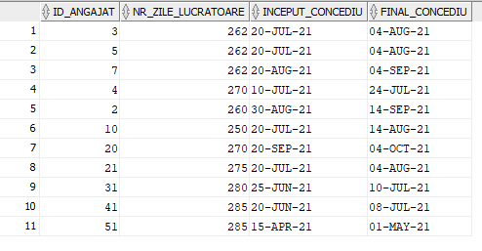

INSERT INTO SALON (id_salon, id_tip, sectie, etaj)

VALUES(10, 1, 'A', 1);

INSERT INTO SALON (id_salon, id_tip, sectie, etaj)

VALUES(34, 3, 'B', 3);

INSERT INTO SALON (id_salon, id_tip, sectie, etaj)

VALUES(38, 3, 'B', 3);

INSERT INTO SALON (id_salon, id_tip, sectie, etaj)

VALUES(59, 4, 'D', 5);

INSERT INTO SALON (id_salon, id_tip, sectie, etaj)

VALUES(22, 5, 'AB', 2);

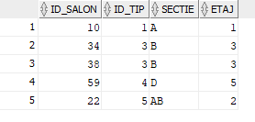

INSERT INTO PACIENT (id_pacient, id_salon, id_adresa, nume, prenume, data_nasterii, telefon)

VALUES(10, 10, 78, 'Alecu', 'Andrei', TO_DATE('2000/01/01', 'YYYY/MM/DD'), '0765738271');

INSERT INTO PACIENT (id_pacient, id_salon, id_adresa, nume, prenume, data_nasterii, telefon)

VALUES(11, NULL, 14711, 'Manica', 'Andreea', TO_DATE('1997/03/01', 'YYYY/MM/DD'), '0765738341');

INSERT INTO PACIENT (id_pacient, id_salon, id_adresa, nume, prenume, data_nasterii, telefon)

VALUES(12, 34, 564, 'Popescu', 'Andrei', TO_DATE('1985/01/01', 'YYYY/MM/DD'), '0734738271');

INSERT INTO PACIENT (id_pacient, id_salon, id_adresa, nume, prenume, data_nasterii, telefon)

VALUES(13, 22, 67, 'Ivanescu', 'David', TO_DATE('1979/12/25', 'YYYY/MM/DD'), '0769868271');

INSERT INTO PACIENT (id_pacient, id_salon, id_adresa, nume, prenume, data_nasterii, telefon)

VALUES(14, 59, 2121, 'Preda', 'Luciana', TO_DATE('1975/05/11', 'YYYY/MM/DD'), '0765778171');

INSERT INTO PACIENT (id_pacient, id_salon, id_adresa, nume, prenume, data_nasterii, telefon)

VALUES(15, 59, 12323, 'Apostol', 'Ana', TO_DATE('2000/05/11', 'YYYY/MM/DD'), '0723778171');

INSERT INTO PACIENT (id_pacient, id_salon, id_adresa, nume, prenume, data_nasterii, telefon)

VALUES(16, 22, 14711, 'Bobes', 'Mihai', TO_DATE('1990/06/21', 'YYYY/MM/DD'), '0765790171');

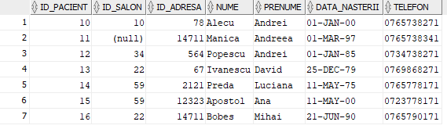

INSERT INTO DETALII_INTERVENTIE (id_detalii_interventie, data_interventie, distanta, cauza_interventie)

VALUES(100, TO_DATE('2021/06/01', 'YYYY/MM/DD'), 45, 'atac cerebral');

INSERT INTO DETALII_INTERVENTIE (id_detalii_interventie, data_interventie, distanta, cauza_interventie)

VALUES(101, TO_DATE('2021/06/02', 'YYYY/MM/DD'), 5, 'arsuri');

INSERT INTO DETALII_INTERVENTIE (id_detalii_interventie, data_interventie, distanta, cauza_interventie)

VALUES(102, TO_DATE('2021/06/01', 'YYYY/MM/DD'), 10, 'picior rupt');

INSERT INTO DETALII_INTERVENTIE (id_detalii_interventie, data_interventie, distanta, cauza_interventie)

VALUES(103, TO_DATE('2021/06/03', 'YYYY/MM/DD'), 40, 'atac vascular');

INSERT INTO DETALII_INTERVENTIE (id_detalii_interventie, data_interventie, distanta, cauza_interventie)

VALUES(104, TO_DATE('2021/06/04', 'YYYY/MM/DD'), 12, 'febra');

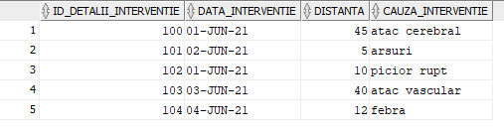

INSERT INTO AMBULANTA (id_pacient, id_ambulanta, id_angajat, id_detalii_interventie)

VALUES(16, 'B23AMB', 20, 100);

INSERT INTO AMBULANTA (id_pacient, id_ambulanta, id_angajat, id_detalii_interventie)

VALUES(11, 'B24AMB', 51, 101);

INSERT INTO AMBULANTA (id_pacient, id_ambulanta, id_angajat, id_detalii_interventie)

VALUES(12, 'B23AMB', 61, 102);

INSERT INTO AMBULANTA (id_pacient, id_ambulanta, id_angajat, id_detalii_interventie)

VALUES(13, 'B25AMB', 51, 103);

INSERT INTO AMBULANTA (id_pacient, id_ambulanta, id_angajat, id_detalii_interventie)

VALUES(15, 'B26AMB', 4, 104);

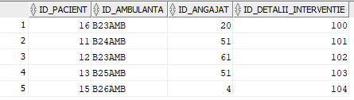

INSERT INTO OPERATIE(id_operatie, nume_operatie, perioada_recuperare, id_pacient)

VALUES(1, 'reconstructie nazala', 15, 11);

INSERT INTO OPERATIE(id_operatie, nume_operatie, perioada_recuperare, id_pacient)

VALUES(2, 'reconstructie nazala', 15, 15);

INSERT INTO OPERATIE(id_operatie, nume_operatie, perioada_recuperare, id_pacient)

VALUES(3, 'apendicita', 10, 10);

INSERT INTO OPERATIE(id_operatie, nume_operatie, perioada_recuperare, id_pacient)

VALUES(4, 'transplat de plamani', 100, 13);

INSERT INTO OPERATIE(id_operatie, nume_operatie, perioada_recuperare, id_pacient)

VALUES(5, 'pietre la rinichi', 20, 16);

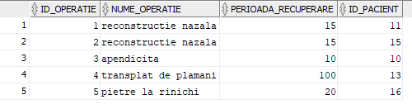

INSERT INTO REALIZEAZA(id_angajat, id_operatie, data_operatie)

VALUES(100, 1, to_date('2019/11/21 08:30:00', 'YYYY/MM/DD HH:MI:SS'));

INSERT INTO REALIZEAZA(id_angajat, id_operatie, data_operatie)

VALUES(61, 1, TO_DATE('2019/11/21', 'YYYY/MM/DD'));

INSERT INTO REALIZEAZA(id_angajat, id_operatie, data_operatie)

VALUES(51, 1, TO_DATE('2019/11/21', 'YYYY/MM/DD'));

INSERT INTO REALIZEAZA(id_angajat, id_operatie, data_operatie)

VALUES(100, 2, TO_DATE('2019/12/23', 'YYYY/MM/DD'));

INSERT INTO REALIZEAZA(id_angajat, id_operatie, data_operatie)

VALUES(51, 2, TO_DATE('2019/12/24', 'YYYY/MM/DD'));

INSERT INTO REALIZEAZA(id_angajat, id_operatie, data_operatie)

VALUES(61, 3, TO_DATE('2020/11/25', 'YYYY/MM/DD'));

INSERT INTO REALIZEAZA(id_angajat, id_operatie, data_operatie)

VALUES(4, 3, TO_DATE('2020/01/13', 'YYYY/MM/DD'));

INSERT INTO REALIZEAZA(id_angajat, id_operatie, data_operatie)

VALUES(100, 4, TO_DATE('2021/10/25', 'YYYY/MM/DD'));

INSERT INTO REALIZEAZA(id_angajat, id_operatie, data_operatie)

VALUES(61, 4, TO_DATE('2020/01/06', 'YYYY/MM/DD'));

INSERT INTO REALIZEAZA(id_angajat, id_operatie, data_operatie)

VALUES(2, 5, TO_DATE('2019/01/14', 'YYYY/MM/DD'));

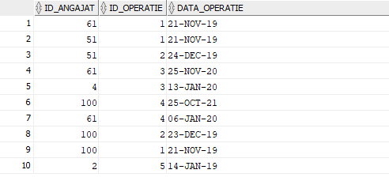

insert into CONSULTA (id_angajat, id_pacient, data_consultatie, diagnostic)

values (2, 10, TO_DATE('2020/01/06', 'YYYY/MM/DD'), 'bronsita');

insert into CONSULTA (id_angajat, id_pacient, data_consultatie, diagnostic)

values (2, 11, TO_DATE('2020/01/06', 'YYYY/MM/DD'), 'gripa');

insert into CONSULTA (id_angajat, id_pacient, data_consultatie, diagnostic)

values (2, 12, TO_DATE('2020/01/10', 'YYYY/MM/DD'), 'probleme cardiace');

insert into CONSULTA (id_angajat, id_pacient, data_consultatie, diagnostic)

values (10, 15, TO_DATE('2020/01/20', 'YYYY/MM/DD'), 'atac cerebral');

insert into CONSULTA (id_angajat, id_pacient, data_consultatie, diagnostic)

values (100, 15, TO_DATE('2020/01/20', 'YYYY/MM/DD'), 'atac cerebral');

insert into CONSULTA (id_angajat, id_pacient, data_consultatie, diagnostic)

values (10, 14, TO_DATE('2020/02/06', 'YYYY/MM/DD'), 'probleme vasculare');

insert into CONSULTA (id_angajat, id_pacient, data_consultatie, diagnostic)

values (100, 16, TO_DATE('2019/06/06', 'YYYY/MM/DD'), 'pietre la rinichi');

insert into CONSULTA (id_angajat, id_pacient, data_consultatie, diagnostic)

values (100, 10, TO_DATE('2015/01/06', 'YYYY/MM/DD'), 'lipsa de fier');

insert into CONSULTA (id_angajat, id_pacient, data_consultatie, diagnostic)

values (61, 14, TO_DATE('2020/01/06', 'YYYY/MM/DD'), 'otita');

insert into CONSULTA (id_angajat, id_pacient, data_consultatie, diagnostic)

values (61, 13, TO_DATE('2000/11/13', 'YYYY/MM/DD'), 'scleroza multipla');

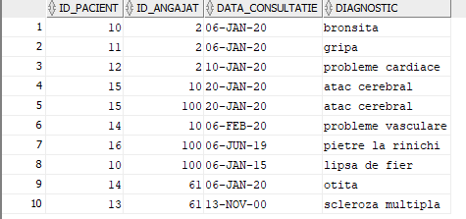

insert into ISTORIC_PACIENT (id_pacient, data_interventie, nume_interventie, problema_medicala)

values (10, TO_DATE('2019/04/06', 'YYYY/MM/DD'), 'consultatie', 'otita');

insert into ISTORIC_PACIENT (id_pacient, data_interventie, nume_interventie, problema_medicala)

values (10, TO_DATE('2020/11/06', 'YYYY/MM/DD'), 'consultatie', 'bronsita');

insert into ISTORIC_PACIENT (id_pacient, data_interventie, nume_interventie, problema_medicala)

values (12, TO_DATE('2018/09/11', 'YYYY/MM/DD'), 'operatie', 'extractie polipi');

insert into ISTORIC_PACIENT (id_pacient, data_interventie, nume_interventie, problema_medicala)

values (15, TO_DATE('2016/04/06', 'YYYY/MM/DD'), 'operatie', 'extractie amigdalita');

insert into ISTORIC_PACIENT (id_pacient, data_interventie, nume_interventie, problema_medicala)

values (16, TO_DATE('2019/04/06', 'YYYY/MM/DD'), 'consultatie', 'gripa');

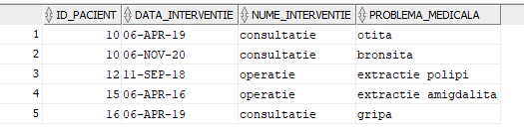

1. **Formulați în limbaj natural o problemă pe care să o rezolvați folosind un subprogram stocat care să utilizeze două tipuri de colecție studiate. Apelați subprogramul.**

--Afisati departamentele cu id impar, ce au mai multi angajati decat un numar nr dat ca parametru.

create or replace procedure ex6(nr number)

is

type tabel_indexat is table of varchar2(50) index by pls_integer;

type vector is array(3) of number;

v vector := vector();

t tabel_indexat;

j number;

begin

j := 0;

for i in 1..5 loop

if i mod 2 = 1 then

j := j + 1;

v.extend;

v(j) := i;

end if;

end loop;

for i in v.first..v.last loop

select nume_departament into t(i)

from departament

where id_departament = v(i) and numar_angajati_departament >= nr;

end loop;

for i in t.first..t.last loop

dbms_output.put_line(t(i));

end loop;

exception

when no_data_found then

raise_application_error(-20000, 'Nu exista departamente');

end;

/

begin

ex6(2);

end;

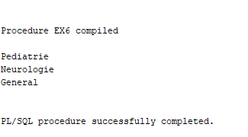

begin

ex6(4);

end;

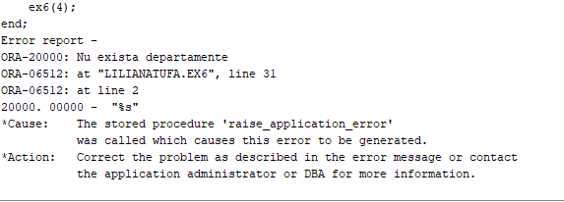

1. **Formulați în limbaj natural o problemă pe care să o rezolvați folosind un subprogram stocat care să utilizeze un tip de cursor studiat. Apelați subprogramul.**

--Afisati pentru fiecare job numele si prenumele persoanelor angajate dupa un an dat ca parametru.

create or replace procedure ex7(nr number)

is

nr_val number :=0;

exceptie exception;

begin

for i in (select id_job, nume_job from job) loop

for j in (select id_job, nume, prenume, data_angajarii from angajat) loop

if i.id_job = j.id_job then

if extract(year from j.data_angajarii) >= nr then

nr_val := nr_val + 1;

dbms_output.put_line(i.nume_job || ': ' || j.nume || ' ' || j.prenume);

end if;

end if;

end loop;

dbms_output.new_line;

end loop;

if nr_val = 0 then

raise exceptie;

end if;

exception

when exceptie then

raise_application_error(-20000, 'Nu exista personal angajat dupa acest an');

end;

/

begin

ex7(2017);

end;

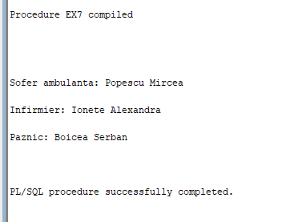

begin

ex7(2021);

end;

/

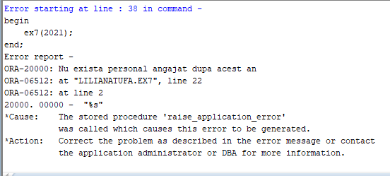

1. **Formulați în limbaj natural o problemă pe care să o rezolvați folosind un subprogram stocat de tip funcție care să utilizeze într-o singură comandă SQL 3 dintre tabelele definite. Tratați toate excepțiile care pot apărea. Apelați subprogramul astfel încât să evidențiați toate cazurile tratate.**

--Determinati numarul de pacienti ce s-au internat in urma unei operatii, numele operatiei fiind dat ca parametru.

create or replace function ex8

(nume_op operatie.nume_operatie%type)

return number is

nr number := 0;

exceptie exception;

begin

select count(s.id_salon)

into nr

from operatie o, pacient p, salon s

where lower(o.nume_operatie) = lower(nume_op) and o.id_pacient = p.id_pacient and p.id_salon= s.id_salon;

if nr = 0 then

raise exceptie;

end if;

return nr;

exception

when exceptie then

raise_application_error(-20000, 'Nu s-au internat pacienti');

when others then

raise_application_error(-20002, 'Alta eroare');

end;

/

begin

dbms_output.put_line(ex8('reconstructie nazala'));

end;

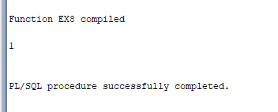

begin

dbms_output.put_line(ex8('transplant de plamani'));

end;

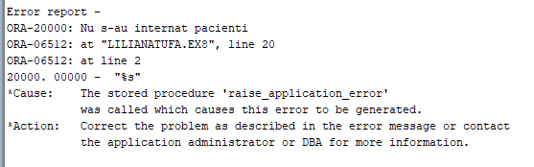

1. **Formulați în limbaj natural o problemă pe care să o rezolvați folosind un subprogram stocat de tip procedură care să utilizeze într-o singură comandă SQL 5 dintre tabelele definite. Tratați toate excepțiile care pot apărea, incluzând excepțiile NO_DATA_FOUND și TOO_MANY_ROWS. Apelați subprogramul astfel încât să evidențiați toate cazurile tratate.**

--Aratati ce probleme medicale au mai avut pacientii (din tabela istoric_pacient) care au fost operati de un anumit doctor, numele acestuia fiind dat ca parametru

create or replace procedure ex9

(nume_ang angajat.nume%type)

is

type tabel_indexat is table of varchar2(50) index by pls_integer;

informatii tabel_indexat;

id_ang angajat.id_angajat%type;

begin

select id_angajat into id_ang

from angajat

where lower(nume) = lower(nume_ang);

select i.problema_medicala

bulk collect into informatii

from angajat a, realizeaza r, operatie o, pacient p, istoric_pacient i

where id_ang = a.id_angajat and a.id_angajat= r.id_angajat and r.id_operatie=o.id_operatie

and o.id_pacient = p.id_pacient and p.id_pacient = i.id_pacient;

dbms_output.put_line('Informatii despre pacientii operati de dr. ' || nume_ang || ': ');

for i in informatii.first..informatii.last loop

dbms_output.put_line(informatii(i));

end loop;

EXCEPTION

when no_data_found then

raise_application_error(-20000,'Nu exista anagajatul introdus.');

when too_many_rows then

raise_application_error(-20001,'Exista mai multe informatii ale angajatilor operati de angajatul dat.');

when others then

raise_application_error(-20002, 'Alta erorare!!');

end;

/

begin

ex9('darie');

end;

/

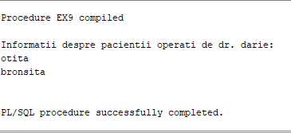

begin

ex9('georgescu');

end;

/

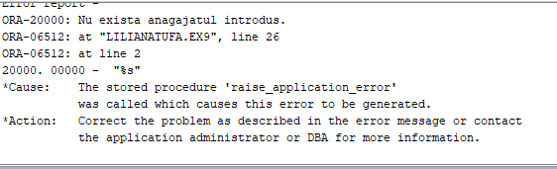

begin

ex9('untesu');

end;

/

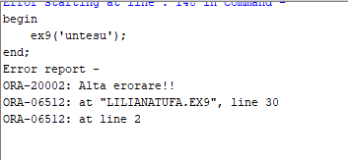

1. **Definiți un trigger de tip LMD la nivel de comandă. Declanșați trigger-ul.**

--Nu se pot face modificari asupra tabelei job in lunile de iarna ale anului.

create or replace trigger trigger_1 before

update or insert or delete on job

begin

if to_char(sysdate, 'MM') = 1 or to_char(sysdate, 'MM') = 2 or to_char(sysdate, 'MM') = 12 then

raise_application_error(-20001, 'Nu puteti efectua modificari in lunile de iarna.');

end if;

end;

insert into job values

(15, 'Supraveghetor', 2000, 3000);

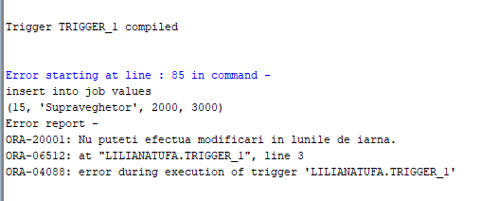

1. **Definiți un trigger de tip LMD la nivel de linie. Declanșați trigger-ul.**

--Nu puteti modifica data unei consultatii cu o data mai mica decat data curenta.

create or replace trigger trigger_2 before

update of data_consultatie on consulta

for each row

begin

if (:new.data_consultatie < sysdate) then

raise_application_error(-20002, 'Nu puteti modifica data consultatiei cu o data din trecut.');

end if;

end;

/

update consulta

set data_consultatie = to_date('2019/01/14', 'YYYY/MM/DD')

where id_pacient = 10 and id_angajat = 2;

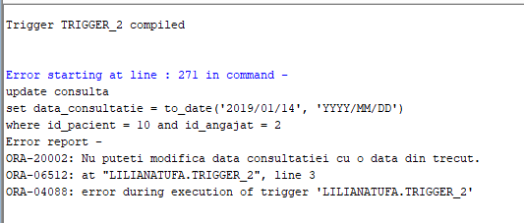

1. **Definiți un trigger de tip LDD. Declanșați trigger-ul.**

--Nu puteti sterge tabele din baza de date.

create or replace trigger trigger_3 before

drop on database

begin

raise_application_error(-20002, 'Nu aveti voie sa stergeti din tabele.');

end;

/

drop table tip_salon;

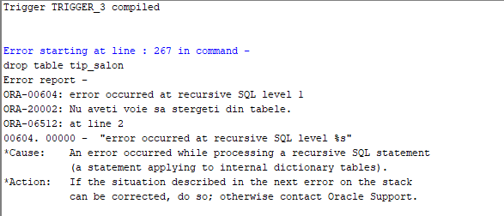

1. **Definiți un pachet care să conțină toate obiectele definite în cadrul proiectului.**

create or replace package pachet as

procedure ex6 (nr number);

procedure ex7 (nr number);

function ex8 (nume_op operatie.nume_operatie%type) return number;

procedure ex9 (nume_ang angajat.nume%type);

end pachet;

/

create or replace package body pachet as

procedure ex6(nr number)

is

type tabel_indexat is table of varchar2(50) index by pls_integer;

type vector is array(3) of number;

v vector := vector();

t tabel_indexat;

j number;

begin

j := 0;

for i in 1..5 loop

if i mod 2 = 1 then

j := j + 1;

v.extend;

v(j) := i;

end if;

end loop;

for i in v.first..v.last loop

select nume_departament into t(i)

from departament

where id_departament = v(i) and numar_angajati_departament >= nr;

end loop;

for i in t.first..t.last loop

dbms_output.put_line(t(i));

end loop;

exception

when no_data_found then

raise_application_error(-20000, 'Nu exista departamente');

end ex6;

procedure ex7(nr number)

is

nr_val number :=0;

exceptie exception;

begin

for i in (select id_job, nume_job from job) loop

for j in (select id_job, nume, prenume, data_angajarii from angajat) loop

if i.id_job = j.id_job then

if extract(year from j.data_angajarii) >= nr then

nr_val := nr_val + 1;

dbms_output.put_line(i.nume_job || ': ' || j.nume || ' ' || j.prenume);

end if;

end if;

end loop;

dbms_output.new_line;

end loop;

if nr_val = 0 then

raise exceptie;

end if;

exception

when exceptie then

raise_application_error(-20000, 'Nu exista personal angajat dupa acest an');

end ex7;

function ex8

(nume_op operatie.nume_operatie%type)

return number is

nr number := 0;

exceptie exception;

begin

select count(s.id_salon)

into nr

from operatie o, pacient p, salon s

where lower(o.nume_operatie) = lower(nume_op) and o.id_pacient = p.id_pacient and p.id_salon= s.id_salon;

if nr = 0 then

raise exceptie;

end if;

return nr;

exception

when exceptie then

raise_application_error(-20000, 'Nu s-au internat pacienti');

when others then

raise_application_error(-20002, 'Alta eroare');

end ex8;

procedure ex9

(nume_ang angajat.nume%type)

is

type tabel_indexat is table of varchar2(50) index by pls_integer;

informatii tabel_indexat;

id_ang angajat.id_angajat%type;

begin

select id_angajat into id_ang

from angajat

where lower(nume) = lower(nume_ang);

select i.problema_medicala

bulk collect into informatii

from angajat a, realizeaza r, operatie o, pacient p, istoric_pacient i

where id_ang = a.id_angajat and a.id_angajat= r.id_angajat and r.id_operatie=o.id_operatie

and o.id_pacient = p.id_pacient and p.id_pacient = i.id_pacient;

dbms_output.put_line('Informatii despre pacientii operati de dr. ' || nume_ang || ': ');

for i in informatii.first..informatii.last loop

dbms_output.put_line(informatii(i));

end loop;

EXCEPTION

when no_data_found then

raise_application_error(-20000,'Nu exista anagajatul introdus.');

when too_many_rows then

raise_application_error(-20001,'Exista mai multe informatii ale angajatilor operati de angajatul dat.');

when others then

raise_application_error(-20002, 'Alta erorare!!');

end ex9;

end pachet;

/

begin

pachet.ex6(2);

dbms_output.new_line;

pachet.ex7(2017);

dbms_output.new_line;

dbms_output.put_line('Numarul pacientilor internati este ' || pachet.ex8('reconstructie nazala'));

dbms_output.new_line;

pachet.ex9('darie');

end;

/

