TASK1:
Createpdb,
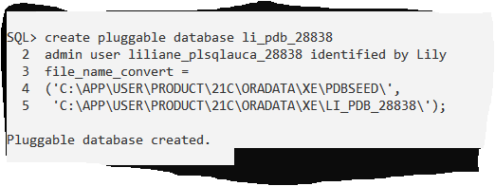
Pdb open state,
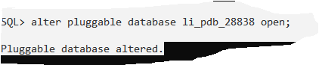

User inside pdb,
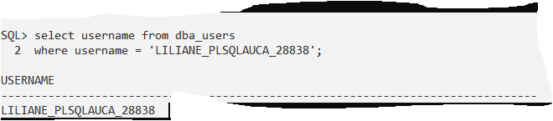

TASK2:
Pdb creation,
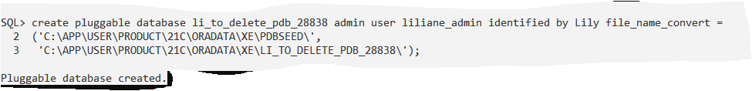
Pdb deletion,
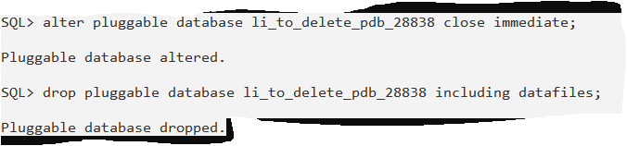
TASK3:OEM,
