Running Python,
To run all the server-side code, you must first install the latest videos of python.
https://www.python.org/downloads/
Then you need to install PyCharm Community Edition.
https://www.jetbrains.com/pycharm/download/?section=windows
Then open PyCharm Community Edition, then open the project folder (with PyCharm).
Then configure the project python interpreter to the systems python interpreter.
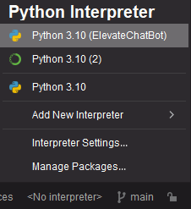
From there you should be able to run any of the scripts via PyCharm.

Running web UI
To run the web UI you must first install node.
https://nodejs.org/en/download
Then open all the UI folder (ElevateChatBot.UI) in visual studio code.
Then you will need to run the python file called app.py
Then you will need to open the terminal in visual studio code and type the following
npx http-server
Then you should be able to run the project as shown in the demonstration.

