At the bottom of the file will be an administrator username and password you can use to log into an administrator account on the login page

Please ensure that node.js is installed and you use bootstrap and jQuery but if not, please use an up to date CDN version of each one to ensure that styling and jQuery match the current version (the node_modules folder should be included, however so you may not need to do this).

Step 1: Please install the latest version of Visual Studio 2022 (.NET 8.0 is supported in the latest version and this solution uses .NET 8.0)

Step 2: Open the solution on Visual Studio (either click the .sln file in the folder itself, or select it from Visual Studio)

Step 4: Before doing anything else with Visual Studio, please download Microsoft SQL Server and SQL Server Management Studio here:  
<https://www.microsoft.com/en-gb/sql-server/sql-server-downloads> (choose developer)

<https://aka.ms/ssmsfullsetup> or <https://learn.microsoft.com/en-us/sql/ssms/download-sql-server-management-studio-ssms?view=sql-server-ver16> and download it here:

Please install these before you do step 5.

Step 5: When open SQL Server Management Studio and copy the highlighted line:  
and then go into Visual Studio, open “appsettings.json” and enter the server name where it says “localhost” here:  


Step 6: Put the database file into the SQL Server backup folder. Navigate to: C:\Program Files\Microsoft SQL Server\MSSQL16.MSSQLSERVER\MSSQL\Backup

(or any equivalent to what is shown below)

Copy the database (GACS.bak) from the downloaded zip file and go paste it into the backup folder.

Step 7: Restore the database:

Open SQL Server Management Studio and right click on the databases folder and select “Restore Database”:

Then, click on “Device” and then the three dots menu button (highlighted):

You will be presented with options to: Add, Remove, and Contents. Please keep the backup media type as “file” and press Add.

It should default to the backup folder and select gacs.bak.

Continue to press “OK” until the database has been successfully restored.

Step 8: Run the IIS Express (either in debugging mode or without debugging) and use the solution as normal.

If the IIS Express errors due to IP addresses or ports, follow this guide below:

Open Visual Studio and click the drop down next to the IIS Express debug button and click on debug properties as highlighted below:

Then, scroll down until you find the app URL and ensure it is set to this value:

Try running it again ensure that it works.

If it does not, try this:  
Navigate to the location of the root folder for the solution (containing all folders as shown here):  
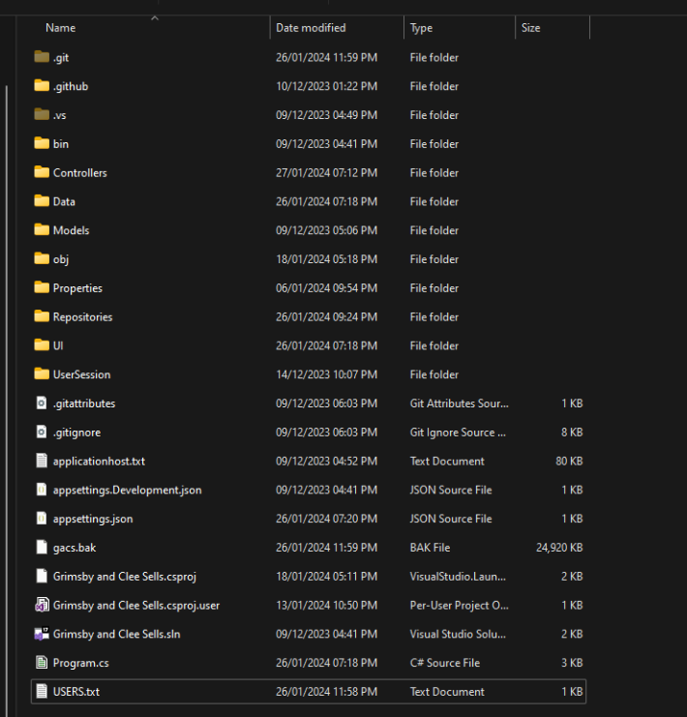

Then, navigate to the .vs folder (if the .vs folder does not appear, please click view and hover over the show selection and click on “show hidden items” if it is turned off.

Then, click on the Grimsby and Clee Sells folder

Navigate to the config folder and open the applicationhost.config file in a text editor such as notepad or visual studio code.

Once you have done that, press “ctrl + f” on your keyboard to start searching that file for a specific word. Please search for the word “Bindings” and keep going until you find these (or any equivalent):

(Do note that there is a bindings section higher up that uses the port 8080, please ignore that one)

If the binding information and ports (localhost in this case) do not match this, please change them to match. Once you have done this, save the file and restart visual studio to ensure that the changes stick. Then, try running the IIS Express Server Again.

If issues continue to occur, please run Visual Studio in administrator mode.

BASE USERS

JaneDoe

Apassword@1

JohnDooe

Apassword@1

EthanSmith

Apassword@1

-Some products have been made by this user (some waiting to be aproved, rejected and approved)

ADMIN

testing1

Apassword@1