**Task 1** - Find the most popular destination airport in each month and save to the Google Cloud Storage bucket in TSV format:

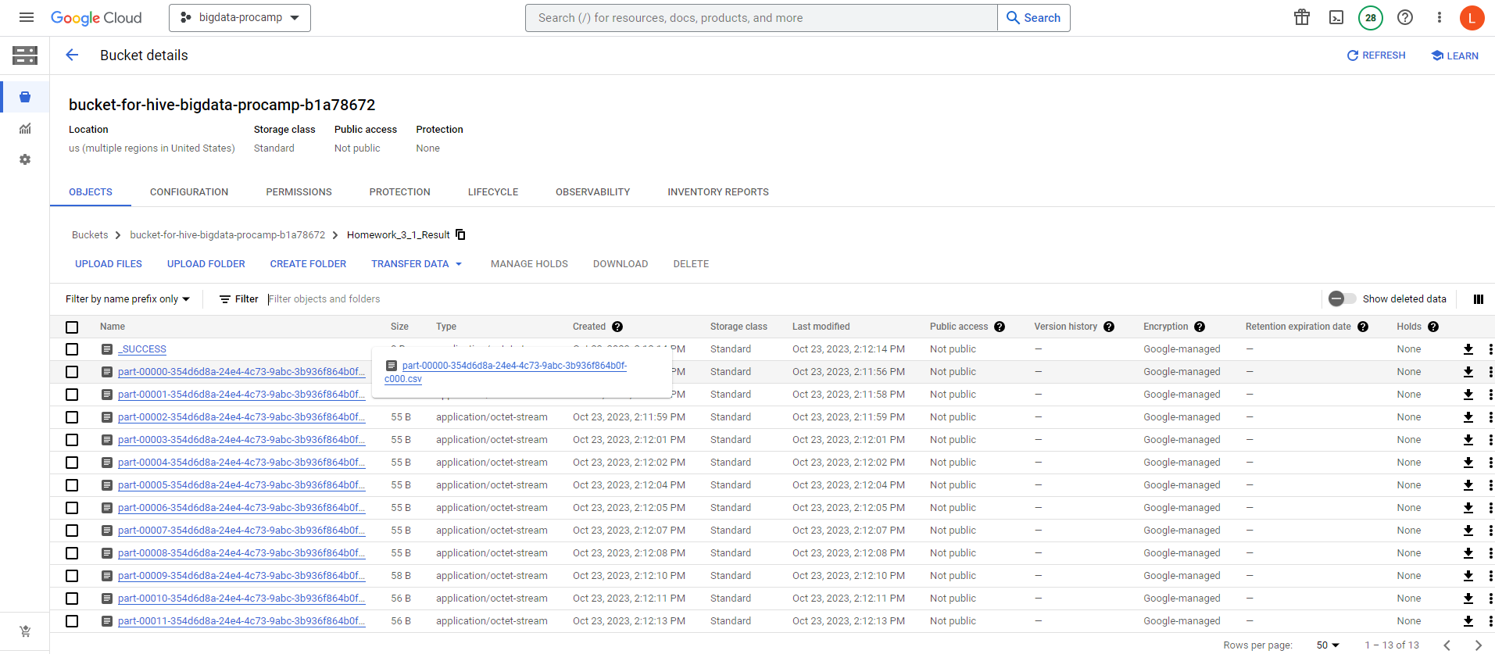

The contents of the file for first month:

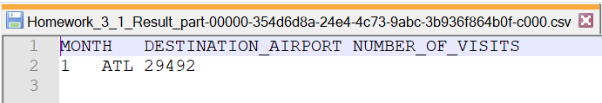

**Task 2** – Calculate percentage of canceled flights per origin airport per airline. Save the result to the GCS bucket in json format sorted by airline name and percentage for all airports but 'Waco Regional Airport' which should be stored in CSV format. Record should contain airline name, origin airport name, percentage, number of canceled flights, number of processed flights. Gather total number of flights per airline for debugging.

* **Data for 'Waco Regional Airport' in CSV format:**

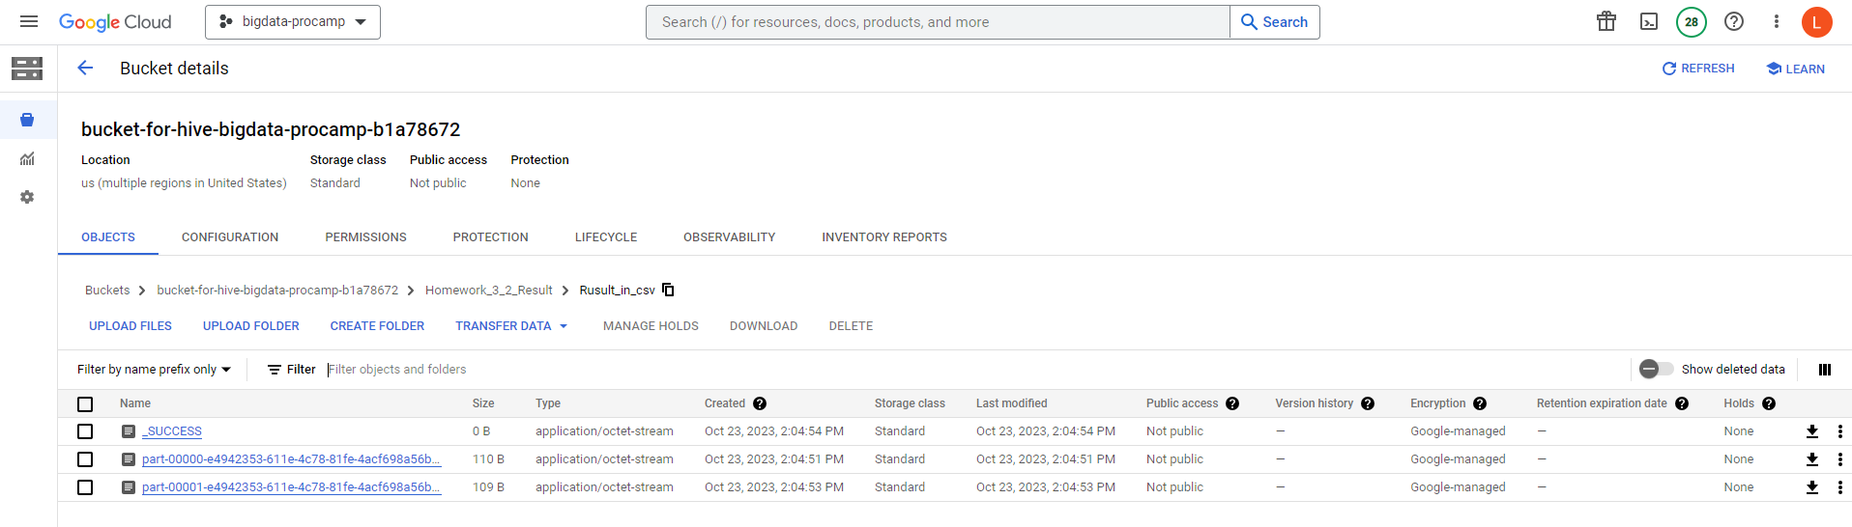

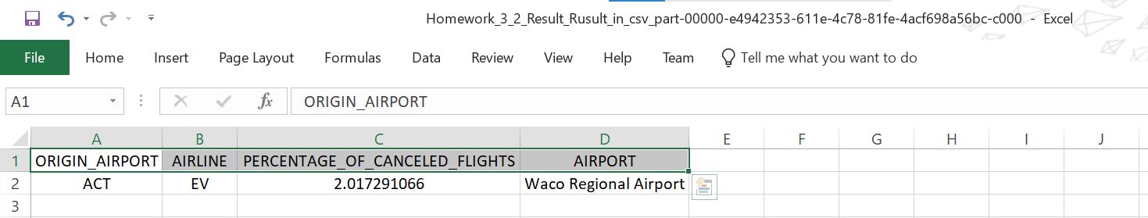

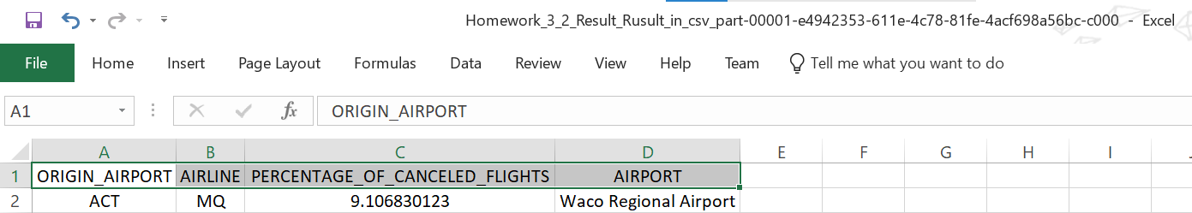

* **Data without 'Waco Regional Airport' in JSON format:**

