Баги мобільного веб-додатку “[Київська міська лікарня ветеринарної медицини](https://www.kmlvm.com.ua/)”

1. **Summary – The icon in the section “Контакти”, clicking on which takes the user to YouTube channel, doesn’t have “Youtube”-caption**

**Severity** – Minor

**Priority** – Low

**Environment** – iOS

Web browser: Google Chrome

**Steps to reproduce:**

1. Open <https://www.kmlvm.com.ua> on the phone
2. Choose the menu “Контакти” from the Hamburger menu
3. Pay attention to the caption on the icon near the Facebook-icon

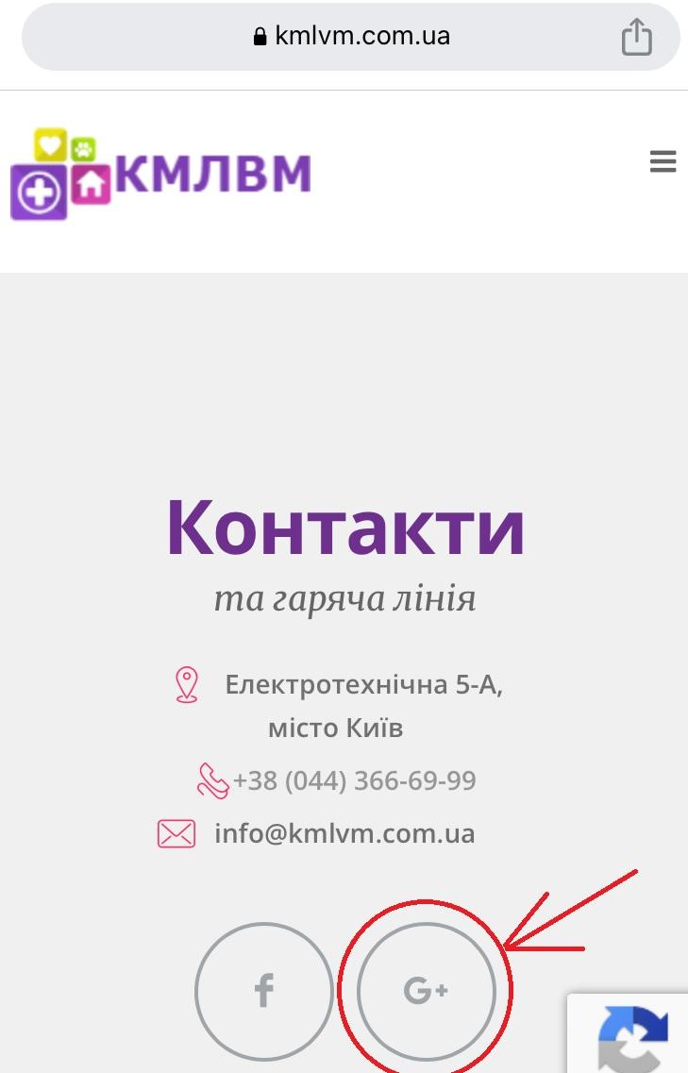

**Actual result:**

The icon that is a link to the clinic’s Youtube-channel has the wrong caption G+

**Expected result:**

The icon that is a link to the clinic’s Youtube-channel has the caption “Youtube”

**2. Summary – The text of the booking form is not fully displayed**

**Severity** – Major

**Priority** – High

**Environment** – iOS

Web browser: Google Chrome

**Steps to reproduce:**

1. Open <https://www.kmlvm.com.ua> on the phone
2. Choose the menu “Онлайн запис” from the Hamburger menu
3. Scroll down to the booking-form and pay attention to the text displayed

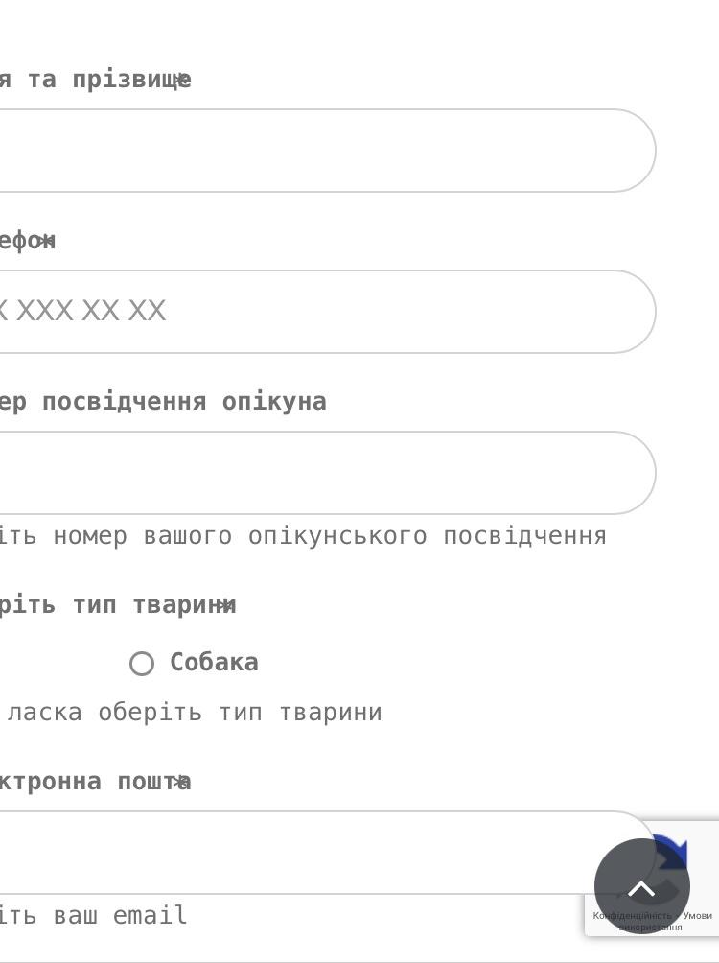

**Actual result:**

Half of the text in the booking form isn’t displayed on the screen

**Expected result:**

The text in the booking form is fully displayed on the screen

**3. Summary – The picture of animals overlap with each other**

**Severity** – Minor

**Priority** – Low

**Environment** – iOS

Web browser: Google Chrome

**Steps to reproduce:**

1. Open <https://www.kmlvm.com.ua> on the phone
2. Choose the menu “Адопція” from the Hamburger menu
3. Click the menu sub-item “Благодійність”
4. Scroll down and pay attention to the images under the footer

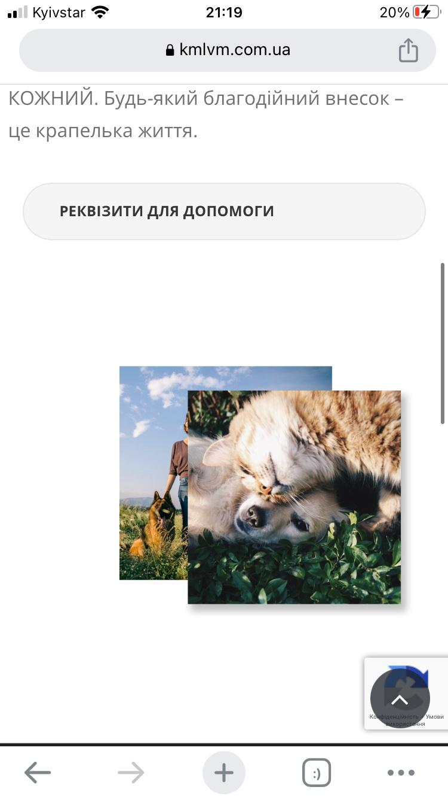

**Actual result:**

One image covers another. The second image cannot be seen

**Expected result:**

Two images can be seen on the screen

1. **Summary – Invalid bank details are listed in the section “Благодійність”**

**Severity** – Major

**Priority** – High

**Environment** – iOS

Web browser: Google Chrome

**Steps to reproduce:**

1. Open <https://www.kmlvm.com.ua> on the phone
2. Choose the menu “Адопція” from the Hamburger menu
3. Click the menu sub-item “Благодійність”
4. Scroll down and click the “Реквізити для допомоги”
5. Pay attention to the bank account number

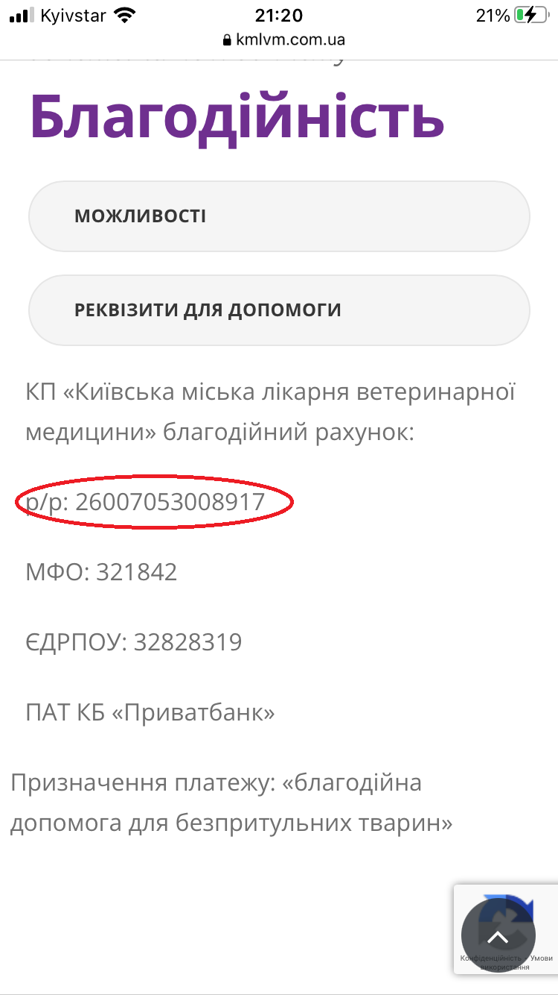

**Actual result:**

Bank account number isn’t valid

**Expected result:**

Bank account number is valid according to IBAN (begins with UA and includes 27 numbers)

**5. Summary – Text about the clinic’s departments is displayed out of the frame**

**Severity** – Minor

**Priority** – Low

**Environment** – iOS

Web browser: Google Chrome

**Steps to reproduce:**

1. Open <https://www.kmlvm.com.ua> on the phone
2. Choose the menu “Ветеринарна допомога” from the Hamburger menu
3. Scroll down to the section “Структурні підрозділи” and pay attention to the text in the frame

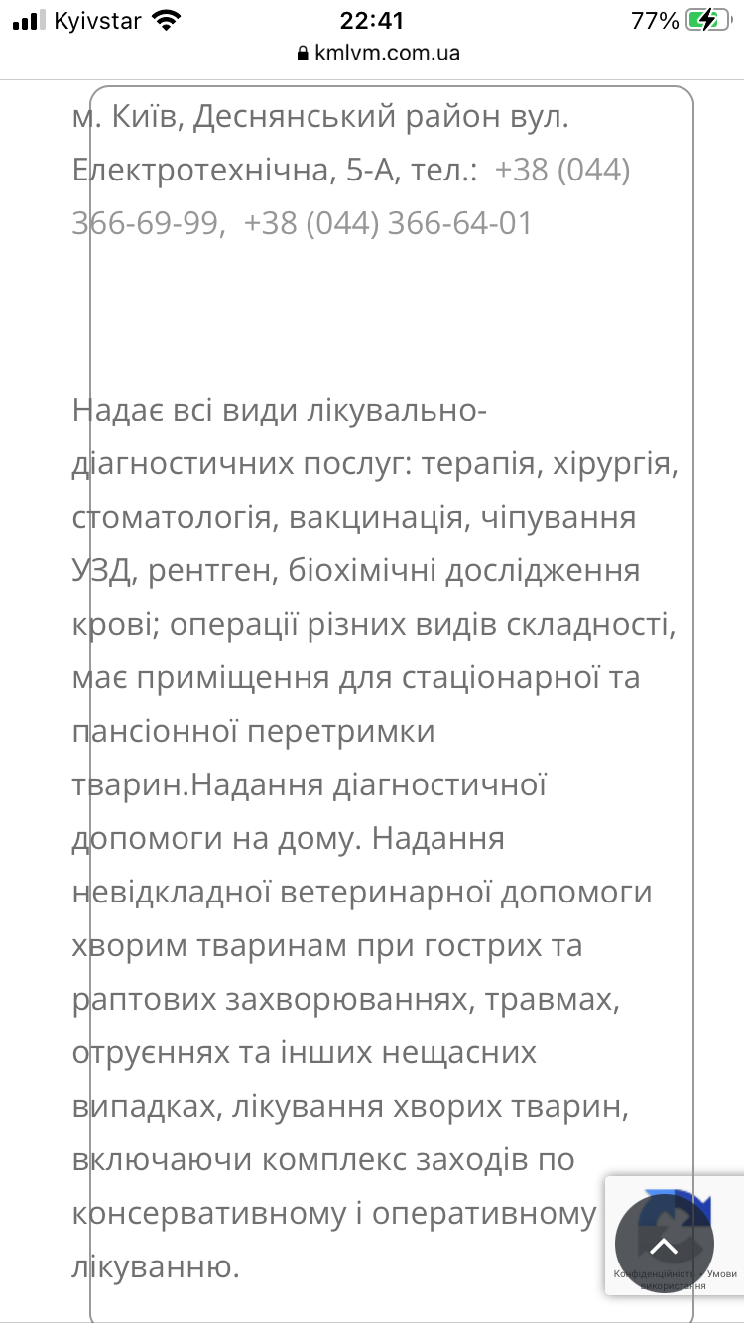

**Actual result:**

The text is out of the frame

**Expected result:**

The text fits completely into the frame

Баги, виявлені під час роботи з емулятором Android Studio, на сайті “[Звірополіс](https://zpolis.com.ua/)”.

**Testing Pixel 6 Android 12.0**

1. **Summary – The placeholders of the drop-down lists on the page “Послуги та ціни” are not fully displayed**

**Severity** – Minor

**Priority** – Low

**Environment** – Pixel 6 Android 12.0

Resolution 1080x2400

Web browser: Google Chrome

**Steps to reproduce:**

1. Open the web-page <https://zpolis.com.ua> in the browser on the phone
2. Choose the menu “Послуги” from the Hamburger menu
3. Pay attention to the drop-down lists

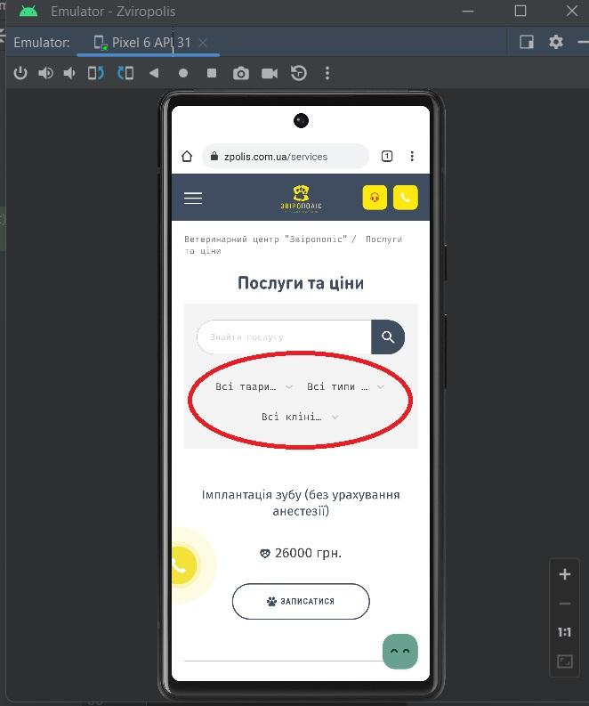

**Actual result:**

The placeholder of each list isn’t fully displayed

**Expected result:**

The placeholder of each list is fully displayed.

**2. Summary – The placeholders of the drop-down list in the pop-up window “Онлайн консультация ветеринара” are displayed in Ukrainian when the language of the site is set to russian.**

**Severity** – Minor

**Priority** – Low

**Environment** – Pixel 6 Android 12.0

Resolution 1080x2400

Web browser: Google Chrome

**Steps to reproduce:**

1. Open the web-page <https://zpolis.com.ua> in the browser on the phone
2. Scroll down to the footer of the page and choose the RU language
3. Click the icon 
4. Pay attention to placeholders of the drop-down lists of the form

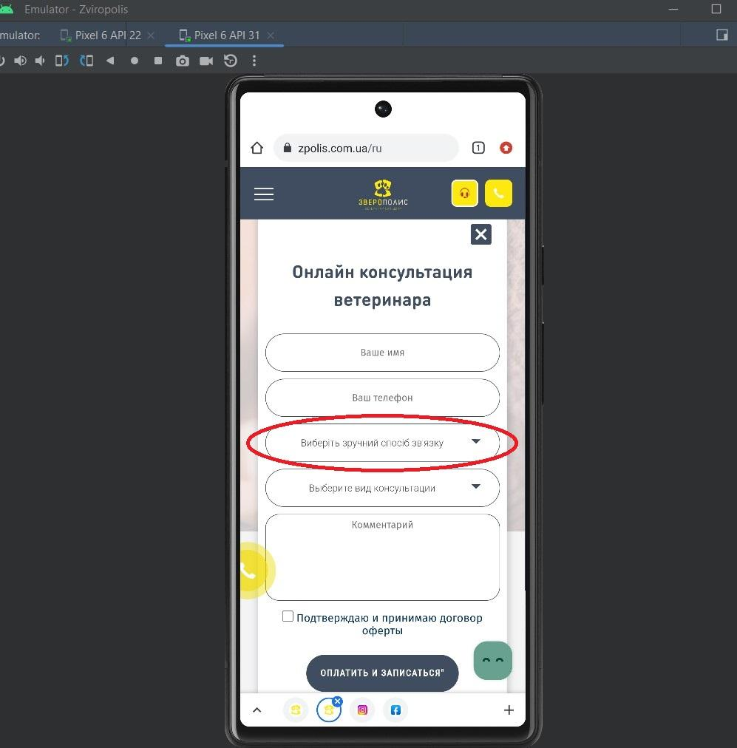

**Actual result:**

The placeholder of the drop-down list for choosing the communication method is displayed in Ukrainian instead of russian

**Expected result:**

The placeholder of the drop-down list for choosing the communication method is displayed in russian

**3. Summary – The text on the page “Питання та відповіді” is displayed in different languages.**

**Severity** – Minor

**Priority** – Low

**Environment** – Pixel 6 Android 12.0

Resolution 1080x2400

Web browser: Google Chrome

**Steps to reproduce:**

1. Open the web-page <https://zpolis.com.ua> in the browser on the phone
2. Scroll down to the footer and make sure the site language is set to UA
3. Scroll up and choose the menu “Питання та відповіді” from the Hamburger menu
4. Pay attention to the language of the text on this page

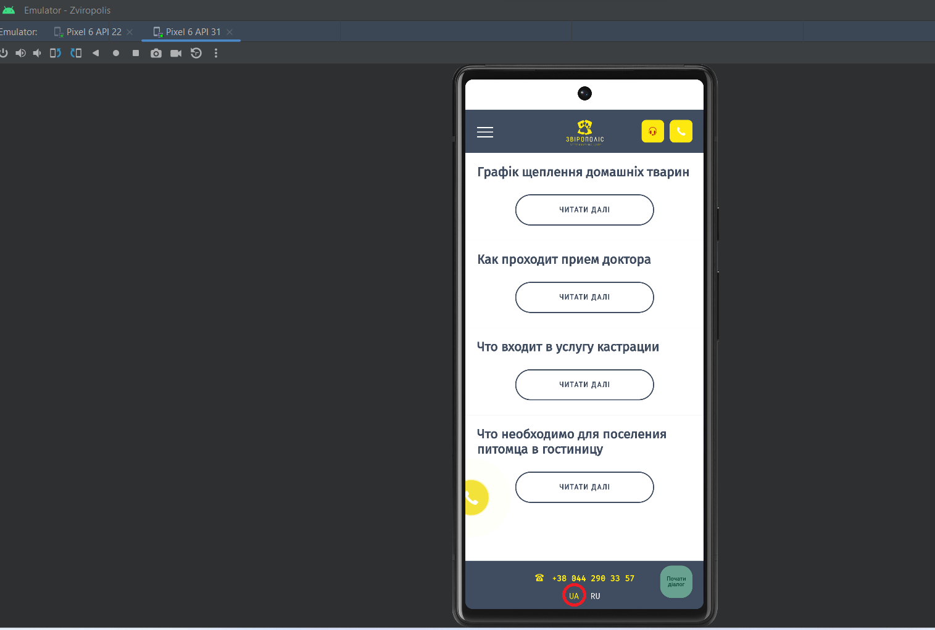

**Actual result:**

The text on the page is displayed in russian and Ukrainian at the same time

**Expected result:**

All text on the page is displayed in Ukrainian

**Testing Galaxy Nexus Android 8.0**

1. **Summary – The photo isn’t fully displayed**

**Severity** – Minor

**Priority** – Low

**Environment** – Galaxy Nexus Android 8.0

Resolution 720x1280

Google Chrome

**Steps to reproduce:**

1. Open the web-page <https://zpolis.com.ua> in the browser on the phone
2. Choose the menu “Акції” from the Hamburger menu
3. Click the button “Детальніше” bellow the article “Планове обстеження” and scroll to see the image

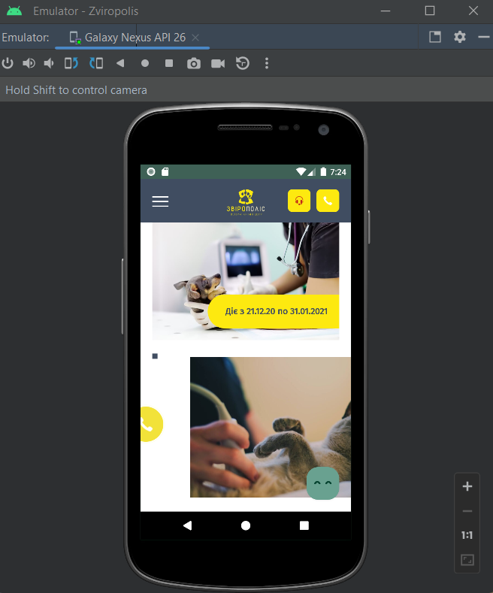

**Actual result:**

The image isn’t fully displayed

**Expected result:**

The image is fully displayed

**2. Summary – The text on the button is displayed in russian when the language of the site is set to UA.**

**Severity** – Minor

**Priority** – Low

**Environment** – Galaxy Nexus Android 8.0

Resolution 720x1280

Google Chrome

**Steps to reproduce:**

1. Open the web-page <https://zpolis.com.ua> in the browser on the phone
2. Scroll down to the section “Наші фахівці”
3. Pay attention to the button in this section

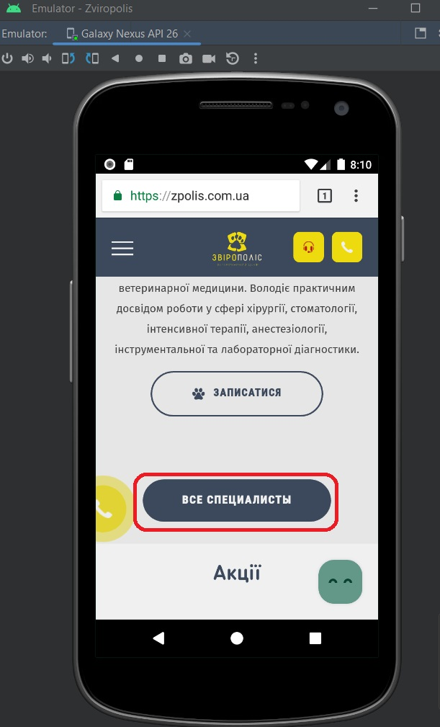

**Actual result:**

The text on the button is displayed in russian instead of Ukrainian

**Expected result:**

The text on the button is displayed in Ukrainian

**3. Summary – The links overlap the sections of the main menu**

**Severity** – Major

**Priority** – High

**Environment** – Galaxy Nexus Android 8.0

Resolution 720x1280

Google Chrome

**Steps to reproduce:**

1. Open the web-page <https://zpolis.com.ua> in the browser on the phone
2. Click the icon Hamburger menu

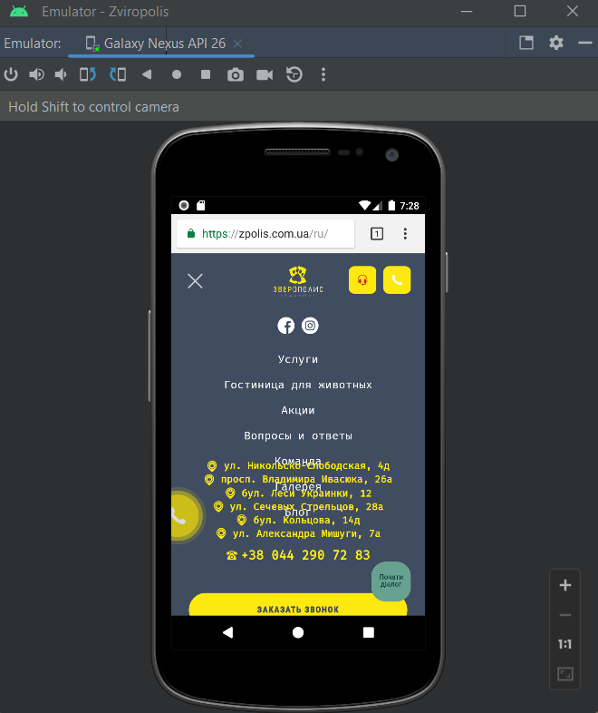

**Actual result:**

The links to the map overlap the menu items

**Expected result:**

All menu items are fully displayed

**Checklist for the mobile app “Дія” testing**

| **“Дія”** |  | **Executions** |
| --- | --- | --- |
| **Type of testing** | **Case** | **pass/fail** |
| Functional testing |  |  |
|  | Check the ability to register in the application |  |
|  | Check the ability to authorize a registered user |  |
|  | Check the display of user documents |  |
|  | Check the ability to pay taxes |  |
|  | Check the possibility to display QR-code of the documents |  |
| Interruptions testing |  |  |
|  | Check if the app pauses or minimizes appropriately, allowing the user to answer the call while incoming call interruption |  |
|  | Check if the app handles the orientation change correctly |  |
|  | Check if the app handles the battery removal correctly |  |
|  | Check if the app handles the disconnecting and connecting to the Wi-Fi |  |
|  | Check the correct work of the app while charging the device |  |
| UI testing |  |  |
|  | Check if the colors in different windows match the app’s overall design |  |
|  | Check that the icons in the bottom menu are the same size and style |  |
|  | Check that the fonts in “Меню” are the same size and style |  |
|  | Check if the images near the categories of “Послуги” correspond to the content of these services |  |
|  | Check if the app doesn’t have spelling and grammatical errors |  |
| Usability testing |  |  |
|  | Check how easy it is for new users to register in the app |  |
|  | Check how easy it is for users to navigate through the menu items |  |
|  | Check how easy it is for users to make a donation for the army |  |
|  | Check the possibility of using the application for people with visual impairments (if the text size is suitable or there is the zooming function) |  |
|  | Check the app's search field in the menu item “Категорії» to ensure that it's effective and efficient |  |