<https://oxford-med.com.ua>

**1. Summary – When you hover the cursor over the icons in the site header, pop-up tooltip doesn’t appear**

**Severity** – Minor

**Priority** – Low

**Environment** – OS Windows 11 64-bit

Web browsers: Opera, Mozilla Firefox, Google Chrome

**Steps to reproduce:**

1. Open <https://oxford-med.com.ua>
2. Hover the mouse cursor over the icon



**Actual result:**

The pop-up tooltip isn’t displayed near the icon

**Expected result:**

The pop-up tooltip “Особистий кабінет” is displayed near the icon

**2. Summary – The location of the clinic in Rivne is displayed on the map at the old address**

**Severity** – Major

**Priority** – Medium

**Environment** – OS Windows 11 64-bit

Web browsers: Opera, Mozilla Firefox, Google Chrome

**Steps to reproduce:**

1. Open <https://oxford-med.com.ua>
2. From the dropdown list of cities choose “Рівне”
3. Go to the page “Контакти”
4. Zoom in on the map to see the location of the clinic

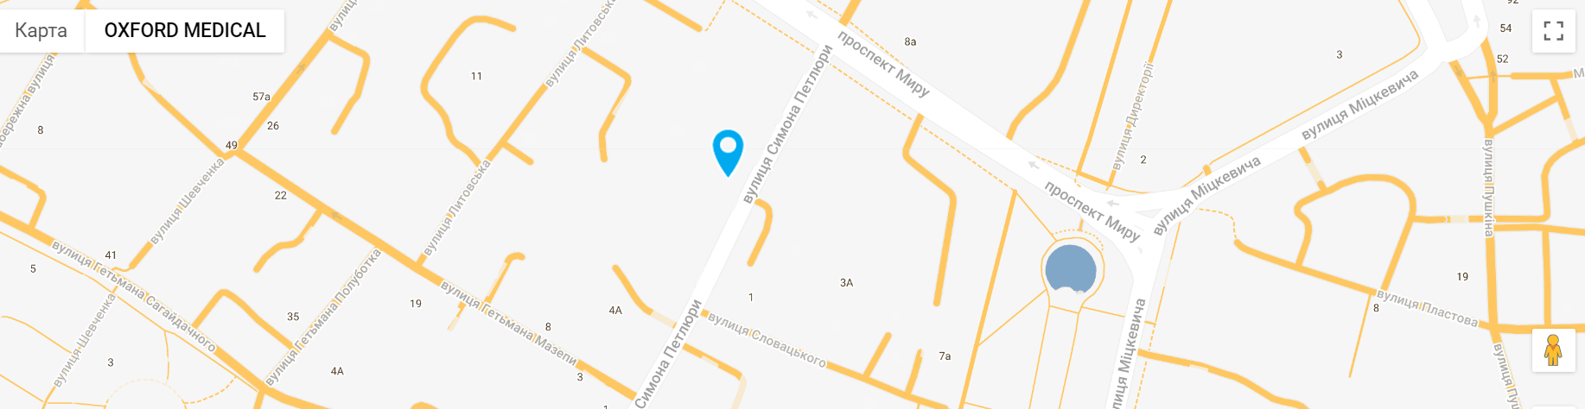

**Actual result:**

The pointer shows the old address of the clinic, not the current one

**Expected result:**

The pointer shows the current address of the clinic

**3. Summary – The language switcher is invisible on the page of the clinic in “Рівне” and becomes visible only when the mouse cursor is over it**

**Severity** – Major

**Priority** – Medium

**Environment** – OS Windows 11 64-bit

Web browsers: Opera, Mozilla Firefox, Google Chrome

**Steps to reproduce:**

1. Open <https://oxford-med.com.ua>
2. From the dropdown list of cities choose “Рівне”
3. Pay attention to the place in header where the language switcher must be displayed



**Actual result:**

The language switcher becomes visible only when the mouse cursor is over it

**Expected result:**

The language switcher is displayed in the header

**4. Summary – Clicking the Viber-phone number near form “Записатись на прийом” in the bottom of the main page doesn’t open the Viber**

**Severity** – Minor

**Priority** – Low

**Environment** – OS Windows 11 64-bit

Web browsers: Opera, Mozilla Firefox, Google Chrome

**Steps to reproduce:**

1. Open <https://oxford-med.com.ua>
2. From the dropdown list of cities choose “Київ”
3. Scroll down to the bottom of the page to see the feedback form
4. Click the Viber-phone number

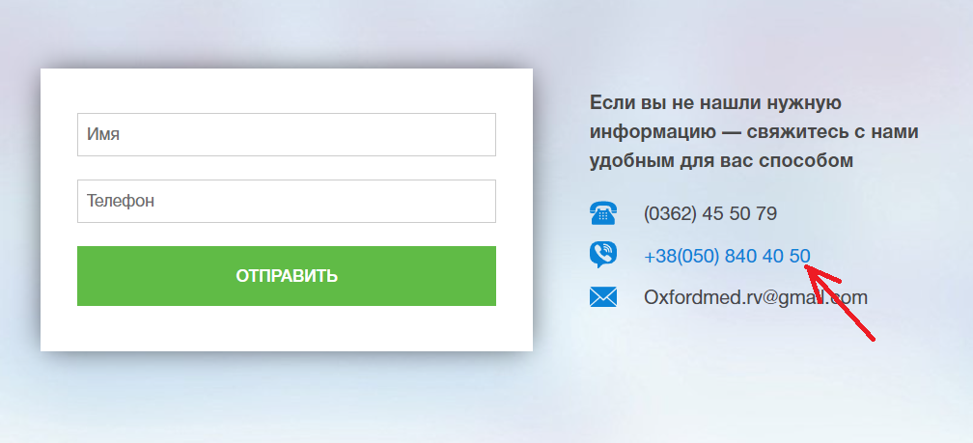

**Actual result:**

The phone number isn’t a link. It’s impossible to launch a viber app to contact the clinic

**Expected result:**

The pop-up window with the ability to launch a viber app is displayed

**5. Summary – The error message is displayed in russian instead of the language selected in the header**

**Severity** – Minor

**Priority** – Low

**Environment** – OS Windows 11 64-bit

Web browsers: Opera, Mozilla Firefox, Google Chrome

**Steps to reproduce:**

1. Open <https://oxford-med.com.ua>
2. From the dropdown list of cities choose “Київ”
3. Choose “УКР” from the dropdown list of languages in the header
4. Scroll down to the bottom of the page to see the feedback form
5. Enter the name in the field “Ім’я” and click the button “Відправити”

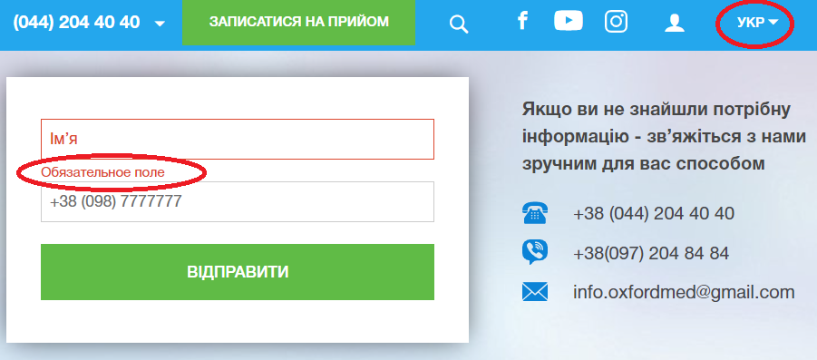

**Actual result:**

The language of the error message is different from the language selected on the site

**Expected result:**

The error message is displayed in Ukrainian “Обов'язкове поле”

Було проведено перевірку знайдених в Opera багів ще в двох браузерах:

* Mozilla Firefox,
* Google Chrome.

Усі три браузери однаково відображають ці 5 багів.

|  | **Номер тел. у хедері** | **Ім’я асистента при виклику чата допомоги** | **Кнопка “Інші міста” у футері сайту** | **Placeholder “Ім’я” у формі “Записатися на прийом”** |
| --- | --- | --- | --- | --- |
| **Font-family** | HelveticaNeue-Bold, sans-serif | Roboto, sans-serif | HelveticaNeue, sans-serif | HelveticaNeue, sans-serif |
| **Font-size** | 16px | 15px | 14px | 14px |
| **Color** | rgb(255, 255, 255) | rgb(8, 69, 52) | rgb(36, 167, 237) | rgb(83, 83, 83) |
| **Background-color** | rgba(0, 0, 0, 0) | rgba(0, 0, 0, 0) | rgb(235, 235, 235) | rgb(255, 255, 255) |