SQL Database Project – WS328700

Introduction
I will be producing a staff management platform for the new Hinkley Point Reactor G
For this system, it will have to do a series of things:
- Have a login system so admins or appropriate people can give out jobs for people to do
- Provide a work schedule for each day that shows when users are working each day
- Provide a way to show the radiation exposure staff members get and how healthy that is for them.
- Should be able to see a work schedule for each person individually and see their exposure levels per person.
- Include a reports section that will show the work happening in each reactor per week showing which days they occur.
- The report section should allow admins to be able to see each staffs schedule so they can see who do, or do not have any work.
- The reports section should also show each workers radiation exposure so that people are admins can see if they are safe or not.

For this a website will be made that accesses a database that will hold all of the information.

Designing the database

DF0
When designing the database it is useful to first create a DF0 (Data flow diagram – Level 0). This allows for a simple way to understand how the database would interact.
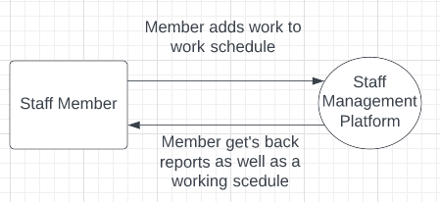
From this we can see that as the staff member interacts with the staff management platform interacts with the database, the user should get back reports and a working schedule.
This allows us to decide on how to create the database and how we would like it to look so now it would be a good idea to create a data dictionary to allow us to know what data we need and would use for each table. It is important to make many to ensure that it is used in the best normal form.

Data Dictionary
The data dictionary can be found in the data dictionary file. This has been made to be in the best normal form possible and include all the data that would be needed by the program. This allows to be able to create all the tables with all the fields needed to work.
To make sure this is also done correctly making an entity relationship diagram could also be good to produce to know how all the tables would be connected to make it easier to write the SQL.

ERD

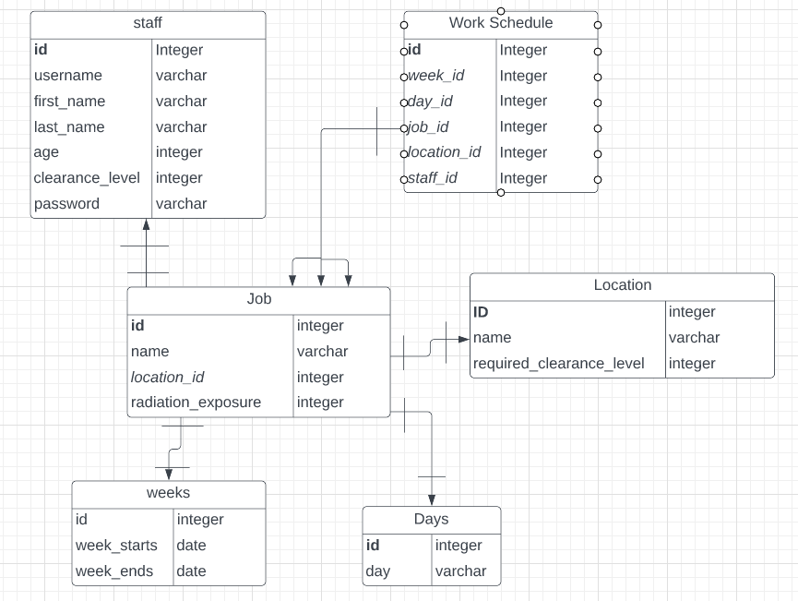
This is an ERD to show how all the data is connected. This also allows to see a simple way of how the tables are connected.

