JMJ MARIST BROTHERS
Notre Dame of Marbel University
City of Koronadal
MIT 261 Parallel and Distributed Systems

Scenarios for CRUD Operations
RetailMetrics Web Application
Database UML Diagram CRUD to Role Matrix Concurrency Reflection
RetailMetrics is a browser-based retail operations and customer commerce system built with Streamlit, FastAPI, and PostgreSQL. This document applies the supplied CRUD and RBAC requirements to the real RetailMetrics schema rather than copying the illustrative subscription example.
The system uses deliberate deletion rules. Cart Items may be physically removed before checkout. Identities, addresses, payment metadata, orders, refund requests, notifications, and audit evidence use deactivation, cancellation, rejection, processing, or retention when physical deletion would break ownership or history.

Contents
Section | Coverage
1 | Dataset architecture roles and CRUD interpretation
2 | Database UML diagram
Scenarios | Ten complete CRUD operation scenarios
3 | CRUD to role mapping matrix
4 | Concurrency and distributed systems reflection
5 | Browser demonstration checklist

1 System and dataset overview
RetailMetrics uses the Toy Store E Commerce Database: website sessions, pageviews, products, orders, order items, and refunds. The web application extends it with staff and customer identities, profiles, addresses, simulated payment methods, catalog configuration, carts, checkout snapshots, refund requests, notifications, and audit records.
Historical table | Approximate rows | Purpose
website_sessions | 472871 | Imported visits and campaigns
website_pageviews | 1188124 | Imported navigation events
orders | 32313 | Imported plus application orders
order_items | 40025 | Purchased products
order_item_refunds | 1731 | Imported plus processed refunds
products | 4 original | Product master

This dataset is suitable because it has realistic volume, connected entities, transaction history, and meaningful responsibilities for Admin, Operations Staff, Analyst, and Customer. record_origin and canonical views preserve imported evidence for Sessions 1 to 3.

Web architecture
Layer | Technology | Responsibility
Browser | Streamlit | Role-specific interface and HTTP requests
Server | FastAPI | Authentication RBAC validation and transactions
Data access | Services and repositories | Business rules concurrency and SQL
Database | PostgreSQL | Constraints foreign keys and durable commits

Core rule The browser never connects directly to PostgreSQL. FastAPI checks authentication and authorization on every protected request.

Roles
Role | Responsibility
Admin | Staff and customer administration products catalog operations audit and reporting
Operations Staff | Daily order and refund processing with necessary customer context
Analyst | Deidentified read-only analytics and reports
Customer | Registration owned resources shopping checkout orders and refund requests
System | Atomic checkout notifications audit and lifecycle enforcement

2 RetailMetrics database UML diagram
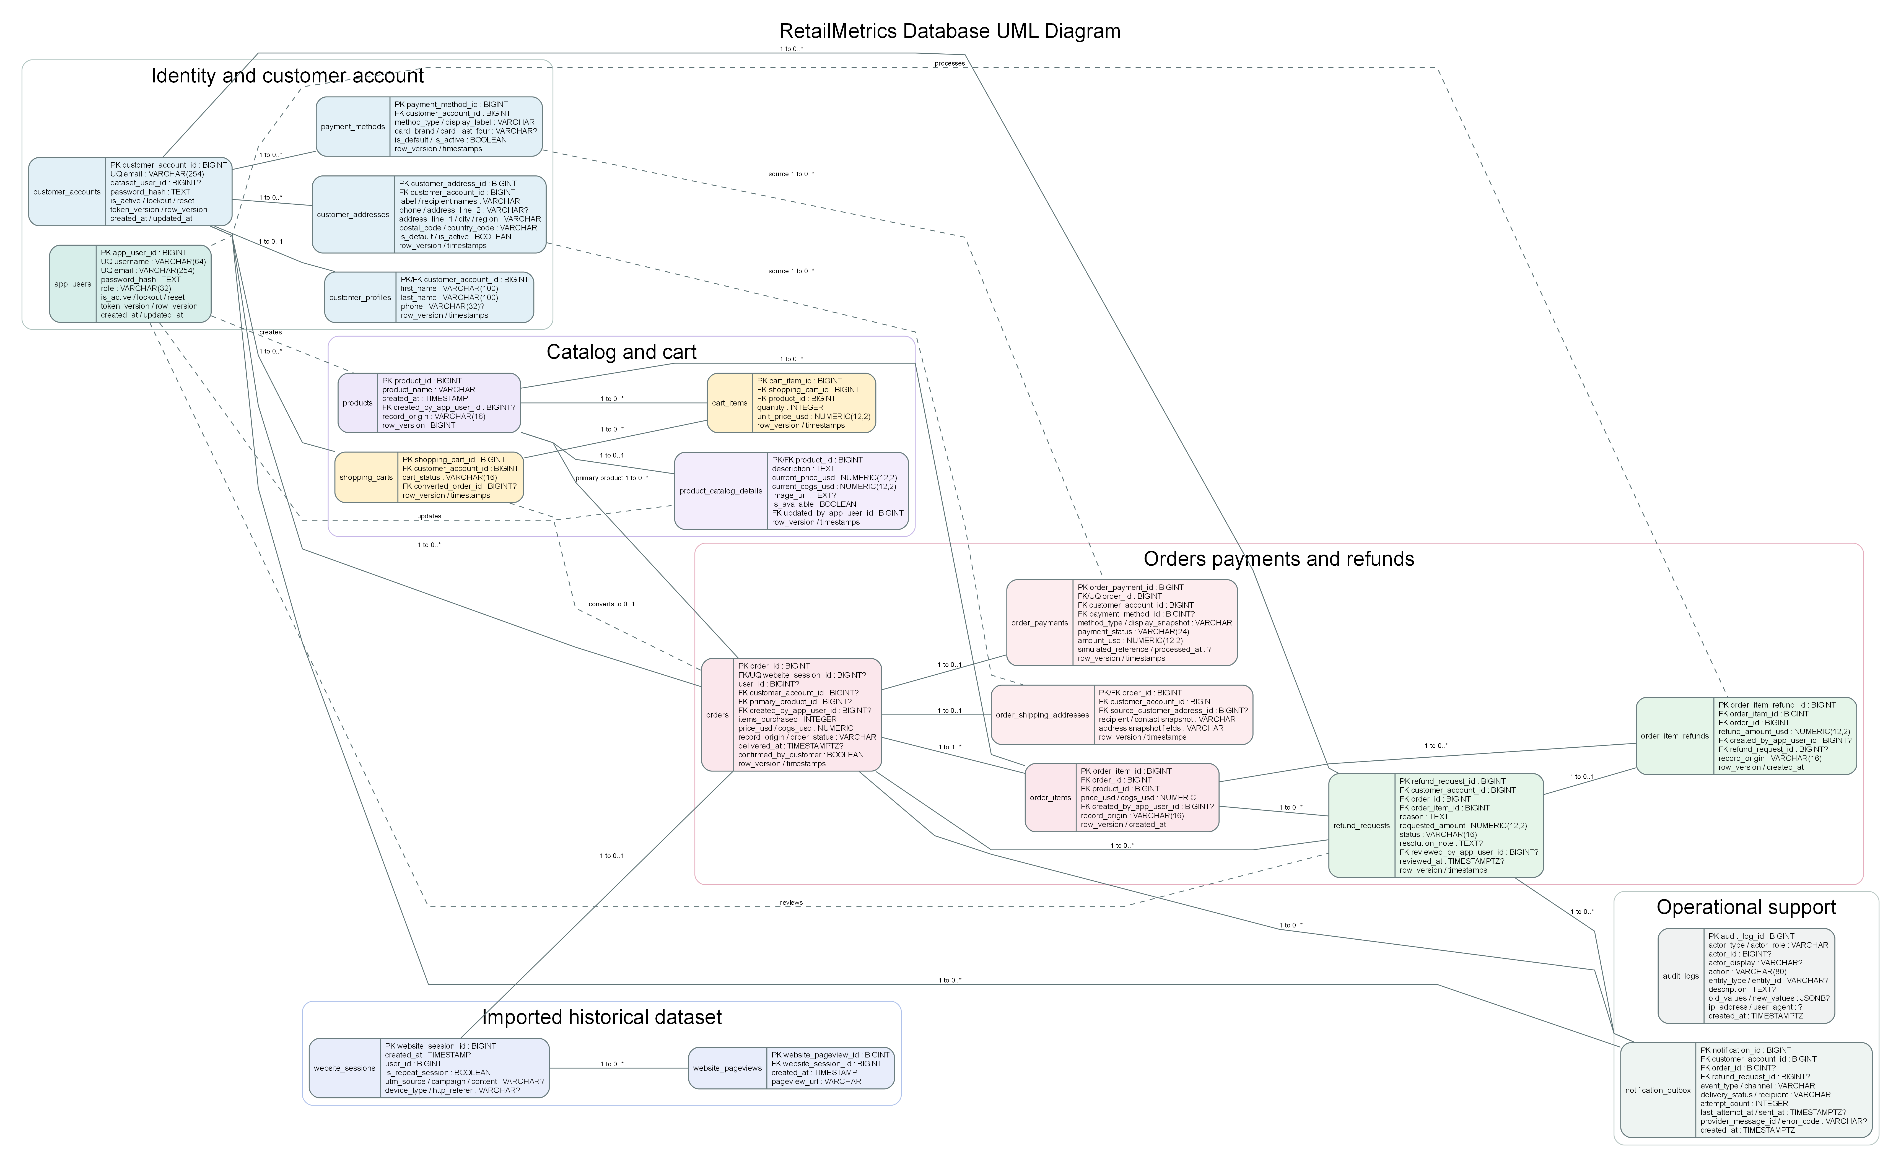
Figure 1 RetailMetrics operational database UML with fields data types keys and multiplicities.
Multiplicity: 1 is exactly one, 0..1 is zero or one, 0..* is zero or many, and 1..* is one or many. Dashed lines show actor attribution or snapshot-source relationships. Historical session and pageview entities are read-only.

UML relationship notes
- app_users stores staff identities; customer_accounts stores customer login identities; imported website_sessions.user_id is not an application login foreign key.
- A Customer Account has zero or one Profile and zero or many Addresses, Payment Methods, Carts, Orders, Refund Requests, and Notifications.
- A Cart has zero or many Cart Items and converts to at most one Order.
- A successful customer Order has one or more Order Items and zero or one shipping and payment snapshot; imported Orders have no portal snapshots.
- A processed Refund Request produces at most one matching Actual Refund.
- notification_outbox belongs to a Customer and targets either an Order event or Refund Request event. audit_logs stores immutable operational evidence.
Category | Entities
Identity | app_users customer_accounts customer_profiles customer_addresses payment_methods
Catalog and cart | products product_catalog_details shopping_carts cart_items
Historical | website_sessions website_pageviews
Commerce | orders order_items order_shipping_addresses order_payments refund_requests order_item_refunds
Support | notification_outbox audit_logs

Scenario 1 Customer Registration and Profile Maintenance
Purpose Create a customer identity and maintain the owned profile.
Tables customer_accounts customer_profiles
Field | Example
email | demo.customer@example.com
password_hash | Server-generated Argon2id hash
first_name / last_name | Demo / Customer
phone | +639171234567
row_version | 1

C Create Registration atomically inserts the Customer Account and required Profile.
R Read The Customer reads own safe account data; staff visibility follows role and Analysts receive deidentified data.
U Update The Customer edits name or phone with row_version; Admin may activate deactivate or unlock the account.
D Deactivate Admin sets is_active false instead of deleting identity and order ownership.
Validation note Another Customer cannot access this profile; Operations and Analyst cannot call Admin status endpoints.

Scenario 2 Staff User Administration and Security
Purpose Maintain staff identities and account protection.
Tables app_users audit_logs
Field | Example
username | operations.demo
email | operations.demo@example.com
role | operations_staff
is_active | true
token_version / row_version | 1 / 1

C Create Admin creates a unique staff username email role and password hash.
R Read Admin lists staff without hashes; each staff user reads own account.
U Update Admin changes role status or unlocks; users change own password; token_version invalidates older tokens.
D Deactivate Accounts are deactivated, preserving creator and reviewer references.
Validation note The final active Admin and the current Admin account are protected from unsafe demotion or deactivation.

Scenario 3 Product and Catalog Management
Purpose Maintain staff-created products and customer-facing catalog configuration.
Tables products product_catalog_details app_users
Field | Example
product_name | RetailMetrics Adventure Kit
record_origin | staff
current_price_usd | 39.99
current_cogs_usd | 18.50
is_available | true

C Create Admin creates a staff-origin Product and its catalog detail.
R Read Staff and Analysts read appropriate fields; Customers see only available configured products without COGS.
U Update Admin changes product or catalog data with row_version.
D Delete or unpublish Only permitted staff-origin products may be deleted; imported products are protected and availability safely unpublishes catalog items.
Validation note A stale update returns HTTP 409 and does not overwrite the current record.

Scenario 4 Customer Address Lifecycle
Purpose Maintain owned addresses without rewriting checkout history.
Tables customer_addresses order_shipping_addresses
Field | Example
label | Home
address_line_1 | 100 Sample Street
city | Koronadal City
province_region | South Cotabato
postal_code | 9506
is_default | true

C Create Customer creates an owned address; the first active address becomes default.
R Read Customer lists only owned addresses.
U Update Customer edits fields or changes the default atomically with row_version.
D Deactivate Deactivation replaces deletion; another active address is promoted when needed.
Validation note Existing order shipping snapshots never change when the source address changes.

Scenario 5 Simulated Payment Method Lifecycle
Purpose Maintain safe demonstration metadata without real credentials.
Tables payment_methods order_payments
Field | Example
method_type | card
display_label | Visa ending in 4242
card_brand / last_four | Visa / 4242
is_default / is_active | true / true

C Create Customer creates card GCash PayPal or Cash on Delivery simulation metadata.
R Read Customer reads own methods; staff sees only safe order snapshots.
U Update Customer changes allowed metadata or selects a new default with row_version.
D Deactivate Deactivation preserves checkout evidence.
Validation note Full card numbers CVV expiry OTP credentials and real account identifiers are rejected.

Scenario 6 Shopping Cart Full CRUD
Purpose Demonstrate literal full CRUD on a pre-checkout resource.
Tables shopping_carts cart_items products
Field | Example
cart_status | active
product_id | 2
quantity | 1 then 2
unit_price_usd | 59.99
row_version | 1

C Create Adding a product creates or reuses the Customer active Cart and inserts a Cart Item.
R Read Customer views own Cart with stored and current prices.
U Update Customer changes quantity from 1 to 2; range ownership and row_version are validated.
D Delete Customer physically removes the Cart Item before checkout.
Validation note This is the clearest literal CRUD demonstration. A second stale-tab update returns HTTP 409.

Scenario 7 Checkout and Order Lifecycle
Purpose Convert a cart into durable order records and process them safely.
Tables shopping_carts orders order_items order_shipping_addresses order_payments
Field | Example
record_origin | customer
order_status | pending
items_purchased | 2
price_usd | 119.98
payment_status | paid simulation

C Create One transaction locks and validates the Cart then creates Order Items and immutable snapshots and converts the Cart.
R Read Customers read own Orders; staff and Analysts receive authorized operational or reporting views.
U Update Staff moves pending to processing to ready_shipped; the owner confirms delivered.
D Cancel A pending Order is cancelled rather than physically deleted.
Validation note The Orders page selects the oldest outstanding order and keeps all historical tables collapsed below.

Scenario 8 Refund Request and Actual Refund
Purpose Request review and process a refund with retained evidence.
Tables refund_requests order_item_refunds orders order_items order_payments
Field | Example
requested_amount | 59.99
reason | Item arrived damaged
status | pending
row_version | 1

C Create Customer submits a request for an eligible owned item.
R Read Customer reads own request; staff reads the oldest actionable queue; Analyst reads reporting evidence.
U Update Admin or Operations approves rejects or processes; processing creates one Actual Refund atomically.
D Close Rejected and processed states replace physical deletion.
Validation note Refund Requests is the single refund page; history and actual refunds are collapsed at the bottom.

Scenario 9 Notifications and Audit Evidence
Purpose Record communications and audit events without weakening transactions.
Tables notification_outbox audit_logs
Field | Example
event_type | order_confirmation
channel | email
delivery_status | pending
attempt_count | 0
recipient | demo.customer@example.com

C Create Business transactions add Outbox rows; supported application actions add Audit rows.
R Read Authorized Admin tools inspect safe status and evidence.
U Update Dispatcher moves pending to sending to sent or failed and records safe delivery metadata.
D Retain Ordinary UI does not delete notification or audit evidence.
Validation note Provider failure never rolls back a committed Order or Refund; secrets are excluded from logs.

Scenario 10 Complete Retail Customer Lifecycle
Purpose Demonstrate end-to-end CRUD RBAC and retained evidence.
Tables all operational entities
C Create Register a Customer create owned Address and Payment Method add Cart Item checkout then submit Refund Request.
R Read Browse catalog view Cart Order Request Actual Refund Notification status and authorized Audit evidence.
U Update Change Cart quantity process Order confirm delivery approve and process Refund.
D Delete or close Remove a pre-checkout Cart Item; deactivate owned resources; cancel or close retained workflows safely.
Validation note Repeat a protected request with an Analyst or unrelated Customer to demonstrate server-side refusal.

Recommended end-to-end order
1. Browse before login and add a toy to the guest bag.
2. Register or sign in and transfer the guest bag to the persistent Cart.
3. Create Address and simulated Payment Method.
4. Show Cart Create Read Update Delete, then add the item again.
5. Checkout and verify the Order.
6. Process the oldest Order as Operations Staff.
7. Confirm delivery as the Customer.
8. Submit approve and process the Refund Request.
9. Verify Actual Refund notification and audit evidence while imported rows remain unchanged.

3 CRUD to role mapping matrix
D* means deactivation cancellation rejection lifecycle closure or retention instead of arbitrary physical deletion. System is internal server behavior.
Resource | Admin | Operations | Analyst | Customer | System
Staff Users | C R U D* | Own R U | Own R U | - | Audit
Customer Accounts | R U D* | R limited | R deidentified | C R U | Lockout reset
Profiles | R | R limited | R deidentified | C R U | -
Addresses | - | - | - | C R U D* | Snapshot
Payment Methods | R snapshot | R snapshot | - | C R U D* | Snapshot
Products | C R U D | R | R | R available | -
Catalog | C R U D* | R | - | R available | -
Cart Items | - | - | - | C R U D | Validate
Orders | R U D* | R U D* | R | C R U D* | Atomic C
Order Items | R | R | R | C via checkout R | Atomic C
Refund Requests | R U D* | R U D* | R reports | C R | Validate
Actual Refunds | R | R | R | R own | C via process
Notifications | R | R status | - | Receives | C R U
Audit Logs | R | - | - | - | C
Historical Data | R | R limited | R | - | Immutable

- Complete CRUD is distributed by business responsibility instead of giving one role unrestricted power.
- Cart Items provide literal C R U D. Products provide Admin CRUD only for staff-origin rows.
- FastAPI enforces every permission even when a Streamlit control is hidden.

4 Concurrency and distributed systems reflection

Optimistic concurrency
Mutable application resources carry row_version. A client submits the version it last read. The repository updates only when the stored version still matches and increments it after success. A stale simultaneous request receives HTTP 409 rather than silently overwriting newer data.
Example Two tabs read Cart Item row_version 4. Tab A commits quantity 2 and creates row_version 5. Tab B submits row_version 4 and is rejected. It must refresh before retrying.

Atomic checkout and refund processing
Checkout locks and revalidates the active Cart and catalog, verifies owned resources, calculates totals, creates the Order and Items, writes snapshots, converts the Cart, and commits once. Refund processing locks the Request and related commerce rows, rechecks remaining value, creates exactly one Actual Refund, and updates payment and order state in one transaction. Any failure rolls back the entire operation.

Multiple application instances
- Use a shared session store such as Redis or carefully managed sticky sessions because opaque Streamlit handles currently live in process memory.
- Keep PostgreSQL constraints transactions and row locks authoritative across every instance.
- Claim Outbox rows atomically so multiple workers do not deliver the same event.
- Add idempotency keys for externally retried checkout-style requests before public multi-instance deployment.

Safe concurrency
Independent reads and different customers owned resources are generally safe concurrently. Catalog edits default-resource changes Cart updates Order transitions Refund processing and staff account changes require row versions or row locks because they can target the same record or invariant.

5 Browser demonstration checklist
1. Open http://localhost:8501 and show public browsing search reviews and the guest bag.
2. Sign in or register a disposable Customer and demonstrate password recovery without exposing a credential or reset token.
3. Create an Address and simulated Payment Method.
4. Demonstrate Cart Item Create Read Update and Delete, then add the item again.
5. Checkout and verify My Orders.
6. As Admin or Operations Staff process the oldest outstanding Order.
7. As the Customer confirm delivery and submit a Refund Request.
8. As authorized staff approve and process the oldest Refund Request.
9. Open collapsed history to verify the Actual Refund and, if enabled, safe audit evidence.
10. Attempt a disallowed action as Analyst or unrelated Customer and show server refusal.
11. Confirm imported historical rows remain unchanged.

Requirement evidence
Requirement | RetailMetrics evidence
Architecture | Browser to Streamlit to FastAPI to PostgreSQL
CRUD | Literal Cart Item CRUD plus retained-resource lifecycle CRUD
RBAC | Authorized success and unauthorized direct-request refusal
Security | Argon2id JWT lockout change password email-link reset token invalidation
Concurrency | row_version HTTP 409 atomic checkout and atomic refund processing
UML | Entities fields data types keys and multiplicities in Figure 1

Source basis
This document follows the structure and deliverable expectations in the supplied Scenarios for CRUD Operations and Requirements for CRUD operations WEB BASED Version PDFs. The entities roles workflows and safety rules are derived from the current RetailMetrics repository rather than the illustrative subscription schema in those references.

