When I enter Section details, below, I would like to add another option – Create Bays (I can do this)

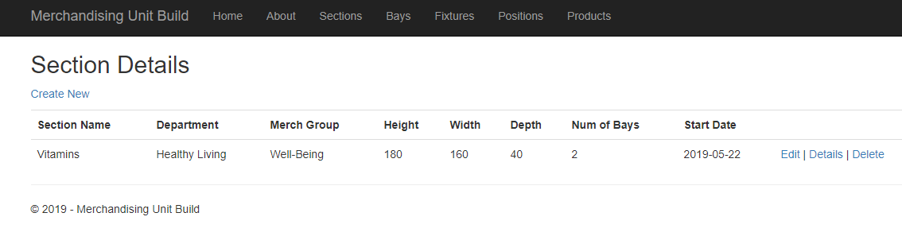

I would then like to create the following lines in the DB table and then I could edit this, if required. The row data can be implied from the Section information above

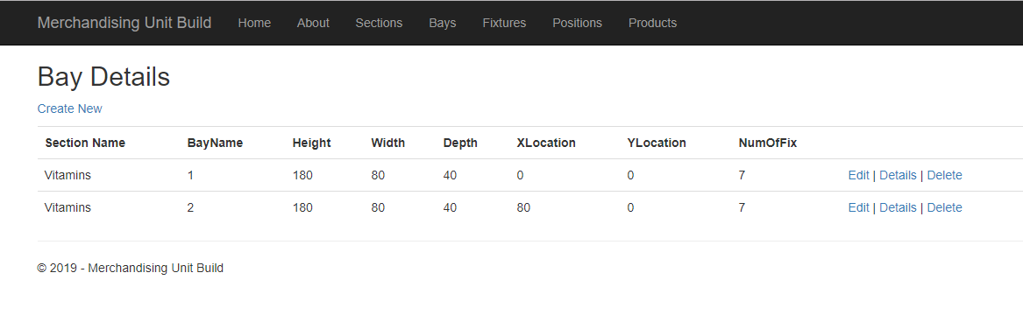

**Section Name** – carried from Section table

**BayName** – always starting at 1 and incrementing by 1

**Height** – as Section height

**Width** – as Section width/Num of Bays

**Height** – as Section depth

**XLocation** – always starting at 0 and incrementing by width of previous Bay(s)

**NumOfFix** – Whole number of Height/25