FACULTY OF ENGINEERING AND TECHNOLOGY

REPORT ABOUT USING THE ALGORITHM DEVELOPMENT,
CONTROL STRUCTURE AND USING MODULES 1-4 ON
PRATICAL REAL WORLD PROBLEM

COURSE UNIT: COMPUTER POGRAMMING
LECTURER: MR. MASERUKA BENEDICTO

BY GROUP 15

DATE OF SUBMISSION: ........./.............../........................
SUBMITTED TO: ........................................................................

ACKNOWLEDGEMENT:
We are grateful to the almighty God for this guidance and strength throughout this work our sincere thanks go to all who supported us and to every group member for their time and effort. Lastly, we acknowledge the sources and references that contributed to this report that have been mentiomed in this report.

ABSTRACT:
This report presents a research on the algorithm development ,control structures and modules 5.1 for solving mathematical problems using various methods such as Euler, Runge-kutta , Scant, and New Ranpson method which helped us to plot graphs that compare the problems analytically by the different methods .The information used was obtained from Matlab textbooks and Youtube tutorials. We divided group members accordingly to achieve this tasks, different individuals were assigned different nurical methods in order to ease the work and save time.

DEDICATION:
This report is dedicated to our lecturer, Mr. Masruka Benedicto who’s guidance and support have been instrumental in our learning journey. We also dedicate this work to group 15 members their unwavering encouragement throughout this project.

DECLARATION:
We, group 15 members hereby declare that this report is our original work, carried out as part of the MATLAB course under the supervision of Mr. Maseruka Benedicto. All sources of information have been duly acknowledged, and this work has not been submitted elsewhere for academic project.
LUGUNGA TIMOTHY................
ODONG ERICK PERRY...................................................
KATUSIME JOEL..............................................................
NABUKWASI SHAKIRA...................................................
NAZIWA PATRICIA............................................................
NANDIJJA LAILA.................................................................
SIDENYA KEVIN ...........................................................…
BULUMA DANIEL………………………………………..
BAHEMUKA GODWINS…………………………………
NAMATA LILLIAN KIZZA………………………

APPROVAL:
This report titled “The Algorithm Development control Structure and using modues 1-4 on practical real world” has been prepared and submitted by Group 15, in partial fulfillment of the requirements for the course. The work presented here is original and has been carried out under the guidance of the instructor.
We hereby approve this report as a reflection of the student’s effort in applying knowledge from Modules 1 to 4 to analyze, interpret, and visualize real-world data.

Table of Contents
ACKNOWLEDGEMENT: i
ABSTRACT: ii
DEDICATION: iii
DECLARATION: iv
APPROVAL: v
CHAPTER 1: INTRODUCTION: １
1.1 Background: １
1.2 Historical Development: １
2.1 NUMBER ONE: ２
CHAPTER 3: RECOMMENDATIONS AND CONCLUSION ２６
3.1 REC0MMENDATION ２６
3.2 CONCLUSION ２６
3.3 REFERENCES ２６

CHAPTER 1: INTRODUCTION:

1.1 Background:
MATLAB, which stands for matrix laboratory, is a high-performance programming language and environment designed primarily for technical computing. Its origins trace back to the late 1970s when Cleve Moler, a professor of computer science, developed it to provide his students with easy access to mathematical software libraries without requiring them to learn Fortran.

1.2 Historical Development:
Initial Development: The first version of MATLAB was created in Fortran in the late 1970s as a simple interactive matrix calculator. This early iteration included basic matrix operations and was built on top of two significant mathematical libraries: LINPACK and EISPACK, which were developed for numerical linear algebra and eigenvalue problems, respectively.
Commercial Launch: MATLAB was officially launched as a commercial product in 1984 by MathWorks, a company founded by Moler along with Jack Little and Steve Bangert. This marked the transition from a simple calculator to a comprehensive programming environment. The software was reimplemented in C, enhancing its capabilities with the addition of user-defined functions, toolboxes, and graphical interfaces.
Expansion and Toolboxes: Over the years, MATLAB has expanded significantly. By the late 1980s, it had introduced several specialized toolboxes for various applications, including control systems and signal processing. The introduction of the Simulink environment further allowed users to model and simulate dynamic systems graphically.
Modern Enhancements: Recent versions of MATLAB have introduced features like the Live Editor, which allows users to create interactive documents that combine code, output, and formatted text. This evolution reflects MATLAB's ongoing adaptation to meet the needs of its diverse user base across academia and industry.
CHAPTER 2: STUDY COVERAGE:

2.1 NUMBER ONE:
FLOW CHART
END
$$Print x_{1}$$
yes
$$calc error<error$$
$$x_{n+1}=x_{o}−\frac{{f(x}_{n})}{{f^{'}}_{\left(x_{n}\right)}}$$
$$calc error=|x_{1}−x_{o}|$$
$$X_{0}=1.5$$
$$f\left(x\right)=x^{3}−x−2$$
$$f^{'}\left(x\right)={3x}^{2}−1$$
$$error={5×10}^{−4}$$

START

$$x=x_{1}$$
no
NEWTON RAPHSON METHOD
EXAMPLE ONE
Start timer
Set initial guess x0 = 2
Define function f(x) = x^3 - x - 2
Define derivative df(x) = 3*x^2 - 1
Set tolerance err = 0.0005
Compute first Newton–Raphson update:
x = x0 - f(x0)/df(x0)
Compute error = |x - x0|
While error > tolerance:
Update x0 = x
Compute next Newton–Raphson update:
x = x0 - f(x0)/df(x0)
Compute error = |x - x0|
End loop
Record final root value x
Stop timer and record timetaken
Compute high-precision reference root xref using fzero
Save variables (x, timetaken, xref) into file "Newton-Raphson.mat"
tic;
x0 = 2;
f = @(x0) x0^3 - x0 - 2;
df = @(x0) (3*x0^2)-1;
err = 0.0005;
x = x0-(f(x0)/df(x0))
x = 1.6364
calc_err = abs(x-x0);
while calc_err>err
x0 = x;
x = x0-(f(x0)/df(x0))
calc_err = abs(x-x0);
end
x = 1.5304
x = 1.5214
x = 1.5214
timetaken = toc
timetaken = 0.1385
xref = fzero(@(x0) x0^3 - x0 - 2,1.6);
save("Newton-Raphson.mat","x","timetaken","xref");

EXAMPLE TWO
Start timer
Set initial guess x0 = 0
Define function f(x) = x^3 + x - 1
Define derivative df(x) = 3*x^2 + 1
Set tolerance err = 0.0005
Compute first Newton–Raphson update:
x = x0 - f(x0)/df(x0)
Compute error = |x - x0|
While error > tolerance:
Update x0 = x
Compute next Newton–Raphson update:
x = x0 - f(x0)/df(x0)
Compute error = |x - x0|
End loop
Record final root value x
Stop timer and record timetaken
Compute high-precision reference root xref using fzero
Save variables (x, timetaken, xref) into file "Newton-Raphson_2.mat"
tic;
x0 = 0;
f = @(x0) x0^3 + x0 - 1;
df = @(x0) (3*x0^2)+1;
err = 0.0005;
x = x0-(f(x0)/df(x0))
x = 1
calc_err = abs(x-x0);
while calc_err>err
x0 = x;
x = x0-(f(x0)/df(x0))
calc_err = abs(x0-x);
end
x = 0.7500
x = 0.6860
x = 0.6823
x = 0.6823
timetaken = toc
timetaken = 0.0540
xref = fzero(@(x0) x0^3 + x0 - 1,1);
save("Newton-Raphson_2.mat","x","timetaken","xref");

SECANT METHOD
EXAMPLE ONE

Start timer
Set initial guesses:
x0 = 1
x1 = 2
Define function f(x) = x^3 - x - 2
Compute slope (approx derivative) between (x0, f(x0)) and (x1, f(x1)):
df = (f(x1) - f(x0)) / (x1 - x0)
Compute first update:
x = x1 - f(x1) / df
Compute error = |x - x1|
While error > tolerance (0.0005):
Update x1 = x
Recompute slope df = (f(x1) - f(x0)) / (x1 - x0)
Compute next update:
x = x1 - f(x1) / df
Update error = |x - x1|
End loop
Record final root value x
Stop timer and record timetaken
Compute high-precision reference root xref using fzero
Save variables (x, timetaken, xref) into file "Secant.mat"
tic;
x0 = 1;
x1 = 2;
f0 = @(x0) x0^3 - x0 - 2;
f = @(x1) x1^3 - x1 - 2;
df = @(x1) (f(x1)-f0(x0))/(x1-x0);
err = 0.0005;
x = x1-(f(x1)/df(x1))
x = 1.3333
calc_err = abs(x-x1);
while calc_err>err
x1 = x;
x = x1-(f(x1)/df(x1))
calc_err = abs(x-x1);
end
x = 1.6429
x = 1.4606
x = 1.5565
x = 1.5026
x = 1.5318
x = 1.5157
x = 1.5245
x = 1.5197
x = 1.5223
x = 1.5209
x = 1.5217
x = 1.5212
timetaken = toc
timetaken = 0.0812
xref = fzero(@(x0) x0^3 - x0 - 2,1.6);
save("Secant.mat","x","timetaken","xref");

EXAMPLE TWO
Start timer
Set initial guesses:
x0 = 0
x1 = 1
Define function f(x) = x^3 + x - 1
Compute slope (approx derivative) between (x0, f(x0)) and (x1, f(x1)):
df = (f(x1) - f(x0)) / (x1 - x0)
Compute first update:
x = x1 - f(x1) / df
Compute error = |x - x1|
While error > tolerance (0.0005):
Update x1 = x
Recompute slope df = (f(x1) - f(x0)) / (x1 - x0)
Compute next update:
x = x1 - f(x1) / df
Update error = |x - x1|
End loop
Record final root value x
Stop timer and record timetaken

Compute high-precision reference root xref using fzero
Save variables (x, timetaken, xref) into file "Secant_2.mat"
tic;
x0 = 0;
x1 = 1;
f0 = @(x0) x0^3 + x0 - 1;
f = @(x1) x1^3 + x1 - 1;
df = @(x1) (f(x1)-f0(x0))/(x1-x0);
err = 0.0005;
x = x1-(f(x1)/df(x1))
x = 0.5000
calc_err = abs(x-x1);
while calc_err>err
x1 = x;
x = x1-(f(x1)/df(x1))
calc_err = abs(x-x1);
end
x = 0.8000
x = 0.6098
x = 0.7290
x = 0.6530
x = 0.7011
x = 0.6705
x = 0.6899
x = 0.6775
x = 0.6854
x = 0.6804
x = 0.6836
x = 0.6815
x = 0.6828
x = 0.6820
x = 0.6825
x = 0.6822
timetaken = toc
timetaken = 0.1129
xref = fzero(@(x0) x0^3 + x0 - 1,1);
save("Secant_2.mat","x","timetaken","xref");

BISECTOR METHOD

EXAMPLE ONE
Start timer
Define function f(x) = x^3 - x - 2
Set initial interval [a, b] = [1, 2]
Set tolerance err = 0.0005
While (b - a) > err:
Compute midpoint c = (a + b) / 2
If f(a) * f(c) < 0:
Root lies in [a, c], so set b = c
Else:
Root lies in [c, b], so set a = c
End loop
Set approximate root x = (a + b) / 2
Stop timer and record timetaken
Compute high-precision reference root xref using fzero
Save variables (x, timetaken, xref) into file "Bisection.mat"
tic;
f = @(x) x^3 - x - 2;
a = 1;
b = 2;
err = 5e-4;
while (b-a)>err
c=(a+b)/2;
if f(a)*f(c)<0
b = c;
else
a = c;
end
end
x = (a+b)/2
x = 1.5212
timetaken = toc
timetaken = 0.0491
xref = fzero(@(x) x^3 - x - 2,1.6);
save("Bisection.mat","x","timetaken","xref");

EXAMPLE TWO
Start timer
Define function f(x) = x^3 + x - 1
Set initial interval [a, b] = [0, 1]
Set tolerance err = 0.0005
While (b - a) > err:
Compute midpoint c = (a + b) / 2
If f(a) * f(c) < 0:
Root lies in [a, c], so set b = c
Else:
Root lies in [c, b], so set a = c
End loop
Set approximate root x = (a + b) / 2
Stop timer and record timetaken
Compute high-precision reference root xref using fzero
Save variables (x, timetaken, xref) into file "Bisection_2.mat"
tic;
f = @(x) x^3 + x - 1;
a = 0;
b = 1;
err = 5e-4;
while (b-a)>err
c=(a+b)/2;
if f(a)*f(c)<0
b = c;
else
a = c;
end
end
x = (a+b)/2
x = 0.6824
timetaken = toc
timetaken = 0.1038
xref = fzero(@(x) x^3 - x - 2,1);
save("Bisection_2.mat","x","timetaken","xref");

FIXED POINT ITERATION METHOD

EXAMPLE ONE
Start timer
Define function f(x) = x^3 - x - 2
Rearrange into x = g(x), e.g., g(x) = (x + 2)^(1/3)
Set initial guess x0
Set tolerance err = 0.0005
Initialize iteration list x_hist with x0
Compute first iterate:
x = g(x0)
Compute error = |x - x0|
While error > tolerance:
Update x0 = x
Compute next iterate:
x = g(x0)
Compute error = |x - x0|
Append x to iteration list
End loop
Record final root value x
Stop timer and record timetaken
Compute high-precision reference root xref using fzero
Save variables (x, timetaken, xref) into file "Fixed_point_iteration.mat"

tic;
f = @(x) x^3 - x - 2;
g = @(x) (x+2).^(1/3);
x = 1;
err = 5e-4;
while true
x1 = g(x);
if abs(x1-x)<err
break
end
x = x1
end
x = 1.4422
x = 1.5099
x = 1.5197
x = 1.5211
timetaken = toc
timetaken = 0.0500
xref = fzero(@(x) x^3 - x - 2,1.6);
save("Fixed_point_iteration.mat","x","timetaken","xref");

EXAMPLE TWO
Start timer
Define function f(x) = x^3 + x - 1
Rearrange into x = g(x), e.g., g(x) = (1 - x)^(1/3)
Set initial guess x0
Set tolerance err = 0.0005
Initialize iteration list x_hist with x0
Compute first iterate:
x = g(x0)
Compute error = |x - x0|
While error > tolerance:
Update x0 = x
Compute next iterate:
x = g(x0)
Compute error = |x - x0|
Append x to iteration list
End loop
Record final root value x
Stop timer and record timetaken
Compute high-precision reference root xref using fzero
Save variables (x, timetaken, xref) into file "Fixed_point_iteration_2.mat"
tic;
f = @(x) x^3 + x - 1;
g = @(x) (1-x).^(1/3);
x = 0.5;
err = 5e-4;
while true
x1 = g(x);
if abs(x1-x)<err
break
end
x = x1
end
x = 0.7937
x = 0.5909
x = 0.7424
x = 0.6363
x = 0.7138
x = 0.6590
x = 0.6986
x = 0.6704
x = 0.6907
x = 0.6763
x = 0.6866
x = 0.6792
x = 0.6845
x = 0.6807
x = 0.6835
x = 0.6815
x = 0.6829
x = 0.6819
x = 0.6826
x = 0.6821
timetaken = toc
timetaken = 0.0755
xref = fzero(@(x) x^3 + x - 1,1);
save("Fixed_point_iteration_2.mat","x","timetaken","xref");

GROUPING DATA FOR PLOTTING
Define list of methods = [Newton-Raphson, Secant, Bisection, Fixed Point]
Define list of problems = [Example1, Example2]

Initialize empty table for computation times

For each problem in problems:
Open New figure
For each method in methods:
Load the saved data file for this method and problem
Extract iterates (x), true root, and time
Compute error at each iteration = |x - true root|
Plot error vs iteration
Store time in the times table
Show legend and set Y axis to log scale

Open new figure
Make bar chart of computation times for all methods and both problems
Label axes and add title
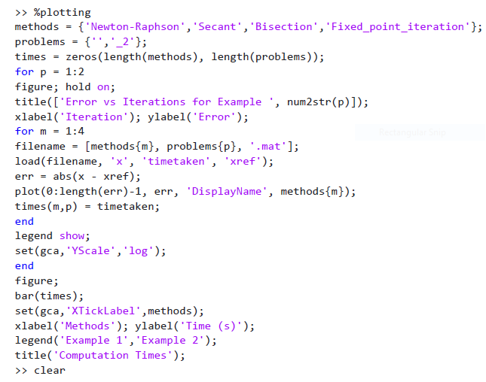

GRAPH COMPARING ANALYTICAL SOLUTIONS TO SOLUTIONS OBTAINED WITH COMPUTATION TIME

For each method and problem:
Plot error vs iteration curve
Use log scale for error axis
After looping:
Create bar chart comparing times

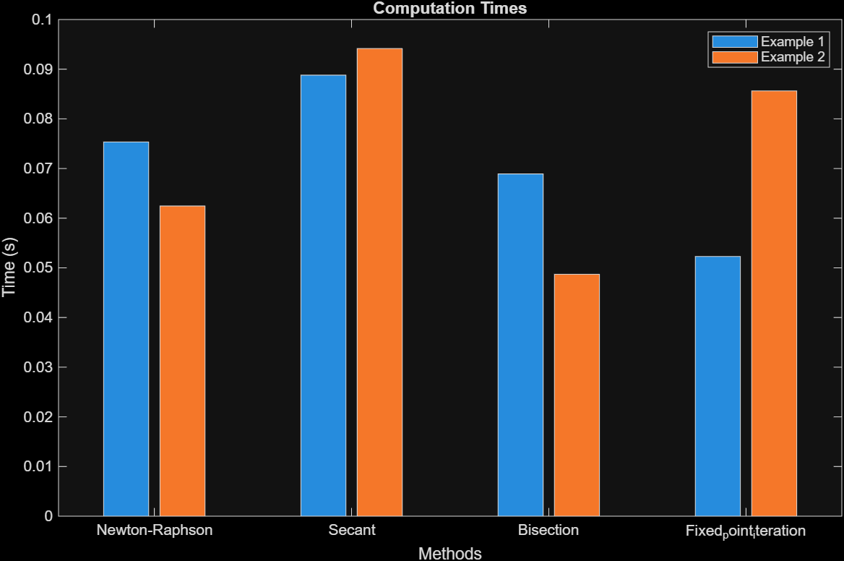
Table 1computation time

Part b
Runge-Kutta method
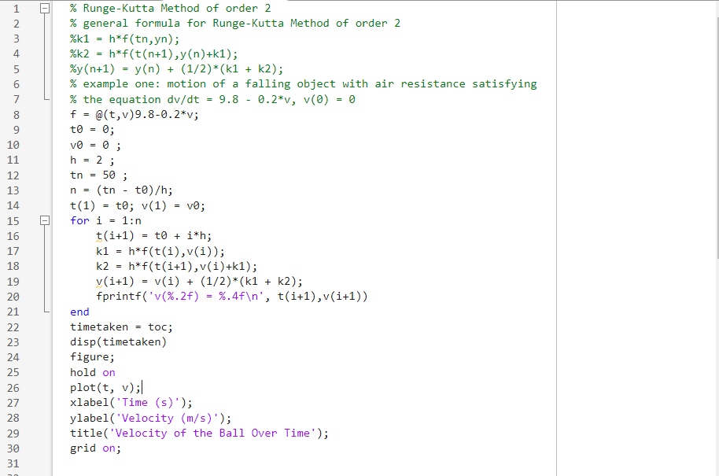
v(2.00) = 15.6800
v(4.00) = 26.3424
v(6.00) = 33.5928
v(8.00) = 38.5231
v(10.00) = 41.8757
v(12.00) = 44.1555
v(14.00) = 45.7057
v(16.00) = 46.7599
v(18.00) = 47.4767
v(20.00) = 47.9642
v(22.00) = 48.2956
v(24.00) = 48.5210
v(26.00) = 48.6743
v(28.00) = 48.7785
v(30.00) = 48.8494
v(32.00) = 48.8976
v(34.00) = 48.9304
v(36.00) = 48.9526
v(38.00) = 48.9678
v(40.00) = 48.9781
v(42.00) = 48.9851
v(44.00) = 48.9899
v(46.00) = 48.9931
v(48.00) = 48.9953
v(50.00) = 48.9968
4.4456e+03
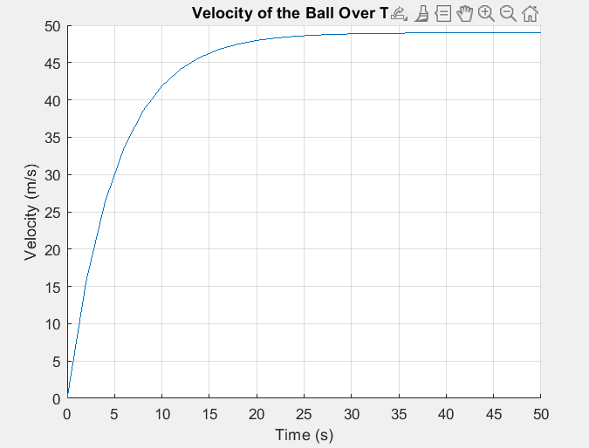
Table 2velocity of ball over time

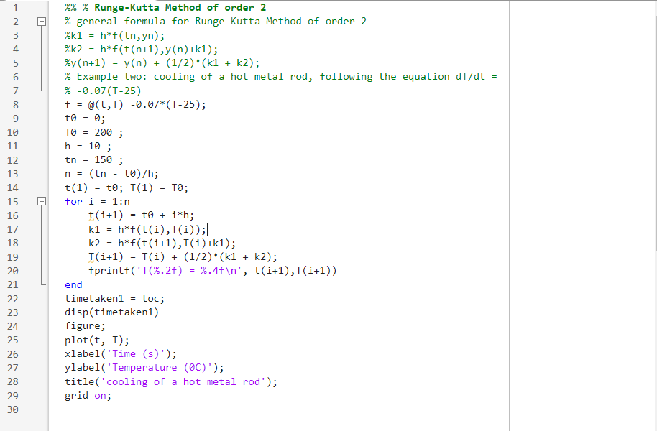
T(10.00) = 120.3750
T(20.00) = 76.9794
T(30.00) = 53.3288
T(40.00) = 40.4392
T(50.00) = 33.4143
T(60.00) = 29.5858
T(70.00) = 27.4993
T(80.00) = 26.3621
T(90.00) = 25.7423
T(100.00) = 25.4046
T(110.00) = 25.2205
T(120.00) = 25.1202
T(130.00) = 25.0655
T(140.00) = 25.0357
T(150.00) = 25.0195
timetaken1 = 5.1043e+03

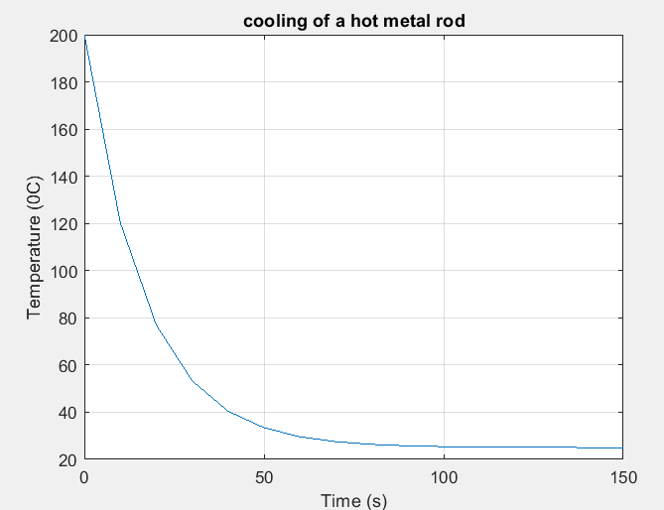
EULER METHOD
PART (A);

%cooling function:T=25 +(85-25)*exp(-o.1*t)
f = @(t) 25 + ( 85-25) *exp(-0.1*t) - 30;
% Find when T=30
df = @(t) -(85-25)*0.1*exp(-0.1*t);
PART (B);

% Newton's law of cooling
k = 0.1; T_env = 25; T0 = 85;
t0 = 0; tf = 50; h= 1;
t=t0:h:tf;

% Exact analytical solution
T-exact = T_env + (TO -T_env)*exp(-k.*t);
% Euler method
T_exact = zeros(size(t)); T_eular(1) = T0;
for i = 1:length(t)-1
T-euler(i+1) = T-euler(i) + h*(-k*(T_euler(i) - T_env));
end

% RK4 Method
T_rk4 = zeros(size(t)); T-rk4(1) = T0;
for i = 1:length(t) -1
k1 = -k*(T_rk4(i) - T_env);
k2 = -k*((T_rk4(i) + 0.5*h*k1) - T_env);
k3 = -k*((T_rk4(i) + 0.5*h*k2) - T_env);
k4 = -k*((T_rk4(i) + h*k3) - T_env);
T-rk4(i+1) = T-rk4(i) + (h/6)*(k1 + 2*k2 + 2*k3 +4);
end
% Display Results for part B
fprinntf('\n--- DIFFRENTIAL EQUATION RESULTS ---\n');
fprintf('Euler Time: %.6f s\n', euler_time);
fprintf('Runge-Kutta 4th order Time: %.6f s\n', rk4_time);

% Plot comparison
figure;
plot(t, y_exact, 'k-','LineWdth', 2);
hold on
plot(t, y_euler,'r--','LineWidth',1.5);
plot(t, y_rk4,'b-.','LineWidth',1.5);
xlabel('Time (t)');
ylabel('population(y)');
legend('Exact solution', 'Euler Method','RK4 Method');
title('Comparison of Numerical Solutions for Population Growth');
grid on;

%Compute and Display Error
error_euler = abs(y_exact - y_euler);
error_rk4 = abs(y_exact - y_rk4);

figure;
plot(t, error_euler,'r-- ', t, error_rk4, 'b-','LineWdth', 1.5);
xlabel('Time (t)');
ylabel('Absolute Error');
legend('Euler Error', 'RK4 Error');
title('Error Comparison Between Euler and RK4 Methods');
grid on

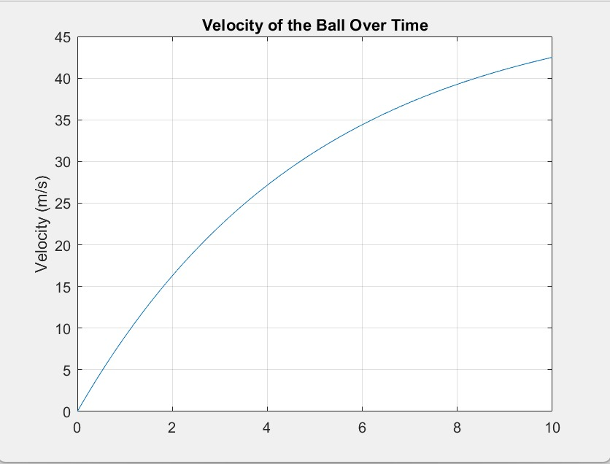

% Parameters
T_initial = 200; % Initial temperature of the rod
T_env = 25; % Environment temperature
k = 0.07; % Cooling constant
dt = 0.1; % Time step
t_final = 60; % Total time for simulation
N = t_final / dt; % Number of time steps

% Preallocate arrays for time and temperature
time = zeros(1, N);
temperature = zeros(1, N);

% Initial conditions
temperature(1) = T_initial;
time(1) = 0;

% Start computation time
tic;

% Euler method for solving the differential equation
for n = 1:N-1
dT = -k * (temperature(n) - T_env); % Calculate the change in temperature
temperature(n+1) = temperature(n) + dT * dt; % Update temperature
time(n+1) = time(n) + dt; % Update time
end

% End computation time
elapsed_time = toc;

% Plotting the results
figure;
plot(time, temperature, 'LineWidth', 2);
xlabel('Time (seconds)');
ylabel('Temperature (°C)');
title('Cooling of the Rod Over Time');
grid on;

% Display computation time
fprintf('Computation time: %.4f seconds\n', elapsed_time);

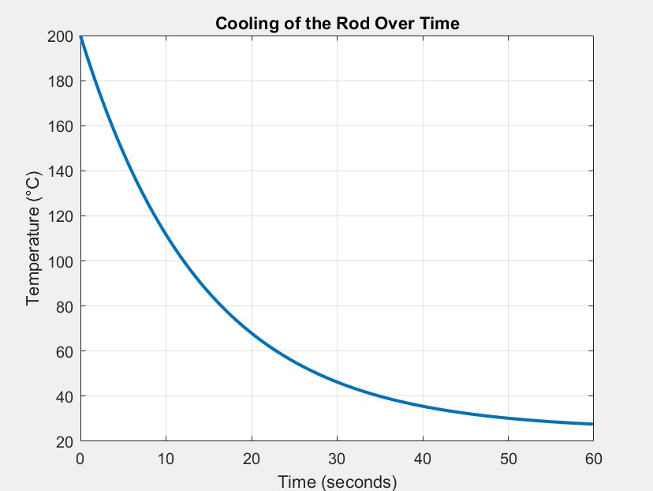

CHAPTER 3: RECOMMENDATIONS AND CONCLUSION

3.1 REC0MMENDATION
Use multiple methods on the same problem to compare accuracy.
Apply higher-order methods like Runge-Kutta for precision.
Use MATLAB for implementation and visualization.
Extend applications to more complex real-world systems.

3.2 CONCLUSION
Numerical methods such as Newton-Raphson, Secant, Euler, and Runge-Kutta provide practical solutions when analytical methods are difficult. While simpler methods are easier to apply, higher-order ones give faster and more accurate results. Visualization confirmed the accuracy and limitations of each approach in real-world problems.

3.3 REFERENCES
Chapra, S. C., & Canale, R. P. (2015). Numerical Methods for Engineers. McGraw-Hill.
Burden, R. L., & Faires, J. D. (2010). Numerical Analysis. Brooks/Cole.
Mathews, J. H., & Fink, K. D. (2004). Numerical Methods Using MATLAB. Pearson.
MathWorks. (2025). MATLAB Documentation

