**Gui Tkinter Simple Calendar App User’s Manual**



User Guide: Desktop Calendar Application

Thank you for choosing our Desktop Calendar application! This user guide will provide you with all the necessary information to effectively use and navigate our simple GUI Tkinter application. Whether you are a student, professional, or simply someone who wants to have a quick reference to the days and dates of a given year, this application is designed to meet your needs. Let's get started!

1. Installation:

* Download or copy paste the Desktop Calendar Source Code.

1. Launching the Application:

* Once you have copy/pasted the Source code into your text editor, run the program

**Important: if you are using visual studio code make sure you trust the workspace and it is not on restricted mode, if in restricted mode the GUI will not run**

1. Application Interface:

* Upon launching, you will see a simple and intuitive graphical user interface (GUI) displaying a window that states **CALENDAR: Enter year**
* type in any year and press **show calendar**
* The calendar will be displayed in a month-by-month format, with each month showing the corresponding days and dates.

1. Navigating the Calendar:

* To view another year, simply press the **x** in the top right corner of the second window, and enter a different year in the **enter year** window (first window)

1. Year Selection:

* Enter any year you, the user would like to view, it’s that simple.

1. Exiting the Application:

* The first screen has two options: **enter year and EXIT.** to exit the calendar application, press the **EXIT** button.

1. Customization Options:

* While there's not really a way to customize the calendar itself, the user can change the colors within the source code.

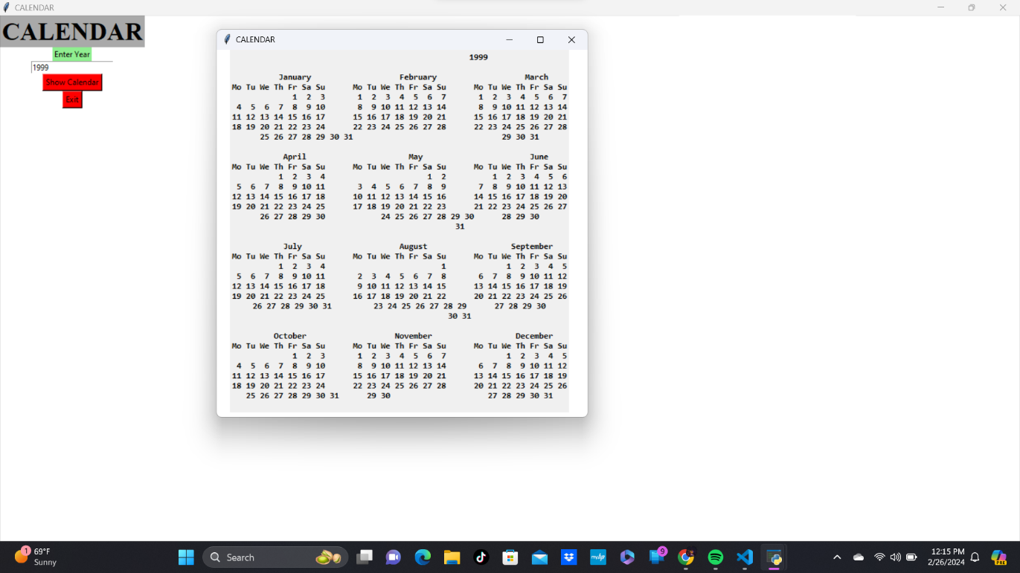Congratulations! You are now equipped with all the necessary information to the Desktop Calendar application effectively. Enjoy having a quick reference to all the days and dates of a given year right on your desktop screen.

