Cornell Engineering World Health

EWH Design Competition Entry

Low-Cost Vital Signs Monitor

May 2015

**Table of Contents IGNORE THIS FOR NOW**

**Problem definition**

**Impact on Developing World**

**Technology**

**Competitors**

**Required Performance Specifications**

**Implementation of Prototype**

**Proof of Performance**

**Business Plan**

**Customers**

Hospitals with In-Patient Care

Government and Health Departments

**Distribution**

**Funding**

**Manufacturing**

**Legal Issues**

**References**

**Appendix**

# Problem definition

See big list of problems

SOURCES

TALK TO PEOPLE

Battery life:

Access to skilled health workers and adequate medical resources are critical to delivering effective treatment and improving health outcomes. However, health providers in developing countries often have limited or non-existing access to medical services, with physician to patient ratios averaging 0.2 physicians per 1,000 people in 2010[1] and a of standard medical devices being commonplace in these hospitals.

Globally, rural areas are served by only 38% of the total nursing workforce and by less than 25% of the total physician workforce.[2] Africa, Compounding this problem of the lack of medical personnel, low budget hospitals are often overwhelmed with patients, making routine rounds to check on each patient an increasingly overwhelming and impossible task. Yet increasingly limited budgeted, low-resource hospitals cannot simply hire more personnel, with trained and educated individuals especially difficult to find and keep monetarily.

In the

As residents in the United States, it is easy to forget that many countries do not have the same resources that we have. In many hospitals in developing areas such as Peru, there is a severe lack of an adequate staff and sufficient equipment. The less technology a medical institute has to monitor patients, the more work nurses must do in order to ensure that every patient is being properly cared for. Consistently making rounds to check on each patient is already an overwhelming task in itself, and as there is already a budget limit, hospitals cannot simply hire more personnel, especially since trained and educated individuals are few and often request larger salaries.

This dilemma, however, can be solved if vital sign monitors equipped with alarms were more affordable to hospitals in developing countries. The ideal low cost vital signs monitor would include sensors that can continuously monitor vitals signs such as blood pressure, pulse ox, heart rate, and temperature. This vital signs monitor would need to include an alarm for when a patient’s vitals signs fall to a dangerous threshold. Another aspect of an ideal low cost vital signs monitor is one that is compatible for patients of all ages and sizes including infants. The device should also be small enough that it can be easily portable from patient to patient.

# Impact on Developing World

## Technology

Our low-cost vital signs monitor is a solution to accommodate for the lack of adequate staff in many third-world country hospitals. Its strong battery life helps doctors to maintain a stable and calm environment. Despite unreliable power sources or even a complete power outage, the monitor would continue to function with full alarm capability if any patient were to go into a critical condition.

The vital signs monitor would allow nurses to more effectively (increase efficiency?) and efficiently use their time. The vital signs monitor would allow the nurses to focus strictly on assisting the doctors and critical patients, rather than spending their time making rounds. (to informal) The SMS capability is one of the strongest components of the device. (don’t state this; informal) Ideally, the nurses would receive a text if any of the patients’ vitals were to change, though there is a lack of stable power in some of these developing regions. Even if the SMS capability were to not work in a specific area, doctors can still use the vital signs monitor which would continue to sound and alert nurses of any changes to patients’ conditions. (state SMS requires stable power supply; clarity)

The inexpensive low-cost vital signs monitor is a wise investment for hospitals with a limit budget. The average cost of a new continuous vital signs monitor on the market today ranges from approximately $2000 to $10,000 dollars.2 Our vital signs, on the other hand, costs less than $200 dollars and can provide the same accurate services as the brand name monitors on the market. The quantity of hospital equipment increases with little compromise of quality.

The vital signs monitor was designed to take up a minimum amount of space. It is also easily packed and transportable to be flown into regions that need it. The waterproof vital signs monitor will be able to withstand severe weather conditions in an environment with improper shelter. Its durability and repairability ensures that it functions for a long period of time.

**PREVIOUSLY WRITTEN INFORMATION**

The average cost of a new continuous vital signs monitor on the market today ranges from approximately $2000 to $10,000 dollars; a price tag that can place a toll on a developing world’s hospital budget.2 Our vital signs, on the other hand, costs less than $300 dollars and can provide the same accurate services as the brand name monitors on the market. With this reduction in price, hospitals such as Bugando in northern Tanzania can afford to purchase more vital signs monitors to help continuously monitor patients staying in hospital beds. The increase in vital signs monitors can make up for the shortage of doctors and nurses available to oversee all patients.

The versatility of our vital signs monitor allows for patient use of all sizes and ages. A medical worker can enter the patient’s sex, height, age and weight in the vital signs and the device will re-calibrate its thresholds to accommodate its alarm trigger points. This feature allows hospitals to save money by purchasing one vital signs monitor to use on all of its patients. The small structure of our vital signs monitor also allows for easy portability and transportation between patients.

## Competitors

As far as low cost continuous vital signs monitors go, our competitors only consists of used vital signs monitors and smart phone vital signs monitors. Examples of Smart phone vital signs monitors include Vital Signs DSP by Lionsgate technologies and Wello by Azoi, Inc.

Vital Signs DSP is a program that can run on any smart device, such as a laptop, smart phone and tablet.3 This software comes equipped with a finger clip medical sensor that can be attached to the audio port of smart devices. The price of this device is currently unknown since it hasn’t been released to the public yet. However, regardless of price, a hospital would still have to purchase a smart device first in addition to the software and finger clip sensor.

Wello by Azoi, Inc is a vital signs monitor for apple and android smartphones. The sensors come on a case that can be purchased for $199.4 This device is not suitable for in-patient care and does not feature continuous monitoring capabilities. The app only measures a person’s instantaneous vital signs and doesn't include any clip on sensors. Instead, a patient would have to constantly hold it up in an awkward and tiring position as shown in fig. 1.

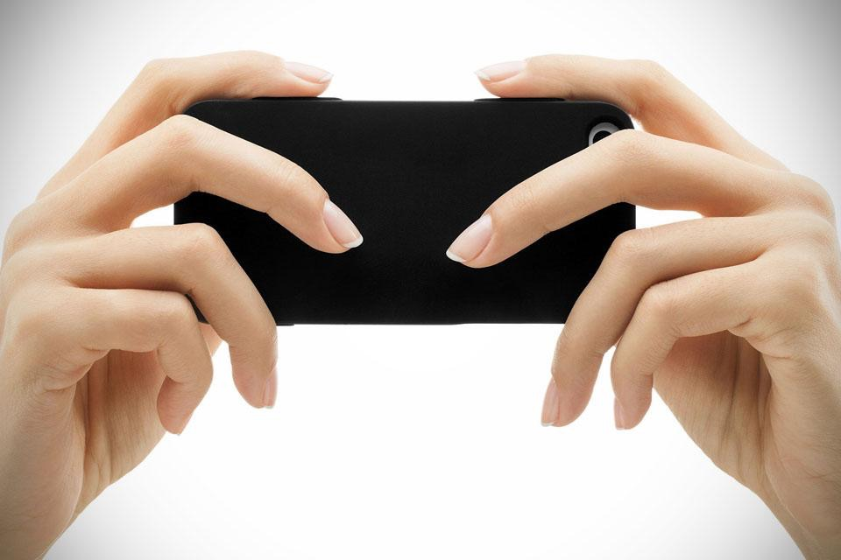

**Figure 1**

Compared to our competitors, our vital signs monitor includes simple sensors that can be clipped or tapped onto patients. Our device does not require the purchase of a smartphone, tablet or laptop which significantly reduces the price. Unlike, Wello, our vital signs monitor is capable of continuous monitoring of a patient’s vital signs. Above all, our vital signs monitor comes equipped with an alarm, a feature that neither of our competitors have.

# Required Performance Specifications

When designing the vital signs monitor, we developed a number of specifications.

1. Safety: It was essential to ensure that our device would not cause harm to patients, even if used incorrectly. This requirement is not based on specific health considerations in a particular country so much as a basic regard for human safety. Throughout the design we ensured that there were no electrical fire hazards or components which could hurt the patient upon contact.
2. Accuracy and Precision of Results: Through talking with Julie Kohn and Mary Clare McCory, we realized that absolute accuracy was not our goal. Instead, this device aims to give immediate feedback about sudden relative drops in patient health. Thus, we relaxed accuracy to
   1. within 3ºF for body temperature
   2. within 8 beats per minute for heart rate
   3. within 3% of the true blood oxygen measurement
   4. be able to distinguish a blood pressure change of >30mmHg/minute
3. Universality: It was found that a major problem in using Western-provided medical equipment is the language barrier. The vital signs monitor had to be simple to use and understand regardless of native language.
4. Power Supply: Because of the lack of power standardization among health care facilities, the vital signs monitor will come with a number of adaptors to accept common power standards. Additionally, it will be equipped with 12 hours of battery life to allow for brown-out periods which are common in developing countries.
5. Notification: When there is a concern about a vital sign, a buzzer will be triggered and the relevant quadrant of the screen will turn red to alert medical professionals to a problem. These can both be reset with the touch of a key.

# Implementation of Prototype

The vitals sign monitor was implemented with an Arduino Mega microprocessor, a custom 3d printed case, and custom 3d printed or silicon-molded sensors. The final implementation can be seen in Appendix 5.

Case: The case was 3d printed for prototyping. SolidWorks software was used to create a 3D model with a place for the flip-out keyboard, screen, and screws to hold the lid on. Holes were later drilled out to accommodate the cords for the sensors and power supply. It was then printed with high-density plastic. See Appendix 1 and 2 for design and implementation.

Finger Clip: Similarly, the finger clip was 3d printed to keep prototyping costs low. It has recessed channels for both LEDs on one half and a recess for the light sensor on the other. The finger clip is part of the pulse/oximetry and blood pressure systems. It measures the relative volume of blood in the finger by taking alternative measurements of optical transparency through the patient’s finger at Red and IR light frequencies alternating every 20 mS. The ratio of these two signals relates to the blood oxygenation and the peaks contained in the data correspond to pulses. See Appendix 3 and 4 for design and implementation.

Wrist Monitor: The wrist monitor functions the same as the finger clip, however, it is designed to strap to a patient’s wrist. Two LEDs are positioned on one side of the silicon casing, flush to the skin. The light sensor is held flush to the patient’s skin on the other end of the monitor. There is no straight line-of-sight between the LEDs and the sensor, so any received light corresponds to the optical transparency at the two wavelengths. The patient is assumed to be relatively healthy when the monitor is attached to the patient. The wrist monitor is tightly strapped to the patient’s wrist and an initial reading of the pulse transit time from the patient’s finger to the wrist is recorded. If this amount of time significantly increases or decreases, there has been a major change in the patient’s blood pressure. Of course, based on placement, patient age, and patient health, this cannot provide a standardized measure of blood pressure, but instead provides a relative measure.

Key Pad: A low cost, waterproof limited alpha numeric keyboard was chosen to allow the user to interact with the screen and input information.

Screen: A single small LED screen provides visual feedback about the patient’s health.

Thermometer: A simple thermistor was chosen as the thermometer. It is soldered directly to long leads, and in practice would be contained in a long, thin, plastic sheath to maintain sterility.

Microprocessor: the Arduino Mega microprocessor was chosen for its ubiquity and stableness. It is also low-power which will increase battery life. All programming was completed in the Arduino (C-based) language.

# Proof of Performance

Prove that your prototype meets the minimum required performance specifications. Include the results of validation tests and measurements of relevant aspects of the prototype’s performance. Provide quantitative evidence that your prototype meets or exceeds the minimum performance specifications and provides a superior solution to that of existing designs.

The first subsystem test was to detect a heart beat. We successfully detected heartbeats to within 7 beats per minute in all trials run. This is below our cutoff of 8 beats per minute. Below is a sample of the data collected and an example of peak detection.

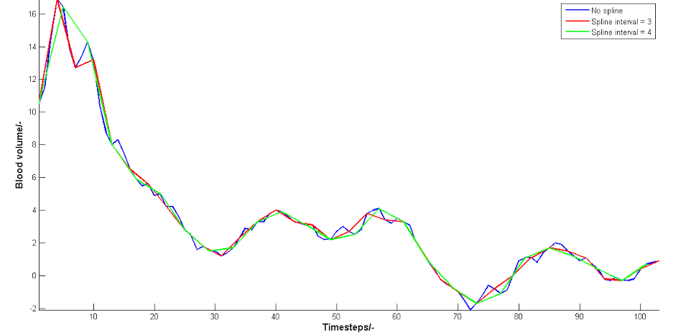

Figure 5.1 Heart Beat Detection

The second subsystem tested was temperature. We achieved readings of 98.3ºF at the armpit of a healthy human. We did not have adequate facilities to accurately test the probe at other temperatures human temperatures, but it also correctly read room temperature.

Our other subsystems have only gone through proof-of-concept testing. We will continue further testing in the future. The blood oxygenation systems gave us consistent numbers, but we were not able to obtain a proper medical blood-oxygenation meter for comparison. We are confident that it will perform to our specifications once testing is possible, since we are not looking for a normative measurement, but a relative one.

And finally, the relative blood pressure was not fully tested because of lack of a good comparison device and subject. From medical papers, we know that pulse transit time is a good relative measure of blood pressure, but to confirm the full functionality of our device, we need access to patients of many ages, sizes, and levels of health. We will continue to pursue this sort of full testing in the future.

# Business Plan

## Customers

### Hospitals with In-Patient Care

Hospitals and health clinics in developing countries with in patient care will be our primary target customers. We will try to sell directly to hospitals in the developing world, but also to any hospital wishing to buy our device, regardless of their location.

### Government and Health Departments

We will also try to convince local health departments and government bodies to subsidize bulk purchases of our vital signs monitor and distribute them to hospitals in their jurisdiction.

## Distribution

**Phase I**: This will be our first phase of distribution as well as our test phase. At this point we will only have manufactured a few prototypes of the vital signs monitor and distribute them to the Bugando Hospital in northern Tanzania, where our contacts Julie Khon and Mary McCory volunteered at. During this phase we will donate the first few vital signs monitors and observe how they well they integrate into the hospital’s environment. We will also collect feedback during this phase and improve upon our product.

**Phase II**: Once Phase I is successfully completed, we will attempt to sell more vital signs monitors to the Bugando Hospital in addition to the ones we have already donated. We will use the success stories at Bugando Hospital to start selling our device to other hospitals in developing countries around the world.

**Phase III**: We will then use the success of our vital signs monitor in hospitals around the world to sell our product to government and health departments of developing countries willing to subsidize bulk purchases of our vital signs monitor and distribute them to local hospitals with in patient care units.

## Funding

Initially, we will need outside funding to assemble the first few prototypes to use in phase I of distribution. This, we hope to inquire through grants and crowd funding initiatives. Once the first few prototypes are sold, we will still need to rely on outside funding in addition to the profits made from the first few sales, to improve upon the product and manufacture more vaccine coolers. Once we have received enough funding, we will start buying raw materials in bulk, which will drive down the cost of these vital signs monitors. Eventually, the sales of the vaccine coolers should start to cover its costs and outside funding won’t need to be relied on heavily. After we have achieved phase II of distribution, the amount of vaccine coolers sold should cover all raw material cost, eliminating the need of a outside funding source. There will be no labor cost because volunteers, such as Cornell EWH members or any trained volunteer wishing to contribute, will carry out construction of these devices.

## Manufacturing

Veteran and trained EWH members will carry out construction of the first few vital signs monitor prototypes to be used in the first phase of distribution. After the completion of phase I, Cornell EWH will recruit trained members to form a sub-team solely devoted to manufacturing vaccine coolers. These volunteers will be rewarded university credit as an incentive to join and manufacture vaccine coolers for distribution. Using this manufacturing system will eliminate labor cost and Cornell EWH can keep the cost of our vital signs monitor low.

An alternative method for manufacturing is to turn our vital signs monitor into a soldering kit like those already offered by Engineering World Health such as the ECG stimulator kit and the heart rate monitor kit. The kit would include all electrical parts outer casing and a microcontroller programed ahead of time by Cornell EWH members. To assemble the vital signs monitor, one simply has to follow the soldering instructions that come along with the kit. This method of manufacturing also eliminates labor costs.

## Legal Issues

Since our technology is intended to be implemented in developing countries with little to no regulations regarding medical devices, FDA and CE approval is not necessary. However, since our major target customers are organizations that were founded and headquartered in the United States and Europe, we will seek FDA and CE approval. Theses approvals not only increases our marketing appeal, but also limits the liability of our organization from getting sued should the product fail in any way.

# References

1. Kohn, Julie, and Mary C. McCorry. "Global Impacts of Biomedical Engineering." Global Impacts of Biomedical Engineering. United States, Ithaca. 5 Mar. 2014. Lecture.

2. "MedicalDeviceDepot.com." *Welch Allyn Vital Signs Monitors : Sun Tech Vital Signs Monitors : Medical Device Depot, Inc.* N.p., n.d. Web. 30 May 2014. <http://www.medicaldevicedepot.com/Vital-Signs-Monitors-s/259.htm>.

3. Lionsgate Technologies Inc. N.p.: Lionsgate Technologies, n.d. *LionsGate Technologies Inc.* Mar. 2013. Web. 30 May 2014. <http://www2.lgtmedical.com/LGT_WHITEPAPER.pdf>.

4. *Wello by Azoi Inc.* N.p., n.d. Web. 30 May 2014. <https://azoi.com/>.

# Appendix

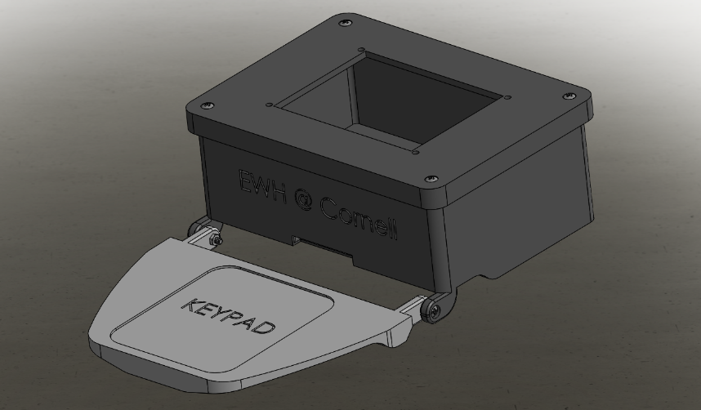

1. Case Design

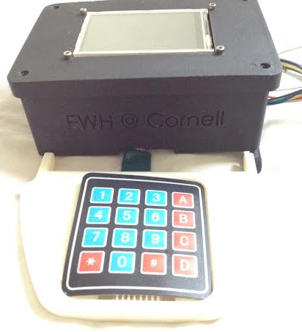

2. Case Implementation

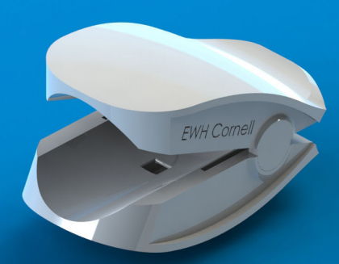

3. Finger Clip Design

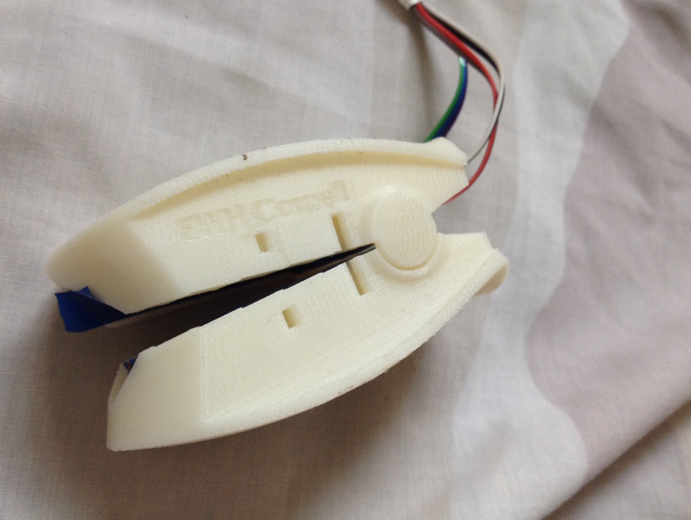

4. Finger Clip Implementation

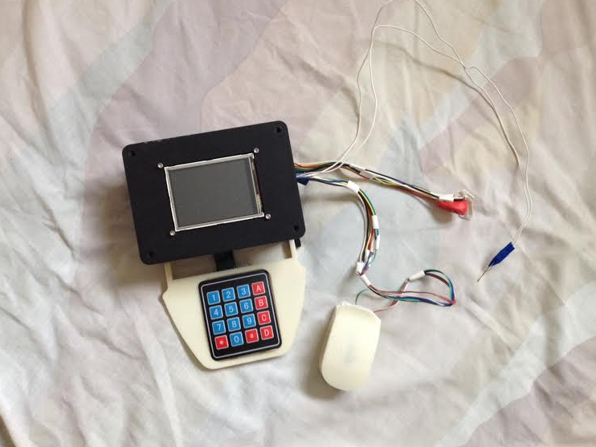

5. Final Design

1. Welcome to flow quickstart guide. .

2. Welcome to flow quickstart guide. .

3. Cornell Engineering World Health, EWH Design Competition Entry, Low-Cost Vital Signs Monitor, May 30 3. Cornell engineering world health EWH design competition entry low-cost vital signs mo[3]nitor may 30th, 3014. .

1. World Bank. The World Development Report 2010: Physician Data Catalog. <http://data.worldbank.org/indicator/SH.MED.PHYS.ZS/countries/4E-XJ-XL?display=graph>
2. World Health Organization. Health Workforce. Global Health Observatory (GHO), World Health Organization. 2012.
3.