Lecture 5 work

Nada Boutros

January 24,2019

# Class 05 R graphics intro  
  
# My first boxplot  
x <- rnorm(1000,0)  
boxplot(x)

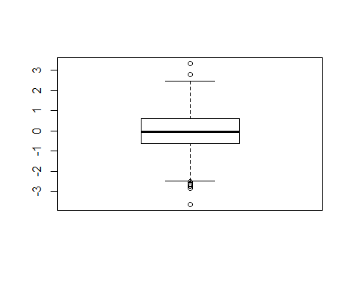

summary(x)

## Min. 1st Qu. Median Mean 3rd Qu. Max.   
## -3.636550 -0.627445 -0.044444 -0.005553 0.608633 3.335318

hist(x)

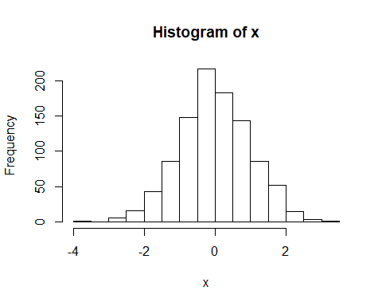

boxplot(x, horizontal = TRUE)

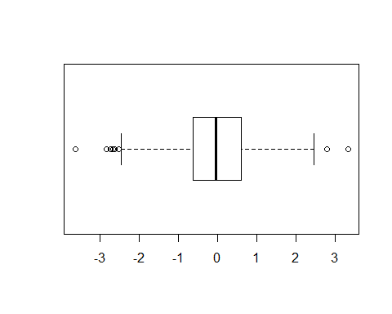

# Hands on session 2  
weight <- read.table("bimm143_05_rstats/weight_chart.txt",header = TRUE)  
plot(weight,pch=15,cex=1.5,lwd=2,ylim=c(2,10),xlab="Age(months)",ylab="Weight(kg)",main="Some title")

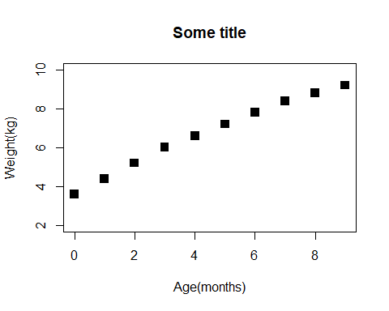

plot(weight,typ="b",pch=15,cex=1.5,lwd=2,ylim=c(2,10),xlab="Age(months)",ylab="Weight(kg)",main="Baby Weight with Age")

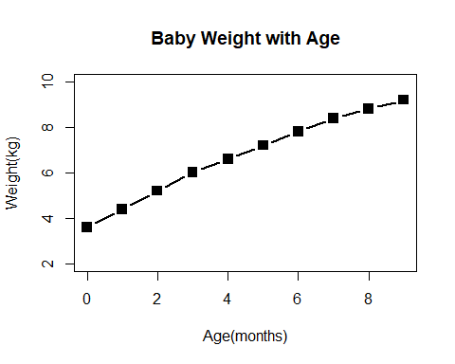

plot(weight,typ="o",pch=15,cex=1.5,lwd=2,ylim=c(2,10),xlab="Age(months)",ylab="Weight(kg)",main="Baby Weight with Age")

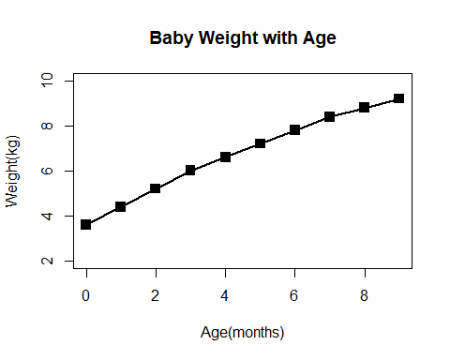

plot(weight,typ="o",pch=15,cex=2,lwd=3,ylim=c(2,10),xlab="Age(months)",ylab="Weight(kg)",main="Baby Weight with Age",col="green")

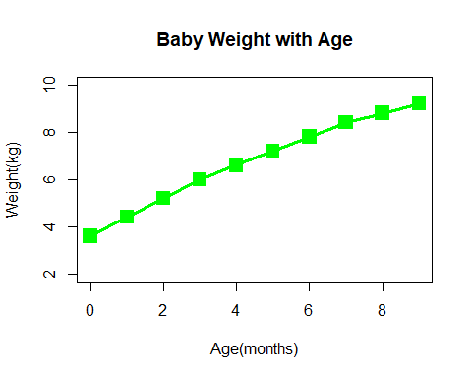

# Try a barplot  
barplot(VADeaths,beside = TRUE)

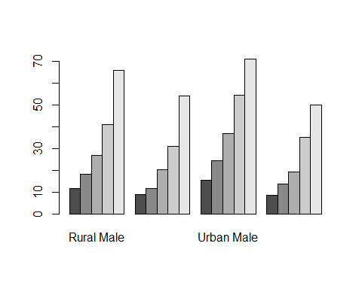

barplot(VADeaths,beside = FALSE)

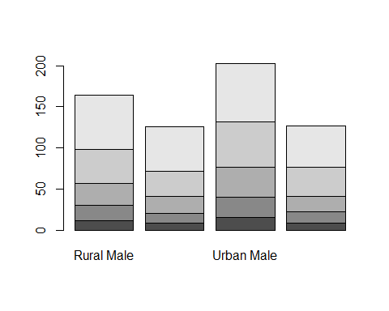

## Input our feature count data  
mouse <- read.table("bimm143_05_rstats/feature_counts.txt", header = TRUE, sep = "\t")  
  
barplot(mouse$Count,horiz = TRUE, names.arg = mouse$Feature, las=2)  
  
#Change margin so we can see the labels  
par(mar=c(3.1, 11.1, 4.1, 2))  
barplot(mouse$Count,horiz = TRUE, names.arg = mouse$Feature, las=2)

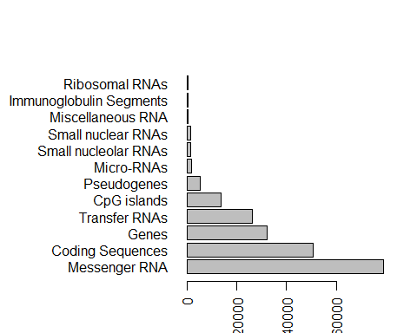

barplot(mouse$Count,horiz = TRUE, names.arg = mouse$Feature, las=1,col = cm.colors(11),ylab="",main = "Number of Features in the Mouse GRCm38 Genome",xlim = c(0,8000))

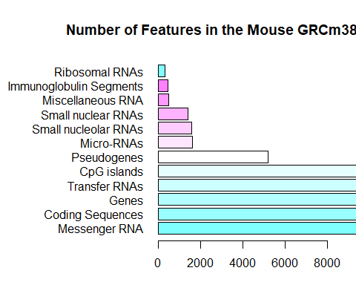

par(mar=c(5.1, 11.1, 4.1, 2.1))  
barplot(mouse$Count,horiz = TRUE, names.arg = mouse$Feature, las=1,col = cm.colors(11),main = "Number of Features in the Mouse GRCm38 Genome",xlim = c(0,80000))

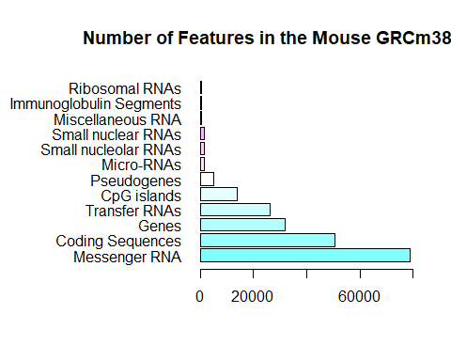

#Section 3:using color in plots  
mf <- read.table("bimm143_05_rstats/male_female_counts.txt", sep = "\t", header = TRUE)  
barplot(mf$Count, names.arg = mf$Sample, col = c("blue","pink"), las=2)

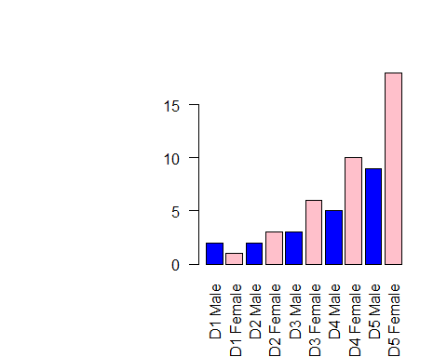

#coloring by value   
e <- read.table("bimm143_05_rstats/up_down_expression.txt", header = TRUE)  
  
#how many genes  
nrow(e)

## [1] 5196

#how many up, down, and all around  
table(e$State)

##   
## down unchanging up   
## 72 4997 127

plot(e$Condition1,e$Condition2, col= e$State)

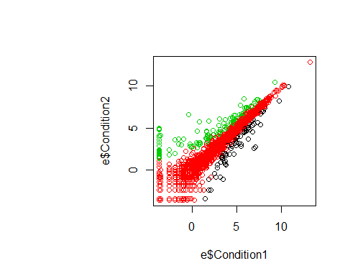

palette(c("purple","turquoise2","blue"))  
plot(e$Condition1,e$Condition2, col= e$State)

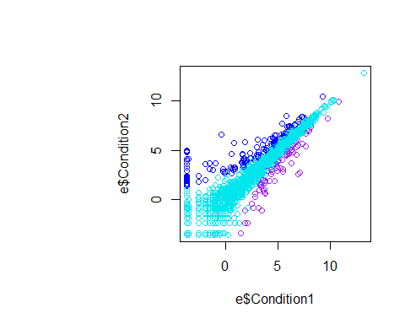

sessionInfo()

## R version 3.5.2 (2018-12-20)  
## Platform: x86_64-w64-mingw32/x64 (64-bit)  
## Running under: Windows 10 x64 (build 17134)  
##   
## Matrix products: default  
##   
## locale:  
## [1] LC_COLLATE=English_United States.1252   
## [2] LC_CTYPE=English_United States.1252   
## [3] LC_MONETARY=English_United States.1252  
## [4] LC_NUMERIC=C   
## [5] LC_TIME=English_United States.1252   
##   
## attached base packages:  
## [1] stats graphics grDevices utils datasets methods base   
##   
## loaded via a namespace (and not attached):  
## [1] compiler_3.5.2 magrittr_1.5 tools_3.5.2 htmltools_0.3.6  
## [5] yaml_2.2.0 Rcpp_1.0.0 stringi_1.2.4 rmarkdown_1.11   
## [9] highr_0.7 knitr_1.21 stringr_1.3.1 xfun_0.4   
## [13] digest_0.6.18 evaluate_0.12