**Time Series Analysis**

**implemented by Maria Pazdnikova, Liliia Shamsutdinova**

**How to**

**Prerequisites**: Make sure that you have SQL Server and Microsoft Analysis Services installed on local PC.

**Step 1**. Update App.config file with your connection strings for SQL Server and Analysis Services instances.

**Step 2**. Update XMLAQuery2.xmla from Resources folder with your connection string for Analysis Services (<ConnectionString> Line 16, Line 25)

**Step 3**. Link SQL Server to Analysis Services. Following link will help you to do it: <http://www.sqlserverdatamining.com/ssdm/Default.aspx?tabid=102&Id=385>

Connection settings displayed in Figure (for Data Source use you default connection to Analysis Services).

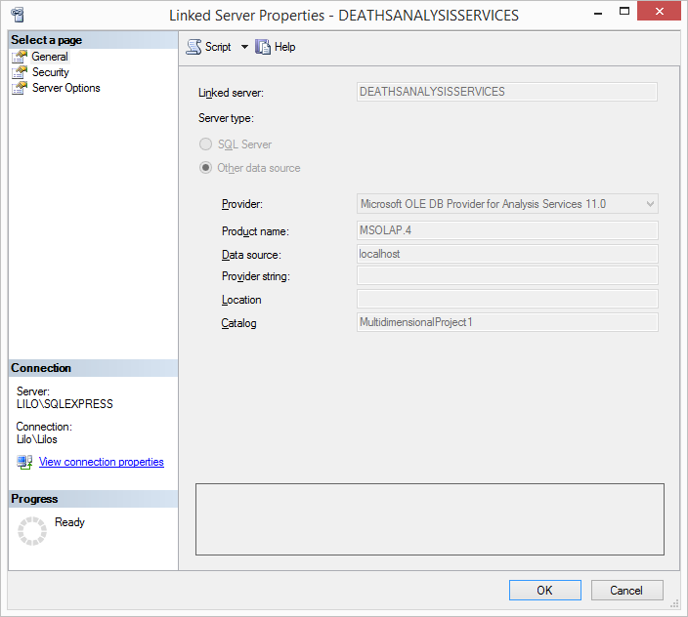

**Step 4**. Run TimeSeriesAnalysis.exe.

**Step 5**. Enjoy☺

**Program description**

Actually we have 3 types of the connection implemented in this program. First type: connection to SQL Server for running SQL queries. Second type: connection to Microsoft Analysis Services to run XMLA queries (creating multidimensional project for time series prediction). Third type: connection to Microsoft Analysis Services to run MDX queries (creating mining structure and mining models).

So typical workflow looks like this:

1. Check if DB Deaths exists on the Server.
2. If DB exists proceed to the next step. If not – restore DB from backup (given in Resources folder) and create multidimensional project in Analysis Services.
3. If it is first prediction – create mining structure and mining model. If not – create only mining model in already existed mining structure.
4. Train model on the data from defined by user Initial Start date till Initial End date.
5. Predict values from Prediction Start date till Prediction End date.
6. Put prediction result to Prediction table.
7. Update table PredictionDeviation with initial date period, prediction date period and mean deviation (mean difference between actual and predicted value).
8. On Analyze Results tab display PredictionDeviation table, min, max deviations.
9. Display graphs (Mean deviation with Initial period and Mean Deviation with Prediction period).

**A few explanations for SSY**

Decided not to download statistics from site in an automatic way. Statistic’s update is extremely rare. Right now we have data only till the end of 2014. So we assumed that it updates once a year and daily checks are not needed.