Phase 3 Report

Group 2

Introduction:

In today's fast-paced world, where demands on our time seem to be ever-increasing, staying on top of our tasks and maximizing productivity can often feel like an insurmountable challenge. However, in this digital age, technology offers us the opportunity to not only manage our daily responsibilities efficiently but also elevate our overall productivity.

Enter "Do," your all-in-one web application designed to transform the way you organize tasks and supercharge your productivity. "Do" is a user-friendly tool created to monitor your workflow, helping you achieve more in less time while reducing stress and overwhelm. This groundbreaking web app combines innovative features and simple design to help you regain control of your schedule and turn your aspirations into accomplishments.

From task management and prioritization to insightful data analytics, "Do" is your personal productivity assistant. Join us as we explore how "Do" empowers you to reach new heights in productivity, simplify your daily life, and ultimately accomplish more than you ever thought possible. Discover a better way to get things done with "Do."

Users of the app:

It is developed for individuals and people who work in teams.

Schedule:

Requirements Modeling:

A:

1-User should be able to add tasks

2- User should be able to create a project.

3 – User should be able to add people to a team

4 – User should be able to assign tasks to his team members (Only the leader can do this)

5 – Users can finish a task by clicking check on it

6 – user can visualize his progress

7 – User can schedule a task

B:

1 – Usability

2 – Integrity

3 – Testability

4 – Reusability

5 – Maintainability

C:

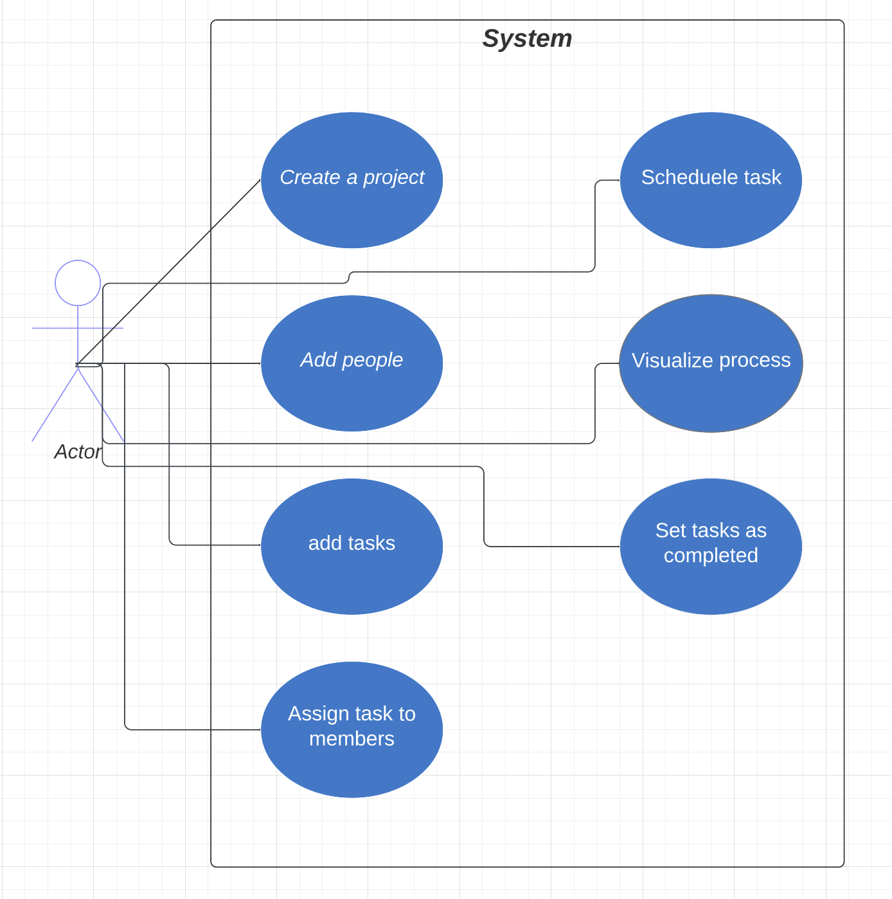

D:

|  |  |
| --- | --- |
| Use case name | Create a project |
| Actors | User |
| Preconditions | User has to be signed in |
| Description | A project is where a set of related tasks are in |
| Postconditions | A project should be appended to the previous projects of the user(if any) |
| Alternative flows and exceptions | No alternative or exception cases |

|  |  |
| --- | --- |
| Use case name | Schedule a task |
| Actors | User |
| Preconditions | A user has to be signed in and a real task should be selected |
| Description | Setting a deadline or due date for a task |
| Postconditions | A task should have a deadline appeared on it |
| Alternative flows and exceptions | No alternatives  Nor exception cases |

|  |  |
| --- | --- |
| Use case name | Add people |
| Actors | User(project owner) |
| Preconditions | A user has to be signed in and a real project should be selected(members<=5) |
| Description | Adding collaborators to the project. |
| Postconditions | The project should appear in the collaborator screen and be able to access it |
| Alternative flows and exceptions | Members should be less than 5. |

|  |  |
| --- | --- |
| Use case name | Add tasks |
| Actors | User |
| Preconditions | User should be signed in and have an existing project |
| Description | User should add his wanted task in a project and visualize them |
| Postconditions | A task should appear in the project page |
| Alternative flows and exceptions | No alternatives nor exceptions |

|  |  |
| --- | --- |
| Use case name | Set tasks as completed |
| Actors | User, Members |
| Preconditions | User, member should be signed in and the task should be uncompleted |
| Description | Tagging a task as complete |
| Postconditions | The task should be removed |
| Alternative flows and exceptions | The user can check all task at once or deleting the project will check all tasks, no exception scenario |

|  |  |
| --- | --- |
| Use case name | Assign task for members |
| Actors | User and member |
| Preconditions | User and member should have a common project |
| Description | User can delegate a task to a specific member |
| Postconditions | The task is added to the member |
| Alternative flows and exceptions | No alternative nor exception scenario |

|  |  |
| --- | --- |
| Use case name | Visualize progress |
| Actors | leader or member |
| Preconditions | Should have a project to visualize |
| Description | The user should have a brief percentage on the progress of the project |
| Postconditions | A summary should appear to the user |
| Alternative flows and exceptions | No alternatives,  If project is empty or completed a special message should appear wither about completed or error showing that this is an empty project |

Class Diagram:

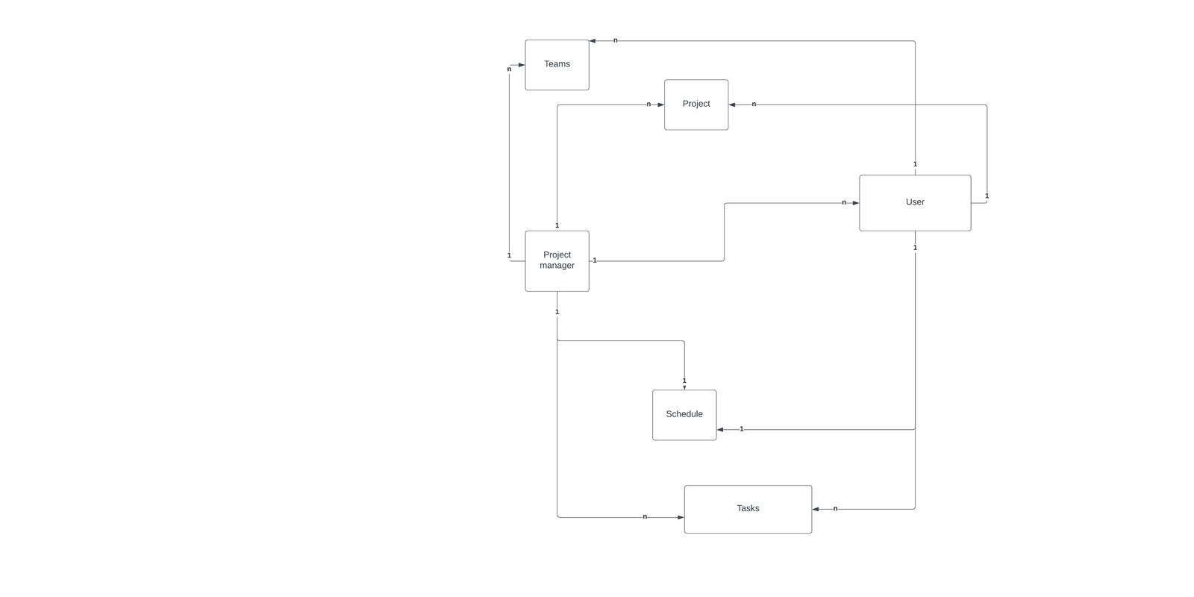

UI Prototype:

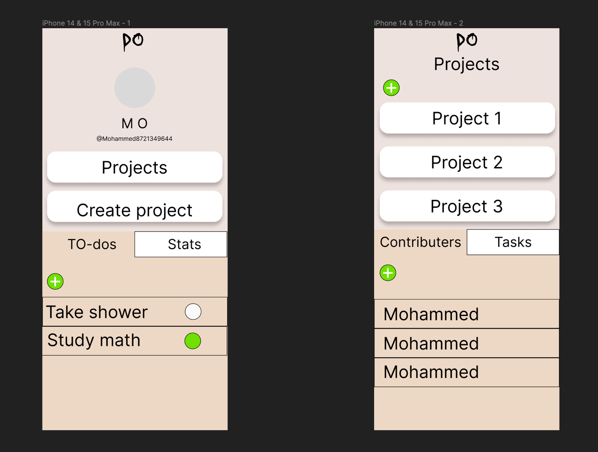

Prototype of the home screen and the project screen

Reference and Definitions :

1 – Usability :

2 – Integrity

3 – Testability

4 – Reusability

5 – Maintainability

A quality requirements taxonomy, as defined in [Wiegers 2003].