BioTIP analysis of alveolar epithelial state changes after lung
injury

GP2 Data Analysis ICA

Abstract

Alveolar type 2 (AT2) cells help restore the distal lung epithelium after injury, but this repair pro- gramme can pass through unstable intermediate states. I analysed a pre-processed mouse lung fibrosis single-cell RNA-seq dataset (GSE141259) with BioTIP, using either sampling time point or anno- tated alveolar cell state as the definition of“state”. After restricting the analysis to AT2, activated AT2, Krt8+ alveolar differentiation intermediate (ADI), AT1 and proliferating alveolar cells, 10,381 cells were retained. Time-point analysis identified significant critical-transition signal candidates around days 6 and 9 after injury, with a weaker candidate peaking at day 10. Cell-type analysis instead high- lighted the proliferating Mki67+ state. These results support a view in which the injury response is not a smooth linear AT2-to-AT1 conversion, but a transient, proliferative and intermediate-state-rich repair trajectory. The two state definitions were informative in different ways: time points captured dynamic phases of repair, whereas cell-type states emphasized transcriptional programmes shared across time.

Keywords: single-cell RNA-seq; alveolar epithelium; AT2 differentiation; BioTIP; critical transition signals

1 Introduction

The distal lung epithelium relies on AT2 cells both for surfactant production and for epithelial repair. After injury, AT2 cells can proliferate and generate AT1 cells, which form the thin gas-exchange surface. In fibrotic injury, however, regeneration is accompanied by persistent transitional epithelial states rather than a simple restoration of the original tissue architecture. Strunz and colleagues described an alveolar regeneration programme in which AT2 cells pass through activated and Krt8+ intermediate states before acquiring AT1-like features; failure to resolve this programme is closely linked to aberrant repair and fibrosis [1]. This makes the dataset a useful test case for methods that search for unstable transition points in high-dimensional expression data.
BioTIP was designed to detect critical transition signals (CTSs) from transcriptomic data by combining transcript fluctuation, co-expression network structure and an index of criticality (Ic) [2]. Conceptually, the method asks whether a group of genes becomes unusually variable and co-regulated in a specific state, which would be expected near a tipping point. This analysis had three aims: first, to demonstrate the

rationale of BioTIP using the published successful case-study setting; second, to apply BioTIP to injury- associated alveolar epithelial cells from GSE141259; and third, to compare whether defining state by time point or by annotated cell type leads to the same biological interpretation.

2 Methods

2.1 Data source and preprocessing

The main analysis used the pre-processed high-resolution single-cell RNA-seq files from GSE141259, generated from the lung injury study by Strunz et al. [1]. Raw count matrices and matched cell metadata were retrieved from GEO. The analysis focused on alveolar epithelial states relevant to AT2 differenti- ation: AT2, activated AT2, Krt8+ ADI, AT1 and Mki67+ proliferating cells. Cells were retained if they belonged to one of these states and passed basic quality filters based on detected genes, UMI count and mitochondrial percentage. The final analysis object contained 10,381 cells.
Seurat was used for object handling, log-normalisation, variable-feature selection, scaling, PCA and UMAP visualisation. BioTIP was then applied to the normalised expression matrix. Because full-scale network and MCI estimation was computationally heavy for the available workstation, the final report uses a reproducible reduced analysis scope: states with fewer than 20 cells were excluded, each state was down-sampled to a fixed maximum number of cells, and the 800 most variable genes were used for BioTIP scoring. This retained the required BioTIP steps while keeping the analysis tractable.
Table 1: Dataset and analysis scope.

Item | Value
Primary dataset | GSE141259 lung injury regeneration scRNA-seq
Input matrix | HighResolution raw-count matrix with matched cell metadata
Cells before lineage filtering | 32,559
Cells retained for analysis | 10,381
Retained cell states | AT2, activated AT2, Krt8+ ADI, AT1, Mki67+ proliferating cells
Analysis A states | Time points after injury; day 28 excluded from BioTIP scoring because only two cells remained
Analysis B states | Annotated alveolar cell states pooled across time

2.2 BioTIP analysis

Two state definitions were compared. In Analysis A, each sampling time point was treated as a state. Day 28 was excluded from BioTIP scoring because only two cells remained after lineage filtering. In Analysis B, each annotated alveolar cell type was treated as a state, pooling cells across time. For both analyses, state-specific fluctuating transcripts were pre-selected using BioTIP’s bootstrap-based relative transcript fluctuation procedure. Co-expression networks were then built for the selected transcripts, par- titioned into gene modules, and scored using the MCI framework. CTS candidates were evaluated by

calculating Ic.shrink across states. Statistical support was assessed with 100 gene-permutation simula- tions, comparing the observed ΔIc.shrink with the corresponding null distribution.
The analysis was performed in R 4.5.2 using Seurat 5.4.0, BioTIP 1.24.0 and GEOquery 2.78.0. Default package behaviour was used except for the explicit state-size, down-sampling and gene-selection limits described above.
Table 2: Software used for the analysis.

Software | Version | Use
R | 4.5.2 | Analysis environment
Seurat | 5.4.0 | Single-cell object handling, normalization, PCA and UMAP
BioTIP | 1.24.0 | RTF pre-selection, network partition, MCI and Ic.shrink scoring
GEOquery | 2.78.0 | GEO metadata and supplementary-file retrieval

3 Results

3.1 BioTIP case-study rationale

The mouse gastrulation case study illustrates the intended behaviour of BioTIP: as cells approach a de- velopmental branch point, a subset of transcripts becomes more fluctuating and more tightly coordinated. In that setting, BioTIP identifies modules whose MCI and Ic scores peak near known transition stages, rather than simply ranking genes by average expression. This is important for the lung injury analysis be- cause the biological question is not only which marker genes define AT2, ADI or AT1 cells, but whether any state shows signs of an unstable transition programme.

3.2 Alveolar cells retained from GSE141259

The retained cells spanned homeostatic control and multiple post-injury time points, with a strong en- richment of activated AT2 and Krt8+ ADI cells during early repair. The cell composition plot shows that activated AT2 cells were especially abundant around days 3–5, while Krt8+ ADI cells became more prominent from approximately day 7 onward. AT1 cells were present at lower abundance but increased after the earliest injury phase. This pattern is consistent with a repair trajectory in which AT2 cells first activate and proliferate, then pass through an intermediate differentiation state before contributing to AT1-like epithelium.

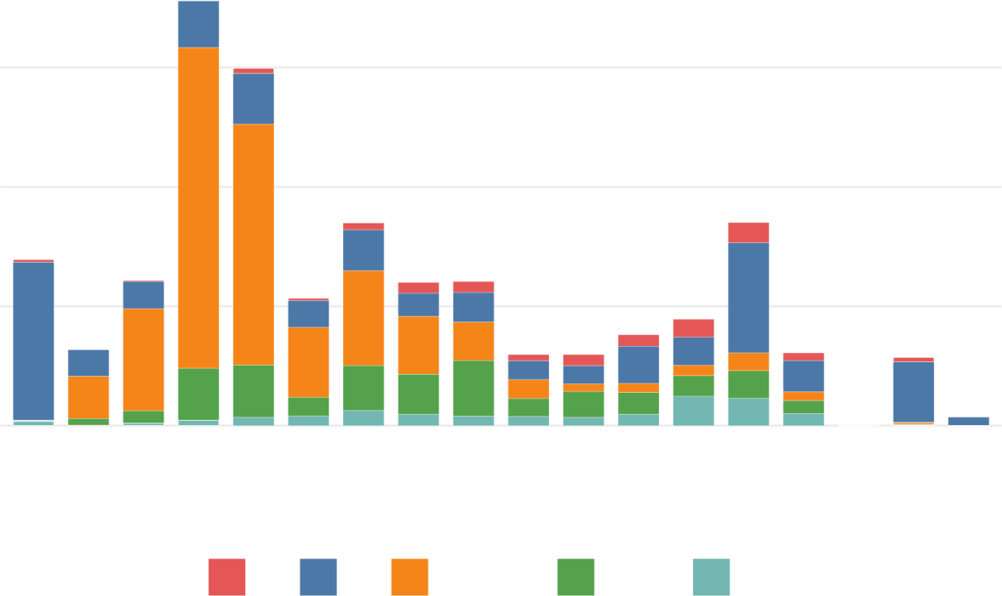
Ce l ls reta ined
PBS
D2
D3
D4
D5
D6
D7
D8
D9
D10
D11
D12
D13
D15
D21
D28
D36
D54
Cell state AT1 AT2 AT2 activated Krt8+ ADI Mki67+ Proliferation
1500

1000
Sampling state
500
0

Figure 1: Composition of retained alveolar-lineage cells across sampling states.
Bars show the number of cells retained after filtering for each annotated cell state.

3.3 Analysis A: time point as state

When sampling time point was used as the state definition, BioTIP returned four CTS candidates. The strongest supported candidates were centred on day 6 (ΔIc.shrink = 1.456, permutation p = 0.01) and day 9 (ΔIc.shrink = 0.961, permutation p < 0.01). A further candidate derived from day 8 had a peak Ic.shrink at day 10 (p = 0.04), suggesting that the underlying module may mark a programme extending across adjacent repair stages. The day 7 candidate was not statistically supported (p = 0.34). Overall, the time-point analysis placed the most credible transition signal between the early activated AT2-rich phase and the later ADI/AT1-skewed phase.

3.4 Analysis B: cell type as state

When annotated cell type was used as the state definition, BioTIP identified one CTS candidate, as- sociated with the Mki67+ proliferating state (ΔIc.shrink = 0.856, permutation p < 0.01). This result is biologically plausible because proliferation is a central component of epithelial repair after injury. It also differs from Analysis A: the cell-type analysis highlights a transcriptional programme shared by prolif- erating cells across time, whereas the time-point analysis highlights when the broader tissue response appears most unstable.

Table 3: BioTIP critical-transition signal candidates from the simplified analysis.

Analysis | Candidate | Genes | Delta Ic.shrink | Permutation p | Peak state
A: time point | day 6 | 20 | l.456 | 0.0l | day 6
A: time point | day 9 | 28 | 0.96l | <0.0l | day 9
A: time point | day 7 | 30 | 0.069 | 0.34 | day 7
A: time point | day 8 | 20 | 0.3l5 | 0.04 | day l0
B: cell type | Mki67+ Proliferation | 3l | 0.856 | <0.0l | Mki67+ Prolif- eration


p=0.00

p=0.34

p=0.04

p=0.00

p=0.01
0.0 0.5 1.0 1.5
Δ Ic.shrink

Permutation result not significant significant
B: Mki67+ Proliferation

A: day 7

A: day 8

A: day 9

A: day 6

Figure 2: BioTIP CTS candidates from the two state definitions. Bar length shows
observed ΔIc.shrink. Labels report empirical gene-permutation p-values from l00
simulations.

4 Discussion

The two BioTIP analyses are complementary rather than directly interchangeable. Time-point states preserve the temporal order of injury and repair, so they are better suited to asking when the system may pass through an unstable transition. In this analysis, the strongest signals around days 6 and 9 fit the expected timing of a shift from widespread AT2 activation towards intermediate and differentiating epithelial states. The day 8 module peaking at day l0 reinforces the same broad interpretation, although it should be treated cautiously because adjacent time points are not independent biological states.
Cell-type states answer a different question. By pooling across time, Analysis B removes temporal ordering and instead asks which annotated cell programme behaves like a critical state. The Mki67+ proliferating signal therefore does not mean that proliferation is the only transition in the experiment. Rather, it suggests that proliferating alveolar cells carry a coherent, high-criticality transcriptional pro- gramme. This is consistent with the biology of epithelial regeneration, where AT2 proliferation precedes or accompanies differentiation into intermediate and ATl-like states.

The analysis also has limitations. BioTIP relies on state definitions supplied by the analyst, and both time points and cell labels are imperfect summaries of a continuous injury response. Some time points were sparse after lineage filtering, and day 28 had to be excluded from scoring. The reduced analysis scope made the computation reproducible on the available workstation, but it may miss weaker modules that would appear in a larger full-scale run. Finally, BioTIP identifies statistical signals of coordinated fluctuation; it does not prove lineage direction or causal regulation. Those questions would require trajectory inference, perturbation data or independent validation.
Despite these caveats, the results are coherent with the published view of post-injury alveolar repair. The strongest time-point signals fall after early AT2 activation and before later resolution, while the cell- type analysis points to a proliferative epithelial programme. I therefore interpret BioTIP as useful for highlighting candidate transition phases, especially when combined with biological annotation, but not as a stand-alone replacement for careful cell-state interpretation.

References

[ 1] Maximilian Strunz, Lukas M. Simon, Mohd Ansari, Jatin J. Kathiriya, Ilias Angelidis, Christoph H. Mayr, Georgios Tsidiridis, Markus Lange, Lukas F. Mattner, Mary Yee, et al. Alveolar regeneration through a krt8+ transitional stem cell state that persists in human lung fibrosis. Nature Communica- tions, 11:3559, 2020.
[2] X. Yang et al. Biotip: a system biology tool for identifying critical transitions in omics data. Nucleic Acids Research, 50(16):e91, 2022.

