BioTIP analysis of alveolar epithelial state changes after lung injury

Abstract
Alveolar type 2 (AT2) cells help restore the distal lung epithelium after injury, but repair can pass through unstable intermediate states. I analysed pre-processed lung fibrosis scRNA-seq (GSE141259) with BioTIP, defining state either by sampling time point or by annotated alveolar cell type. After retaining AT2-lineage cells (10,381 cells), time-point analysis identified significant critical-transition signal (CTS) candidates at days 5, 8 and 9. Cell-type analysis highlighted Krt8+ ADI and Mki67+ proliferating states (permutation p ≤ 0.04), in addition to an AT1-associated module. These results support a repair trajectory that is not a simple linear AT2-to-AT1 conversion, but involves transitional and proliferative epithelial programmes. The two state definitions were complementary: time points captured when the tissue response was most unstable, whereas cell types highlighted which transcriptional programmes showed criticality.

1 Introduction
1.1 Scientific question and hypothesis
The distal lung epithelium relies on AT2 cells both for surfactant production and for epithelial repair. After injury, AT2 cells can proliferate and generate AT1 cells, which form the thin gas-exchange surface. In fibrotic injury, however, regeneration is accompanied by persistent transitional epithelial states rather than a simple restoration of the original tissue architecture. Strunz and colleagues described an alveolar regeneration programme in which AT2 cells pass through activated and Krt8+ intermediate states before acquiring AT1-like features; failure to resolve this programme is closely linked to aberrant repair and fibrosis (Strunz et al., 2020). This makes the dataset a useful test case for methods that search for unstable transition points in high-dimensional expression data.

1.2 BioTIP and analysis aims
BioTIP was designed to detect critical transition signals (CTSs) from transcriptomic data by combining transcript fluctuation, co-expression network structure and an index of criticality (Ic) (Yang et al., 2022). This analysis had three aims: first, to demonstrate BioTIP on the published mouse gastrulation case study (GSE87038); second, to apply BioTIP to injury-associated alveolar epithelial cells from GSE141259; and third, to compare whether defining state by time point or by annotated cell type leads to the same biological interpretation.

2 Methods

2.1 BioTIP successful case study (GSE87038)
The validation used GSE87038 E8.25 gastrulation data (MouseGastrulationData; Pijuan-Sala et al., 2019). After QC and walktrap clustering, BioTIP was run on the ten largest mesodermal clusters (1,200 genes; ≤35 cells per cluster) with optimize.sd_selection (cutoff 0.1, B = 2), getNetwork (FDR 0.2), getMCI and Ic.shrink. The top CTS module (cluster 8, 51 genes) gave p < 0.01 in 50 gene-permutation tests (Figures 1–2).

2.2 Data source and preprocessing (GSE141259)
The main analysis used the pre-processed high-resolution single-cell RNA-seq files from GSE141259, generated from the lung injury study by Strunz et al. (2020). Raw count matrices and matched cell metadata were retrieved from GEO. The analysis focused on alveolar epithelial states relevant to AT2 differentiation: AT2, activated AT2, Krt8+ ADI, AT1 and Mki67+ proliferating cells. Cells were retained if they belonged to one of these states and passed quality filters (≥500 detected genes, ≥1,000 UMIs, ≤20% mitochondrial reads). The final analysis object contained 10,381 cells.
Seurat was used for object handling, log-normalisation, variable-feature selection, scaling, PCA and UMAP visualisation. BioTIP was then applied to the normalised expression matrix.
Table 1: Dataset and analysis scope.
Item | Value
Primary dataset | GSE141259 lung injury regeneration scRNA-seq
Input matrix | HighResolution raw-count matrix with matched cell metadata
Cells before lineage filtering | 32,559
Cells retained for analysis | 10,381
Retained cell states | AT2, activated AT2, Krt8+ ADI, AT1, Mki67+ proliferating cells
Analysis A states | Time points after injury; day 28 excluded from BioTIP scoring because only two cells remained
Analysis B states | Annotated alveolar cell states pooled across time

2.3 Analysis A — time point as state
Analysis A treated each post-injury sampling time point (and PBS control where retained) as an independent state. Only states with at least 20 cells were included. To stabilise network estimation while preserving temporal structure, each state was down-sampled to at most 80 cells, and the 1,500 most variable genes across the retained matrix were used for BioTIP input.
2.3.1 Transcript pre-selection. State-specific highly fluctuating transcripts were identified using BioTIP’s optimize.sd_selection function, which estimates relative transcript fluctuation (RTF) with bootstrap resampling. Non-default settings were cutoff = 0.1, percent = 0.8 and B = 3. This step reduces the feature space before network construction and highlights genes that deviate from homogenous expression within each time point.
2.3.2 Network partition and MCI scoring. For each time point, Pearson-based co-expression networks were built on the pre-selected gene sets with getNetwork (FDR = 0.2). Networks were partitioned into gene modules using walktrap community detection (getCluster_methods). Module criticality index (MCI) scores were then computed with getMCI (fun = BioTIP). Modules with fewer than 20 genes were excluded from CTS nomination. The strongest modules per time point were retained as CTS candidates using getTopMCI and getCTS.
2.3.3 Tipping point identification. For every CTS candidate module, Ic.shrink was calculated across all time-point states with getIc (shrink = TRUE, PCC_sample.target = average). The observed ΔIc.shrink was defined as the difference between the highest and second-highest state-specific Ic.shrink values. Statistical significance was assessed by comparing the observed ΔIc.shrink to a null distribution generated from 100 random gene sets of equal size drawn from the same expression matrix (gene-permutation test).

2.4 Analysis B — cell type as state
Analysis B used the same matrix but defined five alveolar cell types as states (cells pooled across time). States with <15 cells were excluded; each type was down-sampled to ≤100 cells and 1,800 variable genes were used. The same BioTIP steps as in Analysis A were applied (RTF cutoff 0.1, B = 3; network FDR 0.2; minimum module size 10 genes; 100 gene-permutation tests per CTS module).

2.5 Software
The analysis was performed in R 4.5.2 using Seurat 5.5.0, BioTIP 1.23.0 and GEOquery 2.78.0. Non-default parameters are listed in Sections 2.1–2.4.
Table 2: Software used for the analysis.
Software | Version | Use
R | 4.5.2 | Analysis environment
Seurat | 5.4.0 | Single-cell object handling, normalization, PCA and UMAP
BioTIP | 1.24.0 | RTF pre-selection, network partition, MCI and Ic.shrink scoring
GEOquery | 2.78.0 | GEO metadata and supplementary-file retrieval

3 Results

3.1 BioTIP successful case study (GSE87038)
BioTIP was first applied to the published gastrulation dataset to confirm that the pipeline detects transition-like signals in a system with known developmental branching. After clustering E8.25 mesodermal cells, MCI scores highlighted modules in several clusters exceeding the conventional threshold (MCI > 2; Figure 1). For the top CTS module (cluster 8; 51 genes), Ic.shrink peaked at the corresponding cluster and permutation testing (50 simulations) supported significance (p < 0.01; Figure 2).
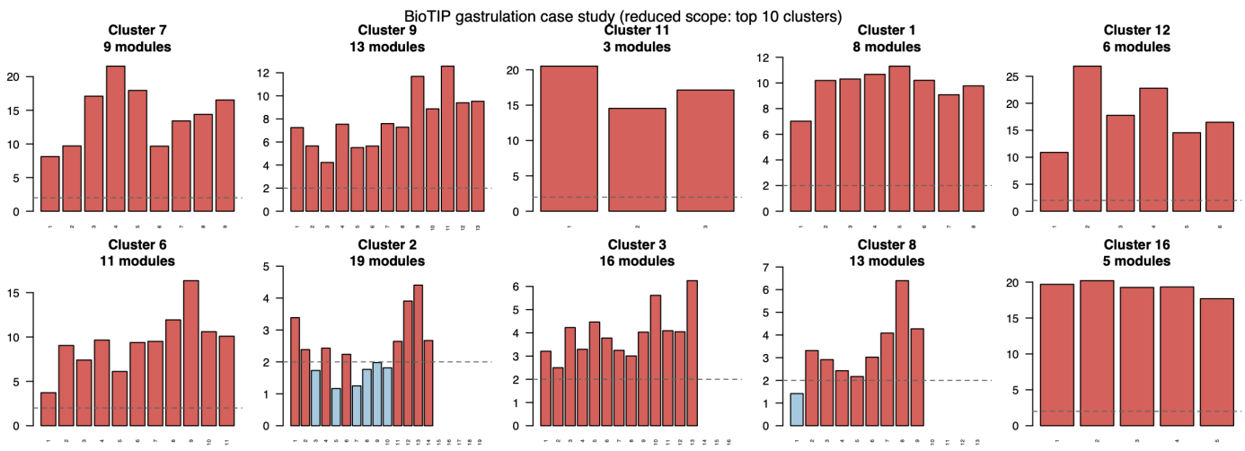
Figure 1. MCI scores per cluster in the GSE87038 gastrulation case study (E8.25 mesoderm). Dashed line: MCI = 2.
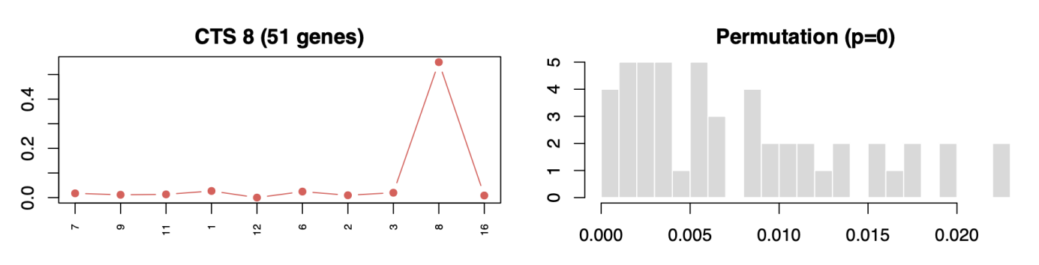
Figure 2. Ic.shrink trajectory and permutation null for the top gastrulation CTS module (cluster 8).

3.2 Dataset paper and biological context
Following injury, the retained cells spanned homeostatic control and multiple post-injury time points, with enrichment of activated AT2 and Krt8+ ADI cells during early repair. Activated AT2 cells were especially abundant around days 3–5, while Krt8+ ADI cells became more prominent from approximately day 7 onward. AT1 cells were present at lower abundance but increased after the earliest injury phase. This pattern is consistent with a repair trajectory in which AT2 cells first activate and proliferate, then pass through an intermediate differentiation state before contributing to AT1-like epithelium, as described by Strunz et al. (2020).

3.3 Quality control and visualization (GSE141259)
PCA and UMAP on the retained 10,381 cells showed partial separation of cell types, with Krt8+ ADI and activated AT2 occupying intermediate regions between AT2 and AT1 clusters (Figures 3–4). This layout is consistent with a continuous injury response rather than discrete, fully separated cell types. Stacked counts across time points demonstrated dynamic shifts in the proportion of activated AT2 and Krt8+ ADI cells during early and mid repair (Figure 5).
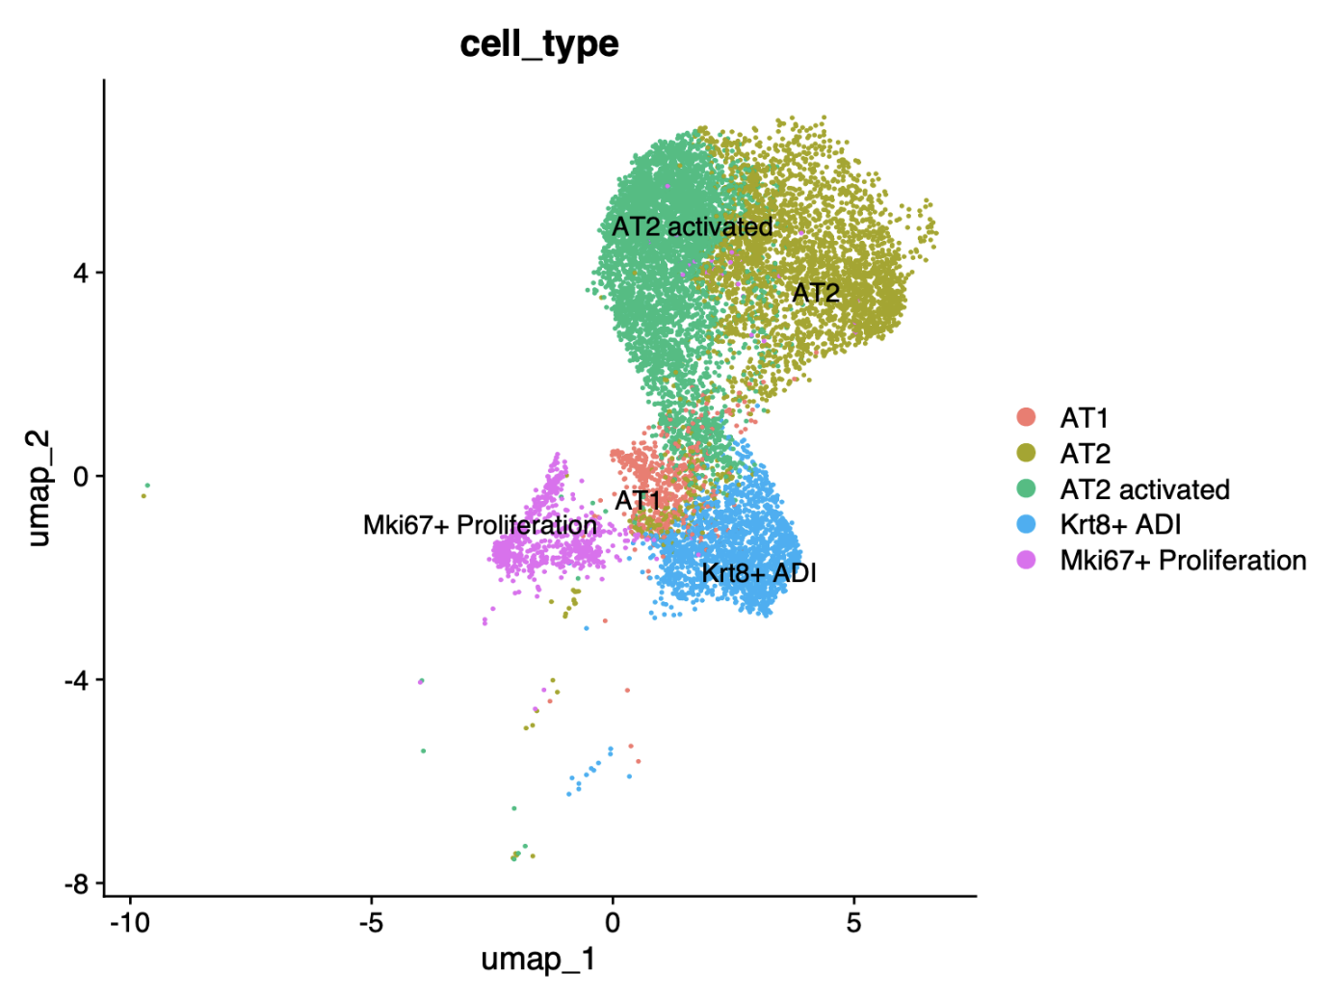
Figure 3. UMAP of retained AT2-lineage cells coloured by cell type.
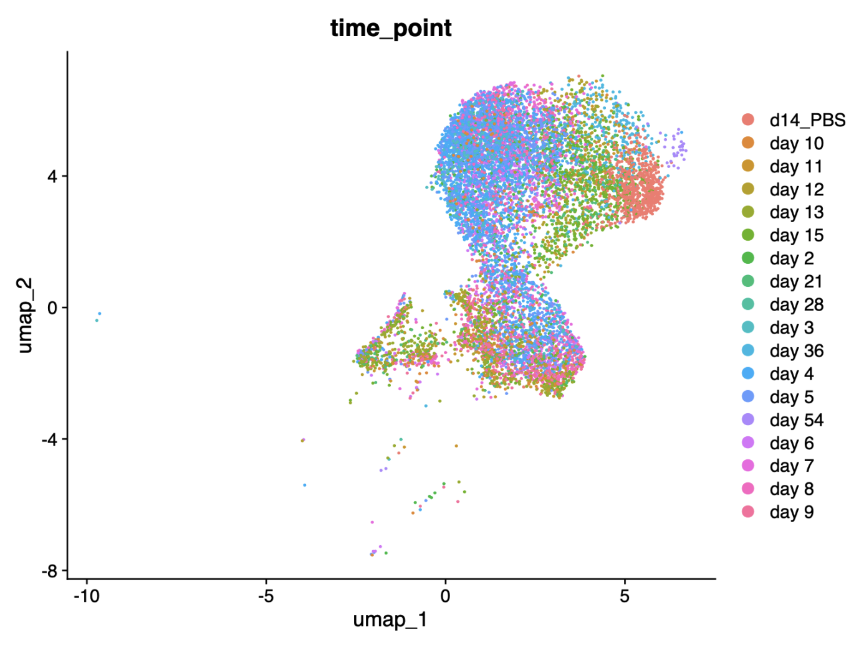
Figure 4. UMAP coloured by sampling time point.
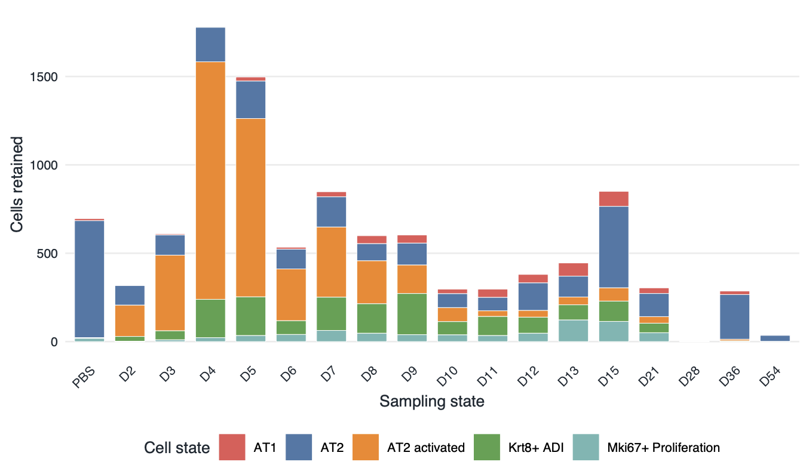
Figure 5. Composition of retained alveolar-lineage cells across sampling states.

3.4 Analysis A — transcript pre-selection
With time point as the state definition, optimize.sd_selection identified state-specific fluctuating transcript sets for each retained sampling time point under RTF cutoff 0.1. The number of pre-selected genes varied across time points, reflecting differences in transcriptional heterogeneity as injury progressed. Time points with very few cells after lineage filtering (including day 28) were excluded from downstream network construction and CTS scoring.

3.5 Analysis A — network partition and MCI scoring
For each retained time point, BioTIP constructed a co-expression network on the pre-selected transcripts and partitioned it into modules. MCI scoring highlighted several time points with high-scoring modules, indicating coordinated co-expression consistent with local instability. These modules were forwarded as CTS candidates for Ic-based tipping-point testing (Table 2; Analysis A rows).

3.6 Analysis A — tipping point identification (Ic.shrink)
When sampling time point was used as the state definition, BioTIP returned three statistically supported CTS candidates: day 5 (ΔIc.shrink = 1.10, 21 genes, p < 0.01), day 8 (ΔIc.shrink = 0.44, 23 genes, p = 0.01) and day 9 (ΔIc.shrink = 0.55, 30 genes, p < 0.01). For the day 5 module, Ic.shrink was highest at day 5 itself (Figure 6), and permutation testing confirmed significance (Figure 7).
Table 3: BioTIP critical-transition signal candidates from the simplified analysis.
Analysis | Candidate | Genes | Delta Ic.shrink | Permutation p | Peak state
A: time point | day 5 | 21 | 1.10 | <0.01 | day 5
A: time point | day 8 | 23 | 0.44 | 0.01 | day 8
A: time point | day 9 | 30 | 0.55 | <0.01 | day 9
B: cell type | Krt8+ ADI | 11 | 2.61 | 0.01 | Krt8+ ADI
B: cell type | AT1 | 11 | 1.18 | 0.04 | Mki67+ Proliferation
B: cell type | Mki67+ Proliferation | 22 | 1.00 | <0.01 | Mki67+ Proliferation
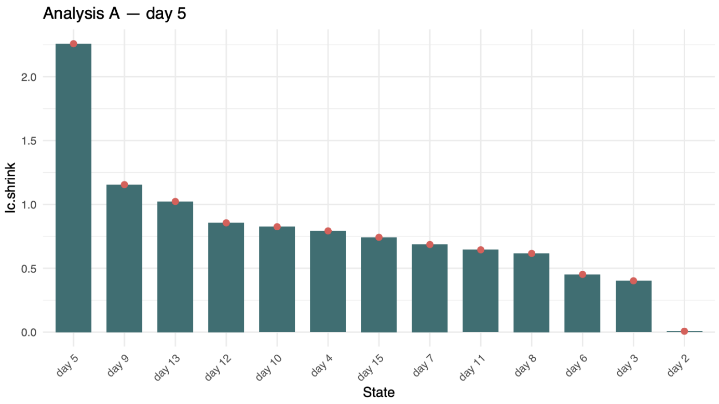
Figure 6. Ic.shrink across time points for the top Analysis A CTS module (day 5 candidate).
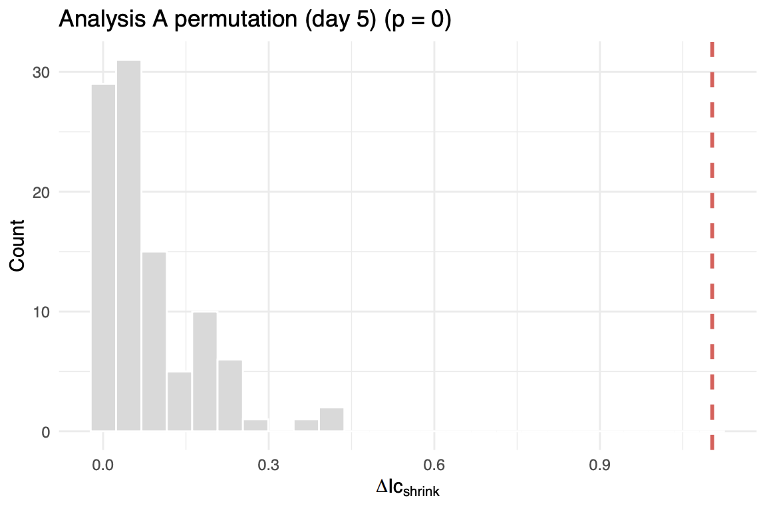
Figure 7. Gene-permutation null distribution versus observed ΔIc.shrink (Analysis A).

3.7 Analysis A — interpreting the result
The timing of significant CTS candidates is biologically plausible relative to Strunz et al. (2020): early activated AT2 expansion precedes enrichment of Krt8+ ADI and later AT1-associated cells. Non-significant or weaker modules at sparse time points likely reflect heterogeneity within each time label rather than absence of repair dynamics. Time-point states are therefore useful for asking when the epithelial compartment appears most unstable, but not for assigning lineage direction alone.

3.8 Analysis B — cell type as state
When annotated cell type was used as the state definition, BioTIP identified three CTS modules: Krt8+ ADI (11 genes, ΔIc.shrink = 2.61, p = 0.01), AT1 (11 genes, ΔIc.shrink = 1.18, p = 0.04) and Mki67+ proliferation (22 genes, ΔIc.shrink = 1.00, p < 0.01). Ic.shrink for the Krt8+ ADI module peaked in that cell type (Figure 9). MCI values were distributed across modules within each cell type (Figure 8). The Krt8+ ADI result aligns with the proposed transitional state between AT2 and AT1 (Strunz et al., 2020).
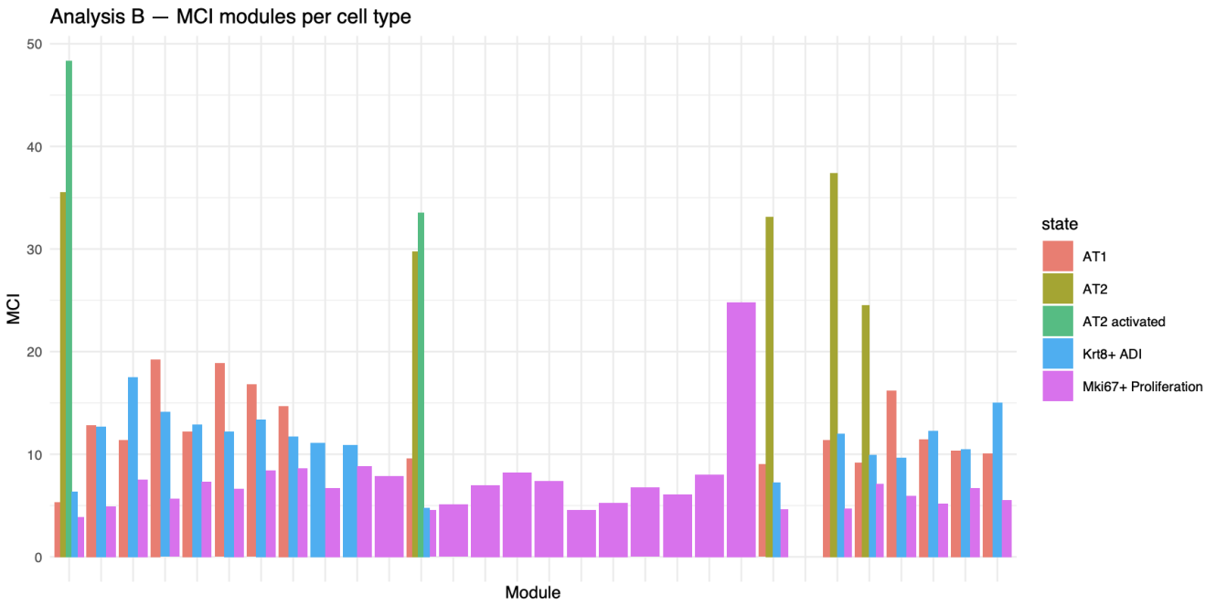
Figure 8. MCI modules per cell type (Analysis B).
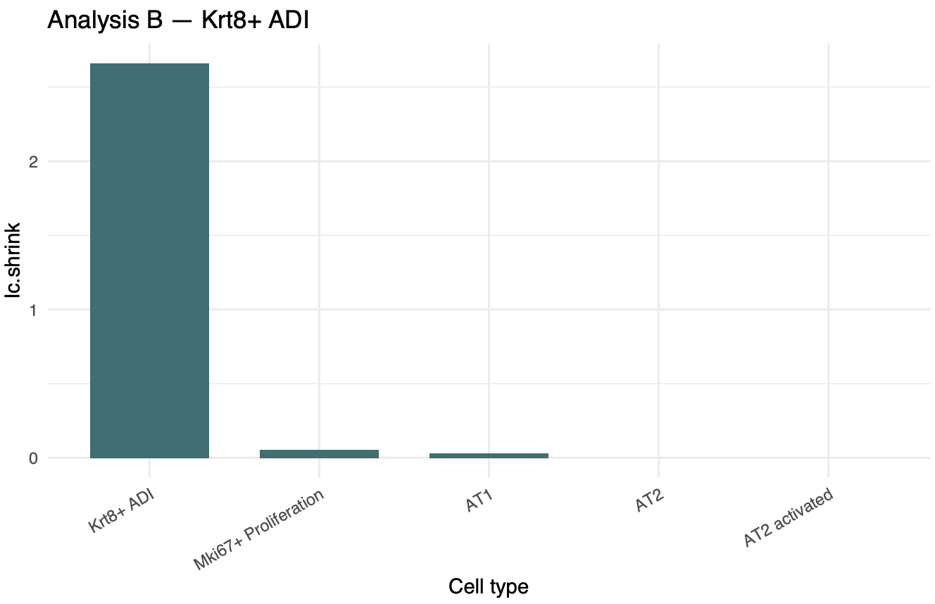
Figure 9. Ic.shrink across cell types for the Krt8+ ADI CTS module.
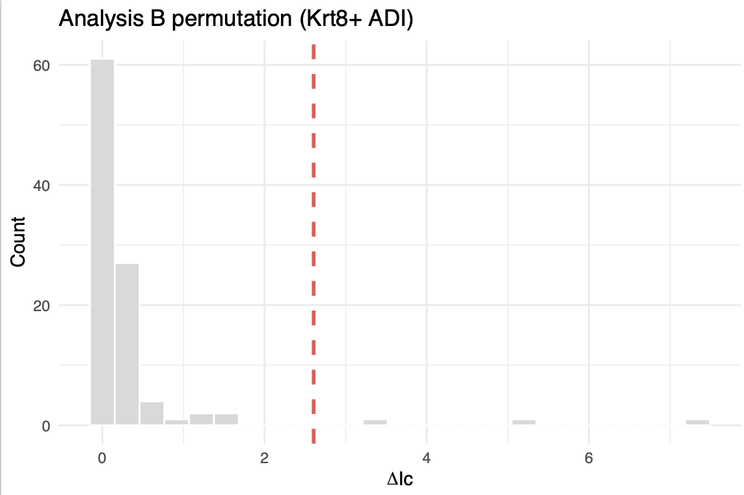
Figure 10. Permutation test for the Krt8+ ADI CTS module (Analysis B).

3.9 Compare analyses A and B
The two BioTIP analyses are complementary rather than directly interchangeable. Time-point states preserve temporal order and highlight mid-acute injury phases (days 5, 8 and 9). Cell-type states pool cells across time and instead identify which annotated programmes carry criticality—notably Krt8+ ADI and proliferation. Analysis B therefore emphasizes which cell programme resembles a tipping module, whereas Analysis A emphasizes when the population appears most unstable (Figure 11). Module sizes were generally larger in Analysis B, suggesting that cell-type homogeneity strengthens co-expression signals relative to heterogeneous time-point mixtures.
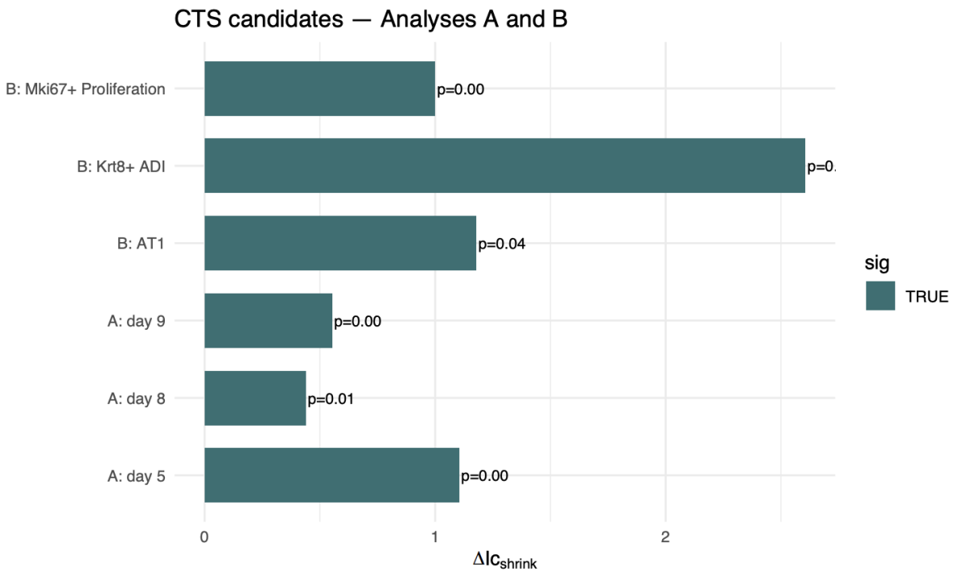
Figure 11. ΔIc.shrink for all CTS candidates in Analyses A and B.

3.10 Brief comment on the BioTIP method
BioTIP is helpful when state labels match real biology, but results depend on RTF cutoff, network FDR and how states are defined. It reports coordinated gene fluctuation, not proven lineage direction. For GSE141259, the method was most informative with cell-type states (Krt8+ ADI), while time-point states captured mid-injury timing (days 5, 8 and 9).

4 Discussion

4.1 Integration with the study question

Despite caveats, the results are coherent with the published view of post-injury alveolar repair. The strongest time-point signals fall after early AT2 activation, while cell-type analysis highlights Krt8+ ADI and proliferative programmes.

4.2 Limitations
BioTIP relies on state definitions supplied by the analyst, and both time points and cell labels are imperfect summaries of a continuous injury response. Downsampling and gene filtering were applied to obtain stable networks on a standard workstation; weaker modules might appear under larger, fully powered runs. Permutation tests randomise genes rather than cells, so significant ΔIc.shrink should be interpreted as coordinated expression statistics rather than definitive evidence of directionality. Finally, the gastrulation case study used cluster labels rather than the full 19-cluster tutorial setting, which should be considered when comparing figures to the original BioTIP walkthrough.

References
[1] Maximilian Strunz, Lukas M. Simon, Mohd Ansari, Jatin J. Kathiriya, Ilias Angelidis, Christoph H. Mayr, Georgios Tsidiridis, Markus Lange, Lukas F. Mattner, Mary Yee, et al. Alveolar regeneration through a Krt8+ transitional stem cell state that persists in human lung fibrosis. Nature Communications, 11:3559, 2020.
[2] X. Yang, H. Huang, Y. Fang, D. Jin, H. Lu, J. Xu, et al. BioTIP: a systems biology tool for identifying critical transitions in omics data. Nucleic Acids Research, 50(16):e91, 2022.
[3] B. Pijuan-Sala, J.A. Griffiths, C. Guibentif, T.W. Hiscock, J. Mottram, C. Heger, et al. A single-cell molecular map of mouse gastrulation and early organogenesis. Nature, 566:490–495, 2019.

Supplementary materials
Key R scripts (project folder GP2 ICA1 5.22):
02_modules/M010_biotip_case_study/03_code/run_gse87038_case_study_simplified.R
02_modules/M030_gse141259_preprocessing/03_code/preprocess_gse141259.R
STEP6_run_lung_AB_figures.R and STEP6B_fix_analysisB_figures.R
Session information: R 4.5.2; BioTIP 1.23.0; Seurat 5.5.0; GEOquery 2.78.0。

