Risk Measurement of Interest Rate Swap (IRS)

Course Title: RMSC5003
Risk Measure
Instructor: Dr. Wong, Tat Wing

Topic 11, Group 3
Presented by:
CHEN, Xiaoan – 1155091924
LI, Hexin - 1155243904
QIANG, Wei – 1155245168
WANG, Tao – 1155239224
YANG, Xiya – 1155241506
YE, Dingkun – 1155157113

December 9, 2025
Table of Contents
1 Introduction of Swap 1
1.1 Market and Size 1
1.2 Different Types of IRS 1
1.3 Plain Vanilla IRS 2
2 Reference Rates 2
2.1 LIBOR 2
2.2 SOFR 3
3 Selected Product 3
4 Methodologies & Results 3
4.1 Key Assumptions 4
4.1.1 Forward-looking method 4
4.1.2 Linear interpolation 4
4.2 Data and Preparation 4
4.2.1 Zero Curve Construction 4
4.2.2 Data Processing 5
4.3 Principal Component Analysis 5
4.4 Modeling 5
4.4.1 Finding the Distribution 6
4.4.2 Estimating Distribution Parameters 6
4.5 Simulation 6
4.6 The VaR & ES 7
4.6.1 Result Analysis 7
4.6.2 Key findings and Risk Implication 8
5 Backtesting Model 8
6 Conclusion 10
7 Appendices i
7.1 Appendix A – Pricing theory of swap i
7.2 Appendix B – Bootstrapping Formula and an example bootstrapped SOFR Curve on Nov 14 i
7.3 Appendix C – Cumulative Sum of PCs ii
7.4 Appendix D - PCs iii
7.5 Appendix E – QQ-R Squared test and Histograms iii
7.6 Appendix F – PnL Distribution v
7.7 Appendix G – US Interest rate during 2014 – 2025 v
7.8 Appendix H – Comparison between predicted and actual losses v
8 Question and Answer vi
8.1 Q&A in Presentation vi
8.2 Comments from Group 11 vii

Introduction of Swap
Swaps stand as pivotal over the counter (OTC) financial instruments in global markets. They revolve around a core agreement between two parties: exchanging cash flows of equivalent economic value over a predefined future period. Anchored on an agreed notional principal, swaps are quoted via the "Swap Rate" (See Appendix A: Pricing theory) — the fixed leg rate specified in the contract. Beyond their basic structure, swaps serve as linchpins for risk management, financing optimization, and arbitrage capture, catering to diverse needs across financial institutions, non-financial enterprises, and public sector entities. Their flexibility and adaptability have solidified their position as indispensable tools amid market volatility and complexity.

Market and Size
The global swap market maintains robust growth momentum, underpinned by rising demand for risk hedging and financing efficiency. As of H1 2024, the total size of the global swap market reached $469.2 trillion, marking a 4.8% year-on-year increase. This scale accounts for 80.3% of the entire OTC derivatives market, highlighting swaps’ dominant role in the derivatives landscape. Key underlying reference rates driving market activity include USD SOFR, EUR EURIBOR, and GBP SONIA — these benchmarks support a wide range of trading strategies, from spread trading to curve arbitrage. Historical data further reflects the market’s expansion: from early 2000s to today, swap volumes have surged alongside globalization and financial innovation, with interest rate swaps remaining the largest segment.

Different Types of IRS
IRSs are OTC instruments and are created upon counterparties needs, therefore, there is no limit for how many different types of contracts that can be invented. Some main types are:
- Same Currencies IRS: Operates within a single currency framework, including fixed for floating rate swap, floating for floating rate swap.
- Different Currencies IRS: Involves transactions across different currencies, the exchange of both principal amounts and interest payments, including fixed for floating rate swap, floating for floating rate swap, and fixed for fixed rate swap.

Plain Vanilla IRS
This study will focus on the most common type of IRS, plain vanilla IRS, which involves two parties agreeing to exchange cash flows based on a single currency: one party pays a fixed interest rate, while the other pays a floating interest rate.
The notional principal serves as the calculation base but is never physically exchanged — only interest payments (or net differences) change hands at predetermined settlement dates. Its "plain vanilla" label stems from its standardized, uncomplicated terms: maturity periods (ranging from 1 to 30 years), payment frequencies (e.g., quarterly, semi-annually), and underlying benchmarks are widely accepted across markets. This standardization enhances liquidity, making Plain Vanilla IRS the go-to instrument for entities seeking to convert floating-rate obligations to fixed, or vice versa, without complex customizations.
The value of contract for the fixed payer is the difference between PV of floating and fixed:
$$Value_{fixed}=PV\left(floating\right)-PV\left(fixed\right)=(1-df_{N})-r_{fixed}∆t\sum_{i=1}^{N}{Z_{i}} (1)$$
The value of the floating side would be the opposite as derivative is a zero-sum game.

Reference Rates

LIBOR
Since its establishment in 1986, the London Interbank Offered Rate (LIBOR) has been one of the core benchmarks of the global financial system, providing a pricing basis for approximately USD300 trillion worth of financial products.
However, its mechanism has fundamental flaws: interest rate data relies on subjective estimates by banks rather than actual transactions, making it vulnerable to manipulation and the system fragile. During the 2008 financial crisis, the scandal of several banks deliberately underreporting interest rates completely exposed this problem, seriously undermining their credibility.
Although regulatory reforms after 2012 attempted to strengthen the trading foundation, market confidence was hard to restore. LIBOR was discontinued on June 30, 2023. The flaws of LIBOR accelerated the transformation of the financial system towards alternative benchmark interest rates based on actual transactions, such as SOFR. At present, LIBOR has entered a stage of gradual withdrawal, and its era as a global benchmark has come to an end.

SOFR
The Secured Overnight Financing Rate (SOFR) was launched in April 2018 and has become the main alternative benchmark interest rate in the US dollar market. This interest rate is released daily by the Federal Reserve Bank of New York. It is based on the actual daily transaction of over one trillion dollars of US Treasury bond repo, collateralized by Treasury bonds, and features near-risk-free, high transparency and a robust structure. SOFR is entirely based on real transaction data, fundamentally enhancing reliability and resistance to manipulation, and can reflect the actual cost of overnight financing more accurately. SOFR has been widely accepted by the global market as the preferred benchmark interest rate for US dollar products. The adoption of SOFR helps enhance the stability and transparency of financial product pricing, which is in line with the trend of the financial market's transformation towards a more stable and trustworthy benchmark system.

Selected Product
This study focuses on analyzing a 5-year USD SOFR Swap OIS. This product is a fixed/float IRS where the floating leg is computed using SOFR captured from Bloomberg on November 14, 2025.
Some of the key terms as follow:
Overview |  | Fixed leg |  | Floating leg
Currency | USD | Day Count | ACT/360 | Day Count | ACT/360
Term | 5 years | Pay Freq | Annual | Pay Freq | Annual
Discounting | OIS | Roll Conv | Backward | Index | SOFR Index
Quote | 3.41615% |  |  | Roll Conv | Backward
This study will stand on the view of a fixed payer – receiving a floating rate cash flow based on SOFR zeros while paying the agreed fixed rate of 3.41615% on each settlement date, with a contract size of US$1 million.

Methodologies & Results
When analyzing the worst-case loss for an IRS, the goal is to find the value change of the floating leg due to the change in interest rate (SOFR zeros) with 95% and 99% confidence level. The following approaches are used in our study to estimate the target.

Key Assumptions
Due to the inaccessibility of data and measurement, the following assumptions are made.

Forward-looking method
This SOFR swap adopts forward-looking interest calculation method (similar with LIBOR swap). The applicable floating interest rate for each interest calculation period is predetermined before the start of each period by using the corresponding rate on the zero curve, thereby locking in the interest rate level for the entire interest calculation period.

Linear interpolation
For any missing data, a linear interpolation was used to construct an estimated data by using two closest available data points on the curve.

Data and Preparation
This study utilizes historical USD SOFR Overnight Indexed Swap data downloaded from the Bloomberg terminal. The data span covers all trading days from January 1, 2014 to November 14, 2025, with daily frequency and maturities ranging from 1 day to 15 years (Refer to SOFR_SWAP.wide.xls for raw data and SOFR_SWAP.wide.filled.xls for dataset after data processing of linear interpolation). The dataset includes swap rates across various maturities, which are used to construct zero yield curves and dynamic term structure indicators for subsequent analysis. Since SOFR is posted as a short-term rate (normally below 1 year), an appropriate SOFR zero curve is essential for reference and computation of discount factors.

Zero Curve Construction
The SOFR zero rates with different tenors are estimated using the Bootstrapping method. Bootstrapping is widely used in the financial industry for constructing a yield curve from the prices of a set of coupon-bearing products, e.g. bonds and swaps. For tenors below 1 year, the swap with a single lump sum payment can be considered as a simple zero-coupon bond. For tenors above 1 year, zero rates are derived by back-calculating from the annual swap rates of the cash flows.
The followings are derived (See Appendix B: Bootstrapping theory and example on Nov 14, also refer to zero_curve_14to25.xlsx for estimated zero curves for all dates):
$${df}_{T}=\frac{1-r_{fixed}∆t\sum_{i=1}^{T-1}{{df}_{i}}}{1+r_{fixed}∆t}{ (2) Z}_{T}={\left(df_{T}\right)}^{-\frac{1}{T}}-1 (3)$$

Data Processing
To get a model that can capture the most important changes, the bootstrapped zero curve need to be rearranged to suit the purpose of the model. To keep the data stationary, the preparation of the data is done by taking the differences between the interest rates at two consecutive trading days and the difference is considered as a measure of change (Refer to zero_curve_14to25_diff.xlsx for daily movement data). The time horizon is chosen to be one day so that the VaR which will be achieved is a daily VaR.

Principal Component Analysis
To solve the problem of high correlation shown in the prepared data, principal component analysis (PCA) was used to reduce the dimensionality by summarizing the data into a few uncorrelated factors, so called principal components (PCs), that explain the majority of rate movements (Refer to zero_diff_PCA_results.xlsx for all the results of PCA).
The result shows that 98.2226% of the variance in data is defined by the first three PCs where each explains 88.7473%, 7.999%, and 1.4763% respectively (See Appendix C: Cumulative sum of PCs).
Appendix D shows how the twelve PCs explain the movements in our data. PC1 shows a parallel shift (also called Level) in the zero curve. It tells how interest rates shift up or down by same amount. In our study, a 5-year zero rate increases by 0.3105bp if 1-year rate increases by 0.1728bp. PC2 stands for a slope change in term structure as there is a change of steepness. Short-term interest rates move in one direction, while long-term rates move in another. The third PC corresponds a curvature of the curve, which describes the shape of the zero curve beyond slope, in terms of how middle term rates move differently with short and long-term rates. It shows a negative-positive-negative pattern in our dataset. These factors have been proven by other studies as well, such as the research of Litterman and Scheinkman in 1988. Hence a three-factor model was employed to model interest rate movements.

Modeling
To predict the future change of the interest rate, a three-factor model is derived in use.
$$Y_{t+1}=Y_{t}+β_{1}PC_{1}+β_{2}PC_{2}+β_{3}PC_{3}$$
where $Y_{t+1}$ is next day SOFR rate, $Y_{t}$ is today SOFR rate, $β_{i}$ is the coefficient or factor score for ith factor, $PC_{i}$ is the principal component.

Finding the Distribution
As the model obtained above, the factor coefficients need to be observed. By analyzing the histograms of our factors, the distribution has a fat-tailed characteristic compared to a normal distribution. Therefore, a normal distribution is not well fitted to our data as it may significantly underestimate losses. Under these circumstances, a t-distribution is proposed to be used for modeling the marginal distributions and will be validated in the subsequent analysis.

Estimating Distribution Parameters
After determination of the distribution, the parameters of t-distribution, degrees of freedom (DF), are needed. The maximum likelihood estimation (MLE) was performed in Python to estimate the optimal degrees of freedom of marginal t-distribution by maximizing and solving the likelihood function. Once the DFs are estimated, a quantile-quantile plot (QQ-plot) is used to test if our data follows the estimated t-distribution and a coefficient of determination (R²) is given as numerical indicator of how closely the plotted points adhere to the ideal straight line. The estimated optimal DF for three PCs are 4.12, 3.04 and 3.00 respectively, with QQ-R² of 99% for all three factors (See Appendix E: Results from MLE and QQ-R²). Low DFs indicate that each marginal distribution has much heavier tails than the normal distribution, and t-distribution would be an appropriate fit on our model.

Simulation
There are three common approaches for calculating value at risk (VaR) and expected shortfall (ES). They are known as historical method, parametric method, and Monte Carlo simulation. In this study, Monte Carlo simulation is applied. It generates a large number of potential scenarios based on factor models. Historical method is rejected because it cannot adequately represent future extreme interest rate volatility, as the future value may not have the same trend with the past. The parametric method is not used because normal distribution does not fit in our case.
Monte Carlo simulation with the following workflow (Refer to pv_pnl_scenarios_14to17.xlsx for all PnL simulation):
- Path Simulation: Generating 10,000 interest rate paths on November 17 based on the three-factor model where $Y_{t}$ is the SOFR zero for Nov 14, 2025 obtained by Equation (2) and (3).
- Valuation: For each simulated path, the value of the contract (with $1 million notional principle) is calculated by using Equation (1).
- PnL Distribution: Constructing Profit and Loss (PnL) distribution based on results.
- Risk Metric Extraction: Calculating VaR and ES from the PnL distribution.

The VaR & ES
VaR measures the maximum potential loss over a target horizon at a given confidence level, providing risk managers with an intuitive risk threshold. For interest rate swaps, VaR reflects the risk that portfolio value declines due to interest rate changes. Mathematically, VaR can be expressed as a quantile of the loss distribution:
$$VaR_{α}=F_{L}^{-1}(α)$$
ES complements VaR by measuring the average loss when losses exceed VaR, providing a more comprehensive view of tail risk:
$$ES_{α}=E[L|L≥VaR_{α}]$$

Result Analysis
Simulation results show that the PnL distribution has a longer left tail, indicating substantial extreme loss risk. This fat-tail phenomenon aligns with actual characteristics of interest rate markets, reflecting that the probability of extreme events is higher than expected under normal distribution assumptions (See Appendix F: PnL Distribution).
Based on Monte Carlo simulations, the following risk measurement results are obtained:
Confidence Level | VaR | ES | ES/VaR Ratio
95% | 576.02 | 2,365.05 | 4.11
99% | 3,316.61 | 5,511.67 | 1.66
On November 17, 2025, we are 95% confident that daily losses will not exceed $576.02, and 99% confident that daily losses will not exceed $3,316.61. Alternatively, there is a 5% (1%) probability that daily losses will exceed the corresponding VaR values. When losses do exceed the 95% VaR, the average loss is approximately $2,365.05; when losses exceed the 99% VaR, the average loss reaches $5,511.67.

Key findings and Risk Implication
- Confidence Level Sensitivity: From 95% to 99% confidence level, VaR increases by 475%, while ES increases by only 133%. This indicates that at extremely high confidence levels, VaR grows much faster than ES, reflecting VaR's sensitivity to distribution tails.
- Significant Tail Risk: ES values are significantly higher than corresponding VaR values (ES/VaR ratios of 4.11 and 1.66 respectively), emphasizing the severity of tail risk. Once the VaR threshold is breached, average losses are multiple times the VaR value.
- Risk Asymmetry: The PnL distribution shows a noticeably longer left tail than right tail, indicating that downside risk exceeds upside potential, consistent with our fixed payer.
- Impact of Position Direction: Inversely, if the position direction were reversed (fixed receiver), the 95% confidence level VaR would exceed $6,000. This may stem from the model training data (2014-2023) coming from a period of rising interest rates, causing model predictions to favor rising rate scenarios, thus being unfavorable for fixed receivers (See Appendix G: federal rate during 2014-2025).

Backtesting Model
5.1 Overall design
The purpose of this section is to verify whether the VaR/ES model established based on PCA and Monte Carlo in the previous section can reasonably describe the one-day risk exposure of a 5-year USD SOFR OIS swap position. The backtesting object is a 5-year SOFR OIS swap with a notional principal of USD1,000,000, where the fixed rate is paid and the floating rate is received. The backtesting period is from January 2, 2023 to November 14, 2025. After excluding holidays, a total of 448 valid trading days were obtained. The holding period for VaR is set to 1 trading day, consistent with the commonly used one-day VaR standard in regulation. For each trading day, the model uses a PCA three-factor structure to simulate the changes in the SOFR zero curve through Monte Carlo simulation, generating 50,000 possible paths each day. Based on this, the distribution of the swap value for the next trading day is obtained, and the VaR and ES at the 95% and 99% confidence levels are calculated (Refer to backtest_simple_var_es.csv for backtesting data).

5.2 Backtesting results comparison
At the 99% VaR level, the probability of exception occurrence is 1%. Among the 448 sample points, the theoretical expected number of exceptions is approximately 4.48. Based on the actual loss sequence constructed, there were 5 trading days when the losses exceeded the 99% VaR of the model. The corresponding exceeding ratio was approximately 1.0246%, which is very close to the theoretical value of 1%, indicating that from a simple frequency perspective, the model did not systematically overestimate or underestimate the risk.

Furthermore, by superimposing the actual loss sequence onto the 99% VaR curve, it can be observed that the exceptions appear as several isolated high-loss days, rather than a prolonged continuous breach of the VaR. This phenomenon provides intuitive support for the subsequent independence test (See Appendix H: Comparison between predicted and actual losses).

5.3 Kupiec POF Test Results
To statistically determine whether the exceptions ratio is reasonable, this study employs the Kupiec Proportion of Failures (POF) test. This test focuses solely on "coverage rate", and the null hypothesis is that the actual exception probability is equal to the theoretical value $1-α$. In this study, $α=99\%$ and the rate of theoretical anomalies was 1%.

According to the calculation results, there were 5 anomalies in 448 samples, with an anomaly ratio of 1.0246%. The corresponding $LR_{POF}$ statistic was approximately 0.003, and the obtained p-value was approximately 0.9566. Since the p-value is much greater than the significance level of 5%, we cannot reject the null hypothesis of "coverage is correct." That is, in the unconditional coverage sense, this VaR model is compatible with the sample data. In other words, from the perspective of "whether there are many anomalies", the 99% VaR given by the model is reasonable.

5.4 Christoffersen Independence and Conditional Coverage Test
To verify whether the outliers are concentrated within a certain period of time, this paper further employs the independence test and conditional coverage test proposed by Christoffersen.

In the sample of this study, the counts of the four transition states are approximately: $N_{00}=477$, $N_{01}=5$, $N_{10}=5$, $N_{11}=9$. Based on these data, the $LR_{ind}$ statistic obtained from the independence test is approximately 0.1037, and the corresponding $p_{ind}$ is approximately 0.7474; further, the $LR_{cc}$ from the conditional coverage test is approximately 0.1067, and $p_{cc}$is approximately 0.9481. Both p-values are significantly greater than 0.05, which means we cannot reject the joint hypothesis of "the outliers are independent and the overall coverage is correct". Statistically, the outliers neither have a significant time aggregation effect nor a systematic coverage deficiency problem.

Conclusion
In this report, we conducted the risk measurement for a 5-year SOFR plain vanilla swap. The key methodology is that the future interest rate changes are simulated by building a linear three-factor model based on PCA.

One key limitation of the measurement in this report is results heavily depend on the accuracy of the interest rate model. The linear three-factor PCA model employed may not adequately capture the complex dynamics of the interest rate curve, particularly during market stress periods. One way to solve it is to implement more sophisticated interest rate models such as multi-factor HJM models, to better capture interest rate dynamics.

The limited data of SOFR is another limitation for our analysis. SOFR as a relatively new reference rate, the historical data is not sufficient to cover multiple economic or interest rate cycles, so that the results are potentially affected by monetary policy or market condition during the period of data we used. However, in the post-LIBOR time, new reference rate products rarely have sufficient historical depth to support model training across multiple interest rate cycles. An ongoing model training and data update would be an appropriate way to address the problem.

Other improvements may include an introduction of comprehensive sensitivity analysis and stress testing under extreme but plausible scenarios.

Appendices

Appendix A – Pricing theory of swap
For no arbitrage principle, the key equation governing pricing is
$PV\left(fixed rate\right)=PV\left(floating rate\right)$.
Key Pricing Steps
Calculate Fixed-Rate Cash Flow Present Value: The formula for this calculation is:
$$PV\left(fixed rate\right)=\left(Swap Rate\right)×\left(Notional Principal\right)×\sum_{t=1}^{N}{\frac{dayS_{t}}{360}×{df}_{t}}$$
where $dayS_{t}$ represents the number of days in period t, and ${df}_{t}$denotes the discount factor for period t (derived from market interest rates).
Calculate Floating-Rate Cash Flow Present Value: Benchmark rates are observable in the market.
The process involves three stages: determining the reference rate for each period, calculating the corresponding floating cash flow, and discounting and summing these cash flows to get the present value.
Derive the Fair Swap Rate: By rearranging the core pricing equation $PV\left(fixed rate\right)=PV\left(floating rate\right)$, the fair Swap Rate is derived:
$$Swap Rate=\frac{PV\left(floating rate\right)}{\left(Notional Principal\right)×\sum_{t=1}^{N}{\frac{dayS_{t}}{360}{×df}_{t}}}$$

Appendix B – Bootstrapping Formula and an example bootstrapped SOFR Curve on Nov 14
$$PV\left(floating\right)=PV\left(fixed\right)$$
The PV of fixed leg is all the fixed rate discounted back to time 0. For floating leg, we may consider earning a SOFR rate at time 1. This is equivalent to (1+SOFR-1) at time 1, which also equals to 1 at time 0 and -1 at time 1 (the interest earned for one year is SOFR). By duplicating this structure into a multi-period, it gives net cash flow of 1 at time 0 and -1 at time N. The PV of floating then can be calculated as $1-\left(1×df_{N}\right)=1-df_{N}$
$$1-{df}_{T}=r_{fixed}∆t\sum_{i=1}^{T}{{df}_{i}}$$
$${df}_{T}=\frac{1-r_{fixed}∆t\sum_{i=1}^{T-1}{{df}_{i}}}{1+r_{fixed}∆t}$$
$$Z_{T}={\left(df_{T}\right)}^{-\frac{1}{T}}-1$$

Estimated SOFR zero curve on Nov 14, 2025
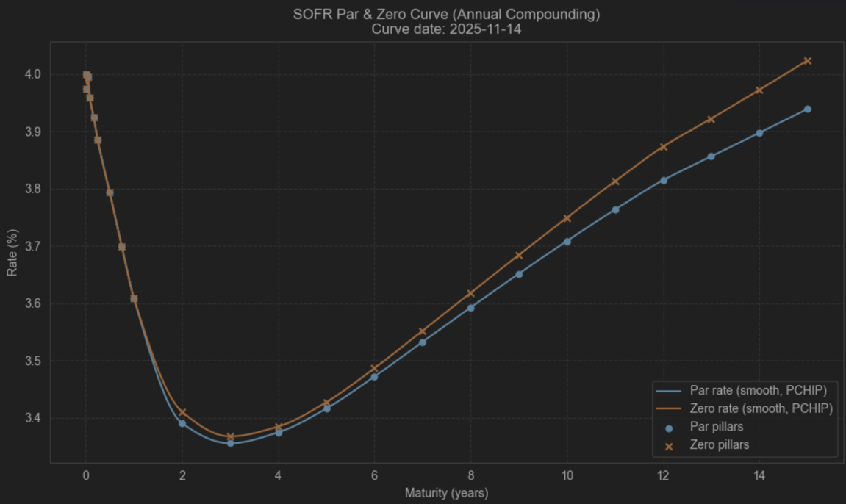

Appendix C – Cumulative Sum of PCs
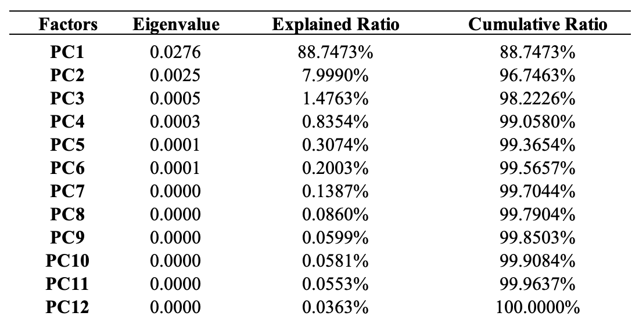

Appendix D - PCs
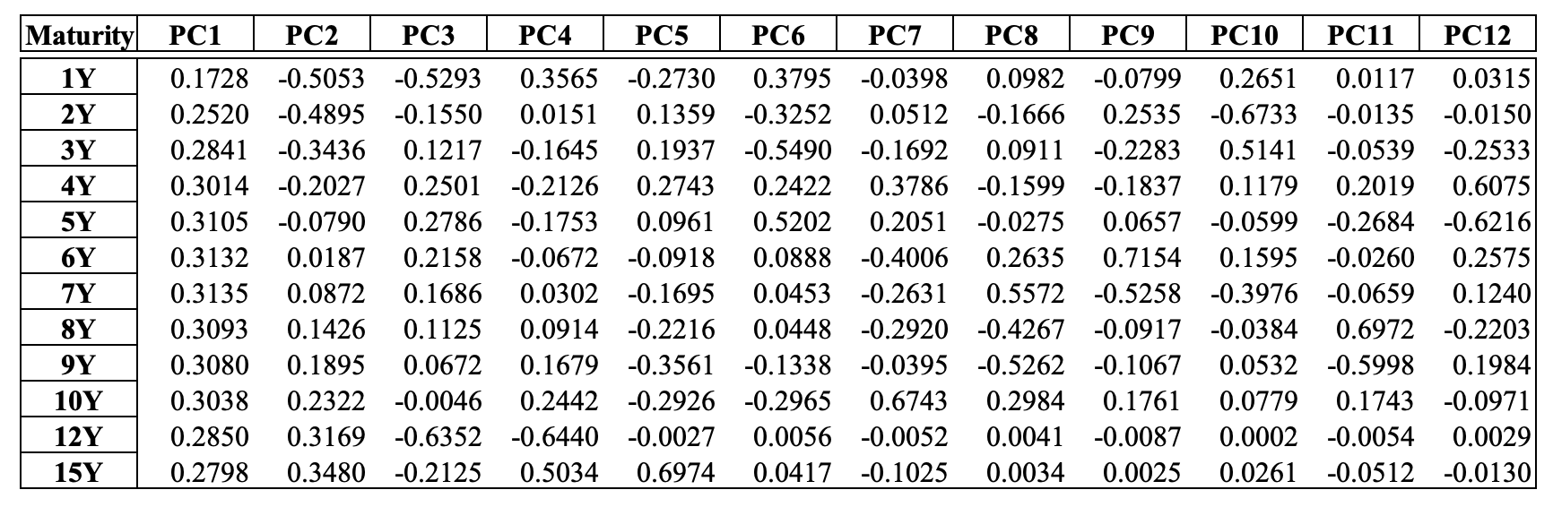

Appendix E – QQ-R Squared test and Histograms
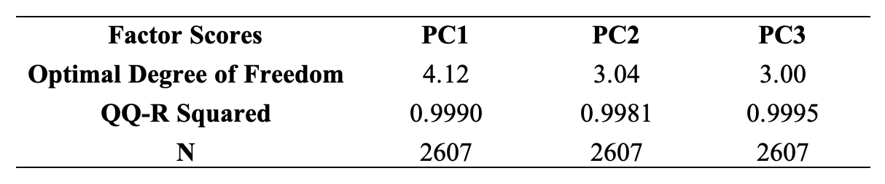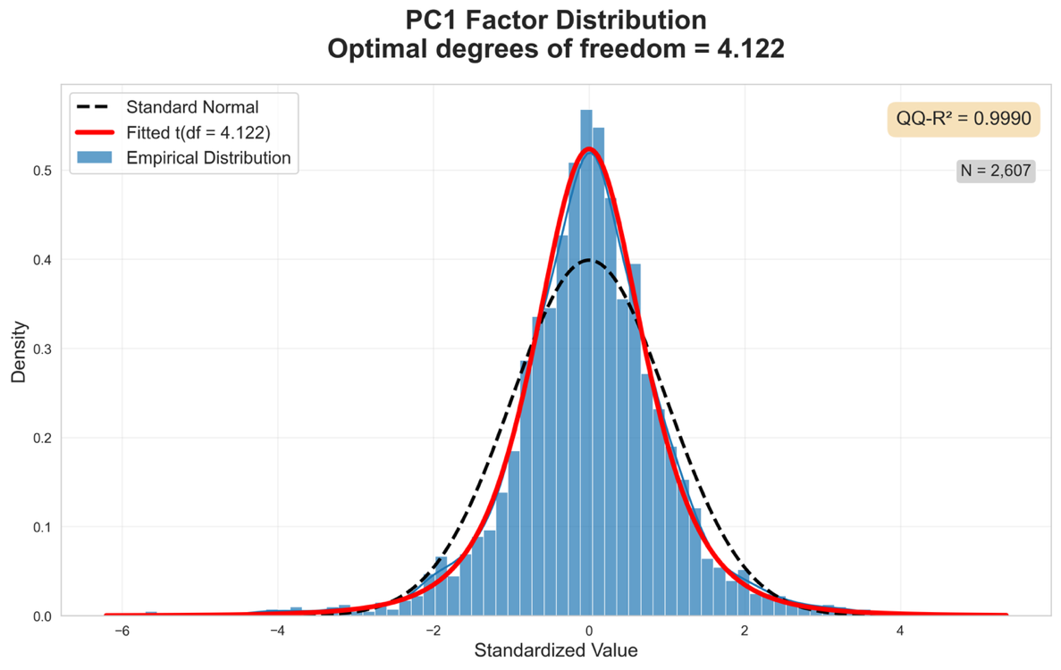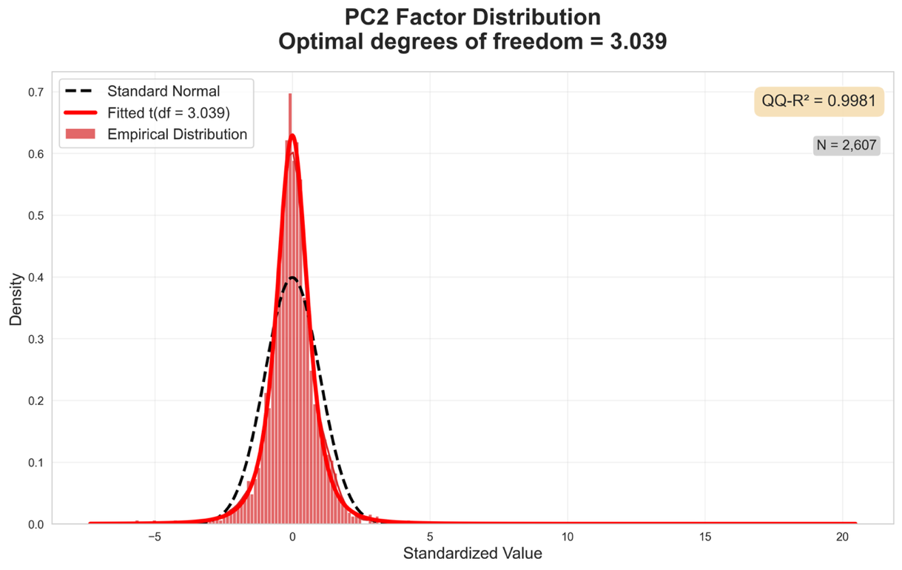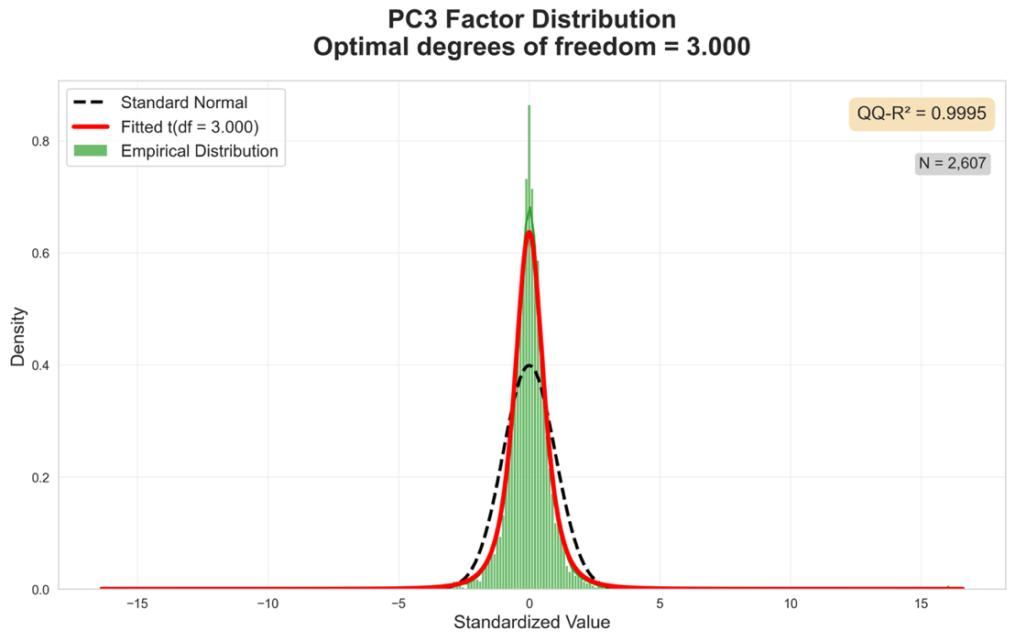

Appendix F – PnL Distribution
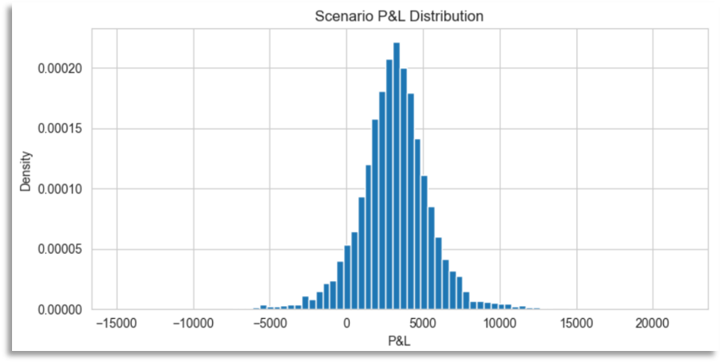

Appendix G – US Interest rate during 2014 – 2025
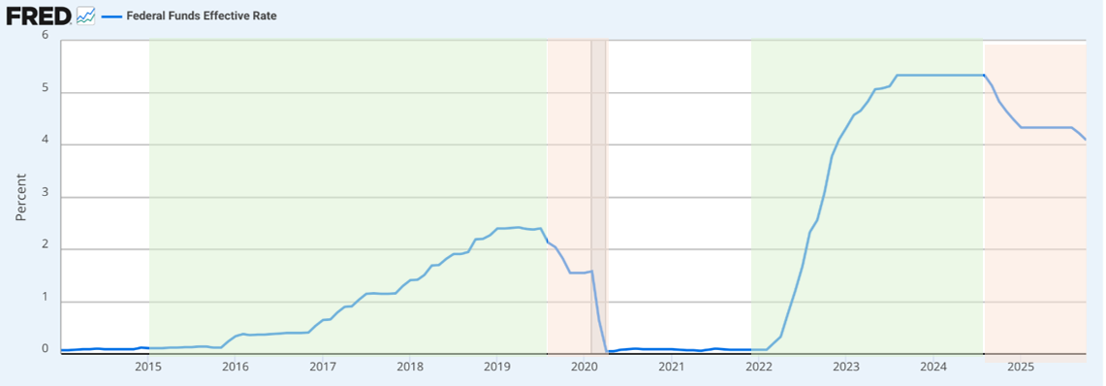

Appendix H – Comparison between predicted and actual losses
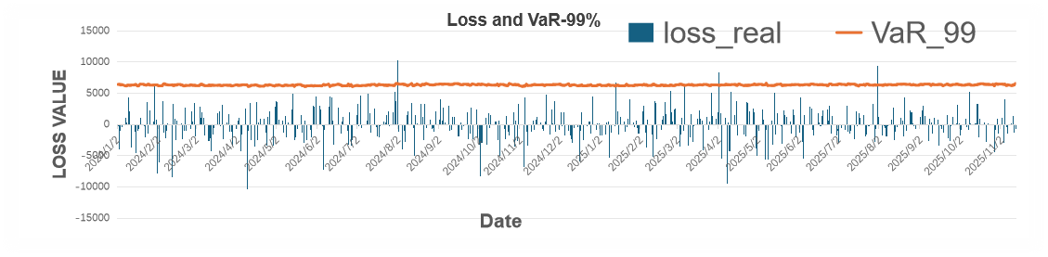

Question and Answer

Q&A in Presentation
Question 1: Why are you using SOFR swap instead of LIBOR swap?
Answer: Refer to slide 8 of our slides, the key differences between LIBOR and SOFR lie in their underlying methodologies and risk profiles. LIBOR is no longer in use since 2023, and the LIBOR now published is estimated in use for the transition period of the existing LIBOR products which were created before 2023. SOFR now is the most popular reference rate with the largest transaction volume. This transition from LIBOR to SOFR represents a fundamental shift toward more reliable and transaction-driven benchmark rates in global financial markets, and that is why we chose a SOFR based product as an example in this project.

Question 2: Why are the three factors identified as level, slope, and curvature?
Answer: This has been proved by many studies, such as the research of Litterman and Scheinkman in 1988. Also, we learnt this in Chapter 2 of this course. In our analysis, the data also shows a similar result.

Question 3: Can you elaborate more on the transformation/bootstrapping process?
Answer: Refer to slide 14 of our slides, the key idea is PV of floating=PV of fixed. The PV of fixed leg is all the fixed rate discounted back to time 0. For floating leg, we may consider earning a SOFR rate at time 1. This is equivalent to (1+SOFR-1) at time 1, which also equals to 1 at time 0 and -1 at time 1 (the interest earned for one year is SOFR). By duplicating this structure into a multi-period, it gives 1 at time 0, and -1 at time N. The PV of floating then can be calculated as $1-\left(1×df_{N}\right)=1-df_{N}$. Same with the formula in Appendix B.

Question 4: Have you considered the correlation of three key factors from PCA?
Answer: As we learnt from the course, we know that principal component analysis (PCA) was used to reduce the dimensionality by summarizing the data into a few uncorrelated factors to solve the problem of high correlation shown in the prepared data. Thus, 3 key factors are uncorrelated.

Comments from Group 11
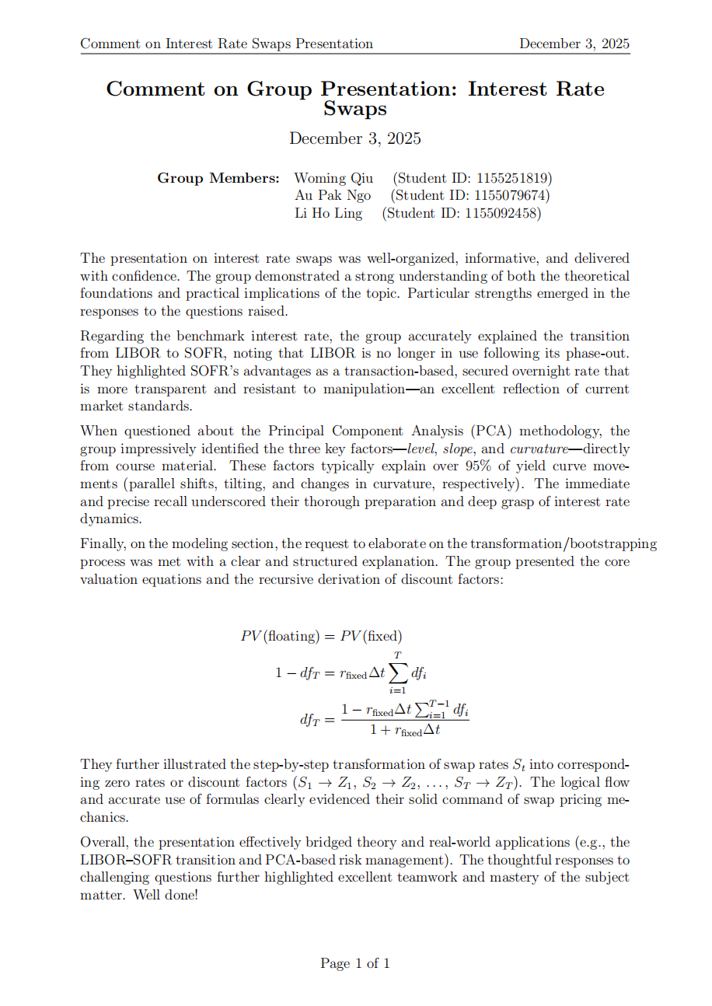

Data before 2018 was estimated by Bloomberg, this study includes it in the scope considering data dimension.

