**SOLUTIONS TO TEXT PROBLEMS:**

**Quick Quizzes**

1. A stock is a claim to partial ownership in a firm. A bond is a certificate of indebtedness. They are different in numerous ways: (1) a bond pays interest (a fixed payment determined when the bond is issued), while a stock pays dividends (a share of the firm’s profits that can increase if the firm is more profitable); (2) a bond has a fixed time to maturity, while a stock never matures; and (3) if a company that has issued both stock and bonds goes bankrupt, the bondholders get paid off before the stockholders, so stocks have greater risk and potentially greater return than bonds. Stocks and bonds are similar in that both are financial instruments that are used by companies to raise money for investment, both are traded on exchanges, both entail a degree of risk, and the returns to both are taxed (usually).

2. Private saving is the amount of income that households have left after paying their taxes and paying for their consumption. Public saving is the amount of tax revenue that the government has left after paying for its spending. National saving is equal to the total income in the economy that remains after paying for consumption and government purchases. Investment is the purchase of new capital, such as equipment or buildings.

These terms are related in two ways: (1) National saving is the sum of public saving and private saving. (2) In a closed economy, national saving equals investment.

3. If more Americans adopted a “live for today” approach to life, they would spend more and save less. This would shift the supply curve to the left in the market for loanable funds. At the new equilibrium, there would be less saving and investment and a higher interest rate.

**Chapter Quick Quiz**

1. d

2. d

3. c

4. b

5. c

6. a

**Questions for Review**

1. The financial system's role is to help match one person's saving with another person's investment. Two markets that are part of the financial system are the bond market, through which large corporations, the federal government, or state and local governments borrow, and the stock market, through which corporations sell ownership shares. Two financial intermediaries are banks, which take in deposits and use the deposits to make loans, and mutual funds, which sell shares to the public and use the proceeds to buy a portfolio of financial assets.

2. It is important for people who own stocks and bonds to diversify their holdings because then they will have only a small stake in each asset, which reduces risk. Mutual funds make such diversification easy by allowing a small investor to purchase parts of hundreds of different stocks and bonds.

3. National saving is the amount of a nation's income that is not spent on consumption or government purchases. Private saving is the amount of income that households have left after paying their taxes and paying for their consumption. Public saving is the amount of tax revenue that the government has left after paying for its spending. The three variables are related because national saving equals private saving plus public saving.

4. Investment refers to the purchase of new capital, such as equipment or buildings. It is equal to national saving in a closed economy.

5. A change in the tax code that might increase private saving is the expansion of eligibility for special accounts that allow people to shelter some of their saving from taxation. This would increase the supply of loanable funds, lower interest rates, and increase investment.

6. A government budget deficit arises when the government spends more than it receives in tax revenue. Because a government budget deficit reduces national saving, it raises interest rates, reduces private investment, and thus reduces economic growth.

**Problems and Applications**

1. a. The bond of an eastern European government would pay a higher interest rate than the bond of the U.S. government because there would be a greater risk of default.

b. A bond that repays the principal in 2040 would pay a higher interest rate than a bond that repays the principal in 2020 because it has a longer term to maturity, so there is more risk to the principal.

c. A bond from a software company you run in your garage would pay a higher interest rate than a bond from Coca-Cola because your software company has more credit risk.

d. A bond issued by the federal government would pay a higher interest rate than a bond issued by New York State because an investor does not have to pay federal income tax on the bond from New York State.

2. Companies encourage their employees to hold stock in the company because it gives the employees the incentive to care about the firm’s profits, not just their own salaries. Then, if employees see waste or see areas in which the firm can improve, they will take actions that benefit the company because they know the value of their stock will rise as a result. It also gives employees an additional incentive to work hard, knowing that if the firm does well, they will profit.

But from an employee’s point of view, owning stock in the company for which she or he works can be risky. The employee’s wages or salary is already tied to how well the firm performs. If the firm has trouble, the employee could be laid off or have her or his salary reduced. If the employee owns stock in the firm, then there is a double whammy⎯the employee is unemployed or gets a lower salary and the value of the stock falls as well. So owning stock in your own company is a risky proposition. Most employees would be better off diversifying⎯owning stock or bonds in other companies⎯so their fortunes would not depend so much on the firm for which they work.

3. To a macroeconomist, saving occurs when a person’s income exceeds his consumption, while investment occurs when a person or firm purchases new capital, such as a house or business equipment.

a. When your family takes out a mortgage and buys a new house, that is *investment* because it is a purchase of new capital.

b. When you use your $200 paycheck to buy stock in AT&T, that is *saving* because your income of $200 is not being spent on consumption goods.

c. When your roommate earns $100 and deposits it in his account at a bank, that is *saving* because the money is not spent on consumption goods.

d. When you borrow $1,000 from a bank to buy a car to use in your pizza-delivery business, that is *investment* because the car is a capital good.

4. Given that *Y* = 8, *T* = 1.5, *Sprivate* = 0.5 = *Y* –*T* – *C*, *Spublic* = 0.2 = *T* – *G*.

Because *Sprivate* = *Y* – *T* – *C*, then rearranging gives *C* = *Y* – *T* – *Sprivate* = 8 – 1.5 – 0.5 = 6.

Because *Spublic* = *T* – *G*, then rearranging gives *G* = *T* – *Spublic* = 1.5 – 0.2 = 1.3.

Because *S* = national saving = *Sprivate* + *Spublic* = 0.5 + 0.2 = 0.7.

Finally, because *I =* investment = *S*, *I =* 0.7.

5. Private saving is equal to (*Y – T – C*) = 10,000 – 1,500 - 6,000 = 2,500.

Public saving is equal to (*T – G*) = 1,500 – 1,700 = -200.

National saving is equal to (*Y – C – G*) = 10,000 – 6,000 – 1,700 = 2,300.

Investment is equal to saving = 2,300.

The equilibrium interest rate is found by setting investment equal to 2,300 and solving for *r*:

3,300 – 100*r* = 2,300.

100*r* = 1,000.

*r* = 10%.

6. a. If interest rates increase, the costs of borrowing money to build the factory become higher, so the returns from building the new plant may not be sufficient to cover the costs. Thus, higher interest rates make it less likely that Intel will build the new factory.

b. Even if Intel uses its own funds to finance the factory, the rise in interest rates still matters. There is an opportunity cost on the use of the funds. Instead of investing in the factory, Intel could use the money to purchase bonds and earn the higher interest rate available there. Intel will compare its potential returns from building the factory to the potential returns from the bond market. If interest rates rise, so that bond market returns rise, Intel is again less likely to invest in the factory.

7. a. Harry will have $1,000(1 + 0.05) = $1,050. Ron will have $1,000(1 + 0.08) = $1,080. Hermione will have $1,000(1 + 0.20) = $1,200.

b. Each student would compare the expected rate of return on his or her own project with the market rate of interest (*r*). If the expected rate of return is greater than *r*, the student would borrow. If the expected rate of return is less than *r*, the student would lend.

c. If *r* = 7%, Harry would want to lend while Ron and Hermione would want to borrow. The quantity of funds demanded would be $2,000, while the quantity supplied would be $1,000.

If *r* = 10%, only Hermione would want to borrow. The quantity of funds demanded would be $1,000, while the quantity supplied would be $2,000.

d. The loanable funds market would be in equilibrium at an interest rate of 8%. Harry would want to lend and Hermione would want to borrow. Ron would use his own savings for his project, but would want to neither borrow nor lend. Thus quantity demanded = quantity supplied = $1,000.

e. Harry will have $1,000(1 + 0.08) = $1,080. Ron will have $1,000(1 + 0.08) = $1,080. Hermione will have $2,000(1 + 0.20) – $1,000(1 + 0.08) = $2,400 – $1,080 = $1,320. Both borrowers and lenders are better off. No one is worse off.

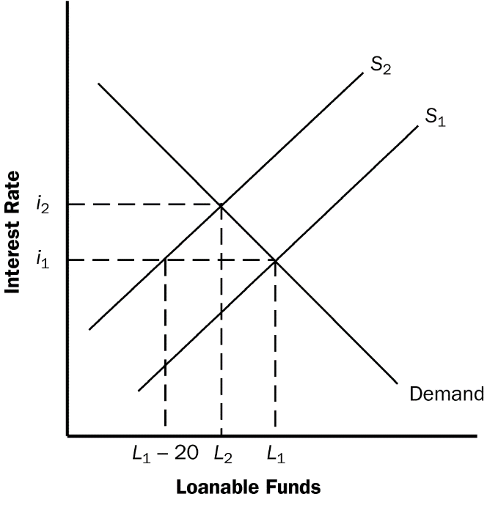

**Figure 1**

8. a. Figure 1 illustrates the effect of the $20 billion increase in government borrowing. Initially, the supply of loanable funds is curve *S*1, the equilibrium real interest rate is *i*1, and the quantity of loanable funds is *L*1. The increase in government borrowing by $20 billion reduces the supply of loanable funds at each interest rate by $20 billion, so the new supply curve, *S*2, is shown by a shift to the left of *S*1 by exactly $20 billion. As a result of the shift, the new equilibrium real interest rate is *i*2. The interest rate has increased as a result of the increase in government borrowing.

b. Because the interest rate has increased, investment and national saving decline and private saving increases. The increase in government borrowing reduces public saving. From the figure you can see that total loanable funds (and thus both investment and national saving) decline by less than $20 billion, while public saving declines by $20 billion and private saving rises by less than $20 billion.

c. The more elastic is the supply of loanable funds, the flatter the supply curve would be, so the interest rate would rise by less and thus national saving would fall by less, as Figure 2 shows.

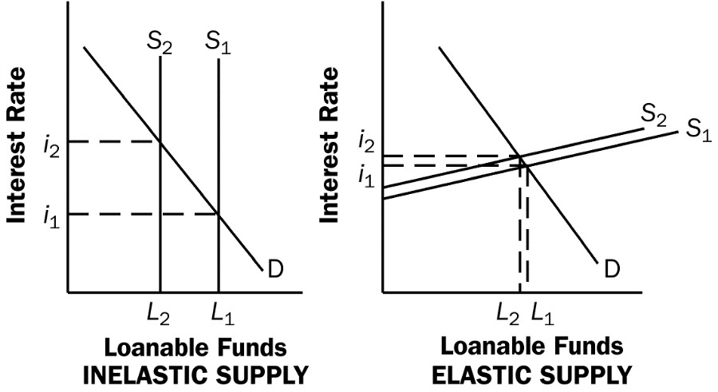

**Figure 2**

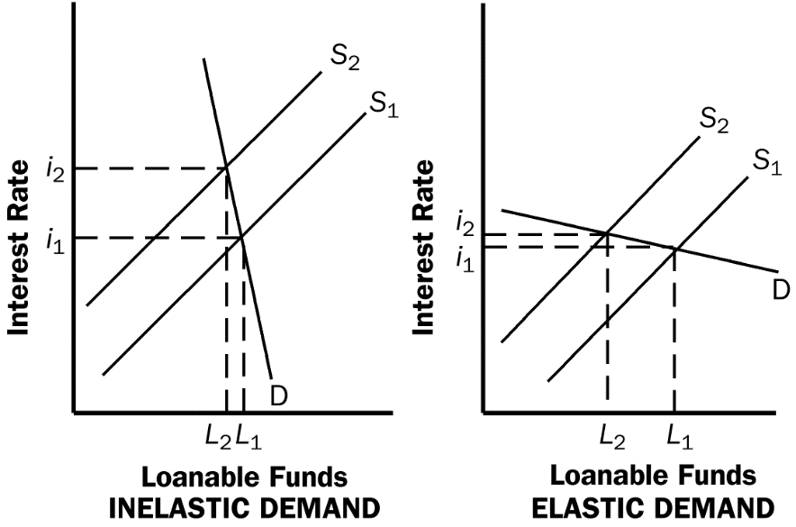

**Figure 3**

d. The more elastic the demand for loanable funds, the flatter the demand curve would be, so the interest rate would rise by less and thus national saving would fall by more, as Figure 3 shows.

e. If households believe that greater government borrowing today implies higher taxes to pay off the government debt in the future, then people will save more so they can pay the higher future taxes. Thus, private saving will increase, as will the supply of loanable funds. This will offset the reduction in public saving, thus reducing the amount by which the equilibrium quantity of investment and national saving decline, and reducing the amount that the interest rate rises.

9. a. Investment can be increased by reducing taxes on private saving or by reducing the government budget deficit. But reducing taxes on private saving has the effect of increasing the government budget deficit, unless some other taxes are increased or government spending is reduced. So it is difficult to engage in both policies at the same time.

b. To know which of these policies would be a more effective way to raise investment, you would need to know: (1) what the elasticity of private saving is with respect to the after-tax real interest rate, because that would determine how much private saving would increase if you reduced taxes on saving; (2) how private saving responds to changes in the government budget deficit, because the decline in the government budget deficit could be matched by an equal decline in private saving, so national saving would not increase at all; and (3) how elastic investment is with respect to the interest rate, because if investment is quite inelastic, neither policy will have much of an impact on investment.