**实验课3**

**时间测试函数举例**

1 #include <chrono>

2 #include <iostream>

3 #include <iomanip>

4

5

6 void boo() {

7

for (int i = 1; i <= 30800888; ++i) {

int j = i * i;

8

9

}

10 }

11

12 double test_1() {

13

14

15

16

17

18

19

20

auto start = std::chrono::high_resolution_clock::now();

// test part

boo();

auto end = std::chrono::high_resolution_clock::now();

std::chrono::duration<double> diff = end - start;

std::cout << std::fixed << std::setprecision(10) << diff.count() <<

std::endl;

return diff.count();

21

22 }

1 #include <time.h>

2

3 void boo() {

4

for (int i = 1; i <= 30800888; ++i) {

int j = i * i;

5

6

}

7 }

8

9 double test_2() {

10 double start = clock();

11

12

13

14

15

// test part

boo();

double end = clock();

double diff = (end - start) / CLOCKS_PER_SEC; // C 风格时间测量的精度为 1 毫

秒

16

17

printf("%.10f\n", diff);

return diff;

18 }

19

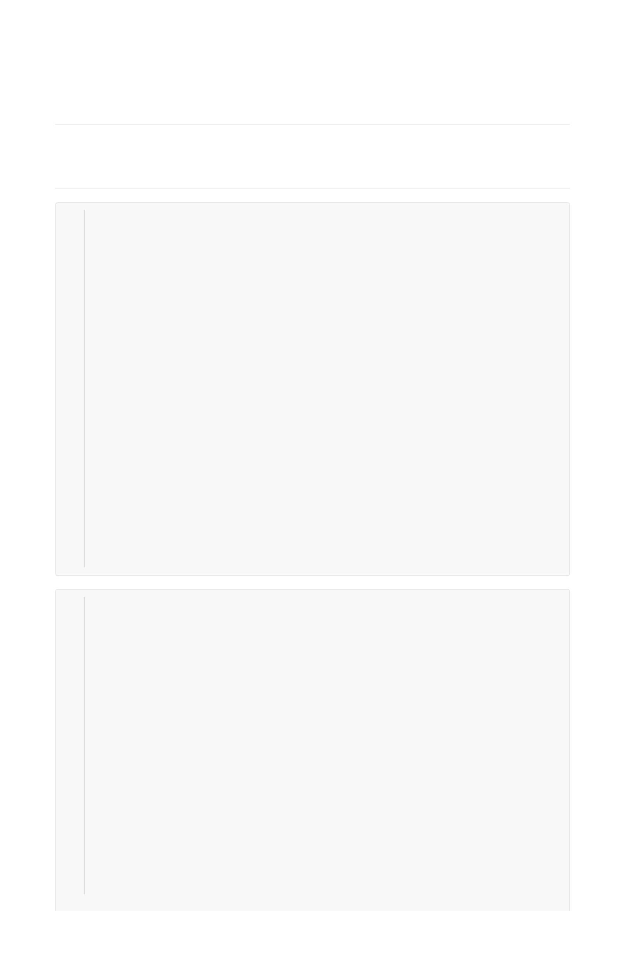

**随机数生成函数举例**

1 #include <iostream>

2 #include <stdlib.h>

3 #include <time.h>

4 using namespace std;

5 int main() {

6

srand((unsigned)time(NULL));

7

8

for(int i = 0; i < 10; i++ )

cout << rand() << '\t';

cout << endl;

9

10

11

return 0;

12 }

