|  |  |  |
| --- | --- | --- |
| **Problem Chosen** B | **2023HSB MCM/ICM Summary Sheet** | **Team Number** 00638 |

**Prediction of instability via Social Stability Early Warning Model**

Color revolutions, a political term, refer to mass protest movements of people, not all of them revolutions in political science, following national elections in countries such as Central Asia and Eastern Europe in the 1980s-2010s due to electoral opacity, electoral fraud, or other political events [1]. In recent decades, with the vagaries of economic, political, and natural factors, various color revolutions have erupted, social unrest has taken place, and the stability of societies has been seriously challenged. Overcoming crises is not an easy task in the modern society where competition is increasingly intense and crises are frequent. Therefore, we have developed a social stability early warning model with a view to using known social conditions to predict whether a society will experience greater unrest or even collapse in the coming period.

In this report, we used subjective judgment combined with knowledge of related disciplines to determine the weight matrix, and selected seven factors, including GDP per capita, GDP per capita growth rate, unemployment rate, school enrollment rate, CPI (Corruption Perceptions Index), inflation rate, and social conflict events, from both qualitative and quantitative perspectives, to establish a system of social stability indicators, and Using machine learning algorithm and TOPSIS method and gray prediction GM (1,1), a social stability early warning model with high confidence is established. The model can distinguish the degree of social stability into three states: stable, moderate, and unstable by calculating scores.

Firstly, we used subjective assignment method and entropy method to determine the weight of each evaluation index, but the obtained model evaluation effect is poor; therefore, we used machine learning algorithms such as decision tree, random forest, and gradient boosting tree to learn and judge the existing data, select the machine learning algorithm with good prediction effect, and obtain the weight of each index from it, so as to optimize our TOPSIS model. Finally, we chose a random forest model with recall and accuracy as the evaluation indicators, and used its weight vector as the weight vector of TOPSIS model; meanwhile, the random forest model has 77.7% recall and 78.4% accuracy, which can be a good early warning model for social stability.

For the available data, the countries and periods judged as "unstable" by the TOPSIS model cover 9 color revolutions, and the countries and periods judged as "moderate" by the model cover the remaining 2 color revolutions. The remaining two color revolutions were covered in the countries and periods judged as "medium". At this point, the team believes that the model is correct and usable.

Based on our existing TOPSIS model, combined with the gray prediction GM (1, 1), we give a forecast of social stability in Azerbaijan in 2023, and explain it with specific predicted values.

In addition to predicting the social unrest situation, we are also able to contribute to the maintenance of social peace and stability by making more constructive recommendations on the current social development through the model. After adopting the suggestions given by the model, we made appropriate modifications to the existing data according to the results, and found that the social stability index is more inclined to the social stability result than the original one, which also reflects the feasibility and correctness of the suggestions sideways.

**Keywords: social stability, TOPSIS method, random forest algorithm, gray prediction GM (1, 1)**

**Catalog**

1. Introduction 3

1.1 Background 3

1.2 Problem restatement 3

1.3 Our thinking and approach 4

2. Model Overview and Assumptions 4

2.1 Assumptions 4

2.2 Model Overview 5

2. Model Preparation 6

2.1 Description of important symbols 6

2.2 Data 7

2.2.1 Sources 7

2.2.2 Data cleaning 7

3. Problem solving 8

4.1 Task 1 8

4.1.1 Selection of indicators 8

4.1.2 Correlation and Causality 9

4.2 Task 2 12

4.2.1 Data Processing 12

4.2.2 Determinations of weight 13

4.2.2.1 Entropy method 13

4.2.2.2 Random Forest Algorithm 13

4.2.3 Topsis Determination Threshold 14

4.2.4 Sensitivity analysis 16

4.3 Task 3 16

4.3.1 Social stability assessment 16

4.3.2 Prediction of future social stability (based on gray prediction GM(1,1)) 17

4.3.3 Recommendations for national development 19

4.4 Task 4 19

4.5 Task 5 20

5. Summary 21

# Introduction

## Background

Since the end of the Cold War, some Western countries have used "color revolutions" as an important means to intervene in the internal affairs of other countries and subvert their destiny. Under the guise of "anti-corruption", "anti-dictatorship" and "improving people's livelihood", "color revolutions" are often used to fight for "democracy", "human rights" and "freedom". "democracy," "human rights," and "freedom," and to engage in "street politics" The "democracy movement" seeks to achieve regime change. In essence, some countries are trying to consolidate and maintain their global status by using low-cost, non-war means to foster regimes close to their own. Against the backdrop of the world's unprecedented changes, it is important to track and judge the new trends of the "color revolution" in order to better understand the evolution of global strategies and safeguard national security interests.[2]

[1]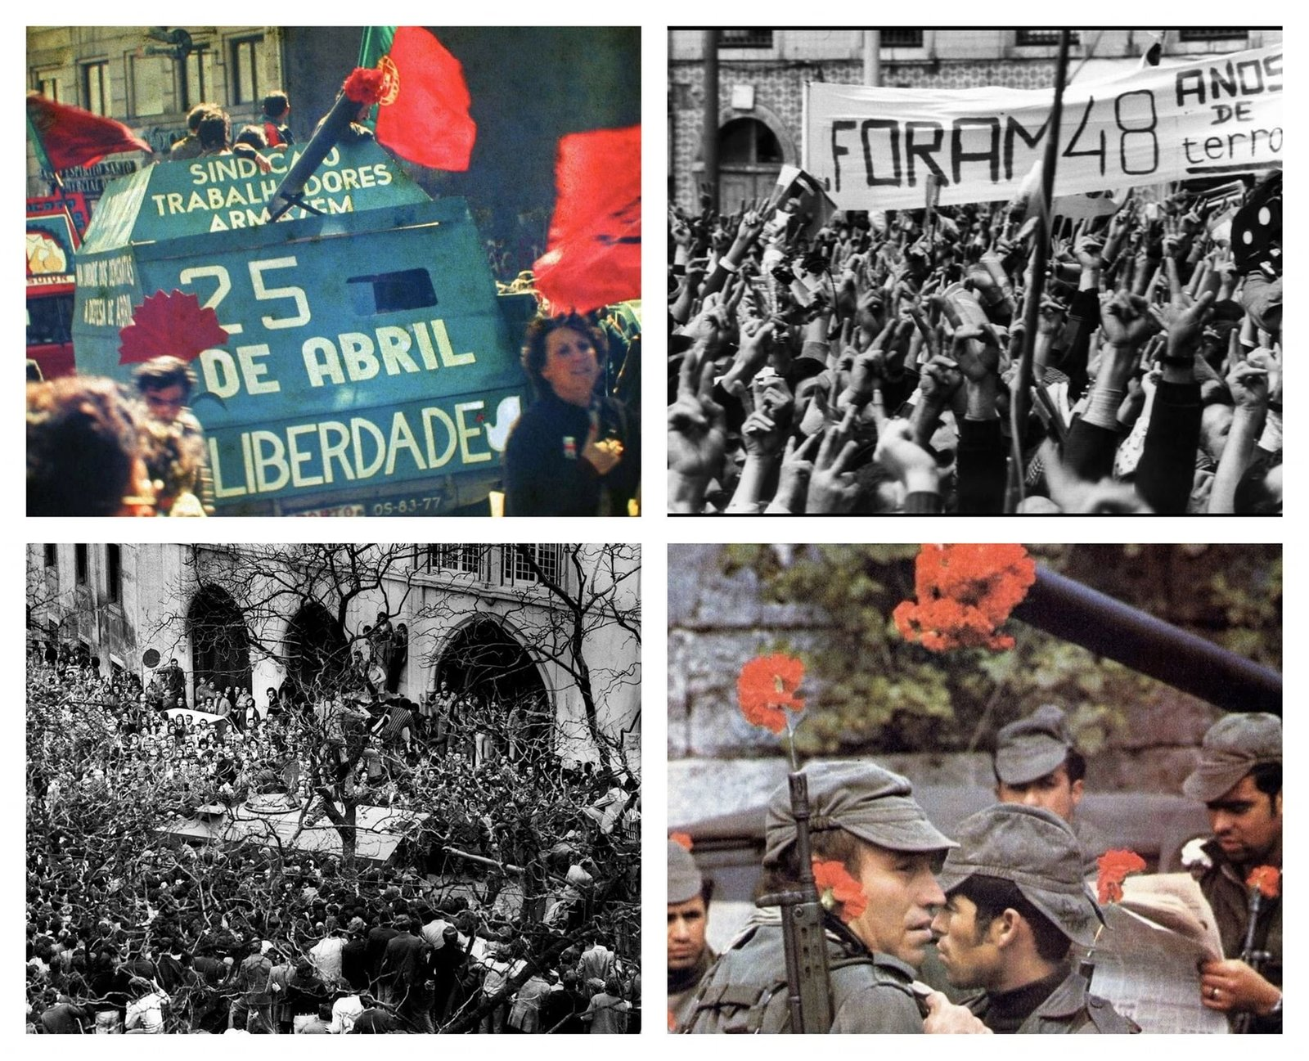

Figure 1：Carnation Revolution [3]

## Problem restatement

1. Establish a system of indicators to evaluate social stability from both qualitative and quantitative perspectives, and at the same time argue for correlation and causality between factors from both perspectives, etc.

2. To build an early warning model of social stability based on the established indicator system through the synergy and checks and balances between indicators.

3. To use the existing model to evaluate countries where color revolutions have failed to overthrow regimes in history, and to point out the reasons for the failed revolutions and make feasible suggestions based on the evaluation results.

4. To use the existing early warning model for social stability to assess countries and regions where color revolutions have led to regime change, and to point out the causes of social instability to the point of regime change.

5. To make recommendations for preventing color revolutions and maintaining social stability to the maximum extent possible.

## 1.3 Our thinking and approach

According to the requirements of the topic, our main ideas and methods for solving the problem are as follows.

1. Select appropriate social factors as evaluation indicators based on background and sociological knowledge, establish a system of indicators for social stability, and explore the relationship between each indicator using Pearson's correlation coefficient and Spearman's correlation coefficient to provide a basis for building a model.

2. Using TOPSIS method, an early warning model of social stability is established to judge/predict the health and stability of the society through the already established indicator system.

3. Using entropy weighting method and tree machine learning model, generate an objective weight vector of indicators and evaluate the effect of this weight vector in TOPSIS model to solve the problem that subjective weighting makes prediction less effective.

4. Use the gray prediction GM (1,1) for short-term prediction, combine the prediction results with the TOPSIS social stability model, and use the model for prediction analysis to assess the social stability status of some countries and regions, and use the model to make suggestions for maintaining social stability.

# 2. Model Overview and Assumptions

## 2.1 Assumptions

The basic assumptions of this paper are as follows.

1. It is assumed that the indicators we selected are representative and can reflect social stability more comprehensively.

2. It is assumed that in the social stability indicator system we establish, each indicator is not completely independent, and the indicators can check and balance each other and influence each other.

3. It is assumed that the social stability indicator system we established can be applied to all countries.

4. It is assumed that all data provided in the Annex are true and reliable from 1995 to 2021.

5. It is assumed that it is reasonable to use average or adjacent values to fill the small amount of vacant data.

6. It is reasonable to assume that a linear regression model is used to fill in a moderate amount of missing data for the same country.

7. It is assumed that it is reasonable to use the average data of countries with similar national strength and situation as the target country to fill a large amount of missing data.

8. It is assumed that for each specific country, the weight of positive and negative news stories for that country does not vary largely with the year.

9. Assume that the "GDP per capita growth" indicator is considered an intermediate variable in this paper and that the resulting scoring mechanism for this indicator is reasonable.

## 2.2 Model Overview

The model contains seven indicators as the basic evaluation basis.

1. GDP per capita (in current dollars)

2. GDP per capita growth score (derived from a composite evaluation of annual GDP per capita growth rates)

3. Total unemployment (as a percentage of total labor force) (simulated ILO estimates)

4. Corruption Perception Index (CPI)

5. Tertiary enrolment (as a percentage of population)

6. Inflation as measured by the CPI (annual inflation rate)

7. The overall social crisis (based on news coverage of the country)

The model is based on the TOPSIS method, combined with a vector of approximate optimal weights generated by the Random Forest algorithm, which constitutes an early warning model for evaluating the degree of social stability. A higher evaluation score obtained from the model represents a more stable society. If the evaluation score of a country in a certain year is lower than the instability threshold, the country is considered unstable and prone to different kinds of social movements in that year, which requires extra attention and precaution; if the evaluation score is higher than the stability threshold, the country is considered to have a stable social state in general and basically no major social unrest will occur in that year; if the evaluation score is between the instability threshold and the stability threshold, the country is considered country's social stability as moderate, with a small possibility of social unrest, social movements, etc. The model makes three different judgments of unstable, moderate and stable in the test performance in the ratio of 1:2:1.

In summary, the entire modeling process can be shown as follows.

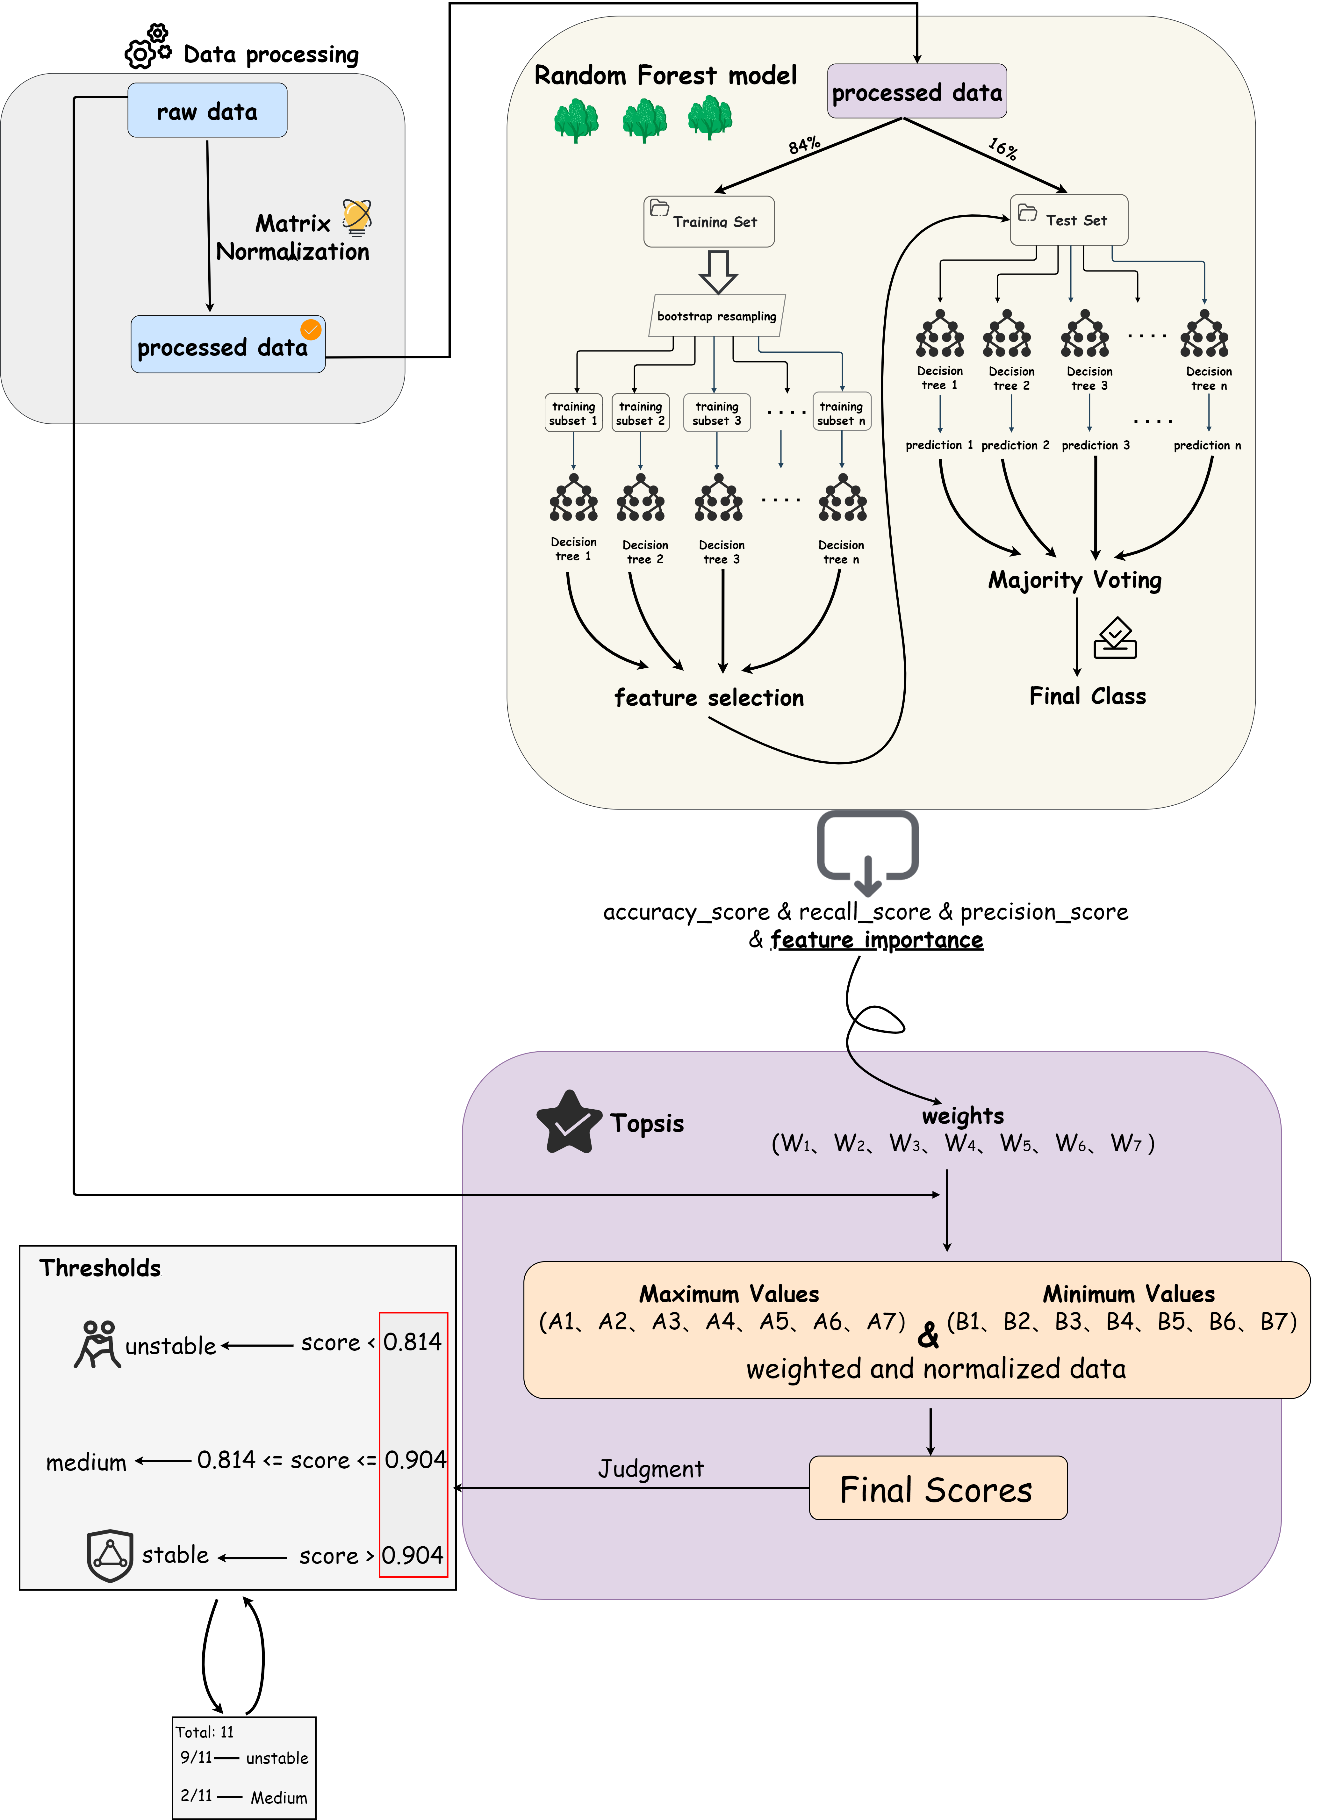

Figure2:Flowchart

# Model Preparation

## Description of important symbols

|  |  |
| --- | --- |
| Symbols | Meaning |
| descript | Raw data for the seven indicators in order :per capita GDP,per capita GDP growth rate,unemployment rate,CPI,school enrollment,inflation,integrated crisis |
| descript | The summation of data item i for a country from 1995 to 2021 |
| descript | The distance between the ith indicator and its minimum value in the topsis method |
| descript | The distance between the ith indicator and its minimum value in the topsis method |
| descript | The weight of the ith indicator |
| descript | The normalized coefficient of the ith indicator |
| descript | The ideal optimal solution of the ith indicator after processing |
| descript | The ideal worst solution after the treatment of the ith indicator |

## Data

### Sources

|  |  |
| --- | --- |
| Name | Sources |
| GDP per capita growth (annual growth rate) | https://data.worldbank.org.cn |
| Inflation as measured by the consumer price index (annual inflation rate) | https://data.worldbank.org.cn |
| Unemployment rate | https://data.worldbank.org.cn |
| School Enrollment | https://data.worldbank.org.cn |
| GDP per capita (current prices in USD) | https://data.worldbank.org.cn |
| CPI | https://www.transparency.org |
| ICEWS Coded Event Data | https://dataverse.harvard.edu/ |

### Data cleaning

We selected data for Armenia, Azerbaijan, Barbados, Belarus, Ecuador, Georgia, Germany, Guinea, Japan, Kazakhstan, Kuwait, Kyrgyzstan, Lithuania, Russia, Tajikistan, Tanzania, Tunisia, Turkey, Turkmenistan, Ukraine, and Uzbekistan. The presence of gaps in the data obtained from the World Bank database was replaced by the average value. Based on completeness finally all datasets were selected between 1995-2021. the data from ICEWS were processed due to the excessive amount of data and the dataset only counts the number of times of social conflicts that occurred in each country in each year in the above mentioned time period. Also, because of the inevitable differences in the data due to the different volume of countries, we adopted regularization and normalization means to unify to the same scale level.

# Problem solving

## 4.1 Task 1

### 4.1.1 Selection of indicators

After an extensive review of sociological, economic, and historical literature, we have selected seven indicators that may affect social stability in this question: GDP per capita, GDP per capita growth rate, college enrollment rate, unemployment rate, corruption perception index, inflation, and comprehensive social crisis.

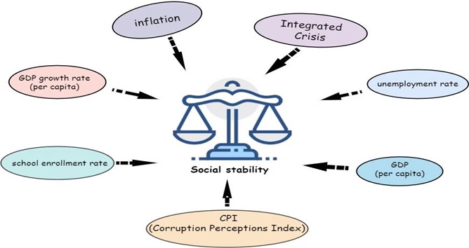

Figure 3

1. Per Capita Gross Domestic Product

GDP per capita (abbreviated as Per Capita GDP) is the quotient of the value of all final goods and labor produced in a country or region's economy divided by the total population of that country in a given period of time (usually one year).

2. GDP per capita growth rate

Per Capita GDP Growth Rate (abbreviated as Per Capita GDP Growth Rate) is the annual growth rate of GDP per capita, which is often used to measure how fast economic development changes from year to year.

3. College Enrollment Rate

The college enrollment rate is an education indicator that refers to the ratio of actual annual college enrollment to the number of people who can afford to enroll in college in a country, and is often used to measure a country's access to higher education and civic literacy.

4. Unemployment Rate

Unemployment rate is the ratio of the unemployed to the working population over a certain period of time, and is often used to measure the amount of idle labor capacity reflecting the unemployment situation in a country or region.

Corruption Perception Index

5. Corruption Perception Index

The Corruption Perception Index (CPI), also known as the Corruption Perception Index, is an assessment of the level of corruption of public officials and politicians in each country according to businessmen, academics and national analysts.

6. Inflation

Inflation, originally meaning an increase in the amount of money in circulation, but also meaning an increase in the price of related goods or services over a period of time (usually a year) and a decrease in people's purchasing power, is often used to measure such things as an overall increase in prices or an increase in the cost of living in a country.

7. Comprehensive Social Crisis

An integrated social crisis, consisting of conflicts between socio-political actors (i.e., hostilities between individuals, groups, sectors, and nation-states), is often used as a measure of how well a country's social environment is doing.

### 4.1.2 Correlation and Causality

To explore the correlation between the variables, we calculated Pearson correlation coefficient and Spearman correlation coefficient between the variables. The Pearson correlation coefficient was calculated as:

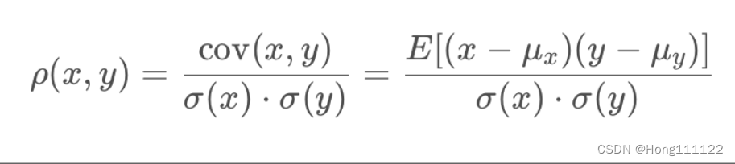

The formula for the Spearman correlation coefficient is：

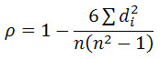

di denotes the difference of the place value of the ith data pair, n denotes the total number of observed samples. [4]

[2] At this point, we draw the correlation coefficient matrix heat map：

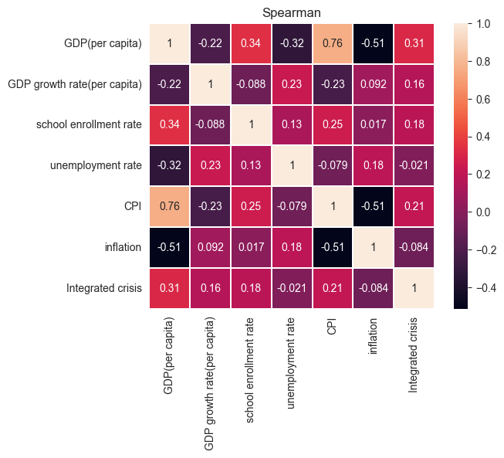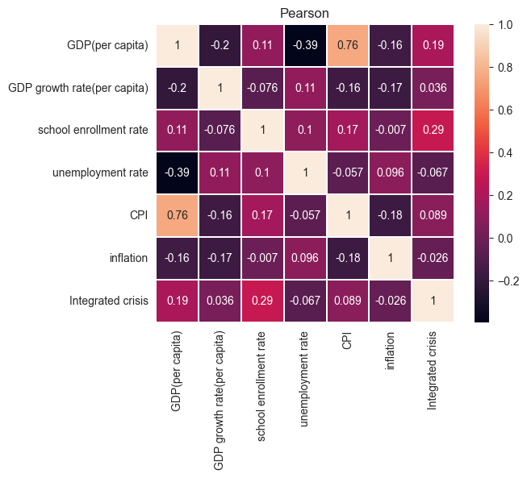

图4

From the figure, we can find that the correlation coefficient between CPI and GDP per capita is as high as 0.76 under both methods, which has a strong correlation. The rest of the correlation coefficients are lower, basically at the level of weak correlation or even almost no correlation.

|  |  |  |  |  |  |
| --- | --- | --- | --- | --- | --- |
| Degree of relevance | Very strong correlation | Strong correlation | Moderate correlation | Weak correlation | Very weak or no correlation |
| Absolute value of correlation coefficient | 0.8—1 | 0.6—0.8 | 0.4—0.6 | 0.2—0.4 | 0—0.2 |

Variable correlation intensity table

GDP per capita is positively correlated with the CPI, and a similar conclusion was reached in a theoretical economics snapshot published in February 2018: "Countries with higher CPIs have higher GDP per capita. "Citizens of countries with higher CPIs have more freedom to do business, the country as a whole has a greater ability to attract foreign investment, and GDP per capita is more higher. At the same time, higher GDP per capita further increases the CPI, and sufficient national wealth can help invest human and material resources to improve the national governance system and fight corruption. GDP per capita is negatively correlated with the unemployment rate, and the Austrian law [5] suggests that unemployment implies the non-utilization of factors of production, so that a rise in the unemployment rate is accompanied by a fall in real GDP, which is also consistent with the results of our qualitative study. Also low consumer demand in countries with low GDP per capita, which cannot provide more jobs, will also backfire on the unemployment rate leading to its decrease.

The above cause-effect relationship is shown in the figure:

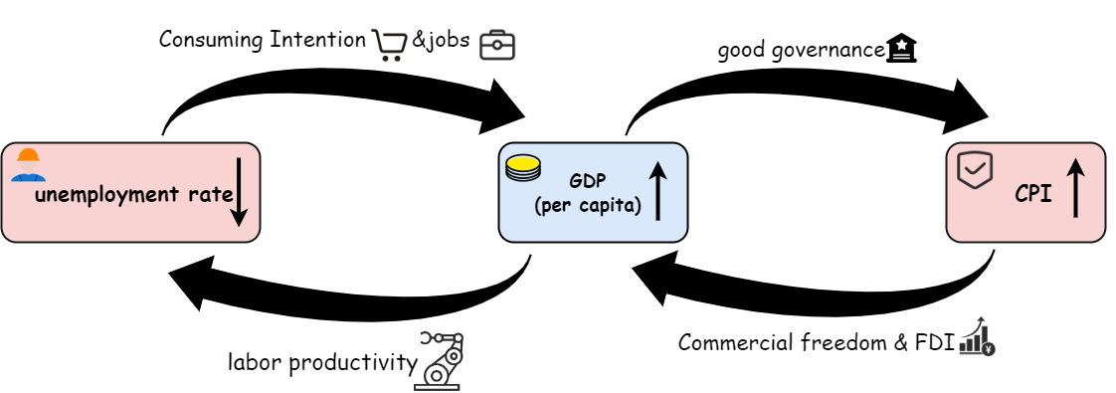

Figure 5

We distill the data for CPI and GDP per capita separately and plot the matrix scatter plot.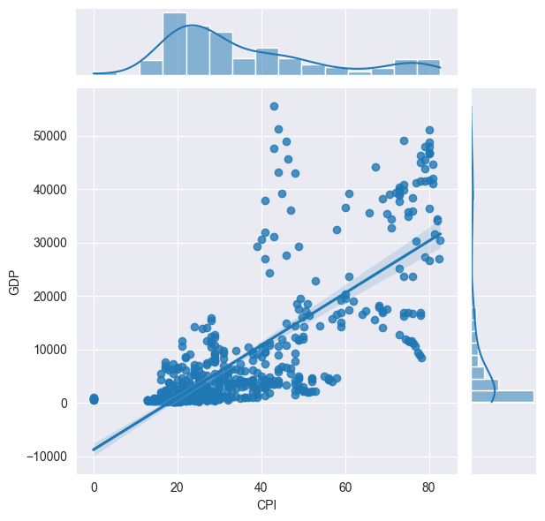

Figure 6

It can be seen that the linear fit is not very good. So, the least squares method was chosen to fit the curve to explore the functional relationship between the two. The fitting results are shown in Figure 7:

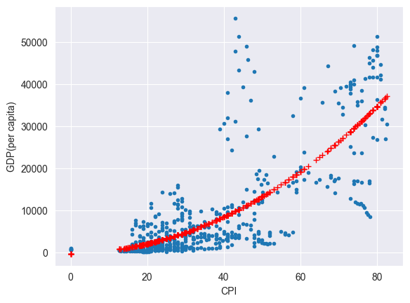

Figure 7

The fitted functional relationship is：



y is the GDP per capita and x is the CPI score.

## 4.2 Task 2

### 4.2.1 Data Processing

Our dataset contains changes in seven indicators for 21 countries over the period from 1995 to 2021 (27 years in total). To facilitate the modeling, we create a matrix (567*7) to store all the data. Where each row represents the data of seven different indicators for the same country in the same year, and each column represents the values taken for the same indicator in different countries for each of the 27 years.

Considering the data collected, the values of the integrated social crisis are very strongly correlated with the country size, and the indicators of integrated social crisis in some large countries can even exceed the values of small countries by two orders of magnitude. Therefore, in order to exclude the disturbances and errors caused by the size of the country, the indicator of the comprehensive social crisis is converted into the ratio of the comprehensive social crisis of the country in that year to the total social crisis of the country in those 27 years as follows:

descript

Before the experiment began, we envisioned that GDP per capita growth would be positively correlated with social stability, i.e., the faster the GDP per capita growth, the more stable the society. However, after the initial experiment, we found that in the 11 countries where color revolutions occurred, the GDP per capita growth rate of the country also tended to be faster when the color revolutions occurred, which was not consistent with our initial assumption. After reviewing relevant information and literature, we found that in fact, in addition to economic regression and slow development, too fast economic development is also detrimental to social stability, and society is most stable when it develops at a moderate rate, which usually refers to an annual per capita GDP growth rate of about 3 percent. Therefore, we set this indicator as an interval type indicator and deal with the principle as follows.:

per capita GDP growth rate:

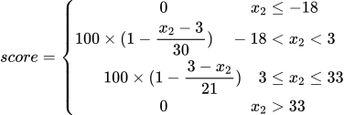

Meanwhile, to avoid systematic errors caused by different magnitudes, we normalize all data by columns and reduce the magnitudes of each indicator to the same level.

### 4.2.2 Determinations of weight

### 4.2.2.1 Entropy method

The AHP method, by subjectively assigning weights to each of the seven indicators, was very unsatisfactory for the experimental results we obtained after our attempts, and could not clearly distinguish the countries where color revolutions had occurred, so we chose to try the entropy weight method, a non-subjective method of assigning weights.

Each element in the probability matrix P is as follows:

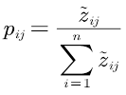

Z is the matrix that has been normalized：

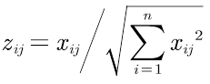

First calculate the entropy of each indicator：

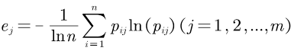

The coefficient of variation is then calculated for each index：

descript

The obtained variance coefficient vector represents the amount of information contained in each indicator, that is, the greater the amount of information contained in the indicator, the larger the corresponding component in the variance coefficient vector, and it is a very objective choice to use the variance coefficient vector as the weight vector.

### 4.2.2.2 Random Forest Algorithm

After experiments, the weight vector obtained by the entropy weight method is still not effective to make the Topsis model have a good evaluation effect, so we use the random forest algorithm commonly used in early warning models.

Our team believes that: the social stability early warning model needs to be more aggressive, i.e., we would rather have the model erroneously warn of instability when the society is stable, or minimize the situation when the society is in turmoil and the model does not appear to warn. This is because the latter is significantly more costly in both cases. At the same time, we believe that the occurrence of a color revolution is only one of the many manifestations of social unrest, and not a decisive factor in social unrest (other factors such as demonstrations, terrorist attacks, general strikes, etc.), so after discussion, we simplify the effect the model needs to achieve as：

1. Distinguish between the degree of stability of societies and, to the extent possible, classify societies with color revolutions as "unstable".

2. The model does not over-predict that societies are "unstable". The positive sample of data is "countries and years with color revolutions" and the negative sample is "countries and years without color revolutions". Therefore, we choose the accuracy and recall rate as the evaluation criteria of the random forest model, and hope that our model has as high a recall rate as possible, i.e., to successfully classify the occurrence of color revolutions as "unstable" and to maintain the proportion of "unstable" judgments as much as possible. We want our model to have as high a recall as possible, i.e., to successfully classify the occurrence of color revolutions as "unstable", and to maintain the proportion of judgments of "unstable" societies as much as possible to avoid the model blindly identifying all societies as "unstable" in order to maximize the recall.

Since the random forest prediction is the probability that the sample is positive, we consider the society "unstable" as long as the probability is not zero. According to this rule, after several experiments, the accuracy and recall of the random forest model we finally selected are as follows：

descript

At this point, the corresponding weight vector of the model is as follows：

**w = [0.016133870975143155, 0.27124328336250164, 0.01683815759318027, 0.024425250495824176, 0.013710197760681922, 0.1388210119528406, 0.5188282278598283]**

After discussion, our team plans to use the weight vectors obtained from the random forest algorithm as the weight vectors needed for the calculations in the Topsis model, instead of using the random forest model directly as the social stability early warning model. The reasons are mainly that the readability of the random forest model predictions is poor, the internal structure of the model is very complex, and also the interpretability of the random forest model is very poor and difficult to be interpreted precisely. At the same time, this random forest model cannot effectively triangulate the social stability situation

### 4.2.3 Topsis Determination Threshold

The weight vector obtained from the above random forest algorithm is used in the Topsis model to calculate the score of each country in each year, and a higher score means a more stable society.

descript

descript

descript

After a trade-off between recall and accuracy, our team chose an instability threshold of 0.814 and a stability threshold of 0.904, meaning that if the composite evaluation score is lower than 0.814 (about 25 percent of the data), society is considered less stable and prone to social movements, including color revolutions; if the composite evaluation score is higher than 0.904 (about 25 percent of the data), society is considered relatively stable and less likely to experience unrest; and if the composite evaluation score is between the two thresholds, society is considered moderately stable and less likely to experience unrest. If the overall evaluation score is higher than 0.904 (the proportion in the data is about 25 percent), the society is considered relatively stable and basically not prone to major unrest; if the overall evaluation score is between the two thresholds, the society is considered moderately stable and less likely to experience unrest

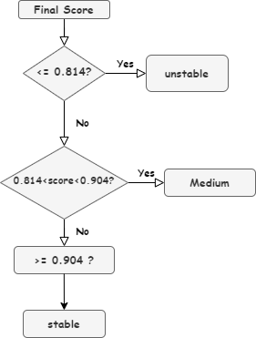

Figure 8

For the 11 countries where color revolutions occurred, 9 of them were considered socially unstable in the year in which they occurred, while the other two countries were considered to have average social stability at the time of their color revolutions. On balance, we believe that 0.904 and 0.814 are the most appropriate thresholds to successfully predict the majority of color revolutions as "unstable" without overly judging the society as unstable. The results of this model are highly informative and practical. If a country is deemed "unstable" in a given year, the government of that country will need to take steps to stabilize society and prevent social movements from occurring.

At the same time, the model integrates seven evaluation indicators, and different indicators complement each other and check each other, and participate together to form the final prediction score, which makes the evaluation results also more scientific.

### 4.2.4 Sensitivity analysis

Finally, we analyzed each indicator of the model separately from a sensitivity perspective, with the horizontal axis representing each indicator and the vertical axis representing the scores. The results of the analysis are as follows：

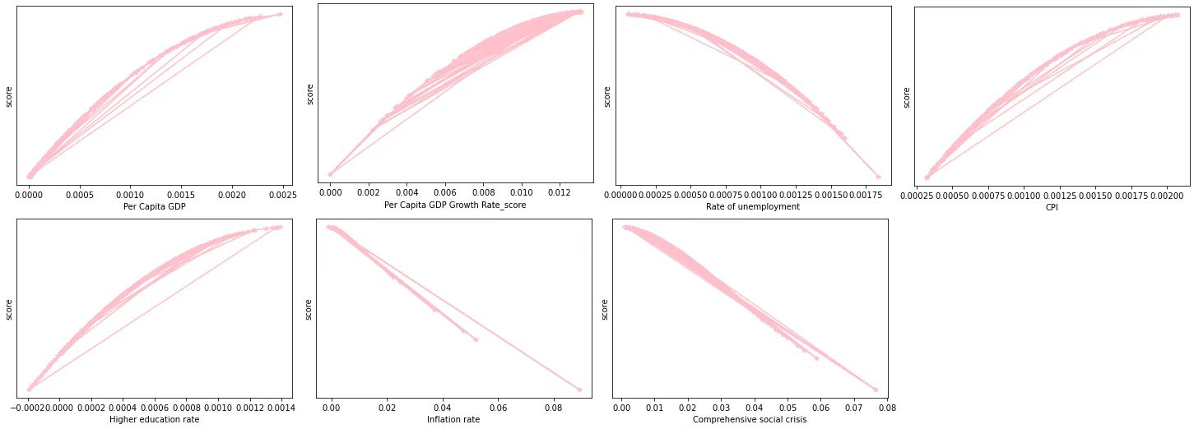

Figure 9

## 4.3 Task 3

### 4.3.1 Social stability assessment

Out of the 21 countries selected, a total of 18 countries had color revolutions that attempted to overthrow the regime but ended in failure. For this question, let's take Azerbaijan as an example.

Azerbaijan had a violet revolution in 2005. The seven factors of Azerbaijan in 2005 are substituted into our model and the value is 0.0, which is within the warning range. Then we extracted the line graph of the seven factors of Azerbaijan over time, and it is obvious that the four factors of inflation rate, GDP per capita, GDP per capita growth rate, and integrated crisis have obvious abnormalities in their values after observation

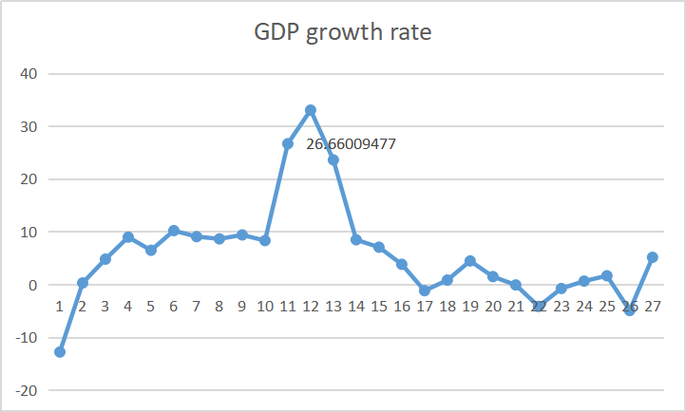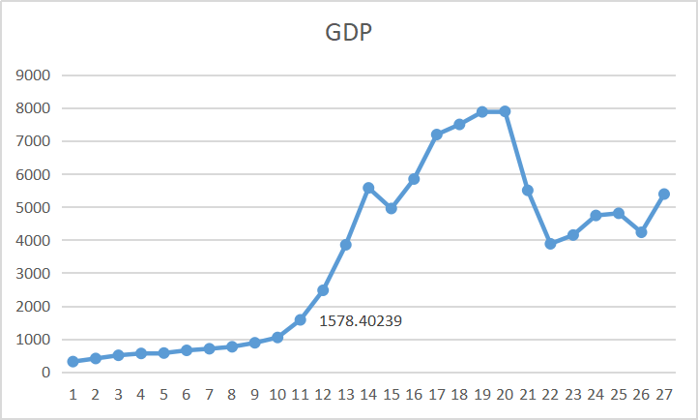

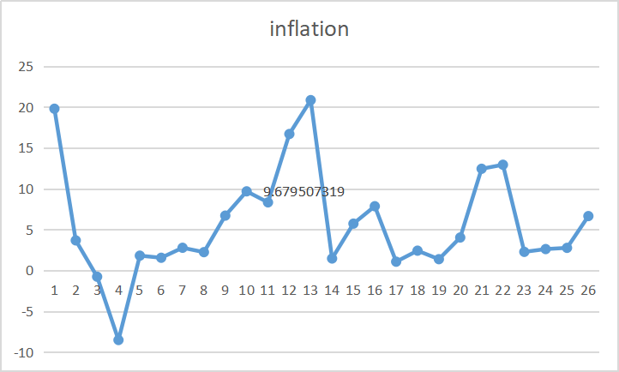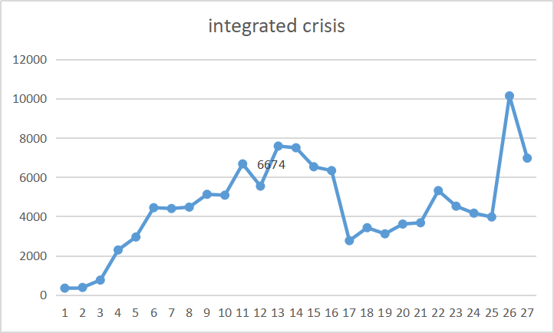

Figure 10：Line graph of the change in the values of the four factors over time

The graph shows that the four factors have seen a relatively large change in 2005, the year in which the color revolution occurred. The GDP per capita growth rate suddenly soared to 26.66% in 2005, and the GDP per capita also saw a significant increase, the inflation rate also became the highest existence around 2005, and the integrated crisis was surprisingly high, increasing by almost 20% compared to the previous year. The abnormalities of these four factors gradually unsettled the Azerbaijani society, intensified internal conflicts and tensed the external situation. This led to the occurrence of the Violet Revolution.

### 4.3.2 Prediction of future social stability (based on gray prediction GM(1,1))

Our evaluation indicators as well as TOPSIS model well explain the social situation in Azerbaijan at the time of color revolutions and analyze the reasons for their occurrence. From this, we hope to forecast the social stability in Azerbaijan in the short term future in order to analyze and predict the next social stability in Azerbaijan, which can provide some reference information for the next development and operation of the country.

The objective of this time is to forecast the social stability of Azerbaijan in 2023, and since it is a short-term future forecast, we have chosen the gray forecast GM(1,1) method. In order to make the best possible use of available data and to minimize the impact of the forecast results on the available data, we chose to use the last ten years of data for Azerbaijan to forecast the values of each indicator for 2023.

In order to determine whether the gray forecasting GM(1,1) method is applicable to our data, before conducting the forecasting analysis process, we perform a cascade test on the data items for Azerbaijan for the last ten years：

descript

If the results of the cascade test for each indicator are within the interval, the gray prediction model is considered to be applicable to the data; otherwise, the model needs to be replaced or the data needs to be flattened and transformed.

Based on the results of the cascade test, each indicator is given the same amount of translational transformation to ensure that each data item passes the cascade test. Next, the forecasting model can be constructed.

First, each item of data for Azerbaijan over the past ten years was summed up item by item to eliminate the randomness of the data and to strengthen the regularity of each indicator.

descript

Take GDP per capita as an example：

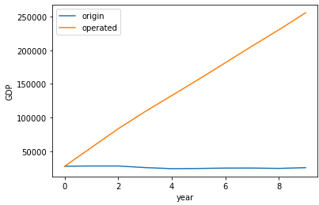

Figure 11

After that, based on the characteristics of the cumulative data, a linear model is constructed using the least squares method and the slope and intercept of the fitted model for each indicator are found. Based on the obtained linear expressions, we can calculate the predicted values of the cumulative data of seven indicators for Azerbaijan in 2023. Based on the cumulative values, we can calculate the predicted approximation of the indicator data for each year under our linear expression：

descript

Residual test (relative error test) for prediction results combined with real data。

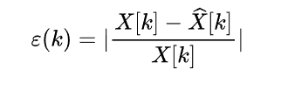

The model is considered reasonable if the results of the tests are all less than 0.2.

All data passed the residual test, so the gray forecast GM(1,1) model is correct and valid, and the obtained forecast data of seven indicators for Azerbaijan in 2023 are as follows

GDP per capita (in current dollars): 5092.8

GDP per capita growth score (obtained from the combined annual growth rate of GDP per capita): -0.254

Total unemployment (as a percentage of total labor force) (simulated ILO estimate): 5.179

Corruption Perception Index (CPI): 29.10

Higher education enrollment (% of population): 28.08

Inflation as measured by the CPI (annual inflation rate): 5.84

Aggregate social crisis (based on news coverage of the country): 4919

Based on our TOPSIS Social Stability Early Warning Model, we calculated Azerbaijan's social stability score in 2023 using seven projections, and the final score is about 0.841, which is between the stability and instability thresholds and is classified as "medium", indicating that Azerbaijan's social stability will be medium in 2023 The likelihood of social unrest is low。

### 4.3.3 Recommendations for national development

The recommendations for the development of Azerbaijan are as follows.

1. Do not allow other countries to interfere excessively in the internal affairs of the country; the intrusion of foreign powers can cut the society internally. The ruling class can take measures of political control to consolidate the regime, such as implementing religious policies, banning opposition activities, imposing political censorship, prohibiting the opposition from expressing its views, implementing political education, defending the purpose of propaganda regime, enforcing political institutions, etc.

2. The abnormally high GDP growth should be taken seriously enough. The abnormal economic growth is often at the expense of other interests and can lead to inadequate and uneven social development and even unpopularity. So economic development should be done in a stable manner rather than leapfrogging.

3. Improve the socio-economic situation, raise the material living standard of the people, improve the efficiency of government services, improve the social security system and other measures to consolidate the regime

## 4.4 Task 4

Data from Kyrgyzstan were selected for this question. The tulip revolution broke out in Kyrgyzstan in 2005 and was successful. According to the model, the index for Kyrgyzstan in 2005 is 0.6297263, which is at the lower level of the index among all predicted data, and it also confirms the established early warning model of social stability that the society is extremely volatile and prone to revolution in that year. Since the highest weight in the model is integrated crisis, which accounts for 51%, we can reasonably guess that the value of integrated crisis has fluctuated considerably when the obtained value appears more extreme. Second, the growth rate of GDP per capita, which has a weight of 27.2% in the model, is also taken into account. Since the weight of the first two has reached almost 80% and the forecast of Kyrgyzstan in 2005 shows extreme instability, the impact of other factors on this revolution is considered negligible here. The validation data are then shown in the figure:

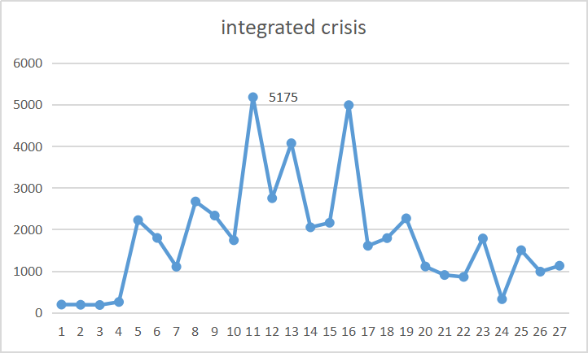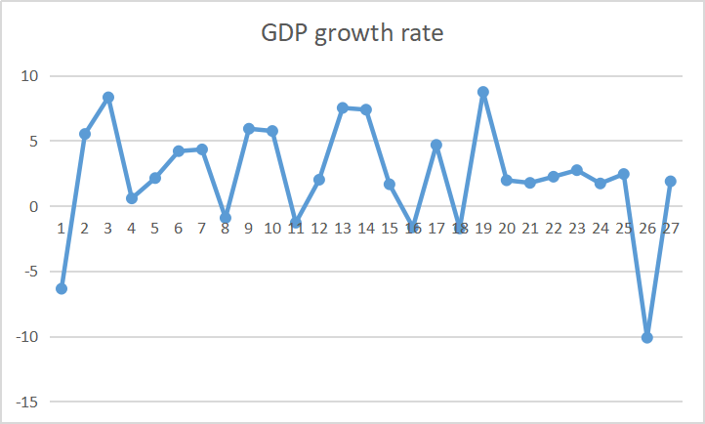

Figure 12

It can be seen that the number of integrated crises increased dramatically in 2005, almost tripling compared to previous years, which is largely in line with our suspicions. The high number of social conflicts is a sign of serious internal conflicts in the society. Also, as the graph below shows, the GDP growth rate in 2005 was negative, which indicates that Kyrgyzstan was in financial shortage in that year. At that time, Kyrgyzstan was one of the poorest countries in Central Asia and the world. After independence, Kyrgyzstan's economy developed slowly and only in 2004 it returned to 80% of its pre-independence 1990 level, of which the shadow economy accounted for about 40%, and its foreign debt reached $1.92 billion, which is equivalent to one year's GDP. Almost 60% of the population of Kyrgyzstan lives below the poverty line and unemployment is very high, especially in the south where almost three quarters of the population is unemployed. About 700,000 people work in Russia, Kazakhstan and other countries. The social division is serious, the gap between rich and poor, north and south, and ethnic groups is prominent, especially the situation of rich north and poor south is becoming more and more obvious. The plan of social contradiction leads to the increasing dissatisfaction of allergic people, especially poor people, with the government. At the same time, the serious corruption in Kyrgyzstan has eroded the foundation of the regime, and the prestige of the rulers has been lost. In this situation, the opposition took advantage of the unfair parliamentary elections and incited the masses to take to the streets, and naturally there were people who responded, so the Tulip Revolution broke out.[3][6][4][7][5][8]

## 4.5 Task 5

In order to prevent the outbreak of color revolutions and maintain social stability, we make the following recommendations based on the established social early warning model and social stability indicator system.

1. Strengthen political education and guide people to understand politics correctly. Strengthen education on socialist political civilization, guide citizens' political thoughts correctly, enhance their political consciousness, promote the understanding of social justice and fairness, and improve the political order.

2、Strengthen the protection of citizens' rights by the government and its departments. Establish a sound and effective system of laws and regulations, update and improve laws and regulations, ensure citizens' rights to litigation and administrative reconsideration, and ensure that their basic rights are effectively protected.

3. Strengthen social management. Establish a sound system of social security prevention, increase social management, resolutely combat illegal activities, timely detection and investigation of illegal acts, and maintain social order and security.

4、Strictly control religious activities and resolutely prevent religious activities from being used to influence political activities.

5、Establish a sound democratic mechanism, improve people's livelihood, strengthen social justice, enhance the economic income of the people, improve the living standard of the people, and ensure social stability.

6、Strengthen the power of the press and media, increase reporting efforts, address some social hotspots and issues of concern to the public, make timely reports, and send positive energy to society in a timely manner.

7、Not to overemphasize economic growth and reject GDPism. Maintain the balanced development of related aspects (such as ecology, employment, and residents' income)[6][9]。

# 5. Summary

Through a series of studies and the results of the model, we can find that there is a high relationship between social instability and even the occurrence of color revolutions and the frequency of social conflict time. Also, the factor occupies more than 50% of the weight in the model. The discrepancy with the team's initial guess is that economic factors are actually not very much associated with the outbreak of revolutions. In addition, according to the data, when the economic development is extraordinarily rapid and good, the society will tend to be unstable. Excessive economic development brings many problems, mainly in the form of imbalance, uneven development of industries, lagging social security system, accelerating economic cycles, increased difficulty in adjusting and adapting to the legal system, increased difficulty in governance, confusion in thinking, and excessive gap between rich and poor, which affects social stability. From the economic point of view, a government can maintain social stability by ensuring healthy economic development and increasing total social wealth while making the distribution of social wealth as reasonable as possible. When a country can solve the problems of people's livelihood in the process of maintaining stable development, strictly punish the problems of corruption, and the government works openly and transparently, the society will naturally develop steadily for the better. [7][10]

**References：**

[1]Polese, Abel; Beachain, Donnacha O. The Color Revolution Virus and Authoritarian Antidotes: Political Protest and Regime

[2] Zheng Dongchao. Alert to the new trend of "color revolution"[J]. Frontline,2022,No.499(04):52-53.

[3] Image source Reddit, Posted by u/GalleonCauldronr/ChineseSocialist, "[Yesterday in History] On April 25, 1974, the Carnation Revolution broke out in Portugal, overthrowing the dictatorship that had been in power for 48 years," https://www.reddit.com/r/ China_irl/comments/uc3n1z, Feb 4, 2023

[4] Meidusha ccc, "Mathematical Modeling: Correlation Analysis Learning - Pearson (pearson) correlation coefficient and Spearman (spearman) correlation coefficient", https://blog.csdn.net/weixin_67565775/ article/details, Feb 5,2023

[5] Okun, Arthur M. "Potential GNP: Its Measurement and Significance," American Statistical Association, Proceedings of the Business and Economics Statistics Section 1962. Reprinted with slight changes in Arthur M. Okun, The Political Economy of Prosperity (Washington, D.C.:

[6] Wu Hongwei. The deep-seated reasons for the regime change in Kyrgyzstan and the future political direction[J]. Contemporary World, 2010(5):4.

[7] Yu Qianjing. A Study of Three Unusual Regime Changes in Kyrgyzstan since Independence from the Perspective of Power Elite Theory[D]. Shanghai International Studies University, 2022. DOI:10.27316/d.cnki.gswyu.2022.000040.

[8] Zhao Longgeng." Regime Change in Kyrgyzstan and the Challenges Facing the New Regime." Peace and Development .04(2005).

[9] Du X.Y.. The Double Impact of Economic Growth on Social Stability [J]. Journal of Armed Police Academy,2008,No.149(11):35-38.

[10] Wang Lei,Hu Angang. An empirical study on the relationship between economic development and socio-political instability - a comparative analysis based on cross-country data[J]. Comparative economic and social systems,2010,(01):83-89.

1. [2] Zheng Dongchao. Alert to the new trend of "color revolution"[J]. Frontline, 2022, No.499(04):52-53.
2. [4] Meidushaccc, "Mathematical Modeling: Correlation Analysis Learning - Pearson and Spearman Correlation Coefficients," https://blog.csdn.net/weixin_67565775/article/ details, Feb 5,2023
3. [6] Wu Hongwei. The deep-seated reasons for the regime change in Kyrgyzstan and the future political direction[J]. Contemporary World, 2010(5):4.
4. [7] Yu Qianjing. A Study of Three Unusual Regime Changes in Kyrgyzstan since Independence from the Perspective of Power Elite Theory[D]. Shanghai International Studies University, 2022. DOI:10.27316/d.cnki.gswyu.2022.000040.
5. [8] Zhao Longgeng." Regime Change in Kyrgyzstan and the Challenges Facing the New Regime." Peace and Development .04(2005).
6. [9] Du X.Y.. The Double Impact of Economic Growth on Social Stability [J]. Journal of Armed Police Academy,2008,No.149(11):35-38.
7. [10] Wang Lei,Hu Angang. An empirical study on the relationship between economic development and socio-political instability - a comparative analysis based on cross-country data[J]. Comparative economic and social systems,2010,(01):83-89.9.