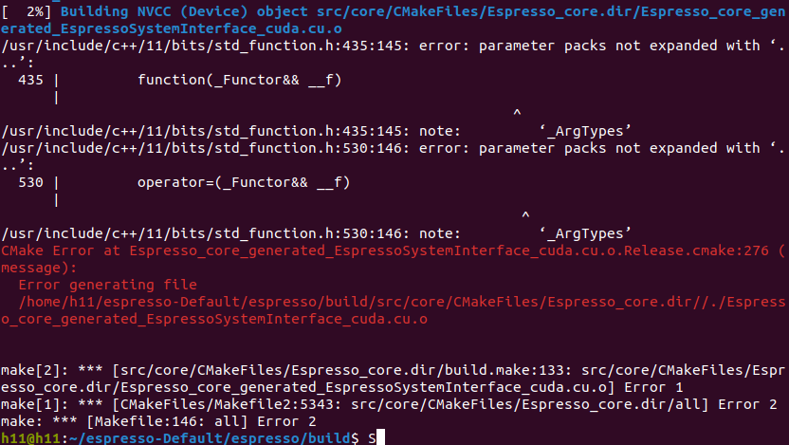**Question about using Lattice Boltzmann fluid in espresso Package.**

Generally I have tried the **stable version (**[ESPResSo 4.2.1](https://espressomd.github.io/doc4.2.1/index.html)) and the **development version** ([ESPResSo devel](https://espressomd.github.io/tutorials.html)). Both of the versions I have encountered the problem of using waLBerla feature/framework But also the GPU part compilation associated with CUDA building.

1. For the version 4.2.1 , when run the tutorial possie flow (https://espressomd.github.io/tutorials4.2.1/lattice_Boltzmann/lattice_Boltzmann_poiseuille_flow.html) it shows error below:

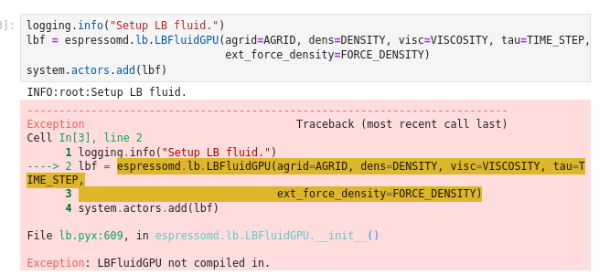But, I have failed to assert the LBFluidGPU after I have inserted a Nvidia GPU card (GeForce GTX 1050 Ti), and followed the installation as the User guide, particularly the GPU acceleration part. ([https://espressomd.github.io/doc/installation.html#myconfig-hpp-activating-and-deactivating-features](https://espressomd.github.io/doc/installation.html" \l "myconfig-hpp-activating-and-deactivating-features)). Please find the error when “make” the LBFluidGPU feature available.

2. For the version 4.2.1, when run the active matter tutorial (https://espressomd.github.io/tutorials4.2.1/active_matter/active_matter.html), it works until the LBFluid/LBFluidGPU module involved (with CUDA commented out), detailed error shows below.

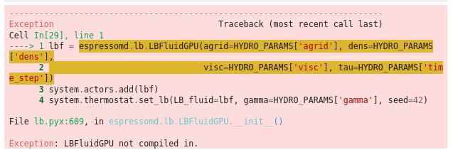

3. For the version del (https://github.com/espressomd/espresso/tree/python), both LB tutorial and active matter tutorials relays on the waLBerla framework, which I failed to incorporate to the espresso, though they were mentioning some guidance (https://espressomd.github.io/doc/lb.html), but still doesn't work in my case.

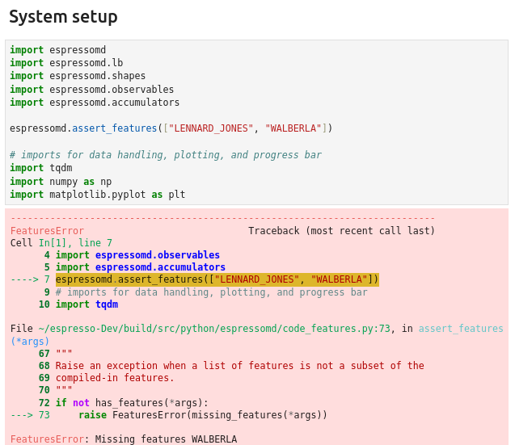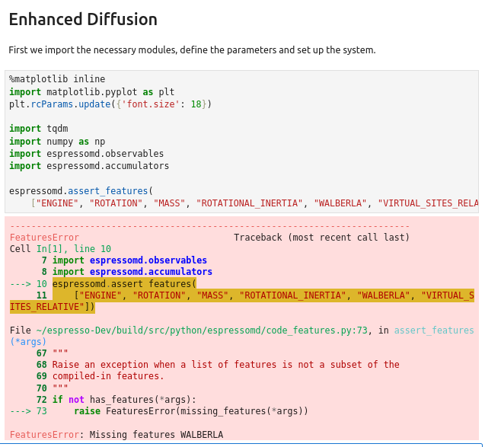

when make this version in the build folder, with CUDA option on, it shows error as below, which is still relate to the CUDA compilation.

