Quantum gates are unitary(linear) operators.

X(0) = 1

X(1) = 0

=>X(X(0)) = 0

Z(0) =0, neutral

Z(1) = -1, positive

H(0) = 1/sqrt(2)(|0>+|1>)

H(1) = 1/sqrt(2)(|0>-|1>)

=>H(H(0)) = 0

Deviation problem, errors exists

X|phi> = X(a|0>+b|1>) = a(|0>)+b(|1>) =

Z(0>+1>/sqrt(2)) = (z|0+z|1)/sqrt(2) =

H(0>+1>/sqrt(2)) = (H|0+H|1)/sqrt(2) = 1/2(|0>+|1>+|0>-|1>)=0

Difference of flip coin and superposition(Hadamard gate)

Two classical coin flips: 0.5 0 , 0.5 1

Two Hadamard gates on |0>: 1 |0>

H(H(|0>) = H(0>+1>/sqrt(2)) =0

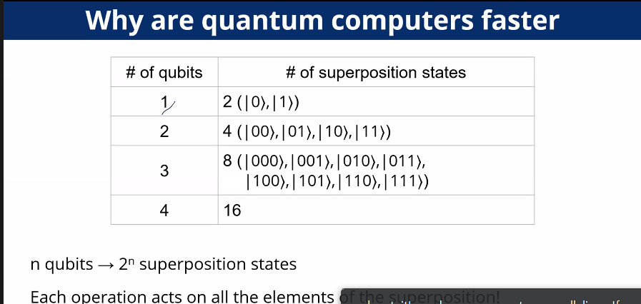

Quantum supremacy

Quantum gates:

CNOT: C: 0 -> do nothing;

C:1 -> flip target gate

Cin |tin | Cout |tout

0 0 0 0

0 1 0 1

1 0 1 1

1 1 1 0

Entanglement((|00>+|11>)/sqrt(2))

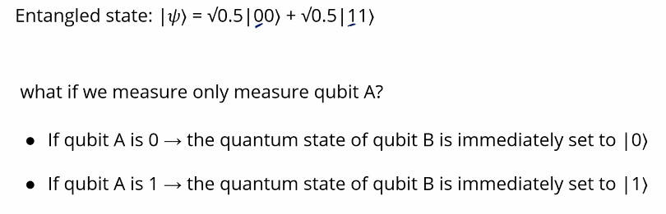Application:

1. Teleportation: transferring information or matter without physically moving

How to create entanglement:

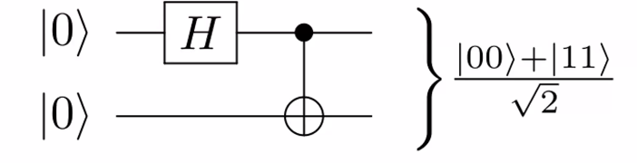

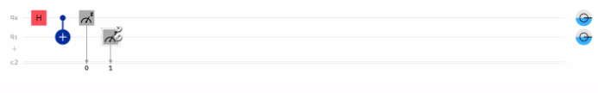

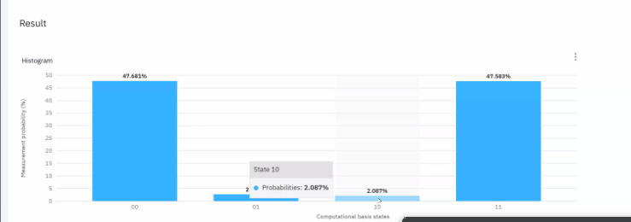

Due to errors of quantum computers

Hw1+hw2 due: Oct. 31st 11:59pm EST

Notice Canvas link