This summer, I am doing mater thesis work related to inverse problem. Taking inverse problem is very helpful to my work. In my work, I basically implement the ’Zeffiro’ to use IAS MAP for reconstruction of the dipole source in EEG and MEG signal. Several basic core ideas of the inverse problem are covered in the summer course, including bayes model, Gaussian/non-Gaussian priors, Marcov chain Monte Carlo methods(Metropolis algorithm and Gibbs Sampler) and Forward Modeling.

The interface utilized to analyze and visualize the results of EEG/MEG experiment is called ‘Zeffiro’. The brief description and some related knowledge covered in summer course are written as the first two parts. In the last part, there is some results implementing it to explore the effect of the parameters of the hierarchical Bayes model on EEG dipole reconstruction.

## 1.1 General Overview

Zeffiro Interface is an open source software package utilizing the ‘Matlab’ (The MatWorks Inc.) environment as a platform. It is designed for the analysis of MEG /EEG signal. The aim of the interface is to provide easy access to advanced and physiologically accurate volumetric forward and inverse computations. The interface includes a sufficient set of well-structured functions that allow users to analyse time series. It includes algorithms for forward and inverse model for dipole source. More specifically, it utilizes finite element mesh in forward simulation and IAS MAP estimates and MCMC sampling in source reconstruction. With Zeffiro Interface, a multilayer volume conductor model can be constructed if a set of tissue layer surfaces is available. The activity of the brain can then be reconstructed as a volumetric current distribution restricted to the grey matter of the brain. The reconstruction can be visualized either in volume or surface mode. Several cutting planes can be applied. A time-lapse for the activity can also be generated as well. If the computer is equipped with a GPU the computation can also be speeded up for processing large systems.

### 1.2 Graphical User Interface

A screenshot of a cell phone

Description generated with very high confidence



The GUI consists of the operation of file, including open and save; editing of the parameters, including using CPU or not; inverse tools for inverse problem and help.

The constitution of the whole visualization of the brain can be divided into sensors, five brain layers (white matter, grey matter, cerebrospinal, skull and sculp), and four detail layers. Any of them can be visualized separately with setting the parameters, for example, scaling. Each size can also be limited in any axis and the view to be exhibited can be set with three different plane rotation degrees as well.

The right part downside the visualization window is the button for calculation and some parameters more precisely determining the visualizibility.

### 2.1 FEM Forward Modeling

in Ω

with u denoting the scalar electric potential field, the conductivity distribution of the head and the primary current density (deural activity) in the brain.

The potential current and primary current density are approximated via and , respectively, where ,,…, are linear nodal basis functions belonging to and , , …, ϵ H(div), then we have the weak form within the subspace of the basis functions as:

with the entries of A, B, C, G as:

When we predidct the potential data calculating the y =Lx, we have the lied-field matrix L:

For tES, it can be solved by setting I =0 for z = RI with

Then we have

## 2.2 IAS MAP estimation algorithm

In the electromagnetic inverse source problem, the goal is to estimate the coefficient vector α from the observations:

where L is either the electric or magnetic lead field matrix and e is noise, for simplicity, which is assumed to be additive. With the noise being white Gaussian of known variance , we have the likelihood:

The prior models that are considered as conditionally Gaussian:

Where DƟ is a diagonal matrix, ,,…,, and the logarithmic term comes from normalizing of the prior density by the determinant of .

Then, the posterior density with conditional on Ɵ is:

Assuming the variance vector Ɵ known and fixed, the MAP estimate for α is:

Which is the classical Tikhonov regularized solution with a penalty defined by the diagonal matrix D. It is known that if θ has equal entries, this solution is smeared out even if the data corresponds to a focal input.

According to [31], the following Iterative Alternating Sequential (IAS) algorithm for computing the MAP estimate, (

(1) Initialize θ = θ0 and set i = 1;

(2) Update α by defining αi = argmax{π(α | y, θi−1)};

(3) Update θ by defining θi = argmax{π(θ | y, αi)};

(4) Increase i by one and repeat from 2. until convergence.

If we compute the posterior density of the pair () considering the hyperprior as the gamma distribution

Then by solving the optimization problem in the IAS MAP estimation algorithm, we have :

If the inverse gamma distribution is considered as the hyperprior, the posterior density of the pair () is:

Again, by solving the optimization problem in the IAS MAP estimation algorithm, we have :

where , and

### 2.3 Analysis process

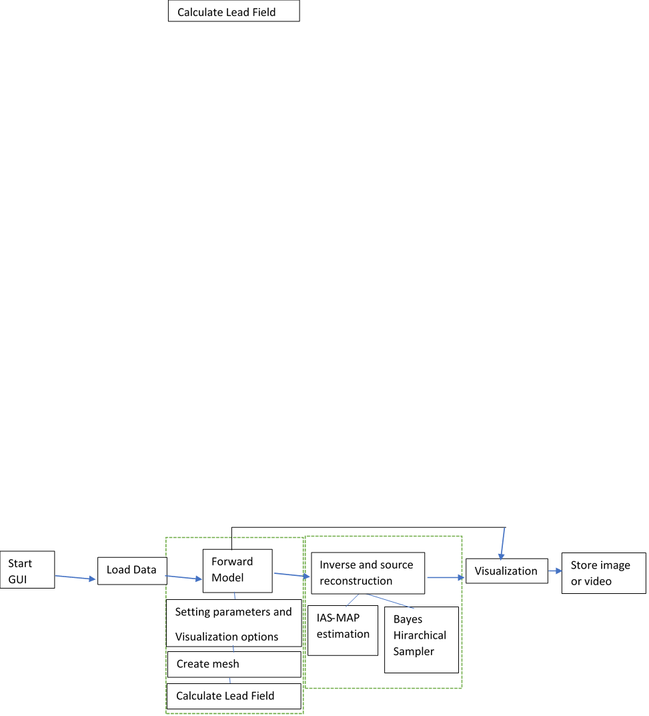

1. Analysis process utilizing GUI

### 2.4 IAS-MAP estimation

First, the user open the IAS MAP Estimation dialog box and set the parameters(Sampling frequency, Time interval start, Low-cut frequency, High-cut frequency, FFT time findow and Time step) to match with the dataset and the investigated frequency range. Choose the desired Data segment.

Next, set the hyperprior (either Gamma or Inverse gamma). Choose Shape parameter and Scaling parameter for the hyperprior. The former one of these determines the shape of the hyperprior (the strengths of the outliers) while the latter one sets the initial prior variance. Note: If the scaling parameter is 1.5 and the gamma hyperprior is used, the reconstructions will be correspond to the classical Minimum Norm Estimate (MNE) and Minumum Current Estimate (MCE), when the number of the iteration steps is 1 and >1, respectively.

Then set the Likelihood STD to match the estimated noise level. This is relative to Data normalization.

Last, choose the desired number of iterations (the more steps the more focal solution will be.) And press start. The reconstruction will be computed for each time step in the dataset.

A screenshot of a cell phone

Description generated with very high confidence

1. IAS MAP Estimation dialog box

## 3. experiment

A screenshot of a cell phone

Description generated with high confidence

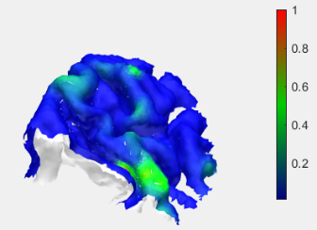

Gamma

1.5

=10^-5

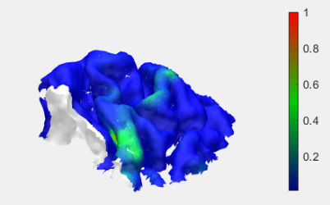

Gamma

1.5

=10^-7

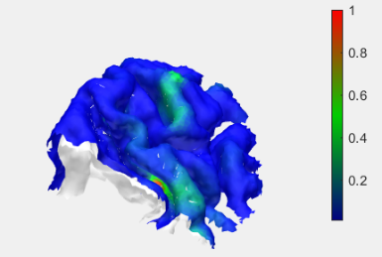

Gamma

1.5

=10^-9

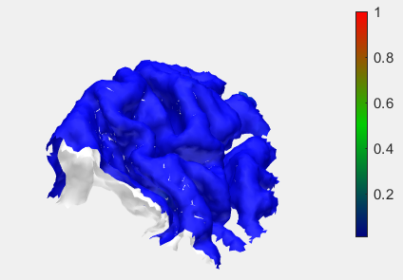

Gamma

1.5

=10^-12

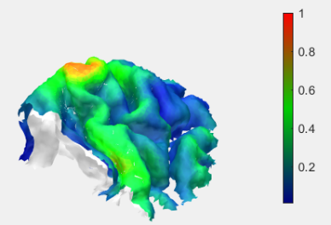

Inverse Gamma

1.5

=10^-5

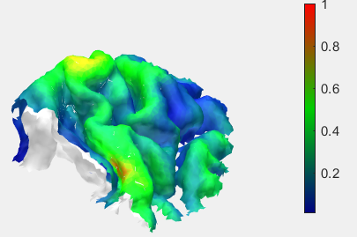

Inverse Gamma

1.5

=10^-7

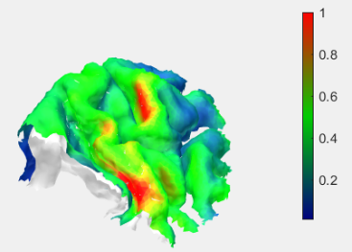

Inverse Gamma

1.5

=10^-9

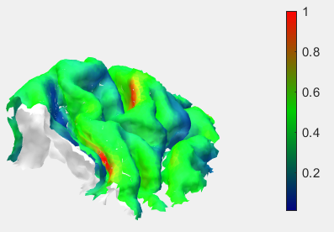

Inverse Gamma

1.5

=10^-12

The snr can show the general degree of how focal is the reconstruction basically, the smaller the scaling parameter is the more focal, the reconstruction will be(The only exception is the inverse gamma hyperprior with shape parameter being 1.5). For gamma, the reconstruction with larger scaling parameter is more focal while for inverse gamma, the reconstruction is most focal at the larger shape parameter with only small scaling parameter.

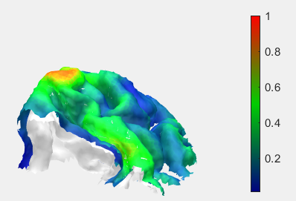

Gamma

3

=10^-5

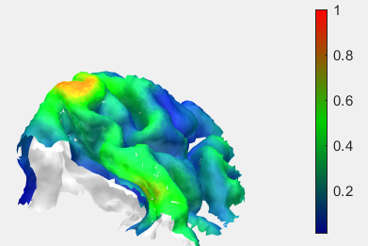

Gamma

3

=10^-7

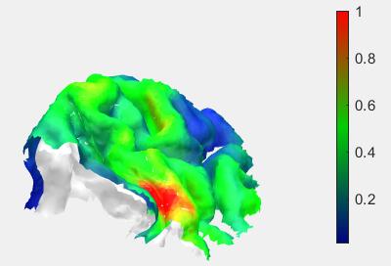

Gamma

3

=10^-9

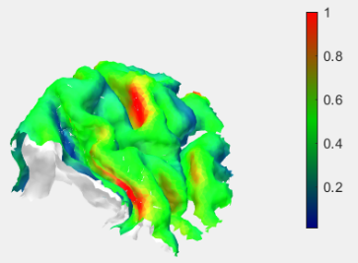

Gamma

3

=10^-12

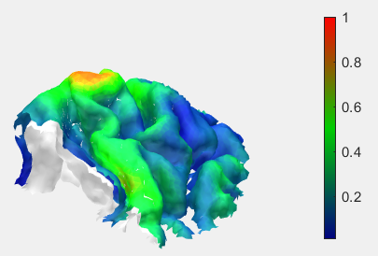

Inverse Gamma

3

=10^-5

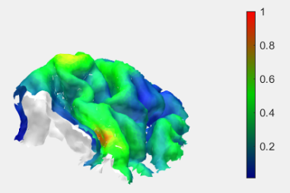

Inverse Gamma

3

=10^-7

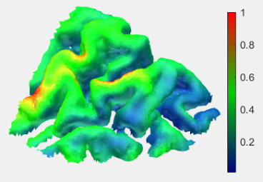

Inverse Gamma

3

=10^-9

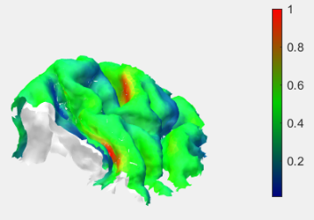

Inverse Gamma

3

=10^-12

However, doing reconstruction needs to have the knowledge that for EEG data, it should be in the sulcus in 3b area which makes the combination of hyperprior as gamma, shape parameter as 1.5 and scaling parameter as 10^-9 becomes the ideal choice （the larger shape parameter makes more changes for the results of gamma and they somehow focal to the wrong place when the scaling parameter is also large. Inverse gamma generally gives larger amplitude around the 3b area but not so focalized. For inverse gamma shape parameter as 1.5 and scaling parameter as 10^-12 works also fine.

This is a simple application of IAS MAP method. More exploration can be done also with MCMC gibbs sampler by utilizing ‘zeffiro’ and with applying ROI in both these two method. In addition, the results is cut into the area around 3b area. However, the snr is just calculated on the whole picture. For better evaluation we might also calculate snr in ROI.