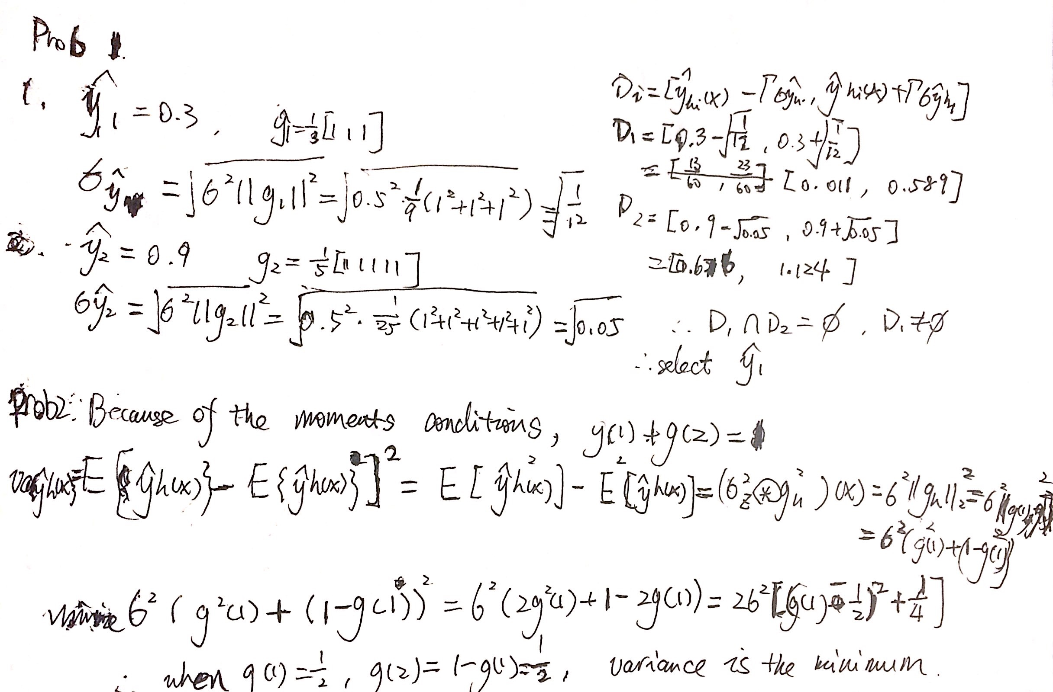

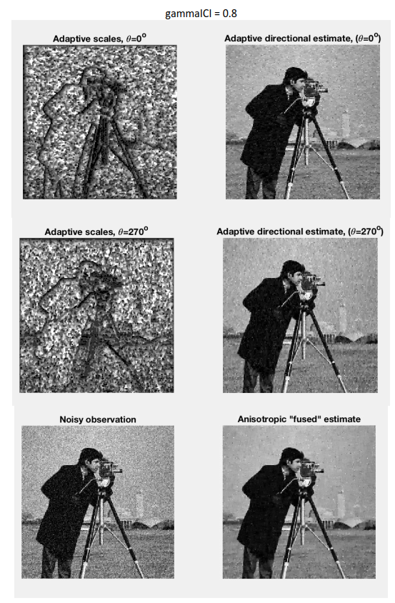

Anisotropic LPA-ICI Denoising Demo

-----------------------------------------------------------------------------------

Initial (noisy) observation criteria values:

ISNR Improvement in Signal-to-Noise Ratio : 6.3115

SNR Signal-to-Noise Ratio : 20.7005

PSNR Peak Signal-to-Noise Ratio : 26.2844

MSE Mean Squared Error (l-2 norm squared) : 152.9833

RMSE Root of Mean Squared Error (l-2 norm) : 12.3686

MAE Mean Absolute Error (l-1 norm) : 8.3293

MAX Maximum Absolute Difference (l-infinity norm) : 106.72

kernels created

Elapsed time is 1.182682 seconds.

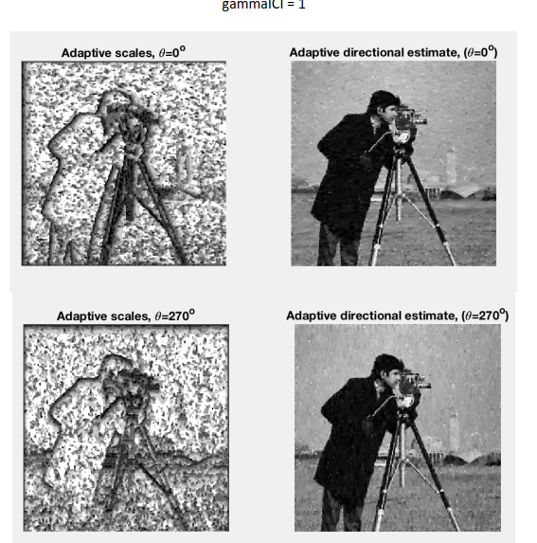

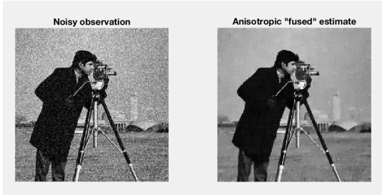

Anisotropic LPA-ICI Denoising Demo

-----------------------------------------------------------------------------------

Initial (noisy) observation criteria values:

ISNR Improvement in Signal-to-Noise Ratio : 7.668

SNR Signal-to-Noise Ratio : 22.057

PSNR Peak Signal-to-Noise Ratio : 27.6409

MSE Mean Squared Error (l-2 norm squared) : 111.9416

RMSE Root of Mean Squared Error (l-2 norm) : 10.5802

MAE Mean Absolute Error (l-1 norm) : 6.8442

MAX Maximum Absolute Difference (l-infinity norm) : 100.3019

kernels created

Elapsed time is 1.158478 seconds.

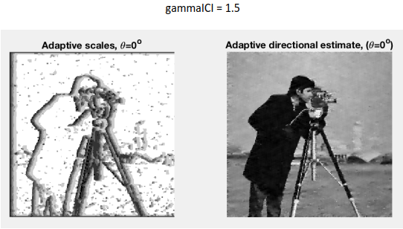

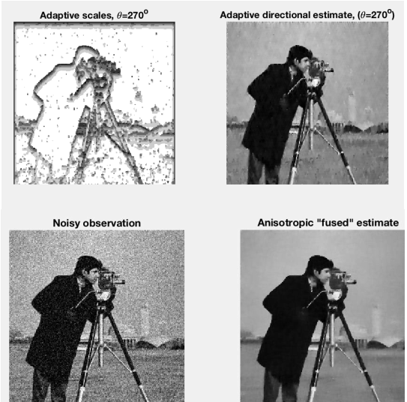

Anisotropic LPA-ICI Denoising Demo

-----------------------------------------------------------------------------------

Initial (noisy) observation criteria values:

ISNR Improvement in Signal-to-Noise Ratio : 6.6445

SNR Signal-to-Noise Ratio : 21.0335

PSNR Peak Signal-to-Noise Ratio : 26.6173

MSE Mean Squared Error (l-2 norm squared) : 141.6923

RMSE Root of Mean Squared Error (l-2 norm) : 11.9035

MAE Mean Absolute Error (l-1 norm) : 7.0963

MAX Maximum Absolute Difference (l-infinity norm) : 145.171

kernels created

Elapsed time is 1.148478 seconds.



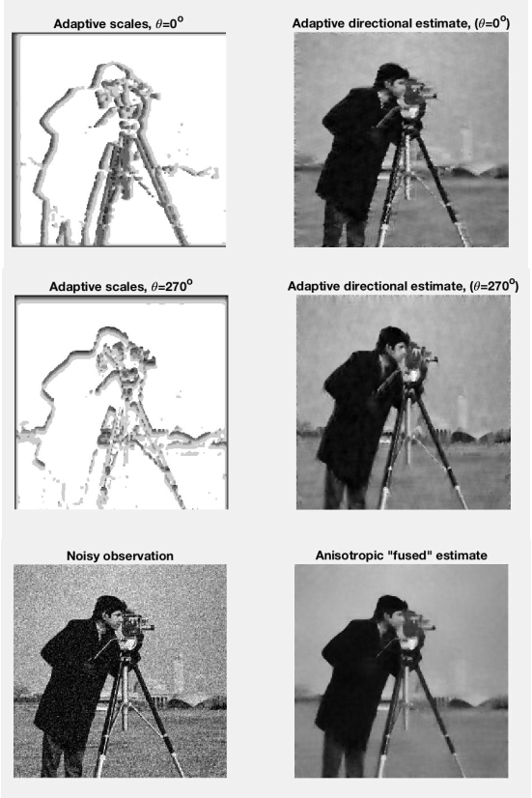

Initial (noisy) observation criteria values:

ISNR Improvement in Signal-to-Noise Ratio : 3.9977

SNR Signal-to-Noise Ratio : 18.3868

PSNR Peak Signal-to-Noise Ratio : 23.9706

MSE Mean Squared Error (l-2 norm squared) : 260.628

RMSE Root of Mean Squared Error (l-2 norm) : 16.144

MAE Mean Absolute Error (l-1 norm) : 9.2629

MAX Maximum Absolute Difference (l-infinity norm) : 163.7193

kernels created

Elapsed time is 1.135876 seconds.

Genrally, smaller scales are represented in a darker shade of grey while the larger is the brighter and of more detail. The criteria values for the denoising of the Cameraman image using 4 directional adaptive estimates. The fused (assuming that the directional adaptive estimates are independent and unbiased, such

fusing is the maximum-likelihood estimate of y (x))is estimate is much better than each of the directional ones.

|  |  |  |  |  |  |  |  |
| --- | --- | --- | --- | --- | --- | --- | --- |
| Gamma=0.8 |  | Gamma=1.0 |  | Gamma=1.5 |  | Gamma=2.5 |  |
| ISNR | 6.3115 | ISNR | 7.668 | ISNR | 6.6445 | ISNR | 3.9977 |
| SNR | 20.7005 | SNR | 22.057 | SNR | 21.0335 | SNR | 18.3868 |
| PSNR | 26.2844 | PSNR | 27.6409 | PSNR | 26.6173 | PSNR | 23.9706 |
| MSE | 152.9833 | MSE | 111.9416 | MSE | 121.6923 | MSE | 130.628 |
| RMSE | 12.3686 | RMSE | 10.5802 | RMSE | 11.9035 | RMSE | 16.144 |
| MAE | 8.3293 | MAE | 6.8442 | MAE | 7.0963 | MAE | 9.2629 |
| MAX | 106.72 | MAX | 100.3019 | MAX | 145.171 | MAX | 163.7193 |

Other denoising result are as followed:

Figure1

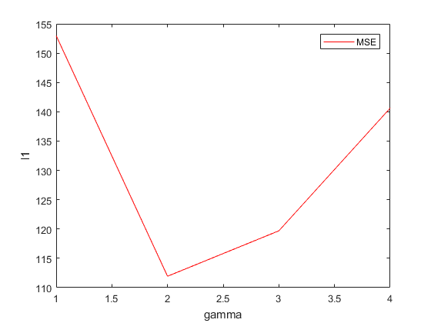

0.8 1.0 1.5 2.5

From the figures, we can see the block spots are less and thus the pictures are clearer when gamma is 1.0. The plots show that for the four gammas, the best found values of gamma is 1.0. The adaptive scales are represented with black being the smallest scale (which corresponds to a Dirac-delta estimate.), and white being the maximum scale (corresponding to be a kernel).