Types and production of fiberglass

**1. History of Glass Fiber**

Glass makers experimented glass fiber production from the ancient time but mass manufacture of glass fiber started in 1893 by Edward Drummond Libbey who exhibited a dress made from fabric combining silk and glass fiber. Russell Games Slayter in 1938 issued first patent considering glass wool production. The produced fiber showed a good electrical insulation properties and for this reason glass fiber products named as electrical glass or E-glass. Starting from 1939 glass fibers were used as insulators in the warships of US navy. Furthermore, during worldwar II glass fiber manufacturing and development in the production of unsaturated polyester resin was the driving force to produce radar domes (radoms) and structural parts of the aircrafts using hand lay up technique. For the first time in 1953 General Motors started mass production of the entire body of Chevrolet Corvette sport cars using glass fiber and utilising sheet molding compound (SMC) technique.

Improvements in the technology, consumer awareness and government regulations resulted that glass fibeer manufacturers spent millions of dollars to minimize waste. Reducing furnace emission is the major challenge for glass fiber maufacturers in which dust, sulfur dioxide and nitrogen oxides plays the importan role. The use of oxygen combustion makes advantage of decreasing the emission of nitrogen oxide to the environment. Glass makers produces fluorine and boron free glasses to eliminate fluorine pollution and minimize air pollutants in manufacturing. Industrial demends are always a driving force to produce fibers with high mechanical strength, corrosion resistance and etc. In this regard, S glass, ECR glass, Boron free and many other type of glasses are produced.

**2. Glass Fiber Manufacturing**

In the modern glass fiber manufacturing plant direct manufacturing process is prefered. In this process raw materials are stored separately in the silo and metered to the mixing tank by accurate weighing followed by transfer to the batch silo to charge to the furnace. This system is computer controlled and air tight in away to prevent spreading of dust.

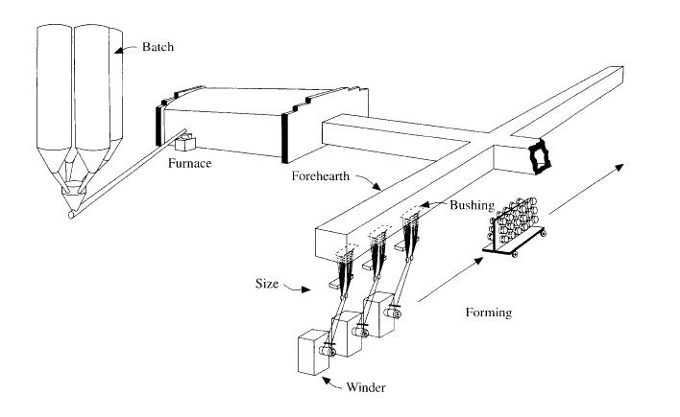The raw materials that is used in the manufacturing of E-glass are; sand for silica, clay for alumina, colemanite or boric acid for boron oxide and limestone or calcite for calcium oxide. E-glass furnace is generally rectangular with a short channel at the exit that is connected to the narrow forehearth channel along which fiber forming is done.

See the figure below.

The best refractory material that is used to build the wall of furnace is dense chromium oxide which is resistant to the corrosive molten E-glass. The refractory is baked by zircon blocks and another layer of of clay blocks. The fuel that is used is usually natural gas which produces the tempreture of around 1600oC to melt the raw materials as they feed to the furnace. During formation of the E-glass and as it moves to the furnace exit the electrodes and bubblers in the bottom of furnace produce convection of the liquid glass in addition to romoving of gasses evolved and to finalize the chemical reactions.

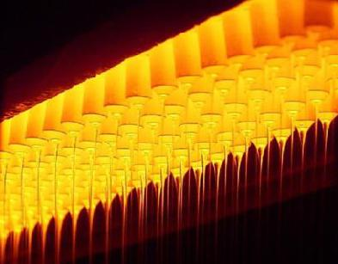As the molten E-glass leaves the furnace it enters to the forehearth channel and conveys into bushing where fibre is formed. The bushing is like spinneret of the synthetic fiber industry, however, it is rectangular in shape and made of platinum and rhodium alloy to withstand high temperature and corossion of molten E-glass, Fig. 3.2. Presence of rhodium in the alloy increases the hardness and stifness that enhances the lifetime of bushing. A bushing contains small holes, nozzles, with the number up to several thousands, e.g., 6000. The bushing is heated electrically for better temperature control and uniformity of the fibers that flow through tips, holes. The orifices of tips ranging from 0.75 to 2.0 mm and as winder or chopper pulls the fibers the linear speed of it may rise up to 60 m/s.

By variation in the winder or chopper speed or output capacity of the bushing the fiber diameters can be changed and therefore fibers with various diameters are produced. Fibers with different diameters are named as shown in the table below.

***Letter designation of glass fiber diameter***

|  |  |
| --- | --- |
| Filament | Average |
| Design | Diameter (µ) |
| D | 5.33 |
| E | 7.32 |
| G | 9.50 |
| H | 10.67 |
| J | 11.75 |
| K | 14.19 |
| M | 15.86 |
| N | 17.38 |
| T | 23.52 |

E-glass melt should have a narrow range of viscosity between 600 to 1000P. The rate of fiber production at the nozzle is the function of the rate of flow of glass and can be described by the Poiseuille’s equation:

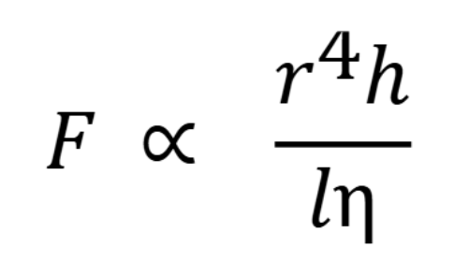

where *F* is the rate of flow, *r* is the radius of the nozzle at its narrowest cylindrical section, *h* is the height of the glass above the nozzle and η is the viscosity of the glass.

As the liquid glass leaves the tip of the nozzle, it is quenched rapidly by circulating cold air and spraying water. The glass will be fully soldified when it reaches to the size applicator that is few meter under bushing. In this stage the aqeous size is applied to the glass surface by either roller or belt applicator.

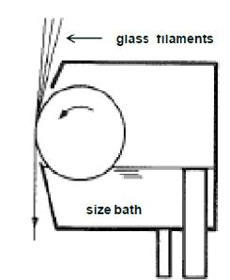

Applicator

Since the glass filaments is wetted by water and size, it can be gathered through split shoes which are usually rotatable grooved disks.

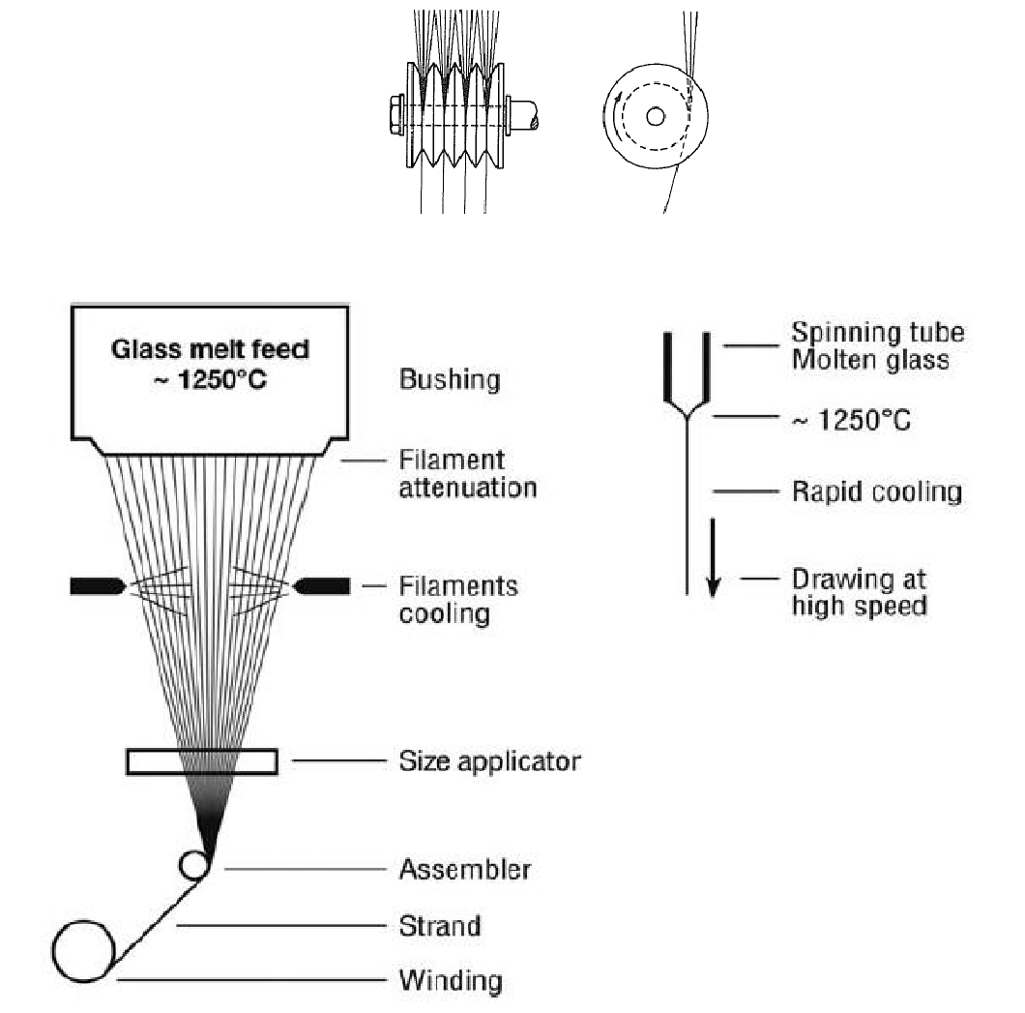

The attenuated glass fibers are traditionally wound on collet which is cylindir powered by winder. The fibers are usually wound on the paper or plastic tube that is slid onto the collet. The function of the tube is to facillitate handling of the forming cakes. The rotation speed of the collet is the key parameter to determine the fiber diameter in the final form. Also, the temperature adjustment of the bushings affect the filaments diameter as well. The other important part of the winder is the traverse that places individual strands to the collet in such fashion that the cake has even build up and the strands can be easily wound after drying.

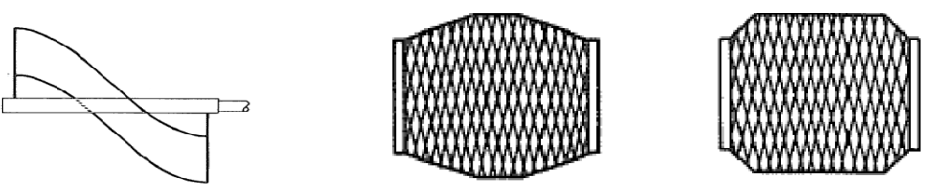

Traverse Cake

**3. Types of Glass Fiber**

In genereal, E-glass named as calcium alumino-borosilicate glass with less than 1% alkali oxide, Na2O. Most glasses contain small amount of flouride which assist the dissolution of raw materials and lower the liquidus temperature of the glass. The E-glass, occasionally, has density of 2.62 g/cm3 and refractive index of 1.562.

The composition of E-glass after long producing time is varying as a result of some factors the encourage or force manufacturers to revise the formulation. The need to reduce the atmospheric pollution due to gasses and dust discharged from E-glass furnaces causes production problems and cost of raw materials. Also, the need to improve some properties like corrosion resistance and higher mechanical performance leads to production of new types of glass fibers.

*Glass fibers by commercial melt process*

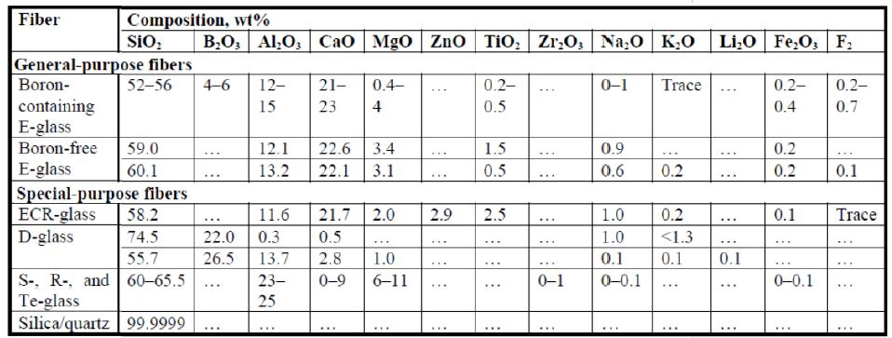

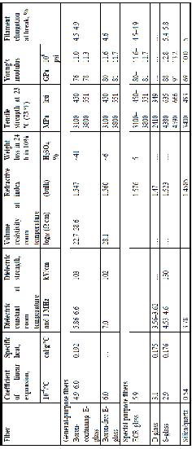As it is seen in the table different types of glass fibers were made to fulfill the industrial needs and this just was possible by modifying formulations.

The Table Shows some physical and mechanical performance of various type of glass fibers.

*Physical and mechanical properties of comercial glass fibers*

*Evolution of commercial pupose E-glass fibers*

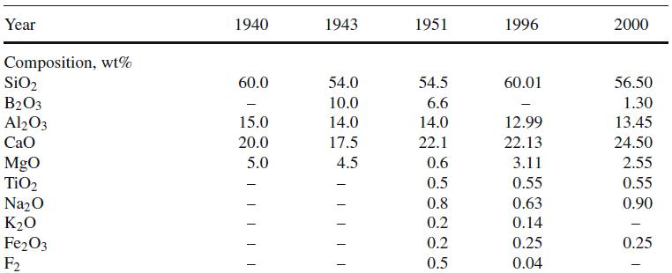

In table, evolution of E-glass is shown. At the beggining E-glass manufacturing was started with Boron free compositon and then in 1943 by addition of Boron processing temperature reduced from 1288 to 1200oC. In 1951 the batch cost was reduced by simplifying the E-glass composition and as a result the amount of B2O3 reduced from 10 to 5-7%. Moreover, the amount of MgO was reduced significantly and the standard formulation for E-glass was stablished [8]. By the 1960’s emision of boron and flourine from melt in a commercial furnace into the atmosphere became an important issue from environment and health point of view. Costly pollution control devices resulted to the design of new flourine free and essentially boron free E-glass compositions that commercialized in 1996. From the beggining of 2000’s more challenges were done to produce low energy and environmentally friendly E-glass for general purpose apllications and as it can be seen addition of TiO2, flux, in combination with boron reduces cost and processing, viscosity of melt.

Viscosity of molten glass is another important parameter by which production variables, energy and fiber forming is affected. As shown in the figure decreasing the amount of boron in the glass formulatıon results higher viscosity and consequently rising the peocessing temperature to the amount of about 90oC for glass fiber manufacturing.

