MIKU'S STATIONERY ✿
Cute things for writing, planning and reading (◕‿◕)
Test document — the shop, products and prices are made up. Price list 2026-10 | Currency: PKR

About us
Miku's Stationery is a small kawaii stationery and book shop in Karachi, Pakistan. Shop 7, Clifton Block 5, Karachi. We sell cute notebooks, pens, planners, stickers and cosy books, and we ship all over Pakistan.
Opening hours: Monday to Saturday, 11:00 AM–8:00 PM PKT. Closed on Sundays.
Prices are in Pakistani Rupees (PKR) and include sales tax.

How we talk
We are cheerful, warm and a little bit kawaii. Short, friendly messages with a cute emoticon now and then, like (◕‿◕) or ✿. We never pressure anyone and we never promise anything we can't do.

Price list
Photo | SKU | Product | Details | Sale Unit | Pack | Price (PKR)
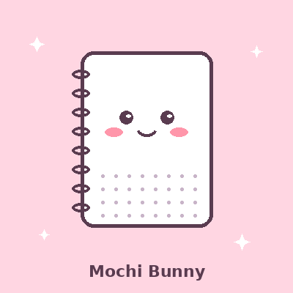 | MK-NB-101 | Mochi Bunny Notebook | A5, dotted, 120 pages, 100 gsm, pink soft cover | notebook | 1 | 1,250
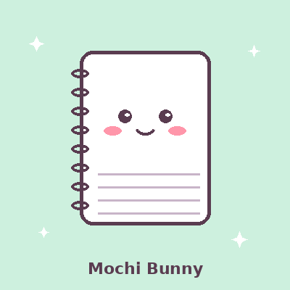 | MK-NB-102 | Mochi Bunny Notebook | A5, lined, 120 pages, 100 gsm, mint soft cover | notebook | 1 | 1,250
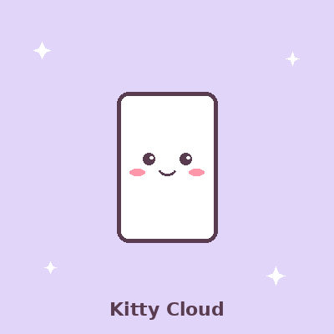 | MK-NB-110 | Kitty Cloud Mini Notebook | A6, blank, 80 pages, lilac cover | notebook | 1 | 650
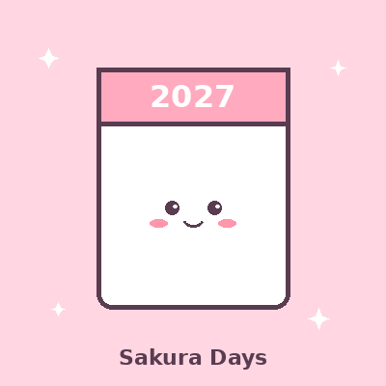 | MK-PL-201 | Sakura Days 2027 Planner | A5, weekly and monthly pages, stickers inside, hardcover | planner | 1 | 3,400
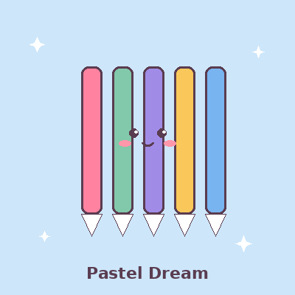 | MK-PN-301 | Pastel Dream Gel Pens | 0.5 mm, 10 pastel colours | pack | 10 | 1,100
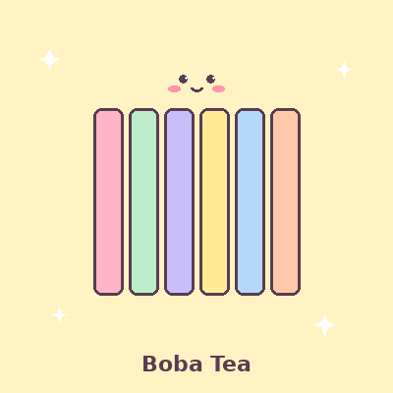 | MK-PN-305 | Boba Tea Highlighters | chisel tip, 6 pastel colours | set | 6 | 950
 | MK-TP-401 | Strawberry Milk Washi Tape | 15 mm × 5 m per roll, 5 designs | set | 5 | 850
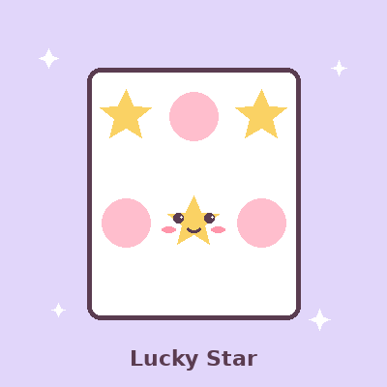 | MK-ST-501 | Lucky Star Sticker Sheets | glossy vinyl, waterproof, 6 different sheets | pack | 6 | 600
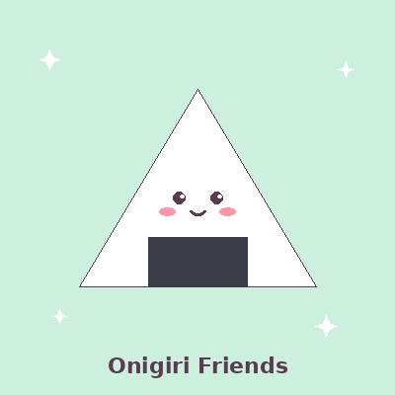 | MK-ER-601 | Onigiri Friends Erasers | dust-free, 4 characters | pack | 4 | 420
 | MK-PC-701 | Bunny Ears Pencil Case | plush, zip, holds 30 pens | unit | 1 | 1,800
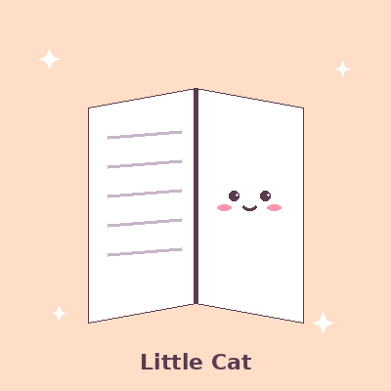 | MK-BK-801 | The Little Cat Café | cosy novel, paperback, 240 pages, English | book | 1 | 1,950
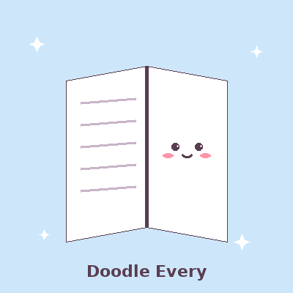 | MK-BK-802 | Doodle Every Day | sketch-a-day activity book, 180 prompts, spiral bound | book | 1 | 1,450
 | MK-BK-803 | Moonlight Bakery Vol. 1 | illustrated comic, paperback, 160 pages | book | 1 | 1,650
 | MK-PA-901 | Printer Paper A4 | 80 gsm, white, 500 sheets | ream | 500 | 1,900
 | MK-GW-950 | Gift Wrapping | pastel paper, ribbon and a handwritten tag | item | 1 | 150

Delivery
Delivery within Karachi is PKR 250 for orders below PKR 3,000, and free for orders of PKR 3,000 or more.
Delivery to the rest of Pakistan is PKR 350 for orders below PKR 5,000, and free for orders of PKR 5,000 or more.
Karachi orders arrive in 1–2 working days; other cities in 3–5 working days. We do not offer same-day delivery.

Discounts
School and office orders: orders of PKR 10,000 or more receive 10% off. There are no other discounts, and discount codes from other shops are not accepted.
Gift wrapping is PKR 150 per item and is not discounted.

Payment
Cash on Delivery is available for orders up to PKR 15,000.
Orders above PKR 15,000 need 50% advance payment by bank transfer, JazzCash or Easypaisa before dispatch, and the rest on delivery.
We do not offer instalments or pay-later.

Returns and exchanges
Unused items in their original packaging can be exchanged within 7 days of delivery.
Opened sticker sheets, opened washi tape and used notebooks cannot be returned.
If a book arrives damaged, send us a photo within 48 hours of delivery and we will replace it.
Refunds for approved returns are sent by bank transfer within 5 working days.

Stock
The Sakura Days 2027 Planner is limited to 40 copies this season. Moonlight Bakery Vol. 2 is not out yet, and we do not take pre-orders.

