Labo 4

Apache on Linux

“Linux is user-friendly...
it's just picky who it's friends are”



Install apache through YUM if not done so already

Make sure Apache is running by showing the running processes on your system. If Apache is not running, start it!

- What command did you use?
[root@localhost ~]# ps aux | grep httpd
root 1190 0.0 0.8 232244 8184 ? Ss 14:31 0:00 /usr/sbin/httpd
apache 1223 0.0 0.4 232244 4632 ? S 14:31 0:00 /usr/sbin/httpd
apache 1224 0.0 0.4 232244 4632 ? S 14:31 0:00 /usr/sbin/httpd
apache 1225 0.0 0.4 232244 4632 ? S 14:31 0:00 /usr/sbin/httpd
apache 1226 0.0 0.4 232244 4632 ? S 14:31 0:00 /usr/sbin/httpd
apache 1227 0.0 0.4 232244 4632 ? S 14:31 0:00 /usr/sbin/httpd
apache 1228 0.0 0.4 232244 4632 ? S 14:31 0:00 /usr/sbin/httpd
apache 1229 0.0 0.4 232244 4632 ? S 14:31 0:00 /usr/sbin/httpd
apache 1230 0.0 0.4 232244 4632 ? S 14:31 0:00 /usr/sbin/httpd
root 1601 0.0 0.0 103152 860 pts/0 S+ 14:48 0:00 grep httpd

If you see Apache is running, stop Apache, and show the list of running processes again. Do you see a difference? yes

- What command did you use?
[root@localhost ~]# service httpd stop
Stopping httpd: [ OK ]
[root@localhost ~]# ps aux | grep httpd
root 1659 0.0 0.0 103148 852 pts/0 S+ 15:06 0:00 grep httpd
[root@localhost ~]# service httpd start
Starting httpd: httpd: Could not reliably determine the server's fully qualified domain name, using localhost.localdomain for ServerName
[ OK ]

When you are sure Apache is running, try surfing from another computer to your Apache web server. (You can use your Window operating system to surf to your Linux machine). The only thing you need to surf to your Apache web server is the ip address of your NIC.
Find a command to show your IP address.

- What command did you use?
[root@localhost ~]# ifconfig
eth0 (…)
inet addr:10.123.97.172 Bcast:10.123.103.255 Mask:255.255.248.0
(…)

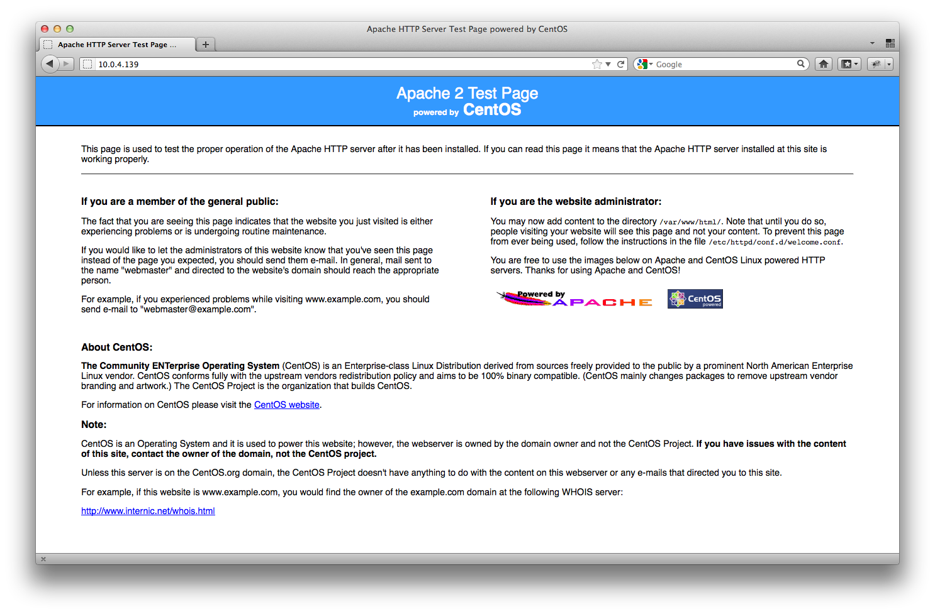

Now try to find where your main Apache configuration file (httpd.conf) is located. When you find this file, make sure to backup your original file to a httpd.conf.OLD file for example.

- What command did you use?
[root@localhost ~]# cd /etc/httpd/conf/
[root@localhost conf]# ls -la
total 60
drwxr-xr-x. 2 root root 4096 Oct 25 17:16 .
drwxr-xr-x. 4 root root 4096 Oct 14 12:07 ..
-rw-r--r--. 1 root root 34418 May 28 2010 httpd.conf
-rw-r--r--. 1 root root 13139 Jul 7 12:31 magic
[root@localhost conf]# cp httpd.conf httpd.conf.old
[root@localhost conf]# ls -la
total 96
drwxr-xr-x. 2 root root 4096 Oct 25 17:41 .
drwxr-xr-x. 4 root root 4096 Oct 14 12:07 ..
-rw-r--r--. 1 root root 34418 May 28 2010 httpd.conf
-rw-r--r-- 1 root root 34418 Oct 25 17:41 httpd.conf.old
-rw-r--r--. 1 root root 13139 Jul 7 12:31 magic

When surfing to the IP address of your Linux machine running Apache, you will see a default page stating that the Apache server has been installed properly. Find out where this default page is located on your Linux system?

- Where is the file located and where did you find this?
[root@localhost conf]# vim /etc/httpd/conf/httpd.conf

#
# DocumentRoot: The directory out of which you will serve your
# documents. By default, all requests are taken from this directory, but
# symbolic links and aliases may be used to point to other locations.
#
DocumentRoot "/var/www/html"

[root@localhost www]# grep 'This page is used to test the proper' * -R
error/noindex.html: <p>This page is used to test the proper operation of the Apache HTTP server after it has been installed. If you can read this page it means that the Apache HTTP server installed at this site is working properly.</p>

For this lab, we will only host one website.

Create a new user named “surfer” and give him password “surfer”.
[root@localhost html]# useradd surfer
[root@localhost html]# passwd surfer
Changing password for user surfer.
New password:
BAD PASSWORD: it is based on a dictionary word
BAD PASSWORD: is too simple
Retype new password:
passwd: all authentication tokens updated successfully.

Create an index.html page inside the home folder of this user and put some basic html in this file.
[root@localhost conf]# cd /home/surfer/
[root@localhost surfer]# vim index.html
[root@localhost surfer]# cat index.html
<h1> You can’t stop the waves, but you can learn to surf </h1>

Change the Apache configuration file so that anyone who’s surfing to your Apache web server sees your newly created html file.
I have no idea why there are dots here, there is no question.

Tip: change the default directory Apache is using to serve up web pages to accomplish this.

- What command did you use?
I encountered some problems and am trying on diffrend machines. Because we’ve been doing so many different configurations in the class.

[root@localhost surfer]# cd /etc/httpd/conf
[root@localhost conf]# vim httpd.conf

#
# DocumentRoot: The directory out of which you will serve your
# documents. By default, all requests are taken from this directory, but
# symbolic links and aliases may be used to point to other locations.
#
DocumentRoot "/home/surfer/public_html "
(…)
#
# Note that from this point forward you must specifically allow
# particular features to be enabled - so if something's not working as
# you might expect, make sure that you have specifically enabled it
# below.
#

#
# This should be changed to whatever you set DocumentRoot to.
#
<Directory "/home/surfer/public_html">

root@localhost surfer]# mkdir public_html
[root@localhost surfer]# mv index.html public_html/
[root@localhost surfer]# telnet localhost 80
Trying ::1...
Connected to localhost.
Escape character is '^]'.
GET /~surfer/
<h1> You can’t stop the waves, but you can learn to surf </h1>
Connection closed by foreign host.

Was your change successful? Check it by surfing to your web server again. If you don’t see any change, ask yourself why?

Tip 2: If the settings you changed above are not working for some reason, check the apache error log file to see what’s wrong. Most likely you will see an error (13) stating that you don’t have permission to surf to the file intended.

If you encounter this problem, remember that apache is running as user/group apache/apache. When you try to surf to files in a directory owned by someone else, make sure apache belongs to the users’ group. You can simply change this by editing the file /etc/group

ARE YO +U++ NUTS ?

If you are not sure what to do, ask your instructor.

If everything works as intended, install the “Very Secure FTP Server daemon” if you didn’t do this already. Tip: Use YUM to do this, the package to install is named “vsftpd”.
………………………………………………………………………………………………………………………………………………………………………………………………
………………………………………………………………………………………………………………………………………………………………………………………………

Start the webserver and test if you can put some files on you webserver, by connecting through an ftp client or through your windows explorer.
………………………………………………………………………………………………………………………………………………………………………………………………………………………………………………………………………………………………………………………………………………………………………………………………………………………………………………………………………………………………

Create a new directory using your ftp client and upload a new webpage in it which you created on your Windows pc for example.

Can you access this file using your browser?
………………………………………………………………………………………………………………………………………………………………………………………………………………………………………………………………………………………………………………………………………………………………………………………………………………………………………………………………………………………………

Upload a new file to your default webdirectory named “default.html” and put some html code in it like “<h1>Default.html</h1>”

Now change your Apache configuration in such a way that default.html is loaded by default, and only when that file doesn’t exist, index.html is loaded.
………………………………………………………………………………………………………………………………………………………………………………………………
………………………………………………………………………………………………………………………………………………………………………………………………

Now, make sure you can follow your Apache access log file in tty12 and request a webpage from Internet Explorer and then from Firefox. Can you spot these access attempts in your log file?

………………………………………………………………………………………………………………………………………………………………………………………………
………………………………………………………………………………………………………………………………………………………………………………………………
Get PHP up and running on your apache server. You can test this easily by putting the following code inside a dummy.php page:

<? Phpinfo() ?>

How did you manage to install php and support PHP as a programming language on your web server?
………………………………………………………………………………………………………………………………………………………………………………………………
………………………………………………………………………………………………………………………………………………………………………………………………
………………………………………………………………………………………………………………………………………………………………………………………………
………………………………………………………………………………………………………………………………………………………………………………………………
………………………………………………………………………………………………………………………………………………………………………………………………
………………………………………………………………………………………………………………………………………………………………………………………………
………………………………………………………………………………………………………………………………………………………………………………………………
………………………………………………………………………………………………………………………………………………………………………………………………
………………………………………………………………………………………………………………………………………………………………………………………………
………………………………………………………………………………………………………………………………………………………………………………………………
………………………………………………………………………………………………………………………………………………………………………………………………

We almost installed a full LAMP-stack but we need one more component. LA...P: that’s right, the MySQL component is still missing. Install mysql-server and make sure apache can communicate with MySQL for use in PHP web applications.

What packages did you install and how did you install them?
………………………………………………………………………………………………………………………………………………………………………………………………
………………………………………………………………………………………………………………………………………………………………………………………………
………………………………………………………………………………………………………………………………………………………………………………………………
………………………………………………………………………………………………………………………………………………………………………………………………
………………………………………………………………………………………………………………………………………………………………………………………………
………………………………………………………………………………………………………………………………………………………………………………………………
………………………………………………………………………………………………

Can you connect to your MySQL Server? Tip: use the Linux client tools.
You could try to connect to you MySQL server using the following command:

mysql –u root –p

This means: connect as user root (the default MySQL user) with a password. Since we don’t want to keep working in a command line environment to create databases (you can if you want), we will use a graphical interface to do the heavy lifting for us.
On windows, you could for example use SqlYOG. On Mac systems a great free client is SequelPro.

Create a user account in MySQL for you personally and make sure you grant all possible access rights to this user. Test if this account works by connecting to your MySQL server using SqlYOG (Win) or SequelPro (Mac).

A good resource to get you started is:
http://dev.mysql.com/doc/refman/5.0/en/account-management-sql.html

How did initially connect to your MySQL Server?
………………………………………………………………………………………………………………………………………………………………………………………………
………………………………………………………………………………………………

How did you create a user account yourname with all priviliges (delete, create database, ...) that can connect from anywhere in the world (%)?
………………………………………………………………………………………………
………………………………………………………………………………………………………………………………………………………………………………………………
………………………………………………………………………………………………………………………………………………………………………………………………
………………………………………………………………………………………………………………………………………………………………………………………………
………………………………………………………………………………………………………………………………………………………………………………………………
………………………………………………………………………………………………

Make that Apache, VSFTPD, NTP (what’s this again?) and MySQL get started automatically next time your boot or reboot your machine. How did you solve this?
………………………………………………………………………………………………………………………………………………………………………………………………
………………………………………………………………………………………………………………………………………………………………………………………………

